**Countries**

The data are available for 195 independent states. We also added country groups to show major clusters.

The Scopus country data required only minor cleaning. The data for Yugoslavia before 2007 were added to Serbia. Several documents for Russia merged with Russian Federation.

Approximately 5% observation reported as *undefined* country were excluded.

### Disciplines

The journals are classified to disciplines according to the [Scopus Journal Classification](https://www.elsevier.com/solutions/scopus/how-scopus-works/content). We use both broad and narrow classification from the Scopus Source List.

Journals can be assigned into multiple disciplines. All documents in the journal are included in the calculation of all disciplines. This is problematic especially in the large multidisciplinary journals such as PLOS ONE.

The calculation of broad and narrow disciplines is processed separately as an independent set of journals.

### Globalization Indicators

The methodology builds on Zitt and Bassecoulard (1999), who proposed some of the indicators and the aggregation process. However since any systematic evidence is very scarce. Some evidence is estimated in Aman (2016), but their estimation does not take into account the research sector size.

The globalization indicators are designed to be as heterogeneous as possible so they can mutually balance their strength and weaknesses. They differ both in the used formula and the underlying data.

Only journals with at least 30 documents in the particular year are included in the calculation.

#### Definitions

Dc,j, (or Dc,d,y) is the number of documents affiliated to country c in journal j (or discipline d) in the year y.

Tj,y and Td,y denote the total number of documents published in the journal j (or discipline d) in year y

The elements xc,j,y of vector xj,y represent the shares of authors from country c in the journal j and year y:

xc,j,y=Dc,j,y/Tj,y

The country distribution md with elements mc,d is calculated as a share of documents D from country c in all journals in the discipline d in all periods Y relative to all documents in discipline d:

mc,d=∑YyDc,d,y/∑Yy∑cDc,d,y

Be aware that each document assigned to authors in multiple countries is fully attributed to each country.

#### Indicators:

Euclid GiniSimpson Largest Contributors English Documents Local AuthorsWeighted Gini

##### Euclidian distance of journal and discipline country profile

*Formula:*geuclid=√∑(xc,j,y−mc,d)2

*Description:*The euclidian distance between journal country distribution and the disciplines country distribution.

*Input:*xj,y and md

*Source:*Zitt and Bassecoulard (1998)

##### GiniSimpson diversity of journal country distribution

*Formula:*gGiniSimpson=1−∑D2c,j,y(∑Dc,j,y)2

*Description:*Gini-Simpson Index is a standard tool for measuring diversity in ecology. This indicator does not take into account size of research sectors in different countries

*Input:*Number of documents in the journal countries Dc,j,y .

*Source:*Aman (2016)

##### Three largest countries surplus

*Formula:*gtop3=∑3c=1(xc,j,y−mc,d)

*Description:*The surplus share of 3 journal's most contributing countries over the disciplines's share of the same countries.

*Input:*xj,y and md

*Source:*own

##### Share of English-written documents

*Formula:*gshareEnglish=DENG,j,yTj,y

*Description:*The share of English-written documents on all documents

*Input:*Number of English-written documents DENG,j,y and Tj,y

*Source:*own

##### Share of authors from journal's domicile

*Formula:*glocalShare=DLOCAL,j,yTj,y

*Description:*The share of documents from the same country as the journal

*Input:*Number of documents DLOCAL,j,y from the same country as the journal's publisher and Tj,y

*Source:*Zitt and Bassecoulard (1998)

##### Gini Index weighted by discipline country profile

*Formula:*

*Description:*The Gini index adjusted for unequally weighted observations. The observations are weighted by the disciplines distribution

*Input:*xj,y and md

*Source:*own

### General calculation framework

Regardless the indicator we used a unified methodology to scale up the individual journals' globalization to the countries and disciplines level.

For the sake of robustness the globalization was calculated only when the authors from a country published in at least 30 journals in a given year and discipline. This leads to gaps in data, particularly in the small disciplines and small countries.

It is possible to compare between countries, disciplines and in time.

Meaningful comparison between indicators is not possible due to large heterogeneity of underlying distributions. The same value from two indicators cannot be interpreted as the corresponding levels of globalization.

#### Definitions

Globalization of country c, discipline d and year y expressed by an indicator i is denoted Gc,d,y,i. It is calculated as a weighted average of globalization of J journals operating in the discipline d:

Gc,d,y,i=J∑j=1ac,d,y,j⋅gj,d,y,i(.)⋅Ci

ac,d,y,j is the share of authors in journal j on all documents affiliated from the country c, discipline d and year y.

gj,d,y,i(.) is the globalization of journal j calculated by indicator i. The individual indicators are described in the indicators section.

Ci=1 for maximizing indicators (i.e. the larger the indicator the larger globalization) and Ci=−1 for minimizing indicators.

Subsequently, the globalization was scaled between 0 and 1:

GSc,d,y,i=Gc,d,y,i−Gmini / Gmaxi−Gmini

where Gmini,i and Gmax,i is minimum and maximum value of an indicator i across all years, countries and disciplines.

**Journals**

The Scopus Source List is a source of journals.

Both active and inactive academic journals with ISSN are considered. We downloaded 34 965 ISSNs for each year from 2005 - 2017.

Only articles, reviews and conference papers are included in this analysis.

The following Scopus API request was used to download the data in August 2018:

ISSN(AAAA-BBBB) AND DOCTYPE(AR OR RE OR CP) AND PUBYEAR = YYYY

where *AAAA-BBBB* is the journal's ISSN and *YYYY* is the year.

### Scopus Database

[Scopus](https://www.scopus.com/search/form.uri?display=basic) is a well-known citation database of peer-reviewed literature, managed by [Elsevier](https://www.elsevier.com/). Together with Web of Science, it is considered a standard bibliometric database. Researchers tend to publish primarily in journals indexed in one of these databases.

In comparison with Web of Science, the Scopus database is less selective (see Mongeon and Paul-Hus 2016) Thus, the Scopus indexation is more benevolent than Web of Science and is likely to contain more locally oriented research.

Scopus is major source of data for this study:

* The list of analyzed journals is taken from Scopus Source List (May 2018), regularly updated document published by Scopus containing the list of Scopus-indexed journals.
* Also the journals subject classification is from the Scopus Source List.
* The journal's characteristics is downloaded directly from the Scopus API. See journals description.
* **Local Journals in Scopus**
* The previous study of Vít Macháček and Martin Srholec analyzed local publishing in the middle-sized countries in Europe (and Israel) in 2013 - 2016. The study revealed strong tendency to publish locally in the former communist countries. This study was unfortunately published only in Czech.
* Researchers from post-communist extensively use local journals (i.e. journals with more than a third of authors from the country). It is not exceptional to publish 20 % of publications in these journals. This is strikingly different to the Western countries such as Denmark, Sweden or Austria, where the same figure is around 2 %.
* **Figure: The Local Journals in selected EU and OECD countries (2013-2016)**
* 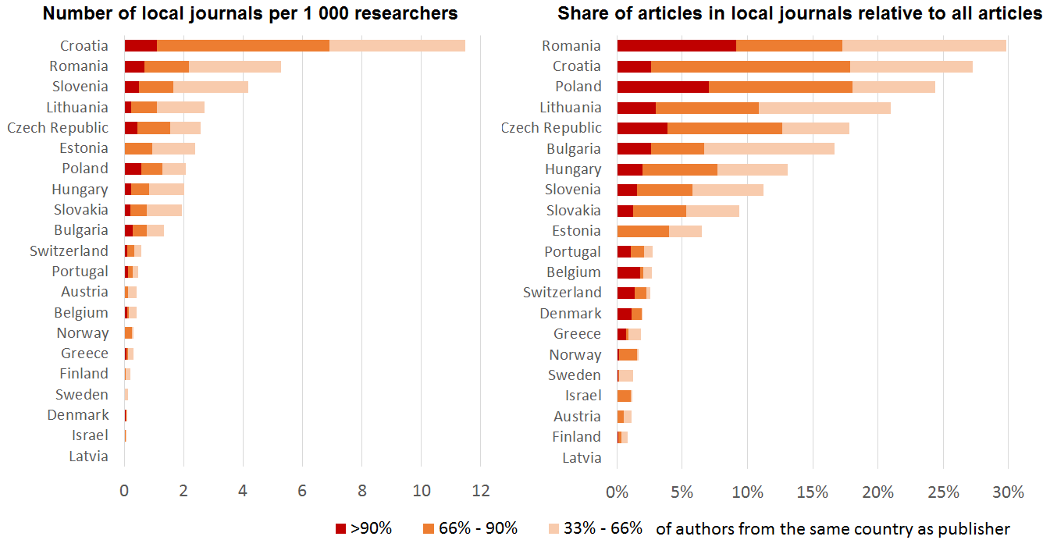
* *Source: IDEA (2017); Scopus; OECD; Eurostat*
* V. Macháček, M. Srholec Místní časopisy ve Scopusu (Local Journals in Scopus, only in Czech, *Studie IDEA*, 17/2017 (2017). Available at: <https://idea.cerge-ei.cz/files/IDEA_Studie_17_2017_Mistni_casopisy_ve_Scopusu/mobile/index.html>
* See full list of references.

**Predatory Journals in Scopus**

An analysis exploring the number of documents published in journals on the Beall's list of "potentially predatory journals" across the world.

**Figure: Share of predatory articles on total number of articles (2015-2017)**

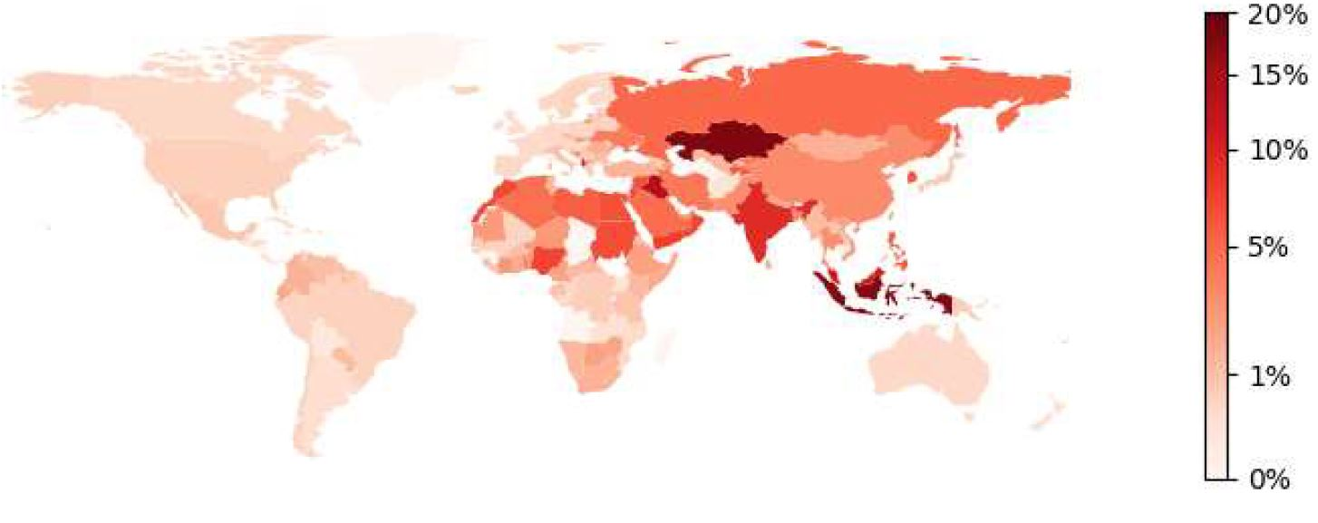

*Source: IDEA (2017); Scopus; the articles from the Frontiers publisher were excluded;*

V. Macháček and M. Srholec Predátorské časopisy ve Scopusu (Predatory Journals in Scopus, only in Czech), *IDEA Study*, 16 (2016), p.1-39. Available at: <https://idea.cerge-ei.cz/files/IDEA_Studie_16_2016_Predatorske_casopisy_ve_Scopusu/mobile/index.html#p=40>

See full list of references.

### Country groups

The country groups are calculated as a simple average of all countries within the group.

##### Development status

International Monetary Fund's former classification from the [IMF Economic Outlook 2003](https://www.imf.org/external/pubs/ft/weo/2003/02/)(Statistical Appendix;p.163)

**Advanced Countries**: *Developed countries from Northern America, Europe, Pacific and Eastern Asia*

Andorra, Australia, Austria, Belgium, Canada, Cyprus, Denmark, Finland, France, Germany, Greece, Hong Kong, Iceland, Ireland, Israel, Italy, Japan, Liechtenstein, Luxembourg, Monaco, Netherlands, New Zealand, Norway, Portugal, San Marino, Singapore, South Korea, Spain, Sweden, Switzerland, Taiwan, United Kingdom, United States

**Transition Countries**: *Countries in the former soviet bloc, but not China*

Albania, Armenia, Azerbaijan, Belarus, Bosnia and Herzegovina, Bulgaria, Croatia, Czech Republic, Estonia, Georgia, Hungary, Kazakhstan, Kyrgyzstan, Latvia, Lithuania, Macedonia, Moldova, Mongolia, Montenegro, Poland, Romania, Russian Federation, Serbia, Slovakia, Slovenia, Tajikistan, Turkmenistan, Ukraine, Uzbekistan

**Developing countries**: *The rest of the world*

Afghanistan, Algeria, Angola, Antigua and Barbuda, Argentina, Bahamas, Bahrain, Bangladesh, Barbados, Belize, Benin, Bhutan, Bolivia, Botswana, Brazil, Brunei, Burkina Faso, Burundi, Cambodia, Cameroon, Cape Verde, Central African Republic, Chad, Chile, China, Colombia, Comoros, Congo, Costa Rica, Cote d'Ivoire, Cuba, Democratic Republic Congo, Djibouti, Dominica, Dominican Republic, Ecuador, Egypt, El Salvador, Equatorial Guinea, Eritrea, Ethiopia, Fiji, Gabon, Gambia, Ghana, Grenada, Guatemala, Guinea, Guinea-Bissau, Guyana, Haiti, Honduras, India, Indonesia, Iran, Iraq, Jamaica, Jordan, Kenya, Kiribati, Kuwait, Laos, Lebanon, Lesotho, Liberia, Libya, Madagascar, Malawi, Malaysia, Maldives, Mali, Malta, Marshall Islands, Mauritania, Mauritius, Mexico, Micronesia, Morocco, Mozambique, Myanmar, Namibia, Nauru, Nepal, Nicaragua, Niger, Nigeria, North Korea, Oman, Pakistan, Palau, Palestine, Panama, Papua New Guinea, Paraguay, Peru, Philippines, Qatar, Rwanda, Saint Kitts and Nevis, Saint Lucia, Saint Vincent and the Grenadines, Samoa, Sao Tome and Principe, Saudi Arabia, Senegal, Seychelles, Sierra Leone, Solomon Islands, Somalia, South Africa, Sri Lanka, Sudan, Suriname, Swaziland, Syria, Tanzania, Thailand, Timor-Leste, Togo, Tonga, Trinidad and Tobago, Tunisia, Turkey, Tuvalu, Uganda, United Arab Emirates, Uruguay, Vanuatu, Venezuela, Vietnam, Yemen, Zambia, Zimbabwe

##### Regions

The regional classification is based on the [World Bank regional classification](http://ec2-18-188-88-0.us-east-2.compute.amazonaws.com:8080/data/WorldBankClassification.xls).

The following regions were further split:

* Europe & Central Asia => *Europe* and *Central Asia*
* Middle East & North Africa => *Middle East* and *North Africa*
* East Asia & Pacific => *East Asia* and *Pacific*

##### Income

Income classification is based on the [World Bank income classification](http://ec2-18-188-88-0.us-east-2.compute.amazonaws.com:8080/data/WorldBankClassification.xls).

##### EU

Three groups are derived from the EU membership:

* EU - All EU countries
* EU15 - "Old" EU Countries (before 2004)
* EU13 - "New" EU Countries (accessed in 2004 or later)

##### OECD

One country group of OECD member countries.

### Zit and Bassecoulard (1998) and (1999)

The pioneering papers on the internationality of science. The 1998 paper suggest a methodology for evaluating globalization of a journal and the 1999 paper suggest scaling to the level of countries and disciplines.

M. Zitt, E. Bassecoulard Internationalization of scientific journals: a measurement based on publication and citation scope, *Scientometrics*, 41(1–2) (1998) 255–271. Available at: <https://link.springer.com/article/10.1007/BF02457982>

M. Zitt, E. Bassecoulard Internationalization of communication a view on the evolution of scientific journals, *Scientometrics*, 46(3) (1999) 669-685. Available at: <https://link.springer.com/article/10.1007/BF02459619>

See full list of references.

### Aman (2016)

A conference contribution with a similar topic, but a single indicator that does not take into account the size of research sector.

V. Aman Measuring internationality without bias against the periphery, *Proceedings of the 21st international conference on science and technology indicators*, p. 1042-1050. Available at: <http://ocs.editorial.upv.es/index.php/STI2016/STI2016/paper/viewFile/4543/2327>

See full list of references.

### Mongeon and Paul-Hus (2016)

The analysis of journals covered by two most important bibliometric databases shows, that Scopus indexes almost twice more journals than Web of Science and if WoS covers a journal it is likely to be indexed also in Scopus.

P. Mongeon, A. Paul-Hus The journal coverage of Web of Science and Scopus: a comparative analysis , *Scientometrics*, 106(1) (2016) 213-228. Available at: <https://link.springer.com/article/10.1007/s11192-015-1765-5>

See full list of references.