**Globalization of Science**

Evidence from authors in academic journals  
by country of origin

WORKING VERSION, PLEASE DO NOT DISTRIBUTE!

Vít Macháček and Martin Srholec

### Introduction

Science knows no limits and borders. Scientific inquiry has therefore gone global long before the economy or culture. Yet this does not necessarily mean that science is global to the same extent everywhere and anywhere.

To which extent are scientific outputs published in global in contrast to local journals? How does this tendency differ across countries and disciplines? And how much has this changed over the last decade or so?

The aim of this study is to show just that. We provide fresh evidence on the globalization of science that allows for a comparison over space, fields and time, namely for 174 countries and various country groups in 4 broad and 27 narrow disciplines over 2005 to 2017.

The study is based on six journal-level indicators of globalization. The benchmark indicators are derived from the composition of authors by the country of origin. For comparison, we also use data on the number of documents by the country of origin and English-written documents.

The journal-level indicators are then aggregated to countries and disciplines. These results are standardized between 0 and 1, where 0 refers to the lowest and 1 to the highest globalization.

The analysis is based on data for 34 964 journals from the [Scopus citation database](https://www.scopus.com/)(downloaded in August 2018). The list of journals and assigned disciplines is obtained from the [Scopus Source List](http://ec2-18-188-88-0.us-east-2.compute.amazonaws.com:8080/data/ext_list_April_2018_2017_Metrics.xlsx) (version of April 2018).

Globalization of science should not be confused with its quality (or relevance); they are likely to be related in many interesting ways, depending on the discipline, but they are different phenomena.

The results are presented in an interactive way that allows readers to customize the output and should be of interest not only to academics but also policy-makers and broader audience across the globe.

For earlier studies of the IDEA think tank on related topics, including on local journalsand predatory publishing, see [here](https://idea-en.cerge-ei.cz/publicationslist).

#### How to use the application

Each point depicts the globalization index GSc,d,y,iGc,d,y,iS of a respective country and discipline in a given year and indicator. For more details see definition of the journal-level indicators and aggregation procedure.

Use the upper dropdown menus to customize the output. One can compare either:

* countries within a discipline, or
* disciplines within a country;

The main dimension is fixed by the button . Up to 10 items can be included in the comparison.

Switch between different globalization indicators in the third dropdown menu.

Moving the cursor over a point displays its value and over connecting lines displays the name of the series.

The dashed grey line shows average of the main dimension, i.e. either for the world or all disciplines.

Keep scrolling down for more information and presentation of the key findings.

Use the menu in the top-centre to jump at any time between the main parts of the study.

### Bear in mind while using

* The globalization indexes are standardized between 0 and 1 across all countries (174), narrow disciplines (27) and years (13).
* Large year-by-year jumps in some series can be driven by adding (or removing) important journals in Scopus.
* Results for country groups are computed as simple averages of member countries. Germany has the same weight as Luxembourg, etc.
* Results for broad and narrow disciplines are calculated separately from scratch; the former are not simply aggregations of the latter.
* Only data on document types of a journal article, review and conference paper are taken into account.
* Journals are fully counted in each discipline, to which they are assigned. Large interdisciplinary journals may affect results for smaller disciplines.
* Comparison of indicators within a country or a discipline could be misleading, hence not facilitated.
* Gini-Simpson and Local Authors indicators do not take into account the research sector size in the estimation.
* For the sake of robustness, only journals with at least 30 documents in the given year are included in the calculation.
* Only results of the aggregation to countries and disciplines based on data from at least 30 journals are reported.
* Smaller countries and disciplines suffer from gaps in the displayed results due to insufficient data.
* Yet results for smaller countries and disciplines based on relatively thin data should be interpreted with caution.

### Broad Picture

#### Transition outsiders

Science in advanced countries has been traditionally globalized.

In contrast, transition countries continue to be relatively isolated.

Developing countries remain in the middle and close to the world average.

Interestingly, there does not seem to be much change here.

*Tip: Display the discipline of your interest using the upper menu. For definition of the country groups see a note below the figure.*

### Big 7

#### The contrast of China and Russia

Not surprisingly, the Unites States jointly with the EU-28 set the upper standard; followed by Japan.

China scored last initially but globalized its science base enormously, eventually converging to a similar level with Brazil and India.

Russia started and remained low, lagging increasingly behind the rest of the pack.

*Tip: Add (or remove) countries (or country groups) using the upper menu. Replace the EU-28 average by individual member countries of your interest.*

### Bottom 10

#### The least globalized (period average)

Not only Russia, but also other former members of the Soviet bloc, cluster at the bottom of the worldwide ranking.

Chinese science turns out to be actually the least globalized in the whole world initially.

*Tip: Replace China by other members of the Soviet bloc to see how they fare in comparison to the world average.*

### Advanced countries by disciplines

#### Consistently global

In advanced countries science is on average highly globalized across disciplines.

Physical and Life Sciences are the most globalized. Health Sciences rank even below Social Sciences. However, the differences are very small.

In fact, it is hard to find sub-discipline that deviates significantly from this narrow corridor.

*Tip: Add sub-disciplines of your interest using the upper menu. For definition of the disciplines see a note below the figure.*

### Russia by disciplines

#### Science of its own

Russian science did not ever break from its inward-looking Soviet past, regardless of the discipline.

Russian Physical and Life Sciences remain significantly less globalized than elsewhere in the world.

The only major exception is the sub-discipline of Pharmacology, Toxicology and Pharmaceutics.

Interestingly, in many disciplines this is in a sharp contrast to the relatively high share of documents published in English.

In fact, about four-fifths of documents with at least one author from Russia were written in English over this period.

*Tip: Display results for a different indicator using the upper menu.*

### China by disciplines

#### From zero to hero

China has profoundly globalized its science system; gradually moving from the lowest globalization rates to prominence at the world stage.

Chinese Social Sciences have become even more globalized than other broad disciplines and already caught-up with the EU-28 and the world average.

In some sub-disciplines, China has already surpassed the United States and steams forward to the top ranking.

If the trend persists, China will soon eliminate the gap to advanced countries in most of the sub-disciplines.

*Tip: Compare to results for Hong Kong using the upper menu (the results for China do not include Hong Kong, which continues to be reported separately by Scopus).*

### Social Sciences in Central and Western Europe

#### Social Sciences in question

In Western Europe, Social Sciences are highly globalized, not unlike Natural Sciences.

In Central (and Eastern) Europe, however, Social Sciences continue to maintain their own local publication silos.

The prime exception is Hungary, where Social Sciences used to be more oriented to the West even before the fall of the Berlin Wall.

*Tip: Add other transition countries (or the group average) to the comparison using the upper menu.*

### Czechia by disciplines

#### Czechia in the spotlight

Czechia is a prime example of formerly advanced country that have been tarnished during the decades of communism reign.

Physical and Life Sciences have continued to be connected to the global arena.

However, Social Sciences have been locked behind the Berlin Wall; they steadily globalize, but from a low base and there is still a long way to go.

*Tip: Explore other countries of the former Soviet bloc using the upper menu. Note, for instance, the development in Ukraine.*

### Concluding remarks

Globalization of science provides a new perspective on the scientific landscape, which in many respects deepens what we know from standard bibliometrics.

The traditional science powerhouses in the North and West remain strong and at the core of the global system; highly interconnected and globalized as ever.

In many countries of the former Soviet block, the low globalization of science is a symptom of a systemic failure; of science that is out of sync with the rest of the world and inefficient.

After the fall of the Berlin Wall, it was understandable that science in transition countries needs time to catch-up. In many disciplines, new infrastructure had to be built from scratch. But three decades onwards, there is no excuse.

China shows that where is a will there is way. In little more than one decade, Chinese science moved from a relative isolation to the front pages of global journals amid enormously expanding in size.

Other developing countries also steer increasing resources to science and could be in the risk of creating ecosystems of local publishing similar to transition countries or worse such as falling for predatory journals.

Globalization of science that is pervasively lower than in similar countries should be a cause for concern that the science system has drifted astray and needs an overhaul of its evaluation and funding framework.

More research is needed to better understand globalization of science. Does globalization of the national science system go hand in hand with quality and impact? Are there spillovers outside of the realm of science? And what can be done about it?

*Tip: Spend more time with the interactive app to explore the position of country and discipline of your interest.*

# Thanks for your attention!

## If you liked it, do not forget to share!

See full list of references

Please cite as: Macháček, V. and Srholec, M. (2019) Globalization of Science: Evidence from authors in academic journals by country of origin. XXX/2019. Think-tank IDEA.

Acknowledgement: Financial support from the research programme Strategy AV21 of the Czech Academy of Sciences is gratefully acknowledged. All usual caveats apply.

Warning: This study represents only the views of the authors and not the official position of the Economics Institute of the Czech Academy of Sciences or the Center for Economic Research and Graduate Education (CERGE), Charles University.

### Countries

Out of 240 countries and territories, for which at least some information is available, we have excluded entities that are either dependent territories, too small and/or with too few data to derive reliable results.

The resulting sample consists of 174 countries, including a large number of developing and transition countries, which together cover the overwhelming majority of the world's population and research output.

Data with "undefined" country origin of authors (about 5% of observations) has been excluded from the analysis. Data for Yugoslavia before 2007 were added to Serbia.

### Country groups

##### Development status

**Advanced countries**: Australia, Austria, Belgium, Canada, Cyprus, Denmark, Finland, France, Germany, Greece, Hong Kong, Iceland, Ireland, Israel, Italy, Japan, Liechtenstein, Luxembourg, Monaco, Netherlands, New Zealand, Norway, Portugal, Singapore, South Korea, Spain, Sweden, Switzerland, Taiwan, United Kingdom, United States.

**Transition countries**: Albania, Armenia, Azerbaijan, Belarus, Bosnia and Herzegovina, Bulgaria, Croatia, Czechia, Estonia, Georgia, Hungary, Kazakhstan, Kyrgyzstan, Latvia, Lithuania, Macedonia, Moldova, Mongolia, Montenegro, Poland, Romania, Russia, Serbia, Slovakia, Slovenia, Tajikistan, Turkmenistan, Ukraine, Uzbekistan.

**Developing countries**: Rest of the world.

Source: IMF (2003) [World Economic Outlook](https://www.imf.org/external/pubs/ft/weo/2003/02/) (Statistical Appendix; pp. 163-169).

##### Income

**High income**, **Upper middle income**, **Lower middle income** and **Low income** depending on Gross National Income (GNI) per capita in US$ (Atlas methodology).

Source: World Bank (2018) [How does the World Bank classify countries?](https://datahelpdesk.worldbank.org/knowledgebase/articles/378834-how-does-the-world-bank-classify-countries) (version of June 2018).

##### Regions

**Europe**, **North America**, **South America**, **Central Asia**, **Middle East**, **East Asia**, **South Asia**, **Pacific**, **North Africa**, **Sub-Saharan Africa** based on geography and administrative borders.

Source: World Bank (2018) [How does the World Bank classify countries?](https://datahelpdesk.worldbank.org/knowledgebase/articles/378834-how-does-the-world-bank-classify-countries) (version of June 2018).

##### Other

**EU-15**: "Old" EU member countries (before 2004).

**EU-13**: "New" EU member countries (accessed between 2004 and 2018).

**EU-28**: EU-15 and EU-13 combined.

**OECD**: OECD member countries (as of January 2019).

### Disciplines

According to the [Scopus Journal Classification](http://ec2-18-188-88-0.us-east-2.compute.amazonaws.com:8080/data/ext_list_April_2018_2017_Metrics.xlsx) journals are classified into 4 broad subject clusters:

1. Life Sciences,
2. Physical Sciences,
3. Health Sciences,
4. Social Sciences

which are further subdivided into 27 major subject areas, such as:

1.1 Agricultural and Biological Sciences,

1.2 Biochemistry, Genetics and Molecular Biology,

1.3 Immunology and Microbiology,

1.4 Neuroscience,

1.5 Pharmacology, Toxicology and Pharmaceutics,

etc.

If a journal is assigned to multiple categories, it is fully counted in each of them.

### Journal Globalization Indicators

The methodology builds on the pioneering work by [Zitt and Bassecoulard (1998)](https://link.springer.com/article/10.1007/BF02457982), which we complement by the contributions by [Buela-Casal (2006)](https://link.springer.com/article/10.1007/s11192-006-0050-z), [Aman (2016)](http://ocs.editorial.upv.es/index.php/STI2016/STI2016/paper/viewFile/4543/2327) and two indicators of our own.

In essence, the most globalized journals have structure (of documents by the country of origin of authors, etc.) that closely resembles the global structure of the whole discipline and vice versa.

Only journals with at least 30 documents in the particular year are included in the calculation.

#### Definitions

Nc,j,yNc,j,y and Nc,d,yNc,d,y is the number of documents with authors affiliated to the country cc in the journal jj and the discipline dd, respectively, in the year yy.

NLOCAL,j,yNLOCAL,j,y is the number of documents with authors from the same country as the publisher of journal jj in the year yy.

NENG,j,yNENG,j,y is the number of English-written documents in the journal jj in the year yy.

Tj,yTj,y denotes the total number of documents published in the journal jj in the year yy.

Note: Documents by authors from multiple countries are fully attributed to each country, i.e. Tj,y≠∑cNc,j,yTj,y≠∑cNc,j,y.

#### Indicators:

Euclid GiniSimpson Weighted Gini Largest Contributors Local Authors English Documents

##### Euclidian distance of journal and discipline country distribution

gEuclidj,d,y=√∑(xc,j,y−mc,d)2gj,d,yEuclid=∑(xc,j,y−mc,d)2

where xc,j,yxc,j,y is the share of the country cc in the journal jj and the year yy:

xc,j,y=Nc,j,yTj,yxc,j,y=Nc,j,yTj,y

and mc,dmc,d is the share of the country cc in the aggregate discipline dd over all years:

mc,d=∑yNc,d,y∑y∑cNc,d,ymc,d=∑yNc,d,y∑y∑cNc,d,y

Source: [Zitt and Bassecoulard (1998)](https://link.springer.com/article/10.1007/BF02457982)

##### Gini-Simpson diversity of journal country distribution

gGiniSimpsonj,d,y=1−∑N2c,j,y(∑Nc,j,y)2gj,d,yGiniSimpson=1−∑Nc,j,y2(∑Nc,j,y)2

Source: [Aman (2016)](http://ocs.editorial.upv.es/index.php/STI2016/STI2016/paper/viewFile/4543/2327)

##### Gini Index of author’s countries weighted by discipline country distribution

gGinij,d,y=∑ni=1vi∗wi−1−∑n−1i=0vi∗wi+1gj,d,yGini=∑i=1nvi∗wi−1−∑i=0n−1vi∗wi+1

where

w=⎡⎢

⎢⎣∑1c=1mc,d..∑nc=1mc,d⎤⎥

⎥⎦v=⎡⎢

⎢⎣∑1c=1xc,j,ymc,d..∑nc=1xc,j,ymc,d⎤⎥

⎥⎦w=[∑c=11mc,d..∑c=1nmc,d]v=[∑c=11xc,j,ymc,d..∑c=1nxc,j,ymc,d]

and xc,j,yxc,j,y is the share of the country cc in the journal jj and the year yy:

xc,j,y=Nc,j,yTj,yxc,j,y=Nc,j,yTj,y

and mc,dmc,d is the share of the country cc in the aggregate discipline dd over all years:

mc,d=∑yNc,d,y∑y∑cNc,d,y

##### Surplus of three largest contributing countries

gTop3j,d,y=∑3c=1(xc,j,y−mc,d)gj,d,yTop3=∑c=13(xc,j,y−mc,d)

where xc,j,yxc,j,y is the share of the country cc in the journal jj and the year yy:

xc,j,y=Nc,j,yTj,yxc,j,y=Nc,j,yTj,y

and mc,dmc,d is the share of the country cc in the aggregate discipline dd over all years:

mc,d=∑yNc,d,y∑y∑cNc,d,ymc,d=∑yNc,d,y∑y∑cNc,d,y

##### Share of documents from journal's domicile

gLocalSharej,d,y=NLOCAL,j,yTj,ygj,d,yLocalShare=NLOCAL,j,yTj,y

Source: [Zitt and Bassecoulard (1998)](https://link.springer.com/article/10.1007/BF02457982)

##### Share of English-written documents

gShareEnglishj,d,y=NENG,j,yTj,ygj,d,yShareEnglish=NENG,j,yTj,y

Source: [Buela-Casal (2006)](https://link.springer.com/article/10.1007/s11192-006-0050-z)

### Database

[Scopus Source List](http://ec2-18-188-88-0.us-east-2.compute.amazonaws.com:8080/data/ext_list_April_2018_2017_Metrics.xlsx) (version of April 2018) provided International Standard Serial Numbers (ISSNs), classification by disciplines and publisher’s domicile of 34 964 academic journals.

In August 2018, detailed data on authors by the country of origin and language of documents in these ISSNs were downloaded from the [Scopus](https://www.scopus.com/) citation database over the period from 2005 to 2017.

Only document types of a journal article, review and conference papers, i.e. the so-called “citable documents”, are included in this analysis.

The following Scopus API request was used to download the data:

ISSN(AAAA-BBBB) AND DOCTYPE(AR OR RE OR CP) AND PUBYEAR = YYYY

where *AAAA-BBBB* is the journal's ISSN and *YYYY* is the year.

### Local Journals in Scopus

In this study, we analysed local academic publishing in selected European countries over the period 2013-2016.

The results revealed strong tendency to publish locally in the former communist countries. Local journals are prevalent in Croatia, Romania, Slovenia, Lithuania or Czechia but rather rare in comparable advanced countries.

In Czechia, for instance, nearly one fifth of all indexed results are concentrated in Czech journals with a high percentage (>33%) of articles by domestic authors. About half of authors contributing to Czech journals are based in Czechia, and another tenth in Slovakia.

In contrast, the vast majority of articles which come out in journals published in comparable advanced countries are written by foreigners. The publishing of local, or at best regional, journals appears to be a distinctly Eastern European phenomenon.

**Local Journals in selected EU and OECD countries (2013-2016)**

(% of authors form the same country as the journal publisher)

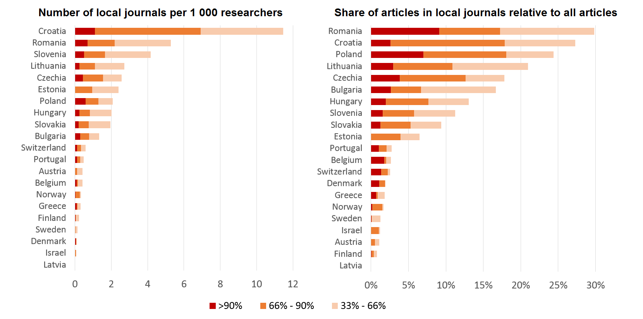

*Note: Number of active journals with more than 30 articles over 2013-2016; number of researchers in the latest available year in full time equivalent.*

*Source: Scopus (April and October 2017), Eurostat, OECD, Scimago, authors' calculations.*

V. Macháček, M. Srholec (2017) [Local Journals in Scopus](https://idea.cerge-ei.cz/files/IDEA_Studie_17_2017_Mistni_casopisy_ve_Scopusu/mobile/index.html) (only in Czech).*IDEA think-tank at CERGE-EI*, Study 17/2017.

### Predatory Journals in Scopus

In this study, we mapped patterns of predatory publishing across the globe over the period 2015-2017.

The analysis is based on Beall's lists of "potentially predatory" journals and publishers, of which we found 3 218 journals in Ulrichsweb and 405 journals in Scopus.

The results shows that predatory publishing has become most widespread in middle-income countries in Asia and North Africa.

However, the analysis also indicates that Beall’s lists need to be used with caution, as some of the implicated journals may not be necessarily fraudulent in the strict sense.

**Share of predatory articles on total number of articles (2015-2017)**

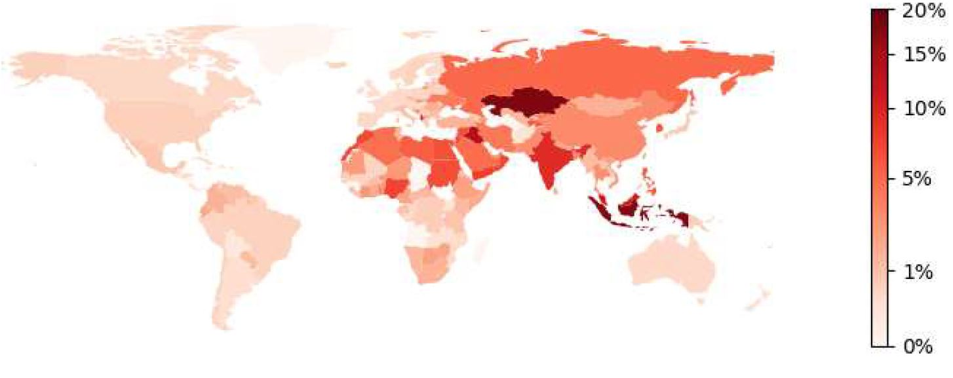

*Note: Articles in journals published by the Frontiers Research Foundation are excluded from predatory publications.*

*Scopus (October 2016), Beall's lists (April 2016), authors' calculations.*

V. Macháček and M. Srholec (2016) [Predatory Journals in Scopus](https://idea-en.cerge-ei.cz/files/IDEA_Study_2_2017_Predatory_journals_in_Scopus/files/downloads/IDEA_Study_2_2017_Predatory_journals_in_Scopus.pdf). *IDEA think-tank at CERGE-EI*, Study 2/2017.

### References

V. Aman (2016) [Measuring internationality without bias against the periphery](http://ocs.editorial.upv.es/index.php/STI2016/STI2016/paper/viewFile/4543/2327), *Proceedings of the 21st international conference on science and technology indicators*, p. 1042-1050.

G. Buela-Casal, P. Perakakis, M. Taylor and P. Checa (2006) [Measuring internationality: Reflections and perspectives on academic journals](https://link.springer.com/article/10.1007/s11192-006-0050-z), *Scientometrics*, 67(1), p.45-65.

IMF (2003) [World Economic Outlook](https://www.imf.org/external/pubs/ft/weo/2003/02/) (Statistical Appendix; pp. 163-169).

V. Macháček and M. Srholec (2016) [Predatory Journals in Scopus](https://idea-en.cerge-ei.cz/files/IDEA_Study_2_2017_Predatory_journals_in_Scopus/files/downloads/IDEA_Study_2_2017_Predatory_journals_in_Scopus.pdf), *IDEA think-tank at CERGE-EI*, Study 2/2017.

V. Macháček, M. Srholec (2017) [Local Journals in Scopus](https://idea.cerge-ei.cz/files/IDEA_Studie_17_2017_Mistni_casopisy_ve_Scopusu/mobile/index.html) (only in Czech).*IDEA think-tank at CERGE-EI*, Study 17/2017.

World Bank (2018) [How does the World Bank classify countries?](https://datahelpdesk.worldbank.org/knowledgebase/articles/378834-how-does-the-world-bank-classify-countries) (version of June 2018). Accessed on March 15th 2019.

M. Zitt, E. Bassecoulard (1998) [Internationalization of scientific journals: a measurement based on publication and citation scope](https://link.springer.com/article/10.1007/BF02457982), *Scientometrics*, 41(1–2) 255–271.

M. Zitt, E. Bassecoulard (1999) [Internationalization of communication a view on the evolution of scientific journals](https://link.springer.com/article/10.1007/BF02459619),*Scientometrics*, 46(3) 669-685.