# Globalization of Research Output

## **Evidence from academic journals by countries and disciplines**

## **WORKING VERSION, PLEASE DO NOT DISTRIBUTE!**

Vít Macháček

 Think-tank IDEA of the Economic Institute of AS CR

**Globalization of Scientific Journals**

**Motivation**

Researchers should present their results to the global audience. They should be published in the globalized journals, that are contributed by authors from wide range of countries. Then the journals can meet its primary objective of a scientific communication platform.

In some countries the local journals are extensively used. Our previous IDEA study revealed strong tendency to publish locally in Eastern Europe. In Croatia, Lithuania, Poland and Romania more than 20 % of research output is published in journals with more than 33 % of local authors. The same figure is below 2 % in Finland, Austria, Israel or Sweden.

This study seeks to construct measures of journal's output globalization (from now on just globalization) and scale it up to the country and disciplines level, to allow for comparison in time, space and across disciplines. The main goal is to reveal the differences in the publishing patterns across countries and disciplines.

Research sector is ongoing a massive transformation. The number of publications grows rapidly in both traditionally research-oriented countries and also in many newly developing countries, where the research infrastructure is built from the ground up. Globalization contains a useful information about this transformation process.

Do not confuse globalization with quality. Many globalized journals publish low-quality results. However in most cases important discoveries will be published in the globalized journals. The system-wide lack of globalization indicates an important structure of local journals.

Local publishing does not necessarily imply malpractice. It can be a consequence of locally bounded research topic - consider Arts and Humanities. However substantially lower globalization compared to other countries within a single discipline puts the efficiency of the research system in question.

**Methods**

A set of 6 journal-level indicators of globalization were developed. They are designed to be heterogeneous both in terms of the data and in the underlying mathematics. See the detailed description of indicators.

Subsequently, the indicators were aggregated to the level of countries and disciplines. The result is a weighted average of individual journals scaled between 0 and 1, where 0 is lowest globalization and 1 is the highest. The description of the aggregation process is available in the general framework. Several country groups averages were included in the results to show globalization patterns on the global level.

All of the data used in this analysis are from the Scopus database. The country and language data are downloaded using the Scopus API. The list of journals and their disciplines are taken from the Scopus Source List. The disciplines assignment is based on the 5 broad subject clusters and 27 major subject areas from the Scopus journals' classification.

Methodology is inspired by Zitt and Bassecoulard (1999), who proposed some of the indicators and the aggregation process. However since any systematic evidence is very scarce. Some evidence is estimated in Aman (2016), but their estimation does not take into account the research sector size.

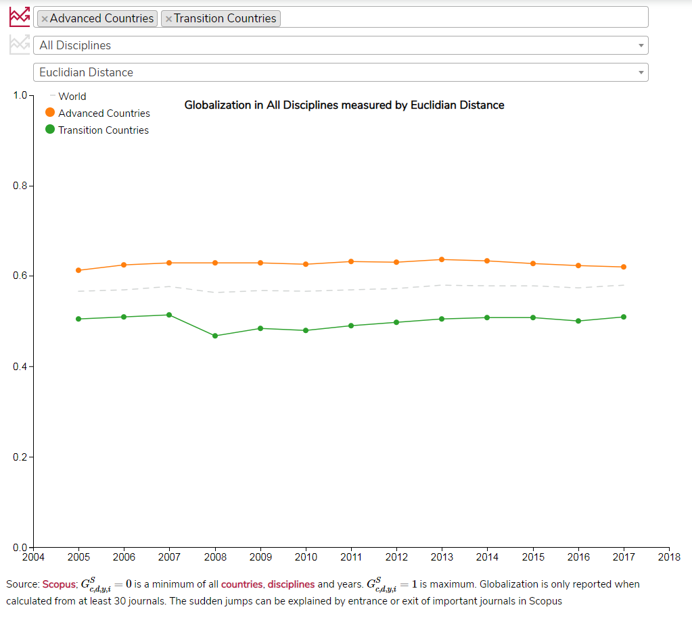

#### Reading the chart

Each point on chart represents the globalization index GSc,d,y,iGc,d,y,iS for country (or country group) cc, discipline dd, indicator ii and year yy. See the general framework and the description of indicators.

The dropdown menus can be used to choose the appropriate combination.

It is possible to compare within the particular dimensions using the button  . Reader can choose to compare:

* *countries* within the same indicator and discipline
* *disciplines* within the same country and indicator

When comparing countries also the world average of a given discipline and indicator is displayed on chart.

**Keep in mind while reading ...**

* The year-by-year jumps are caused by adding and removing journals from the Scopus database.
* Journals can be assigned to multiple disciplines. All journals are fully counted in each discipline. This is problematic especially for the disciplines where large interdisciplinary journals are important.
* The globalization is only reported when the authors from a given country and discipline publish in at least 30 journals in the particular year.
* It is only possible to compare results within an indicator. Comparison across indicators is misleading as the underlying journals distribution varies.
* Our methodology favour publishing in English over publishing in other world languages.
* Country groups are computed as simple averages of member countries.
* Both narrow and broad disciplines are calculated separately from a different set of journals.
* The globalization development takes the world trend into account. Disciplines aggregates are calculated from all available years, while the journal data use only a given year.
* Only articles, reviews and conference papers are considered. This is especially important for disciplines, where other document types (for example *books* or *letters*) are commonly used.

#### Broad picture

Globalization systematically differ between two country groups: *Advanced Countries* (mainly Western Europe, USA, Australia and Asian developed countries) and *Transition Countries* (former Soviet satellites; not including China and other East Asian post-communist countries).

In most disciplines and indicators, the *Transition Countries* are less globalized than *Advanced Countries*.

*Tip: Explore Advanced and Transition countries' globalization in different disciplines and indicators using the upper menu.*

### Advanced Countries

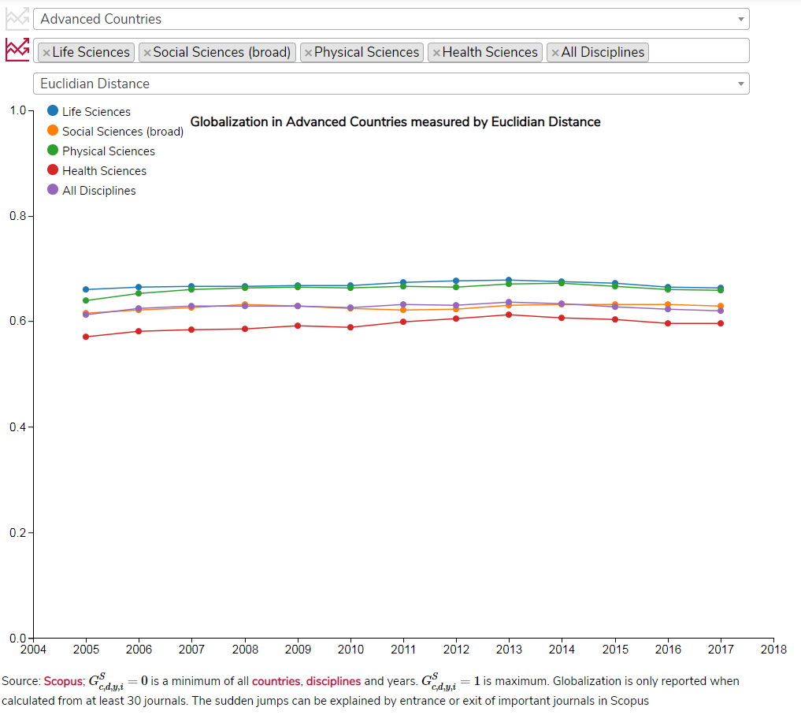

Relatively high globalization is a common standard in the *Advanced Countries*. The *Life Sciences* are similarly globalized as the *Physical Sciences* or *Social Sciences*.

Also within the narrowly defined disciplines, the globalization is high.

There is a common pool of journals used by researchers from *Advanced Countries*. No matter whether the author is from the United States, Sweden or Israel, she will probably publish in similar journals. In this sense, the journals meet their objective of a scientific communication intermediary.

Even in the Advanced Countries the local journals exist. But they are rather exceptional. A standard publications is published in the globalized. This pattern can be considered a benchmark of a good practice as these countries set standards in the research management.

Perhaps surprisingly the tendency to publish globally is similar across disciplines. In *Economics, Econometrics and Finance* the globalization is roughly similar to that of *Biochemistry, Genetics and Molecular Biology*. Even in the *Arts and Humanities*, most of the publications are published in the globalized journals.

### Transition Countries

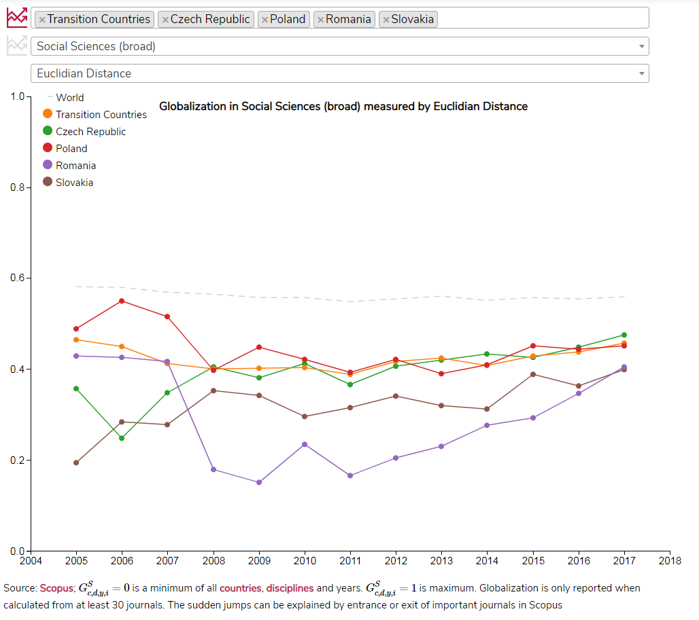

In the *Transition countries* the globalization is low especially in the *Social Sciences*.

Globalization gradually grows, but the difference persists.

*Tip: Also Health Sciences are below average in these countries. You can see the difference when comparing with Life Sciences.*

Researchers in *Transition Countries* extensively publish in local journals, especially in the *Social Sciences*. On average 60 % of all documents from *Transition Countries* are published in the lower half of social sciences journals by *Euclidian Distance*. The same figure is below 30 % in the *Advanced Countries*.

Moreover, the case of Eastern Europe shows that rather than an interconnected ecosystem competing to the advanced countries, there is a set of separated ecosystems focusing each on the different country (see study IDEA).

The social scientific research had to start from scratch after the fall of the Berlin Wall. Entire new infrastructure had to be built, while facing fierce competition and strict standards in the already established journals. Together with benevolent research policy it led to the emergence of local journals with low globalization.

Almost 30 years after the fall of communism this "glass curtain between East and West" is clearly visible. Good example is *Economics, Econometrics and Finance*: In 2017 70% of all documents from *Austria*, *Germany*, *Netherlands*, *Norway*, *Sweden*and *Switzerland* were published in the upper half of journals ranked by *Euclidian distance*. The same figure is below 20% in the *Czech Republic*, *Lithuania*, *Russian Federation*, *Slovakia* or *Ukraine*.

### Russian Federation

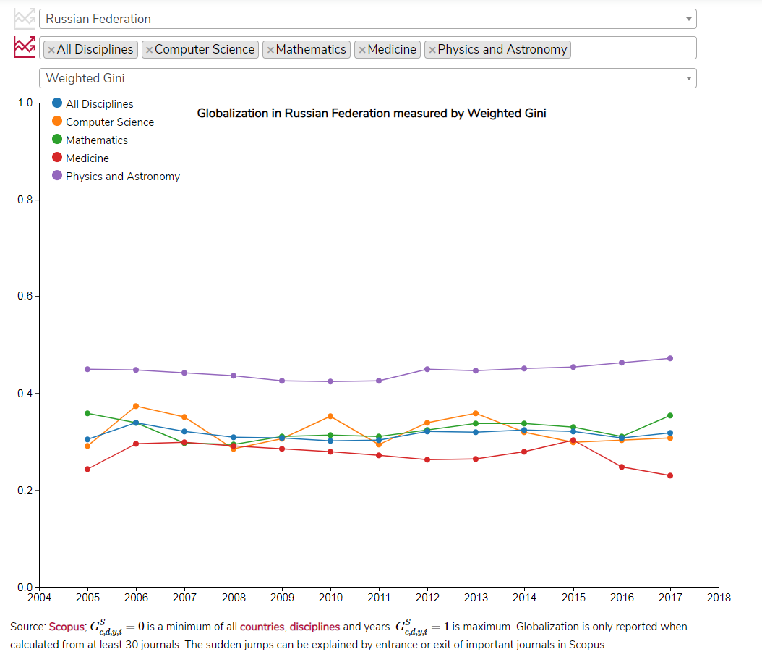

The prime example of such disconnected research system is Russia. Its globalization is among the lowest in most disciplines and indicators.

Unlike most under-globalized countries, Russia does not indicate any growing tendency in most disciplines.

Russia's research was inward-looking already during the Soviet era. The communist leadership was not excited about sharing their discoveries. Although there were many initiatives to reform the Russian system since the fall of communism (see Moed 2018), none if it lead to higher globalization. Russians are still struggling with sharing their discoveries globally.

The lack of globalization does not imply publication in local language. In fact, 84% of all Scopus-indexed documents with at least one Russian-affiliated author were written in English. However as these journals were locally focused, it probably did not lead to higher impact of these publications (see Kirchik, Gingras and Lariviere 2012).

The low globalization is not concentrated in several disciplines of strategic importance. It is a widespread systemic issue.

### China

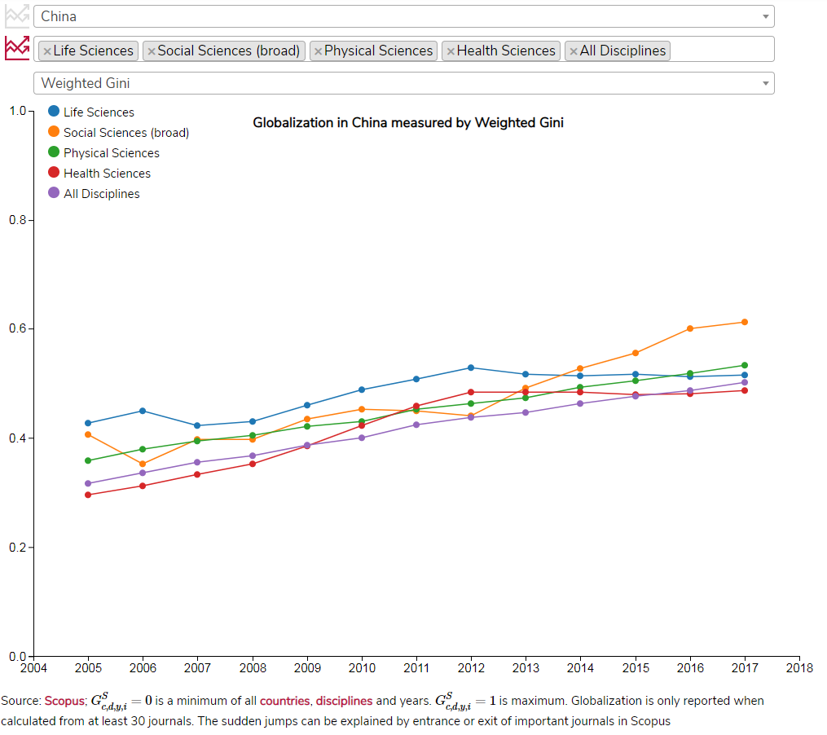

The development in China is strikingly different to the Russian example. China used to have one of the least globalized research systems in the world. Since 2004 the globalization grows by a stable pace in most disciplines. The gap between *Advanced Countries* and *China* is narrowing and if the trend persist, it could become comparable in 2025.

Interestingly, the globalization recently gained high momentum in the *Social Sciences*. Chinese authors seem to understand that active communication with the social researchers abroad can be very fruitful for improving domestic policies.

China's research reform is remarkable. Between 2004 and 2017 the number of Scopus-indexed documents grew by 375 %, while in US it grew by 37 %. Likely it will soon become the largest research system in the world. Our research adds another piece of puzzle in the success of Chinese research. Next to growth in the overall impact and international collaboration (Zhou and Glanzel 2010), also Chinese participation in globalized journals grow.

**Concluding remarks**

The Globalization of Research Output is a useful trigger warning. When it is significantly lower than in other countries, the policy-makers, research managers and general public should investigate the efficiency of the research evaluation in the particular discipline.

On the other hand high globalization does not prove good research management. By no means it can be used as an indicator of quality.

The China's integration is successful, but the trend in Indonesia or Brazil is less promising. Building new research infrastructure in developing countries is subject to risk of emergence of local publishing ecosystems.

The lack of globalization can have consequences outside of the academic community. For example the social sciences are the building block of evidence-based policies. Good governance requires international experience, as well as an exchange of innovative methods.

More detailed insight is needed to better understand the consequences of globalization. For example:

* Additional research can shed more light into the complicated relationship between globalization and impact.
* Is the "western" social science well-suited for the needs of developing countries? The developing countries' problems can differ substantially from those of advanced countries. How it should reflected in the globalization?
* What is the ideal mix of globalized and local journals? Is the case of Advanced Countries really worth of following?
* How is globalization of research output related to the international knowledge transfer? Are more globalized countries and disciplines producing higher-impact publications? Are there spillovers outside of the research community?

*Tip: We recommend to spend a longer time with the interactive app to explore in detail the situation in your country and discipline.*

