ViTess gui (Qt)
Graphical user interface Documentation

Version 0.1
Lydia Fleischhauer-Fuß
JCNS2 – 28.September 2021

Dokumentstatus
Erstellt: | Name | Datum  28.09.2021 | Unterschrift
Geprüft: | Name | Datum  xx.0x.2021 | Unterschrift
Freigegeben: | Name | Datum  xx.0x.2021 | Unterschrift
Stand: | Datum  28.09.2021 | Version  0.1 | Status  Entwurf
ersetzt Stand: | Datum | Version | Status
Verteiler:

Contents
1 Abstract 4
2 Installing Application 4
2.1 Requirements for the GUI 4
2.2 Compile and start Vitess-Qt 4
3 YAML files 5
3.1 Modul definition yaml files 5
3.2 Instrument yml file 5
4 General GUI structure 6
4.1 Menu bar 6
4.2 Buttons and general parameters 7
4.3 Modul selection 7
4.4 Single modul window 8
4.5 Output area 8
4.6 Parameter subwindow 9
5 Programm classes and methods 9
5.1 Main 9
5.2 Mainwindow 9
5.3 Modultable 15
5.4 Parameter 17
5.5 Progress 18
5.6 Series 18
5.7 Chopperphases 19
5.8 Chrystalanalyzer 19
5.9 Big 20
5.10 Help 20
5.11 Tools 21
5.12 Convert.c 21
6 ToDo 22

Abstract

The graphical user interface (GUI) can start VITESS pipes and helps to input and edit the parameters of a simulation. The GUI is written in Qt, a cross-platform framework written in cpp. The input and output files are written in YAML Ain’t Markup Language (YAML), a human readable data-serialization language format. The parser yaml-cpp is used to handle the yaml files. Each modul that has a yaml-definition file will appear in the modul selection box. When choosen a modul its input parameter fileds will be displayed. When you move with the mouse over the parameter labels you will get some detailed information about the input field. If you need more information you can click on the help menu. HTML text will be displayed in your browser, which will be started automatically.

Installing Application

Requirements for the GUI

- Qt

Qt is a cross-platform application and UI framework

Linux: yum install qt5-qtbase-devel and qt-creator
Windows: download with Qt Online Installer as open source user (see www.qt.io/download )

- Yaml-cpp

yaml-cpp is a YAML parser and emitter in C++ matching the YAML 1.2 spec.

Linux yum install yaml-cpp from epel repository (yum install epel-release)
Windows: git clone https://github.com/jbeder/yaml-cpp.git
Build with cmake ( see: https://github.com/jbeder/yaml-cpp#readme )

Compile and start Vitess-Qt

Change to vitess/GUI-Qt directory.
Adapt vitess_qt.pro to current installation
qmake-qt5 vitess_qt.pro or qmake under windows
make

./Vitess-Qt
or call the program directly with instrumentfile that should be loaded
./Vitess-Qt <instrument file>

YAML files
There are two different kinds of yaml files. The single modul definition files and the instrument description yaml files.

Modul definition yaml files

Every modul has his own modul definition file. So if you want to use a new modul in gui, you have to prepare a matching new yaml file and store it in vitess/YAML subdirectory. At first the file defines the used cModul in pipe and then describes the modul input parameter design in the gui. Entries are sorted in a grid layout with three columns and unlimited rows. Parameters are described with label and input field. Editable entry fields will be checked by validators and change color to red if input is not acceptable. If a modul has a subparameter design, set via type ‘window’, this parameters are stored in a separate yaml definition file in YAML/parameter directory.
The description parameter strings of input fields are:
type: “title”, ” file”, “string”, ” float”, ” int”, ” switch”, ”combo”, ”window”
title: the field is not editable and expands over the a whole row
file: editable text field with additional buttons. The browse button can be used to select a file and pushing edit button will display the contents.
string: free text input field
float: input can be float or double, it will be checked by validator
Int: intger input checked by validator
switch: default No , YES means checkbox is set
combo: comboBox for selection list
window: generate button, when pressed parameter subwindow will open.
descr: description of the parameter label, text will be shown in label field
tooltip: optional detailed description shown when mouse cursor remains over label
default: optional default value for parameter
min: optional minimum value
max: optional maximum value
column: column of parameter in gui (0-2), default = 0, type title and file are
stretched over all columns
prefix: prefix string of parameter in pipe beginning with -.

Instrument yml file

This file will be created when a composed simulation is saved. Extension is yml and the file contains all needed instrument simulation parameters. Entries are instrument name, global parameter, values of single modul parameters and serie variables parameter. The moduls appear in the order in which they are used in the instrument.

General GUI structure
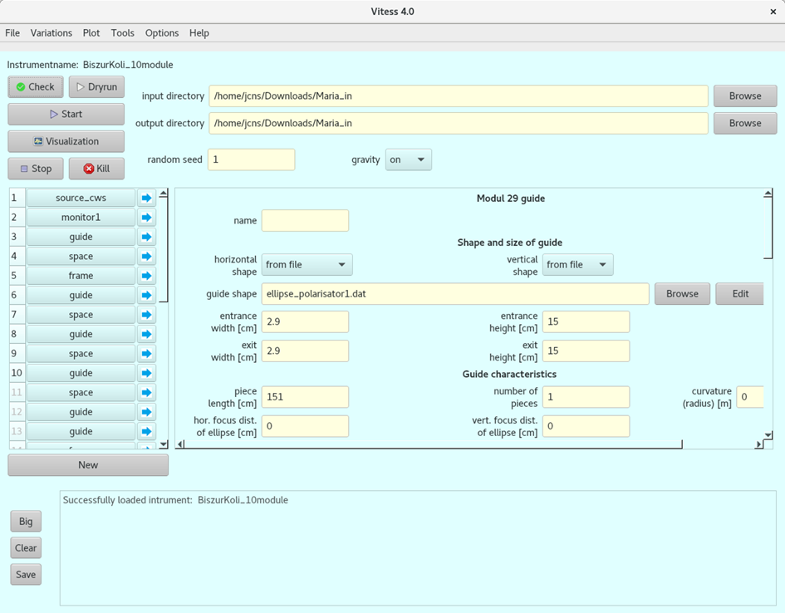

Menu bar

File: Contains basic functions such as save, load or begin an instrument.
You also can find the export as python or shell script, the display of an *.inf file and the application exit in this menu item.

Variations: Includes the copy and paste of modul parameters, the setting of instrumentname and generation of series.

Plot: In the moment gnuplot is called. Not tested on windows

Tools: Includes different auxiliary routines like Convert Ascii to Binary,etc.

Options: For setting some global parameters like buffersize or minimum neutron weight.

Help: General info to VITESS and single moduls. Has to be adapted.

Buttons and general parameters

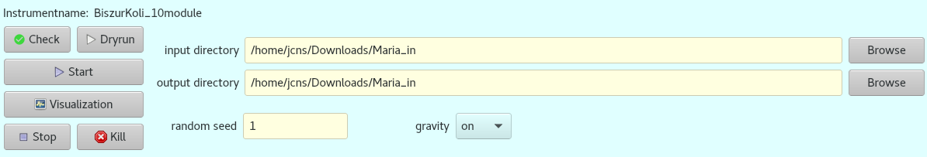

Check: Show selected pipe in output area
Dryrun: Run simulation pipe with fixed 100000 trajections.
Start: Start simulation with specified parameters.
Visualization: Run simulation with the different steps of the visualization.
Stop: Terminate processes without new trajections.
Kill: Kill all running processes at once.
Set global parameters like input and output directory, random seed and gravity

Modul selection

Table for creating the modul sequence in the instrument. Moduls can be choosen or changed with left mouse press in the modul selection field. Pressing an arrow the parameters of the selected modul will be displayed.With right mouse touch on vertical header you can choose actions in the opened submenu.
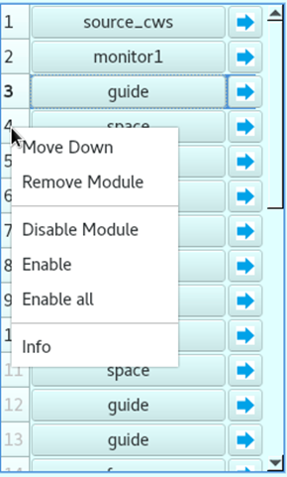

Move Down: To insert modul move all entries from this position downwards.
Remove Module: Remove modul from used moduls in instrument.
Disable Module: Selected modul will not be executed in simulation. Vertical header number
becomes transparent.
.

Enable Module: Disabled modul will be enabled again and executed in next measurement.
Enable all: All disabled moduls will be enabled again.

Single modul window

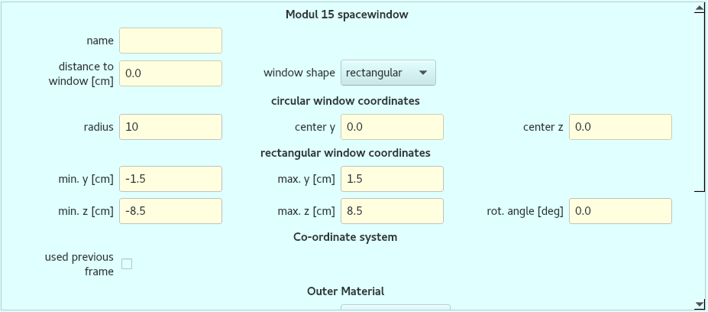

Design for single moduls specified in definition yaml file. Input fields have different validators depending on parameter type specification and optional min/max values. If the entry is not acceptable the input is denied. If the input is out of limits the field background turns red. Selection box string entries are translated via convert functions to integer indexes used in pipe.

Output area

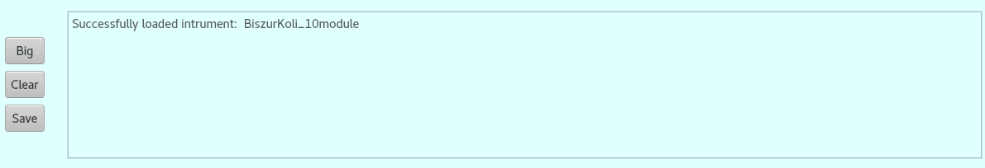

All outputs are displayed here. Messages can be deleted or saved , a larger message window can also be diplayed

Parameter subwindow

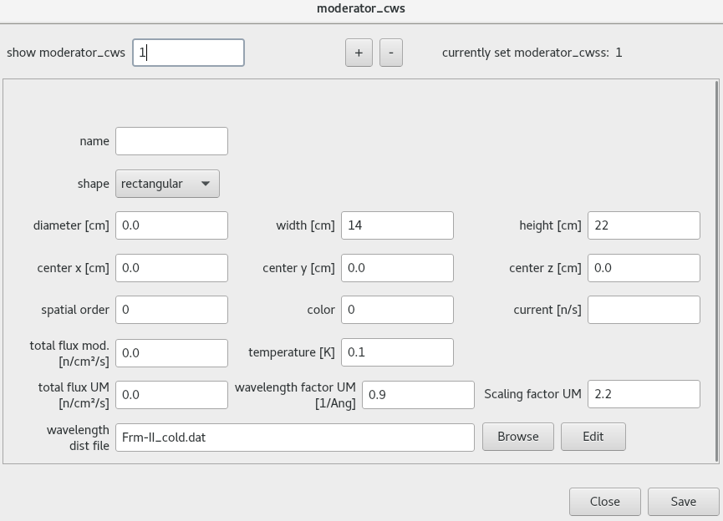

Subwindow designed from vitess/YAML/parameter/<parameter name>.yaml file. The dialog belongs to parameter specified in modul definition file with type “window”. For example different moderator windows can be set. The number can be increased or decreased with + and - , the current number is also displayed.

Programm classes and methods

Main

Starts the application with special style. Background color of some widgets has been changed.
w.centralWidget()->setStyleSheet("QWidget {background-color:lightcyan;}"
" QLineEdit {background-color:lightyellow;}"
" QPushButton {background-color:lightgray;}");

If program is called with instrument filename as argument, this instrument is directly loaded.

Mainwindow

- Constructor

Set logfile name template to /tmp/logfile
Get Vitess main directory from application path and set it to default instrument in/output directory. All input files in gui will be searched in instrumentInDir, all output files will be written to instrumentOutDir.
Read all existing modul definition *.yaml files from vitess/YAML subdirectory. Base filenames (without extensions) are set to entries in the modul selection box.
Generate differernt maps:
ModulFiles key: modulname
val: list of definition filename and used c-module in pipe
ModulParam key: modulparameter
val: parameter definitions (type,description...)
ModulGui key: modulname
val: modul design scrollarea
Module key: modulname
val: map ModulParam
Create modul selection table with used moduls and addWidget to layout.
Connect signals and slots
Create instances for big output and generate series dialogs

- Menu bar entry File

void on_actionLoad_triggered();
Select saved instrument yml file from opened file dialog.
Then loadInstrument(<filename> will be called.

void on_actionSave_as_triggered();
void on_actionSave_triggered();
Open file dialog and save instrument in yml file by calling
saveFile(<filename>)

void on_actionNewInst_triggered();
Clear current design and output area

void on_actionPy_Python_script_triggered();
Export pipe as python script

void on_actionBat_shell_triggered();
Export pipe as shell script

void on_actionShow_inf_File_triggered();
Open file dialog and show selected inf file in separate window.

void on_actionExit_triggered();
Close all application windows.

- Menu bar entry Variations

void on_actionCopy_Module_Parameters_triggered();
Read current modul values and keep in yaml node

void on_actionPaste_Module_Parameters_triggered();
Insert values from yaml node in current modul if modul names match.

void on_actionSet_Instrument_Name_triggered();
File dialog opens to select new instrument name. Set instrument input
dir to filepath and change instrument name in gui.

void on_actionGenerate_Series_triggered();
Create new dialog to set series parameter.

- Menu bar entry Plot

Creates gnuplot argument file for plots with one or two dimensions. Start gnuplot in terminal if installed. Tested only on linux.

void on_actionPlot_File_triggered();
Select file and start external gnuplot one dimensional
void on_action2D_Plot_File_triggered();
Select file and start external two dimensional gnuplot

- Menu bar entry Tools

Call toolCommand function with fitting c-modul name as argument. Start external terminal program with vitess/Modules/shelexec under windows and xterm under linux

void on_actionConvert_Ascii_to_Binary_triggered();
void on_actionDefine_Direction_triggered();
void on_actionGenerate_Mirror_Files_triggered();
void on_actionGenerate_Surface_Files();
void on_actionGenerate_Extraction_System_triggered();
void on_actionGuide_Shape_triggered();

Generate separate gui windows for input parameter and start related vitess functions
void on_actionCryst_Analayzer_Spectrom_triggered();
void on_actionCompute_Chopper_Phases_triggered();

- Menu bar entry Options

Set some global parameters. Currently implemented are settings for buffersize and minimum neutron weight.
void BufferSize_triggered();
Select right size in menu and save it in variable nBuffer
void minNeutWeight_triggered();
Select minimum neutron weight and set variable MinWght

- Menu bar entry Help

Generate new window to show help information
void on_actionGeneral_Information_triggered();
void on_actionUser_Interface_triggered();

Open webbrowser and show local pdf file
void on_actionTutorial_triggered();
void on_actionOptimization_triggered();

Open webbrowser and show selectd local html file
void on_actionVisualization_triggered();
void helpTools_triggered();
void helpModules_triggered();

- Buttons

void on_pushCheck_clicked();
Get global parameter and collect data from all enabled instrument moduls. Read input field values from lineEdits. For comboBox items find entries in functionMap (defined in tools.h) and get pipe values by calling matching routine in convert.c. CheckBox value is set to 1 if checked else 0. Look for values in parameter subwindows. If parameter has prefix and is not empty, append to pipe string and show it in output area textBrowser.

void on_pushDryrun_clicked();
Call pushCheck, then set tracectories fixed to 100000. Check if first modul is a source modul. Call startPipe() to start the simulation.

void on_pushStart_clicked();
Call pushCheck. Check if first modul is a source or read_in. Call startPipe() to start the simulation.

void on_pushVisual_clicked();
Call pushCheck. Check if first modul is a source modul. Set trajectories fixed to 10000. Start timer to repete test of visual simulation runs to be ready without blocking program. If timeout is emited slot visualActive() is called and Visualization starts.

void on_pushStop_clicked();
Run all processes to the end without getting new trajectories

void on_pushKill_clicked();
Kill all running processes immediately.

void on_pushFresh_clicked();
Clean modul table and right single modul area. Set instrument name empty.

void on_pushOutdir_clicked();
Open file dialog to set outout directory.

void on_pushIndir_clicked();
Open file dialog to set input directory

void browseBut_clicked();
Open filedialog,select file and put filename into belonging text field

void editBut_clicked();
Get filename from belonging text field and show content of selected instrument input directory file in separate window.

void paramBut_clicked();
Get to clicked button belonging filename from textfield and read selected parameter yaml file. Show separate parameter window.

void on_pushBig_clicked();
Hide output area and open separate window for bigger output textbrowser.

void on_pushClear_clicked();
Clear output area.

void on_pushSave_clicked();
Open file dialog and save output textbrowser content to selected file in instrument output directory.

- Slots

void showSelectedModul(int);
Arrow button is pressed, show gui of selected modul in right stackedWidget.

void changeModulWidget(QString modul,int row);
Module table value changed or module added, so change content of stackedWidget at index <row> or append modul design to stackedWidget

void removeModule(int);
Remove modul from stackedWidget

void insertModule(int);
Insert modul in srackWidget

void changeParamWidget(QString filename,QString initName);
Slot after emited signal from parameter class to save parameter window values. Put filename in corresponding textfield.

void visualActive();
Stop timer that checks if part of visualization run is active. Call Visualization function.

void showTextBrowser();
Show output widget.

void startSerie(QStringList serieVar, QVector<QVector <QString>> table ,QStringList SelSelect, QStringList copyFiles, QString copyDir);
This function will be executed if start serie button in Series window is clicked. It starts serie measurement with arguments from separate series window. Entries are:
string list <modulnr>:<prefix>:<parameter name>, vector of series table rows, selected iteration steps, names of files to copy and target directory name.
Get pipe string for instrument enabled modules. For all selected iteration steps look for variable parameter entries in matching modul pipe strings. If found replace parameter value with value from serie table. Otherwise, because parameter value was empty before, append prefix and parameter value to modul pipe command string. Then start series simulations. Wait until single measurement is ready, copy selected files into specified target directory and start next simulation.

void checkIsValide();
Validator slot for lineEdits. If field has not acceptable input, set background color to red.

void finishedLast();
If last process in pipe finished get elapsed measurement time. Compose <instrumentOutDir> + "/XC" + <year> + <day in year> + “.log” to protocol file name. Write whole pipe command to protocol file. Append contents of used modul logfile to gui output area. Insert each logfile creation date/time and content into protocol file. If process chain was interrupted, comment in protocol file in which modul. Close progress dialog and write measurement time to output area. Set pipe to inactive.

void finishedSort();
Will be called if visualization is ready. Look if InstantPlayer is installed then show x3d file.

- Other Functions

void designModul(QString modulName);
Design gui for single modul. Create scrollArea with gridlayout in right stackedWidget. Maximal three columns and unlimited rows. Load modul yaml definition file and call getModulParameter to sort parameter into modul widget.

void getModulParameter(YAML::Node& config,QString modulName);
Set modul header label to modulName. Get modul parameters from yaml node config. Start loop over all modul parameters. For every parameter fill his definition values in mapParam. Sort all parameters and belonging mapParam into map ModulParam. After calling getWidgetDesign (in tools.cpp) to put matching parameter design in gridLayout, make some slot connections. Connect browse and edit buttons. For sub parameter create separate widget Parameter class, get values from matching yaml file under /YAML/parameter/ <parameter>.yaml. Design parameter window. Connect parameter pushButton and save button of separate Parameter window. Connect function checkIsValide to lineEdits to test if input is valide. Finally put some spacer in layout if row count is less then 15.

void saveFile(QString instrumentFile);
Open chosen instrument yml file. Generate yaml node pipe, fill it with global parameters and all gui entries data for selected instrument moduls. Get series variables data from separate class and insert into pipe. Write pipe to instrument file.

void readCurModul(YAML::Node& curModule,int index);
Get all widgets and values from current modul stackedWidget and save the entries in yaml node curModule. If modul has subparameters also store these values.

void pasteCurModul(YAML::Node curModule,int index);
Get entries and values from yaml node CurModule and sort into current modul stackedWidget.

void loadInstrument(QString fName);
Clean modul table and right modul area stackedWidget. Get yaml instrument configuration from file. Loop over modules entries. If module name is GlobalParameters call loadHeader to get global parameter values. Else insert module in modul table, this emits signal changedComboVal and slot changeModulWidget will be executed to add modul to stackedWidget. Ckeck if modul is disabled. If instrument contains Serie entry, load serie variables from file and fill entries in series window.

void loadHeader(YAML::Node& config);
Get global entries from yml file and insert values in gui. Set right menu entries for minimum neutron weight and buffersize. Set input and output directory for loaded instrument.

void getHeader(QTextStream& out);
Get global parameter values from gui and matching prefixes from mapHeader

void writeHeader(YAML::Node& config);
Write global parameters to yaml node

void startPipe();
If pipe is active, write message to output area and return.
Else clear process list and create new process for every enabled modul in instrument. Remove old logfiles in /tmp. Connect finished signal of last process in list to slot finishedLast. Set pipe to active. Create and start progressDialog and elapsed timer to get simulation progress and measurement time. Build chain of processes of enabled modules with setting setStandardOutputProcess. Every process gets his input from the output of previous process. Start processes with pipe modul command strings and dump message box if error occurred.

void progress();
Create and show new progress dialog. Progress class arguments are:
length of simulation process list, identifier of disabled moduls and logfile name template.

void toolCommand(QString prog);
Start new process in shell with given prog string. Under windows /Modules/shelexec.exe else xterm is used.

void Visualization();
Create progress dialog and start elapsed timer to get measurement time. Generate process list. Visualization executes two simulation and one sort run. First simulation will run with appended global parameter --vgeometry.inf to each process command string. In second simulation –-V<logFname><processnr>v is added to every pipe process. After the two simulation runs are ready, vitess modul sortiap will be started as new process. The sortiap modul will start with parameters: "-x –o<InstrumentOutDir>”/geom<nr>”.x3d” + “<logFname><nr>v” files. Sortiap will arrange the trajectories into a result x3d file.
If process is ready, slot finishedSort will call InstantPlayer if installed.

void delay();
wait one second but events will still be executed.

bool eventFilter(QObject *obj, QEvent *ev);
Check if mouse button is pressed in a lineEdit object and series window is visible. Then create strings with selected <modul nr>:<parameter prefix>:<parameter name> and <parameter value>. Emit signal to Series class.
Also comboBoxes should not react on mouse wheel movements.

Modultable

- Constructor

Class ModulTable defines a two columns wide tableWidget. First column contains toolButton with all used yaml modul names in selection menu. In the moment submenus for source-, sample- and monitor moduls are defined. In second column an arrow toolbutton will appear. To set color of vertical header set style to “fusion”. If right mouse button pressed on header, slot showContextMenu will be executed to show header menu. Call addNewRow method to add new toolbuttons to table.

- Slots

void butModulItemChanged(QAction*);
Modul from tool button menu was selected. Set current table row to index of clicked button and change color of matching vertical header item to red. If a modul was selected, emit signal changedComboVal to mainWindow to adupt stackedWidget.

void arrowButtonPressed(bool);
An arrow tool button was pressed. Set current table row to index of clicked button and change color of matching vertical header item to red. Emit signal arrowPressed to mainWindow to show matching design in modul area.

void showContextMenu(const QPoint&);
Right mouse pressed on vertical table header. Menu actions to insert, remove, disable and enable modul will appear. Matching slot will be connected.

void disableModule();
Set disableFlag at index and color of header entry at mouse position to light gray

void enableModule();
Unset disableFlag at index and set color of header entry at mouse position to black

void enableAllModules();
Unset all disableFlag indices and set color of header to black

void removeModule();
Remove current row from table, adupt header and send signal removeCombo to mainWindow to delete selected modul from stackedWidget.

void insertModule();
Called by menu action move down. Inserts row into table with “—inactive—“ and arrow button. Modul to insert can be selected.

void infoModule();
If existing, show <module name>.www info file in textbrowser.

- Other functions

void loadModule(QString text)
Called from mainWindow loadInstrument to search text in modul names and add fitting button and arrow to table. Emit signal changedComboVal with modul name and index to slot changeModulWidget in mainwindow to add module to stackedWidget.

void setDisabled()
called from mainWindow loadInstrument to set header color of all disabled modules to lightGray.

void cleanModules()
Called from mainWindow to clear button vectors, set table row count to 0 and add new “inactive” row to table.

void addNewRow()
Generate new toolbutton with modul selection menu and current text “—inactive—“. Connect signal action triggered to slot butModulItemChanged. Add arrow button and connect clicked signal to slot arrowButtonPressed. Increase row count and set buttons to cell widgets in table. Adupt vertical table header.

Parameter

- Constructor

Show parameter window without close cross, so window can only be closed with close or save button.

- Slots

void on_numberEdit_returnPressed();
Jump to specified index in parameter entry window, or add new window.

void on_butMinus_clicked();
Decrease number of parameter input widgets.

void on_butPlus_clicked();
Design additional parameter input widget.

void browseBut_clicked();
Open instrument input directory and select file. Add file name, without directory, to the corresponding input field.

void editBut_clicked();
Get filename from belonging text field and show its content in separate window.

void checkIsValide();
Validator slot for lineEdits. If field has not acceptable input, set background color to red.

void on_pushClose_clicked();
Remove all widgets from stackedWidget. Set number of parameter windows to one.

void on_pushSave_clicked();
Get file name to save parameter values temporarily. If whole instrument is saved, values will be stored in instrument file. Generate yaml node and call getData to fill it. Save data to file and close window.

void designParameterWin(QString filename);
Design new scrollArea with three columns wide gridlayout. Update the top displays. Load parameter definition file and call getModulSubParameter to configure parameter widget. Put scrollarea input widget to stackedwidget.

void loadFile(QString filename);
Called from mainWindow if parameter button is clicked. Temporarily saved yml parameter file is loaded and values are filled in stackedwidget.

void saveData(YAML::Node& config,std::string key,QString param,QString parFile);
Is called from mainwindow if whole instrument is saved. Call getData to fill yaml node with current values.

void getModulSubParameter(YAML::Node& config,QString modulName);
Get list of the single parameter definitions from yaml node and call getWidgetDesign, in tools.cpp, to fill scrollarea and set matchin parameter validators.

void getData(YAML::Node& configWin, int i);
Fill yaml node with current values of parameter stackedwidget with index i.

Progress

- Constructor

Create new progress dialog and timer. Start timer and connect its timeout signal to function perform

- Slot

void perform();
Check which simulation logfiles have already been written and set the corresponding progress number.

Series

- Constructor

Set series variablen field to read only. Call setVertHeader to set vertical header of table. Connect horizontal header clicked signal to a slot

- Slots

void setSeriesVariable(QString text, QString val);
The Slot is triggered when right mouse button is pressed over a mainwindow text input filed. Add <modulNr>:<prefix>:<parameter name> to series variable text field. Fill parameter name in horizontal header. Insert <modulNr>:<prefix> in first, delta zero in second and value in third table row ,where columns are sorted by modul number.

void on_iterations_valueChanged(int arg1);
Iteration value changed. Change vertical header, set new row count of table and adjust values.

void on_seriesTable_cellChanged(int row, int column);
Delta value in row one changed. Calculate new table values.

void on_sectionClicked(int index);
Delete column by mouse click on horizontal header.

void on_pushStart_clicked();
Create vector with table rows. Emit signal with series values to mainwindow, where simulations will be started.

void on_pushCancel_clicked();
Clear set values.

void on_pushBrowse_clicked();
Create or select target directory

void on_pushScript_clicked();
Not yet implemented

- Other functions

void getSerieVariablen(YAML::Node& config)
Get items from parameter widget and store in yaml node.

void loadSerieVariablen(YAML::Node& config)
Load entries from yaml node and sort in widget input fields. Called when loading the instrument.

void setVertHeader()
Set vertical header of table, with entries for “Selection”, “Delta” and loop over iteration index.

Chopperphases

- Constructor

Create separate widget with class argument string containing “vitess/Modules/chop_phases -o/tmp/logfile/chop_phases”

- Slots

void on_Calculate_clicked();
Get parameter values from input fields and start chop_phases process. Wait for finished and show logfile output.

void on_Quit_clicked();
Close separate window.

Chrystalanalyzer

- Constructor

Create separate widget with class argument stringlist containing system identifier and instrument input directory.

Set text field input to:
"cas_v40<system> --Z2 –L<instrumentInDir>/CAS_log60arm10.dat -PCAS_par60arm10.dat
-SCAS_S60arm10.dat -TCAS_D60arm10.dat -l6.174745 -w0.03 -k0"

- Slots

void on_Cancel_clicked();
Close window

void on_Execute_clicked();
Start in text field defined process

Big

- Constructor

Connect range changed signal of textbrowsers vertical scrollbar to scrolltoBottom slot. Always jump to current outputs in simulation.

- Slots

void setBrowserText(QString text);
Set text as textbrowser content.

void scrolltoBottom(int min,int max);
Set value of vertical crollbar to maximum.

void on_pushSmall_clicked();
Close separate output window and emit signal to insert text into mainwindow output area.

void on_pushClear_clicked();
Clear output area in separate and main window.

Help

- Constructor

Set some local helpfiles to show in class. They need to be adjusted.

- Functions

void on_comboBox_activated(int index);
Select helpfile to show in textbrowser

void guiHelp();
void showHelp(int);
Show help files in output text field.

Tools

void getWidgetDesign(QString parName,QMap<QString,QString> mapParameter,
QGridLayout *gridLayout,int &row,int &index);
Design gridLayout for single parameter. Function arguments are:
parameter name, parameter gui definition map with type, label description, tooltip, default, min, max,column, usw. , gridLayout, current row and column index in layout.
Select the different input fields according to the parameter type. Generate formLayout from label and matching input field via parameter specification. Set validators according to the type.

void pythonScript(QString instDir,QStringList cmdList, QString logfile);
Generate python script with pipe command string. Simulation values are stored in result.txt.

void shellScript(QString instDir,QStringList cmdList, QString logfile);
Generate shell script with pipe command string. Simulation results are stored in result.txt.

Convert.c

The _Txt2ID functions in convert.c are used to convert the current text of comboBoxes to enum values handled in vitess c-modules. So every new comboBox entry in a modul yaml definition file should have an entry in functionMap defined in tools.h.
Normally the functions return integer enum values but Axis_Txt2Id and ModShape_txt2ID return character values. Perhaps this can be adapted, then the additional conversion in mainWindow functionMapChar would be omitted.

ToDo

- Modify vitess_qt.pro and adupt it to a general yam-cpp installation.

- When opening file dialog under linux, Gtk-Message appears:
Gtkdialog mapped without a transient parent. Set in fileDialog flag QFileDialog::DontUseNativeDialog

- In menu Options some entries are not yet implemented. Global parameter prefixes have to be inserted in mainWindow map mapHeader and matching functions for menu action strings in convert.c must be applied. Currently global random number generator is not transferred to pipe, so default ran3 is used. Under trajectories default X3D is handled.

- To avoid warnings, adapt call of QProcess::start to new Qt definition: QProcess::start(const QString &program, const QStringList &arguments,OpenMode mode = ReadWrite)

- Improve error handling

- Adapt help files.

- Exchange used maps into structures.

- Change logfile name. Now it is /tmp/logfile<enabled modulnr>. Make it more user specific

- Adapt plot programmes. Gnuplot not tested under windows. InstantPlayer cannot be installed directly under centos8 needs older libraries.

- Now series parameters are always saved, insert menu selection item.

- In convert.c the functions _Txt2ID normally return integer enum values but Axis_Txt2Id and ModShape_txt2ID return character values. Perhaps this can be adapted, then the additional conversion in mainWindow functionMapChar would be omitted

