**(1) Java program that can be run from command line**

I created a maven project in Eclipse which is attached. There are two classes in the project - Parser.java and Properties.java. The Java 8 JVM is used.

The code input is a set of named parameters as requested:

accesslog

startDate

duration

threashold

I created a jar file and tested project by running the following command:

C:\inthechat_workspace\Wallethub_project>"C:/Program Files/Java/jdk1.8.0_144/bin/java" -cp ./target/Wallethub_project-0.0.1-SNAPSHOT.jar com.ef.Parser --accesslog="C:/inthechat_workspace/Wallethub_project/log/access.log" --startDate="2017-01-01 13:00:00" --duration=hourly --threshold=100

It works for both “daily” and “hourly options”.

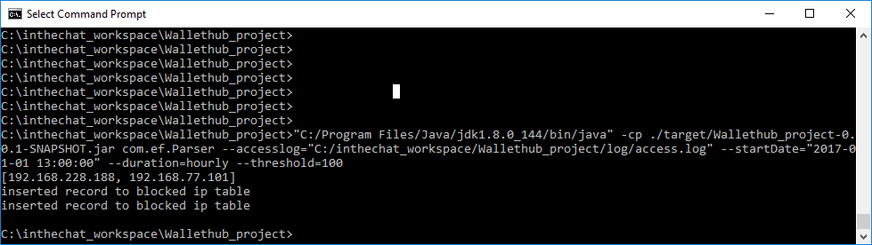

**(2) Source Code for the Java program**

Eclipse project, included

**(3) MySQL schema used for the log data**

I created a DB using MySql workbench which is called “ip_info and three tables as requested:

“access_log”

“blocked_ips_hourly”

“blocked_ips_daily”

Screenshots of these tables are given below.

Schema of each tables is:

CREATE TABLE `access_log_tab` (

`id` BIGINT unsigned AUTO_INCREMENT,

`date` DATETIME NOT NULL,

`ip` VARCHAR(20) NOT NULL,

`request` VARCHAR(20) NOT NULL,

`status` INT NOT NULL,

`useragent` VARCHAR(255) NOT NULL,

PRIMARY KEY (`id`)

);

CREATE TABLE `blocked_ips_hourly` (

`id` BIGINT unsigned AUTO_INCREMENT,

`ip` VARCHAR(20) NOT NULL,

`comment` VARCHAR(255) NOT NULL,

PRIMARY KEY (`id`)

);

CREATE TABLE `blocked_ips_daily` (

`id` BIGINT unsigned AUTO_INCREMENT,

`ip` VARCHAR(20) NOT NULL,

`comment` VARCHAR(255) NOT NULL,

PRIMARY KEY (`id`)

);

access_log_tab

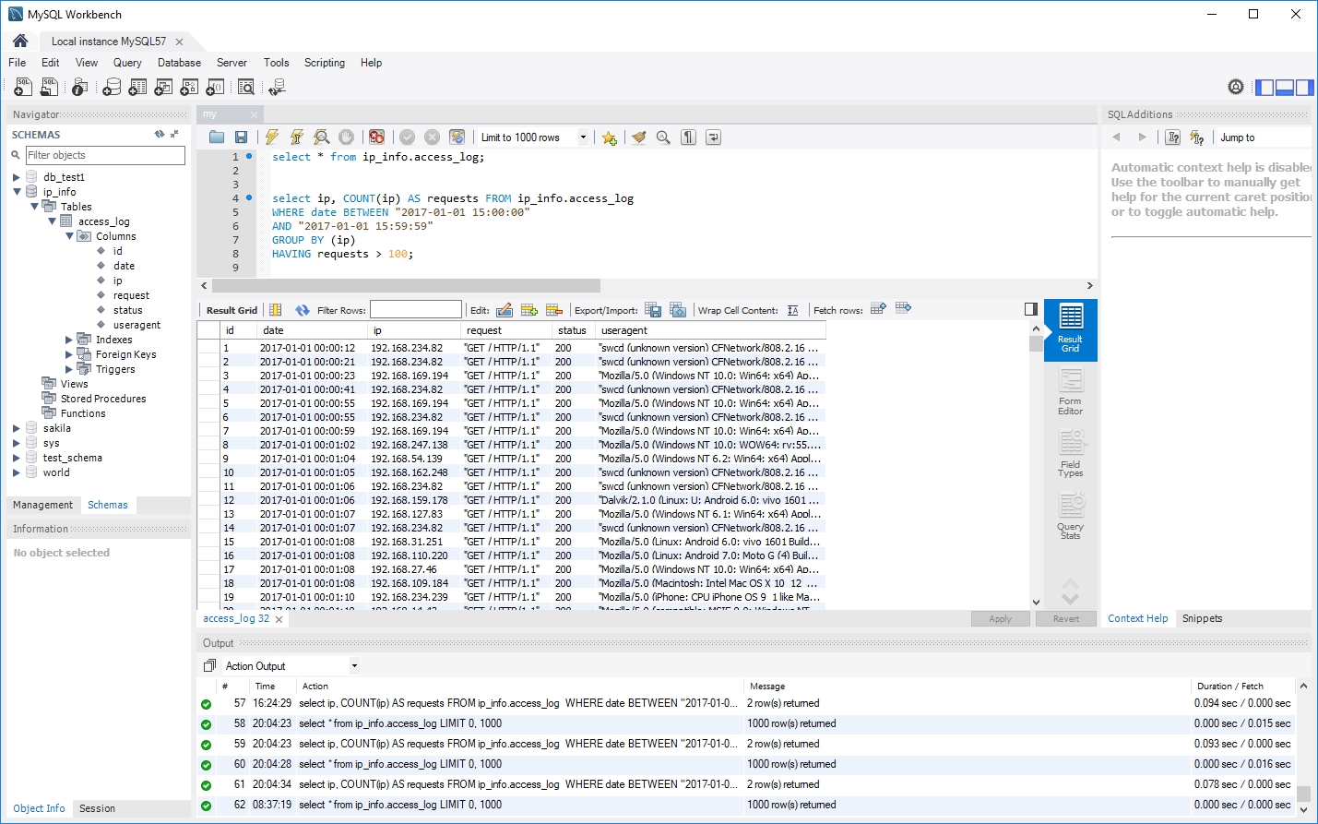

blocked_ips_hourly

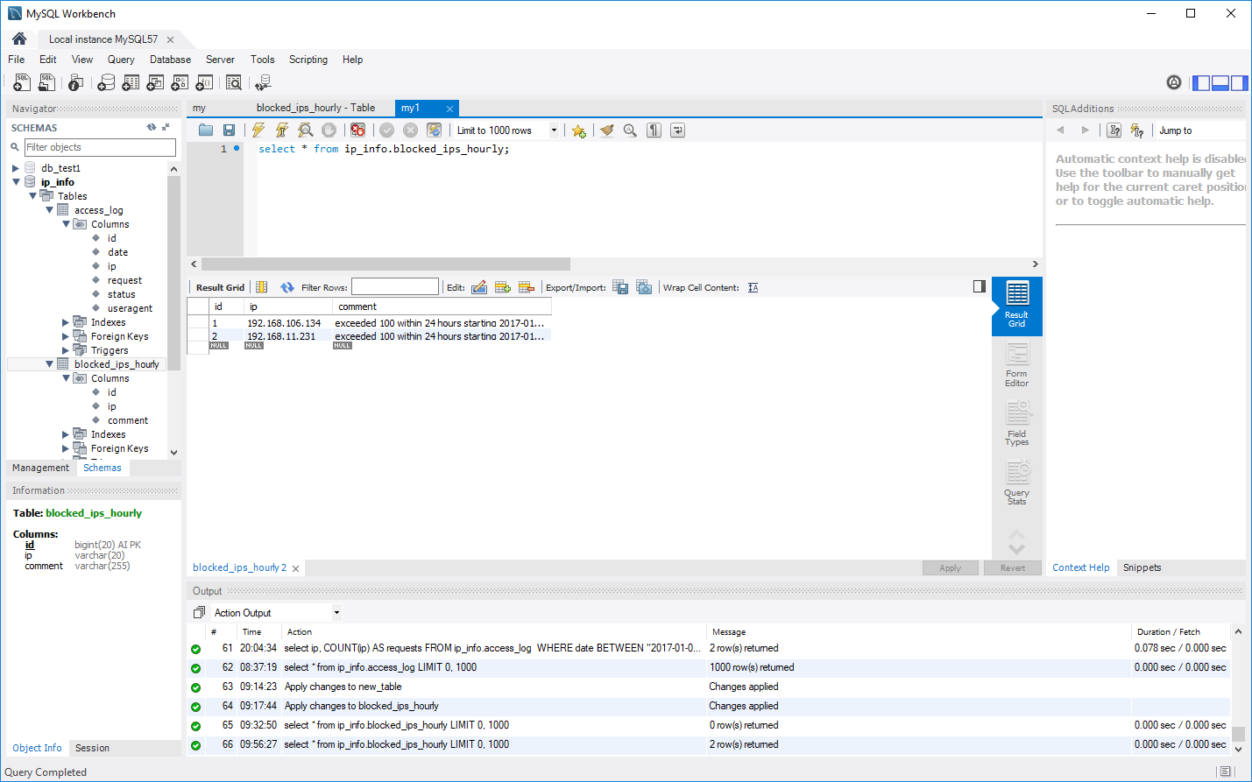

blocked_ips_daily

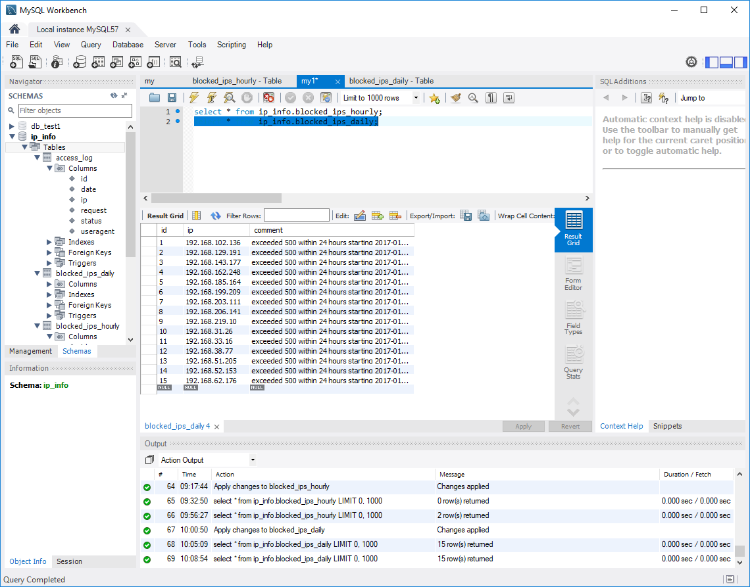

**(4) SQL queries for SQL test**

All queries are in the code.

Example of a Query to retrieve blocked IPs:

SELECT ip, COUNT(ip) AS count FROM access_log

WHERE date BETWEEN "2017-01-01 13:00:00"

AND "2017-01-01 14:00:00"

GROUP BY (ip)

HAVING count > 100;

In the query the range is indicated in BETWEEN statement. The code transforms startDate and duration to start and end.