

**Project Report**

**On**

**[RETAILFURNITURE]**

**PREPARED BY: Bhakti Vithlani**

**Drashti Mashru**

**GUIDED BY: Miss. Dhara Trambadiya**

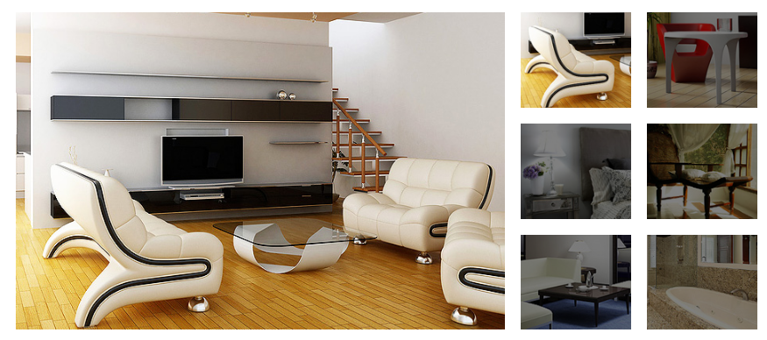

**DEPARTMENT OF COMPUTER ENGINEERING**

BALAJI INSITUTE OF ENGINEERING &TECHNOLOGY, JUNAGADH.

2017-18

**BALAJI INSTITUTE OF ENGINEERING & TECHNOLOGY**

At.Makhiyala, Junagadh-Dhoraji Highway, Junagadh – 362014 Ph.:0285-2687238 Fax:+91-285-2687338

**Certificate**

This to certify that Miss. Vithlani Bhakti, Drashti Mashru Enrollment Number 146630307039,146630307020 have successfully completed project on “RETAIL FURNITURE” as a partial fulfillment of Diploma in Computer Engineering at Balaji Institute of Engineering & Technology, Makhiyala, Junagadh, Gujarat.

**Internal Guide: Head of Department**

###### Miss. Dhara Trambadiya Miss. Dhara Trambadiya

Acknowledgement

I have taken efforts in this project. However, it would not have been possible without the kind support and help of many individuals and organizations. I would like to extend my sincere thanks to all of them.

###### I am highly indebted to (Miss. Dhara Trambadiya) for their guidance and constant supervision as well as for providing necessary information regarding the project & also for their support in completing the project.

I would like to express my gratitude towards my parents & member of (Balaji institute Of Engineering & Technology) for their kind co-operation and encouragement which help me in completion of this project.

I would like to express my special gratitude and thanks to industry persons for giving me such attention and time.

My thanks and appreciations also go to my colleague in developing the project and people who have willingly helped me out with their abilities.

We express a deep sense of gratitude to, Miss. Dhara Trambadiya HOD of CE dept. Balaji institute Of Engineering & Technology, Junagadh who gave us the inspiration and his precious time for preparing this report. I am also thankful to all other faculties of our institute For their precious guidance.

Abstract

The Main Objective of The Project in RETAIL FURNITURE to manage the Furniture Information,take online order from user , give user Details and also provide home delivery. The RETAIL FURNITURE project will consist of various modules like Registration System, Manage order of user ,Manage product system. The purpose of this project is to automate the registration process and reduce paper work , and easily order the furniture and managing the order in various furniture and maintaining a complete database and records.

Index

|  |  |  |
| --- | --- | --- |
| Ch No | Subject Content | Page No |
| Ch-1 | Introduction | 1 |
|  | 1.0 Introduction | 1 |
|  | 1.1 Project summary | 1 |
|  | 1.2 Purpose | 2 |
|  | 1.3 Scope | 2 |
|  | 1.4 Technology and Literature Review | 3 |
| Ch-2 | Project Management | 4 |
|  | 2.1 Project Planning and Scheduling | 4 |
|  | 2.1.1 Project Development Approach | 4 |
|  | 2.1.2 Project Plan | 4 |
|  | 2.1.3 Schedule Representation | 5 |
|  | 2.2 Risk Management | 6 |
|  | 2.2.1 Risk Identification | 6 |
|  | 2.2.2 Risk Planning | 7 |
|  | 2.3 Estimation | 8 |
|  | 2.3.1 Effort Estimation | 8 |
|  | 2.3.2 Cost Estimation | 8 |
| Ch-3 | System Requirement Specification | 9 |
|  | 3.1 User Characteristics | 9 |
|  | 3.2 Software and Hardware Requirement | 9 |
|  | 3.3 Constraint | 9 |
| Ch-4 | System Analysis | 10 |
|  | 4.1 Study Of Current System | 10 |
|  | 4.2 Feasibility Study | 10 |
|  | 4.2.1 Technical feasibility study | 10 |
|  | 4.2.2 Operational feasibility study | 10 |
|  | 4.2.3 Economical feasibility study | 11 |
|  | 4.3 Requirements Validation | 1 |
|  | 4.4 System design | 11 |
|  | 4.4.1 Use Case Diagram | 12 |
|  | 4.4.2 E-R Diagram | 14 |
|  | 4.4.3 Data Dictionary | 15 |
|  | 4.4.4 Data Flow Diagram (Context Level) | 19 |
| Ch-5 | System Design | 21 |
|  | 5.1 System Activity Diagram | 21 |
|  | 5.2 System Procedural Design: | 23 |
| Ch-6 | Implementation Planning and details | 24 |
|  | 6.1 Implementation Environment | 24 |
|  | 6.2 Modules Specification Features | 24 |
|  | 6.3 Sample Coding | 24 |
| Ch-7 | Testing | 29 |
|  | 7.1 Testing Plan | 29 |
|  | 7.2 Testing Method | 29 |
|  | 7.2.1 Black box testing | 29 |
|  | 7.2.2 white box testing | 29 |
|  | 7.2.3 Unit testing | 29 |
|  | 7.2.4.Alpha testing | 30 |
| Ch-8 | Screenshots and User Manual | 31 |
| Ch-9 | Limitation & future enhancement | 40 |
| Ch-10 | Conclusion | 41 |
| Ch-11 | References& Bibliography | 42 |

Index of Diagram

|  |  |  |
| --- | --- | --- |
| **Sr No** | **Figure Name** | **Page No** |
| 1. | Use Case Diagram | 12 |
| 2. | E-R Diagram | 14 |
| 3. | DFD Diagram | 19 |
| 4. | Activity Diagram | 21 |