CORE CONCEPTS AND SKILLS
UI/UX DESIGN INTERNSHIP REPORT

Name: Vithya Sree B
Institution: Ramco Institute of Technology
Domain: UI/UX Design
Tool: Figma
Project: StudyMate – Student Study Planner App

1. Introduction
This report presents the Core Concepts and Skills learned and applied during my UI/UX design internship. The main objective of this phase was to understand the fundamental principles of user interface and user experience design and apply them through a practical Figma project. I created StudyMate, a student study planner mobile application that helps students organize tasks, subjects, schedules, and progress.

2. UI/UX Fundamentals
I studied the difference between User Experience (UX) and User Interface (UI). UX focuses on users, their needs, goals, problems, and interactions with a product. UI focuses on visual and interactive elements such as typography, colors, buttons, spacing, icons, cards, and navigation. I learned that a good interface should be simple, consistent, readable, accessible, and easy to navigate.

3. User-Centered Design
StudyMate was designed around the needs of students who manage multiple subjects, assignments, classes, and deadlines. I planned a simple user flow so a student can open the application, log in, view progress, add a task, and check subject progress without unnecessary steps. This helped me understand the importance of designing around user goals.

4. Information Architecture and User Flow
The application contains five main screens: Splash Screen, Login Screen, Home Dashboard, Add Task, and My Subjects. The prototype connects Splash to Login, Login to Home Dashboard, Home to Add Task, Add Task back to Home after saving, and Home to My Subjects through the bottom navigation. This structure helped me understand how information architecture supports smooth navigation.

5. Wireframing and Visual Design
I planned the placement and hierarchy of important elements before finalizing the interface. The mobile frames use consistent spacing, rounded cards, clear headings, readable text, and a light visual style. Purple is the main accent color, while green and other colors are used for progress indicators. Consistent typography, spacing, and component styles were maintained across screens.

6. Figma Implementation
Figma was used to create the complete mobile UI. The Splash Screen introduces StudyMate and provides a Get Started button. The Login Screen contains email, password, remember-me, Google login, and account creation options. The Home Dashboard shows greeting, search, overall progress, tasks, upcoming classes, and navigation. Add Task contains title, subject, date, time, priority, and description. My Subjects displays Python, Java, Machine Learning, and UI/UX progress.

7. Prototype and Interaction Design
I created interactive connections using Figma Prototype mode. Get Started navigates to Login, Log In navigates to Home Dashboard, the plus button opens Add Task, Save Task returns to Home, Subjects opens My Subjects, and Home returns to the Home Dashboard. These interactions demonstrate the main user journey and make the design suitable for prototype presentation.

8. Design Best Practices Learned
I learned to maintain visual hierarchy, consistent spacing, typography, colors and components; use familiar icons and labels; keep important actions visible; maintain readable contrast and font sizes; reduce unnecessary steps; and keep navigation consistent across screens.

9. Practical Learning and Challenges
During implementation, I practiced selecting frames and buttons correctly in Figma, creating prototype connections, and testing navigation. One challenge was selecting the complete button instead of the text layer inside it. Using the Prototype tab and connecting the correct element to the destination frame helped me understand Figma interactions and the importance of testing every navigation path.

11. Conclusion
The Core Concepts and Skills phase helped me build a practical foundation in UI/UX design. Through StudyMate, I applied user-centered thinking, information architecture, visual hierarchy, typography, color usage, component consistency, mobile screen design, and prototyping in Figma. I also gained experience in testing interactions and correcting prototype connections. This project improved my confidence in Figma and prepared me for a larger practical implementation project.

10. Screenshots of the StudyMate UI/UX Project
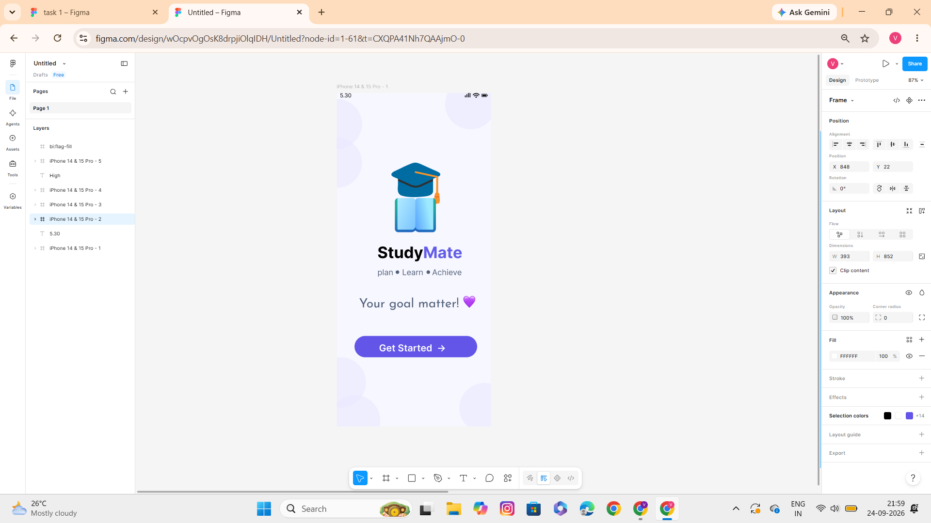
Figure 1 – Splash Screen

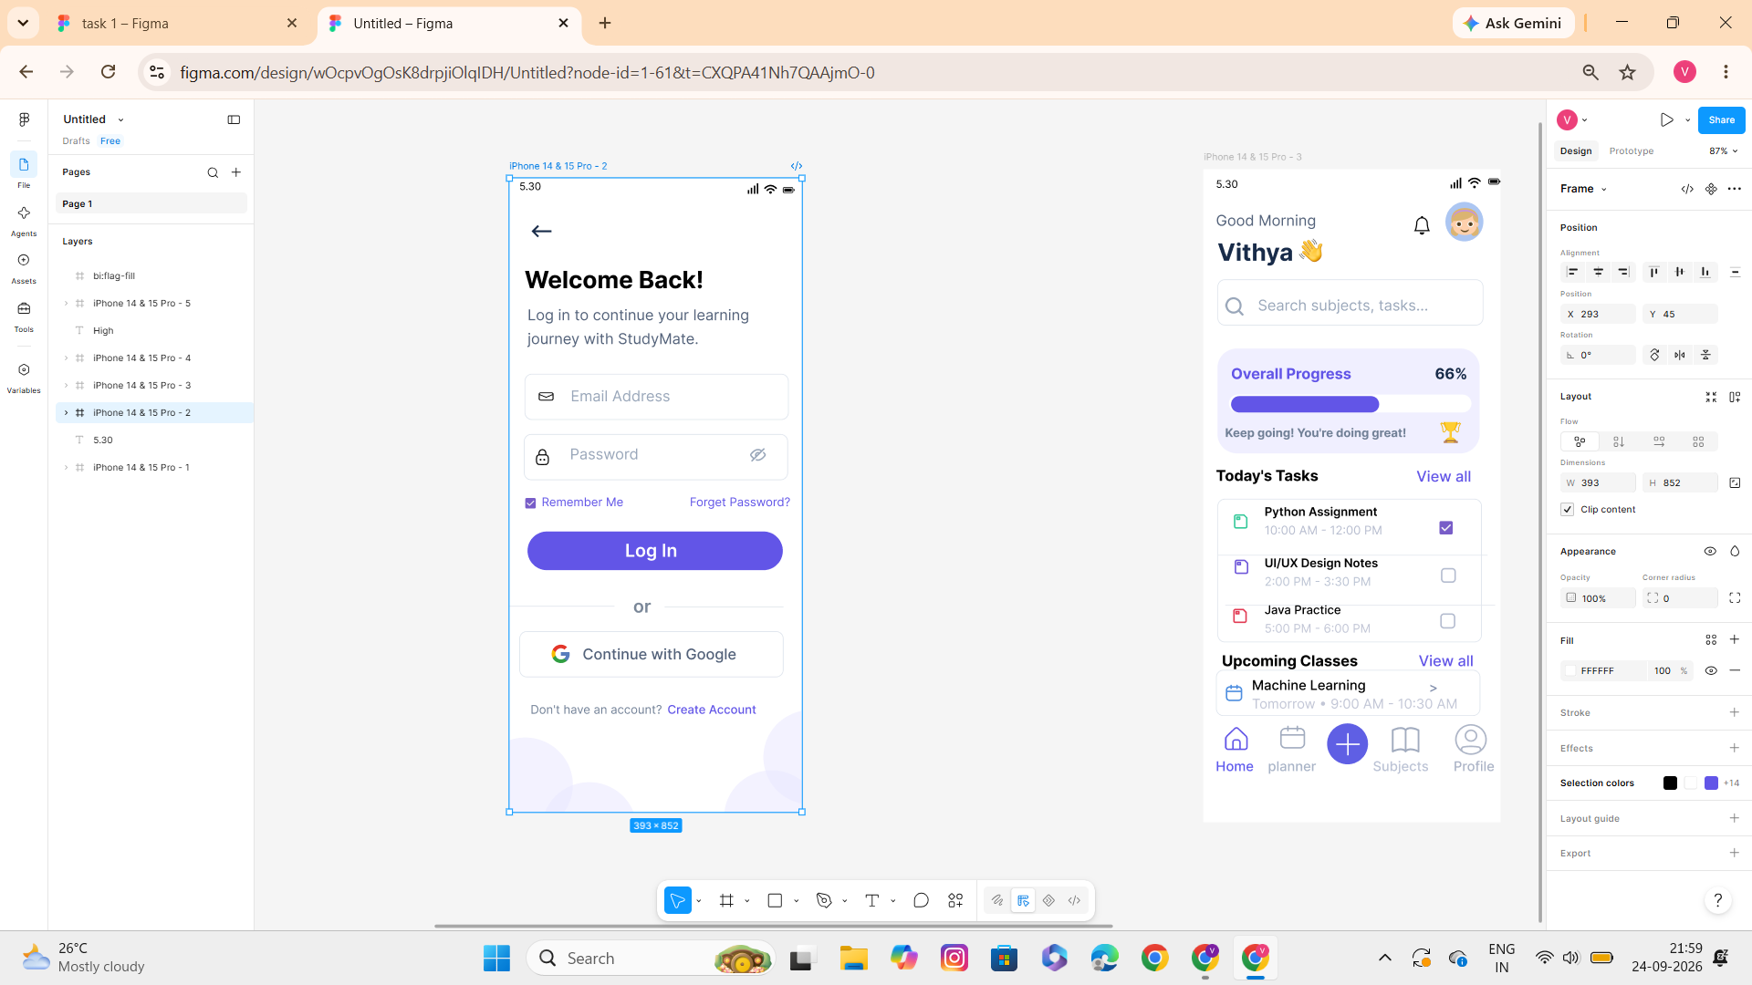
Figure 2 – Login Screen
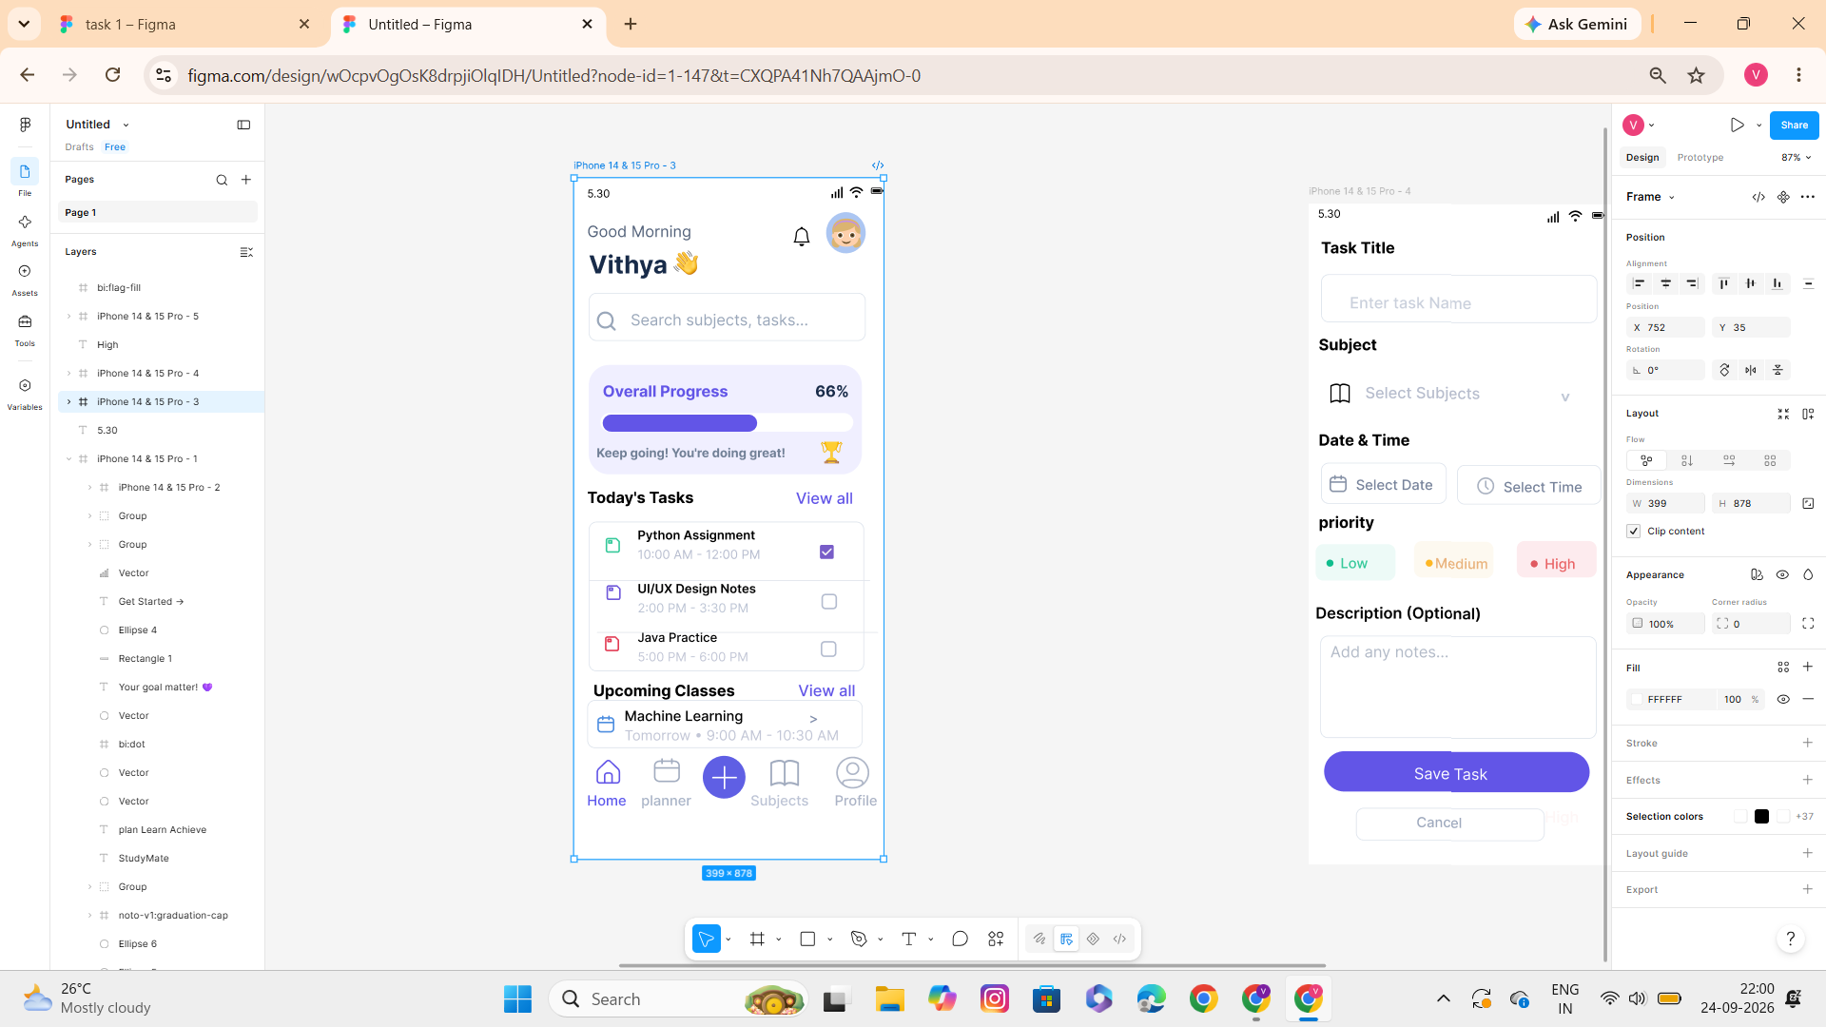
Figure 3 – Home Dashboard

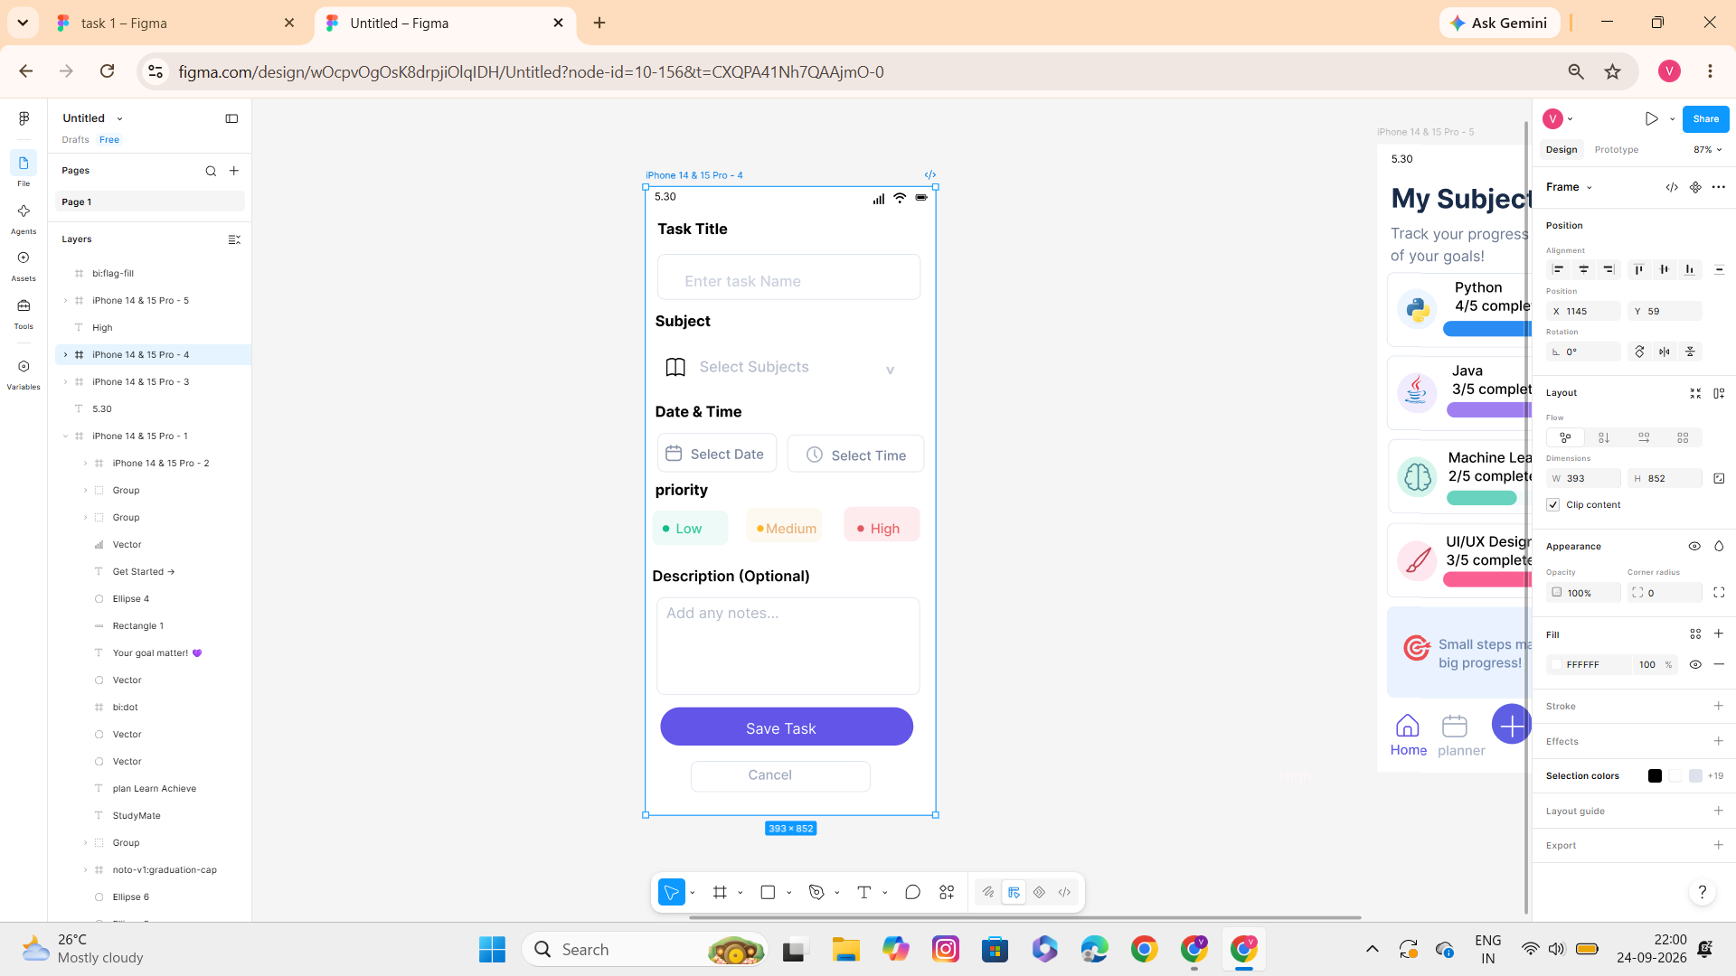
Figure 4 – Add Task Screen

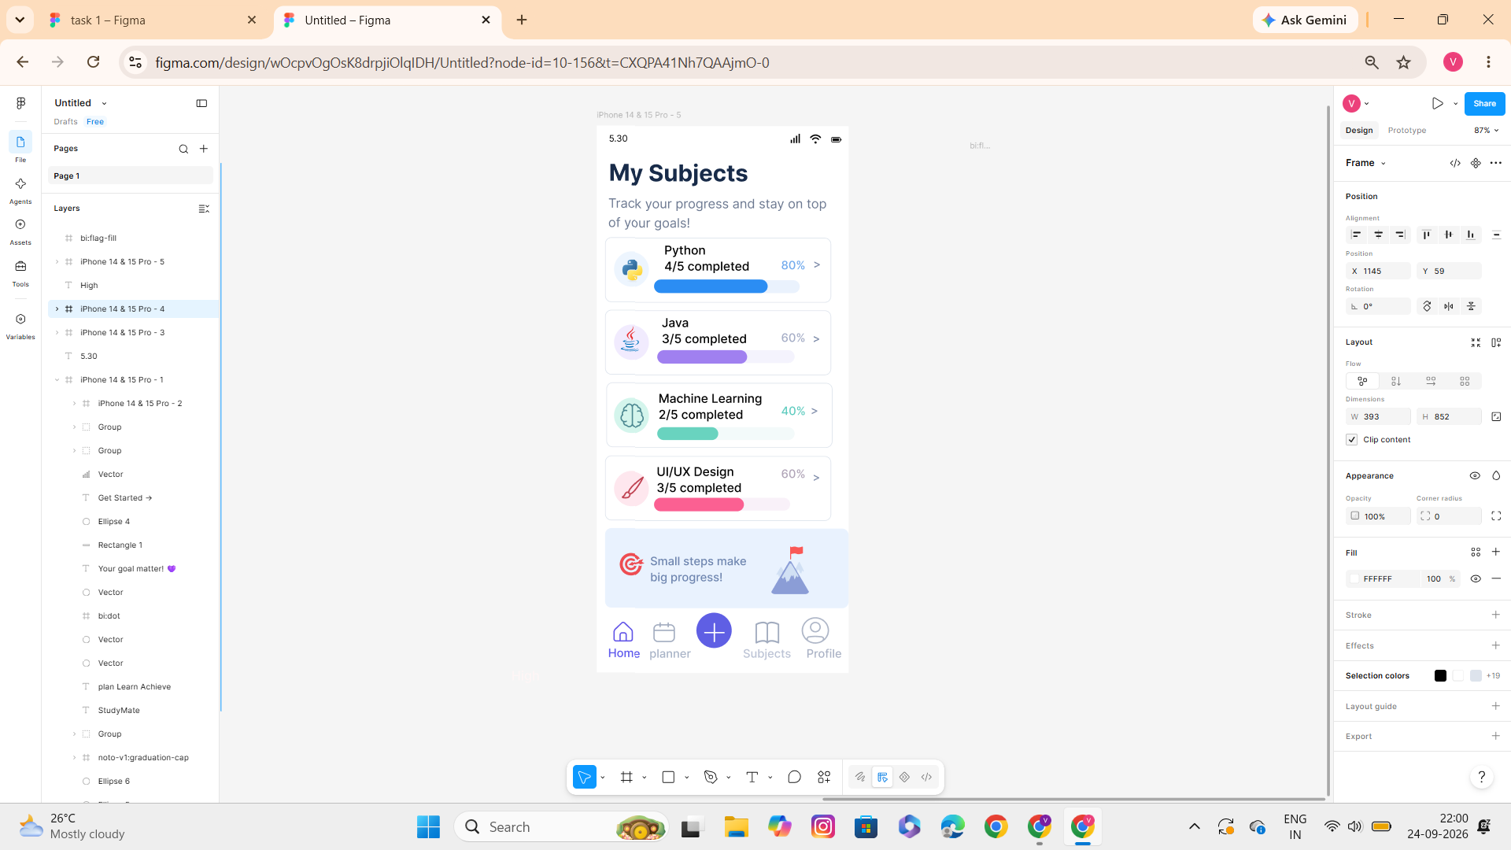
Figure 5 – My Subjects Screen

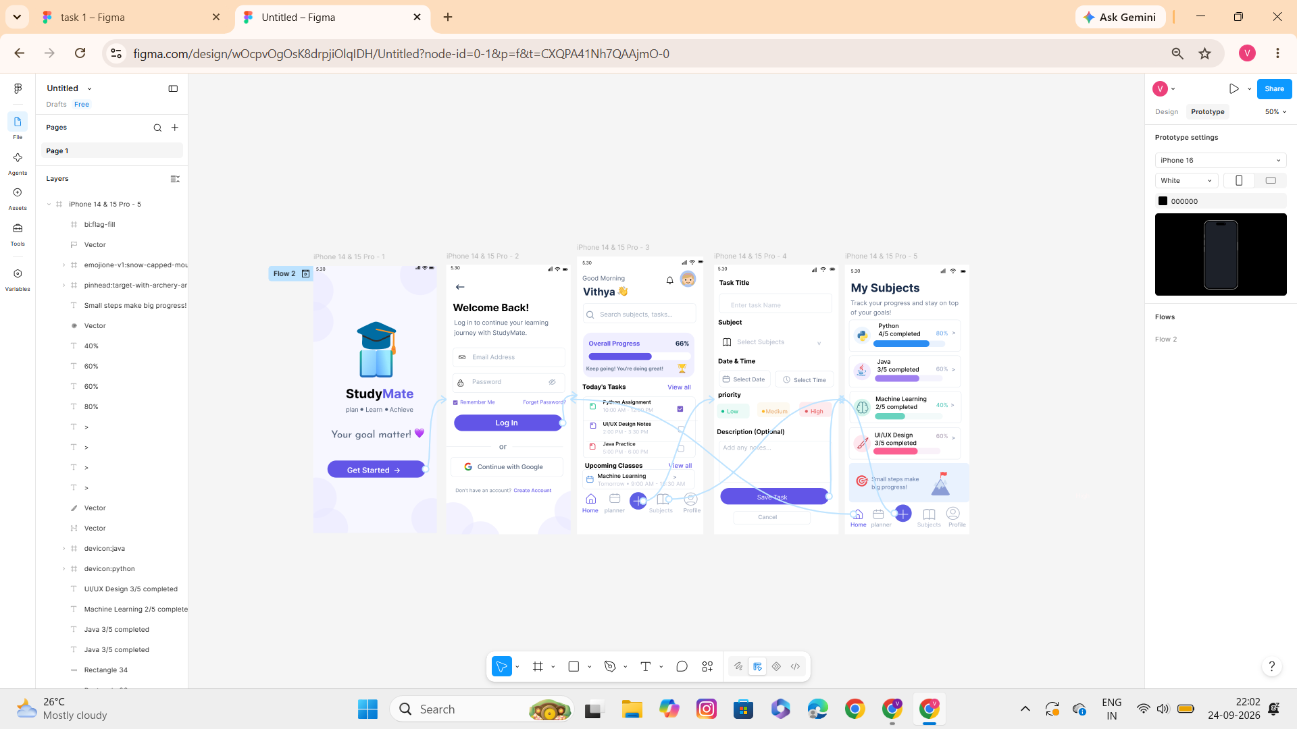

Figure 6 – Figma Prototype Connections

12. Tools Used
- Figma – UI design, screen creation and interactive prototyping.
- Microsoft Word – report documentation.
- Web browser – learning and design references.

