**MYSQL TASK:**

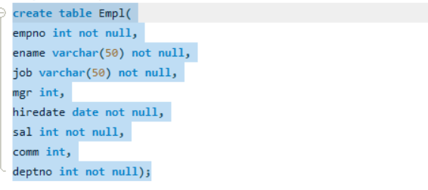

1. A. Write a query to display ename and salary of employee whose salary are greater than or equal to 2200

**Query: select ename,sal from Empl where sal>=2200;**

Output:

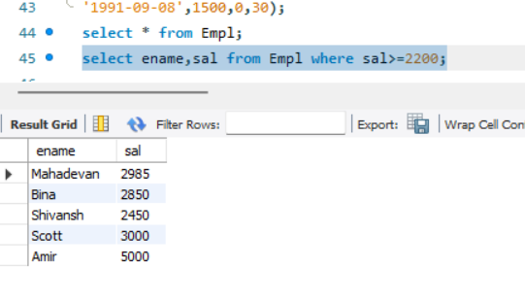

B. Write a query to display details of employee who are not getting commission:

**Query:** **select * from Empl where comm IS NULL;**

Output:

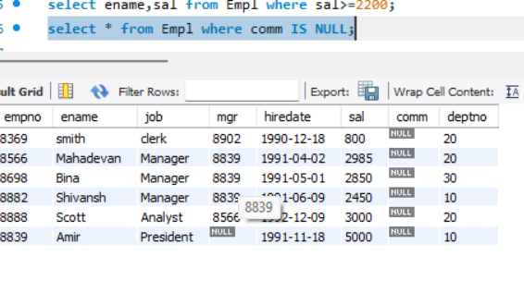

C. write a query to display the name,job title and salary of employee who don’t have their salary in the range of 2500 to 4000:

**Query: select * from Empl where sal NOT BETWEEN 2500 and 4000;**

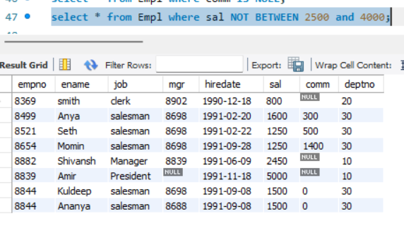

D. Write a query to display the name, job title and salary of employee who don’t have a manager?

**Query:** **select ename,job from Empl where mgr IS NULL;**

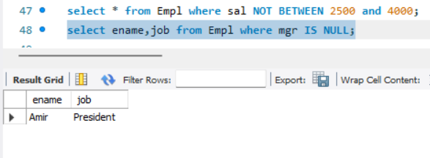

E. Write a query to display the name of employee whose name contains ‘a’ as third alphabet:

**Query: Select ename from Empl where ename like "__a%";**

Output:

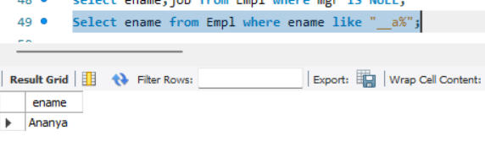

F. Write a query to display the name of employee whose name contains ‘t’ as last alphabet:

**Query: Select ename from Empl where ename like "%t";**

Output:

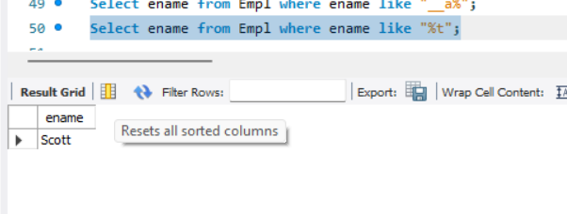

**TASK 2**

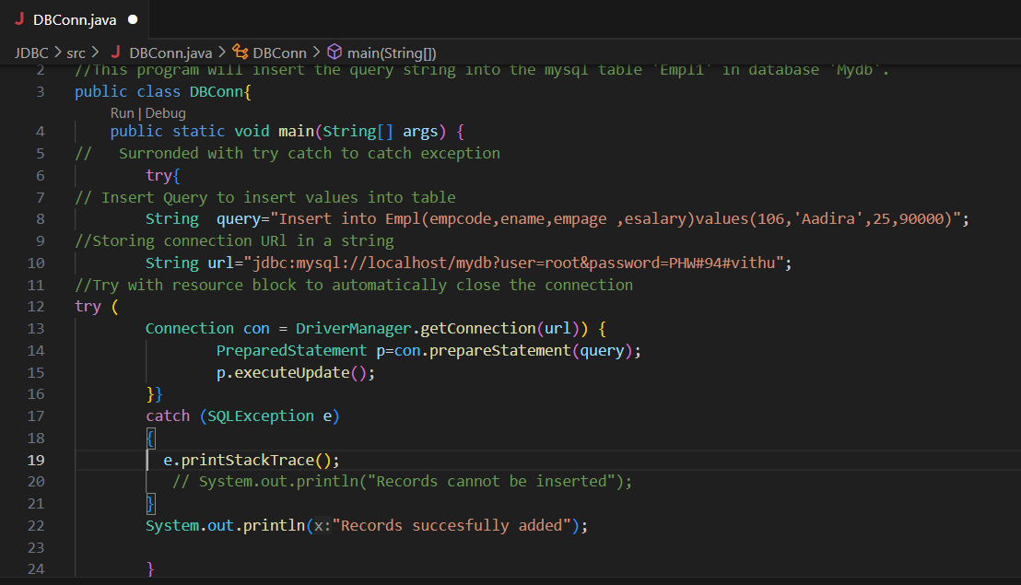

**OUTPUT:**



