1. (Dataset: Climate.xlsx) There has been a lot of press recently about climate change and CO2 emissions1. The data series for this problem contains data on Global CO2 Equivalent Emissions (Giga-tons of CO2 per year) from 1900 – 2016. The 2015 Paris Agreement pledge was to lower emissions by at least 26 percent below 2005 levels by 2025.

**a. Create a solid time series model for this data and include your final output here. Briefly list the steps you took to come to this model.**

ANS:

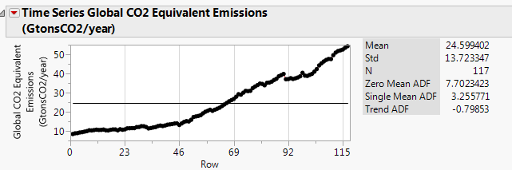

I plot the time series for CO2, all Dicky-Fuller T-statistics indicate that the series is not stationary.

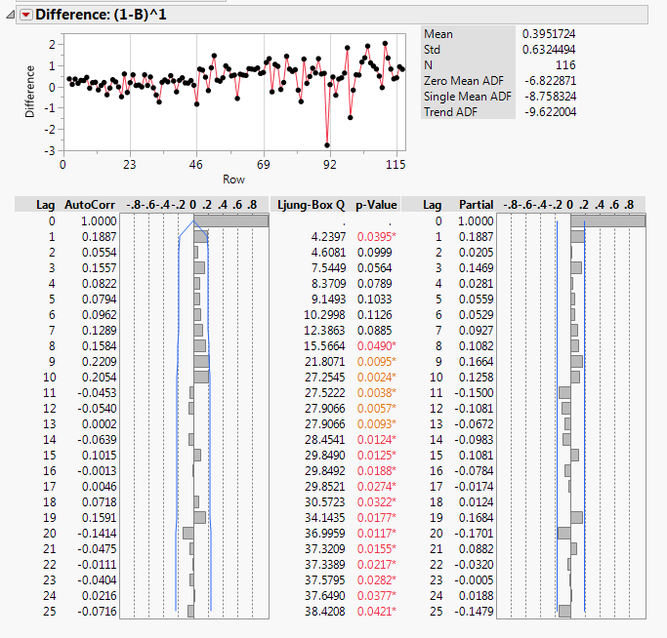

I take 1 difference and noted that all Dicky-Fuller T-statistics indicate a stationary so I(1) is considered. ACF graph indicates that MA() term can go upward to MA(10) and PACF graph indicates that AR() term can go upward to AR(1).

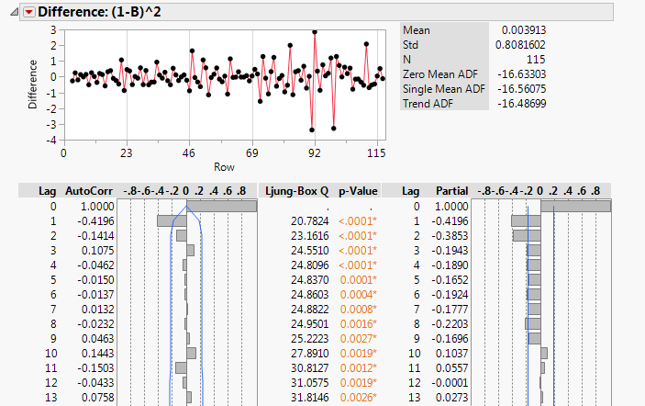

I also try I(2) but its PACF graph indicates over differencing so I narrow down the model to I(1).

I run ARIMA model group based on the narrowed down parameters and obtain the following top candidate models:

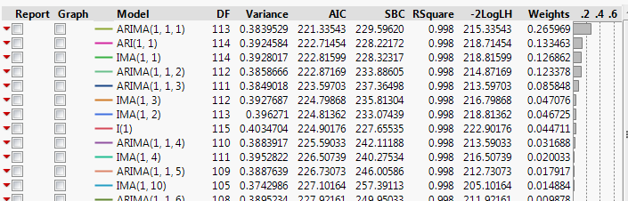

The top 3 models – ARIMA(1,1,1), ARIMA(1,1,0), and ARIMA(0,1,1) have comparable prediction performance and satisfactory residual plots but all parameters of ARIMA(1,1,1) are significant as 1% level of significant(the other two models do not) so I decide ARIMA(1,1,1) is the best model.

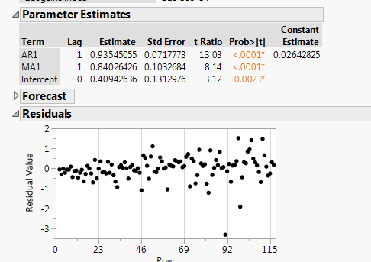

**b. Calculate a prediction for 2025 if the emissions trend continues the same way.**

ANS: 59.56 Giga-tons of CO2 per year.

**c. What is a 95% interval for your above prediction? Do you think there is a chance to meet the Paris Agreement pledge if steps aren’t taken?**

ANS: Interval: 64.46 - 54.67 Giga-tons of CO2 per year. At 95% interval, there is no chance to meet the goal, as the lower band of the prediction is still much higher than the CO2 level in 2005(45.35 Giga-tons of CO2 per year).

2. (Dataset: Unemployment.xlsx) The following variables represent the Help Wanted Index and  
Unemployment Rate in the USA form the years 1969 through 2000.

HWI: National help wanted index

UNRATE: Unemployment rate %

**a. Based on just the top Time Series plot in JMP, do either of these series look stationary?**

ANS: No. The values of both series seem to come back to the mean but it does not look like they have a constant variance.

**b. Use our standard statistical procedures to determine if the HWI variable is stationary.  
i. Include here your basic output results (no graphs are necessary here) and your decision.  
ii. If your series is NOT stationary, what do you need to do to fix it? Prove that your  
modification creates stationarity.**

ANS:

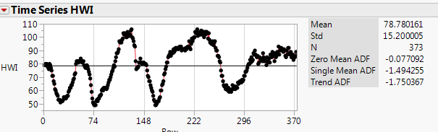

HW1 is not stationary as all of its Dicky-Fuller T-statistics do not pass the 1% significant threshold.

It can be made stationary by taking 1 difference, I(1). All Dicky-Fuller T-statistics pass 1% significant threshold and indicate stationary.

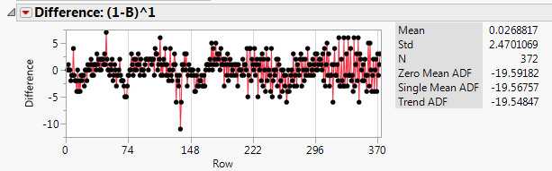

**c. Use our standard statistical procedures to determine if the UNRATE variable is stationary.  
i. Include here your basic output results (no graphs are necessary here) and your decision.  
ii. If your series is NOT stationary, what do you need to do to fix it? Prove that your  
modification creates stationarity.**

ANS:

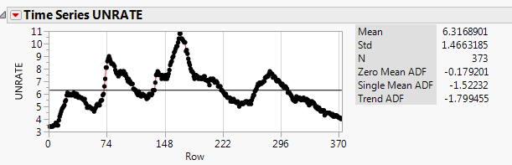

UNRATE is not stationary as all of its Dicky-Fuller T-statistics do not pass the 1% significant threshold.

It can be made stationary by taking 1 difference, I(1). All Dicky-Fuller T-statistics pass 1% significant threshold and indicate stationary.

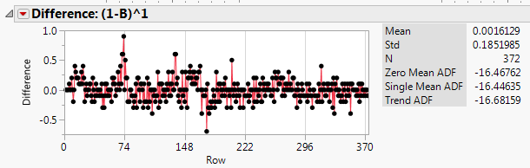

**d. Now create a simple regression model using UNRATE to predict HWI without any modifications, but be sure to include a constant.  
i. What is your regression equation?  
ii. Test this model for the possibility of cointegration and report your statistical results. What  
do you determine?**

ANS:

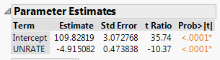

The equation is:

HW1 = 109.83 - 4.92*UNRATE

I investigate the residual’s time series of the model:

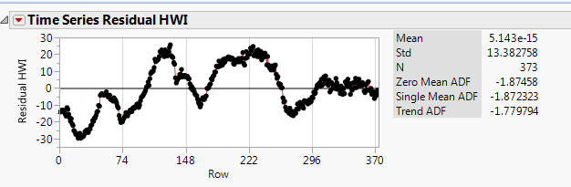

Dicky-Fuller T-statistics indicate a non-stationary so there may not be a cointegration between both series.

3. (Dataset: PlantExpenditures.xlsx) The goal of this question is to use a distributed lag, or dynamic regressionmodel to determine the parameters of the long and short-run impact of manufacturing sales (Sales, in billions of seasonally adjusted dollars) on the investment in equipment (Expend, also in billions of seasonally adjusted dollars).

**a. Use the Koyck Approach to estimate the parameters you need. What is your output for this model?**

ANS:

I run the regression model Expend ~ lag(Expend,1) + Sales, and obtain the following result:

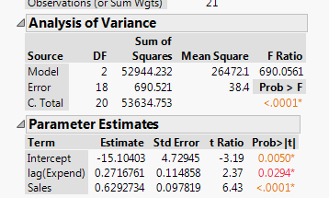

The estimated lambda for Koyck is 0.27. The estimated alpha is -15.1/(1-0.27) = -20.68

Both median lag and mean lag indicate that incorporating only 1 lag period is enough. The estimated model is:

$$Expend= -20.68+0.63*Sales+\left(0.63*0.27\right)*lag(Sales,1)$$

**b. What is the short-run impact of a one-unit (one billion dollar) increase in Sales?**

ANS: From the equation above one unit increased in Sales resulted in 0.63 unit increased in Expend.

**c. What is your long-run demand function for expenditures?**

ANS:

The estimated total impact is 0.63/(1-0.27) = 0.86, so the long-run function is:

$$Expend= -20.68+0.86*Sales$$

**d. How many lags of Sales would you suggest including? (Explain why)**

ANS:

From a., the estimated lambda is 0.27

The number of lag used can be calculated from Median Lag and Mean Lag

For Median Lag, the estimated Median Lag = $-\frac{ln⁡(2)}{ln⁡(0.27)}$ = 0.53

For Mean Lag, the estimated Mean Lag = $\frac{0.27}{1-0.27}$ = 0.37

Both approaches indicate that all changes can be accounted by incorporating just one lag period, so, only 1 lag of Sales is sufficient.