**REPORT**

Name: Vitthal maledar

Unique id : 2005064

Subject: Model based design

Topic: Anti lock braking system modelling

CONTENTS:

* Introduction
* Requirements of the model
* Inputs
* Outputs
* Architecture of the model
* Building and analysis of the model
* Conclusion

Introduction

Title of problem: Modelling of the anti lock braking system.

Anti lock braking system is part of vehicle which prevents the locking up of the wheels when the vehicle is over steered and maintains steady grip. It simulates the dynamic behaviour of vehicle under the hard braking conditions. This model corresponds to single wheel of vehicle.

The corresponding equations are pasted below ,

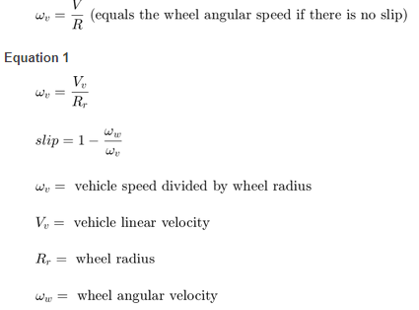

The wheel rotates with initial angular speed that corresponds to the vehicle speed before the brakes are applied.

When slip=0, the vehicle speed and vehicle speed are equal.

When slip=1, wheel is locked.

A desirable slip value is 0.2, which means that the number of wheel revolutions equals 0.8 times the number of revolutions under non-braking conditions with the same vehicle velocity.

Requirements:

When it comes to simulation of the model anti lock braking system, there are inputs and outputs to be determined and provided with right inputs to give proper outputs.

Inputs are desired given slip which is 0.2 and the constants related to the modelling equations are provided. And outputs are wheel speed, vehicle speed and slip, these are main factors on which anti lock braking can be tested.

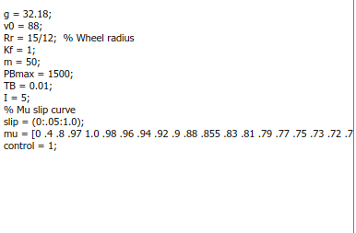

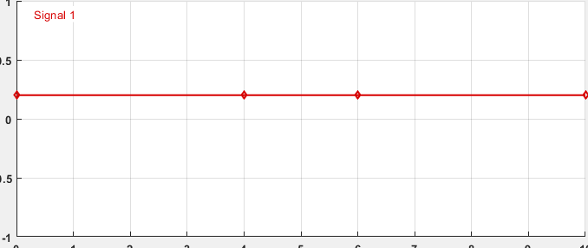

Inputs given to the model ABS

Architecture:

The model consists of three parts/subsystems which wholly describes model,

* Wheel speed calculation subsystem block : This subsystem contains blocks which are useful to calculate the wheel speed required for the slip calculation. This model is reference model for the Abs modelling.

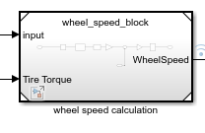

* Matlab function block : it is used for the calculation of the slip.

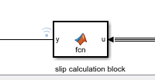

* Bang bang controller : it is an ideal controller used for anti lock braking system.

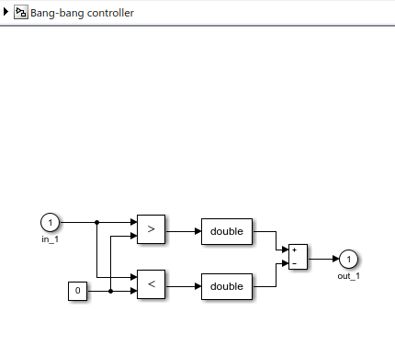

Building and analysis of model:

The model is started with wheel speed calculation subsystem, this subsystem is made reference model for the access and to work on it separately.

Here, model referencing technique is used for the subsystem. It is given below here,

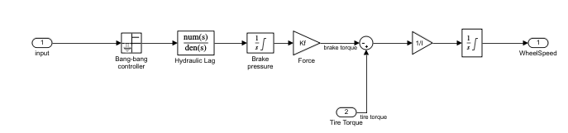

Wheel speed calculation

In this model, to calculate the wheel speed, bang bang controller(ideal controller for ABS ), hydraulic lag transfer function, brake pressure and tire torque are required.

Matlab function functionality is used to calculate the slip for the control of antilock braking system.

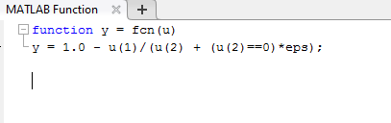

Matlab function(relative slip calculation)

These are two subsystems required for building the main model antilock braking system.

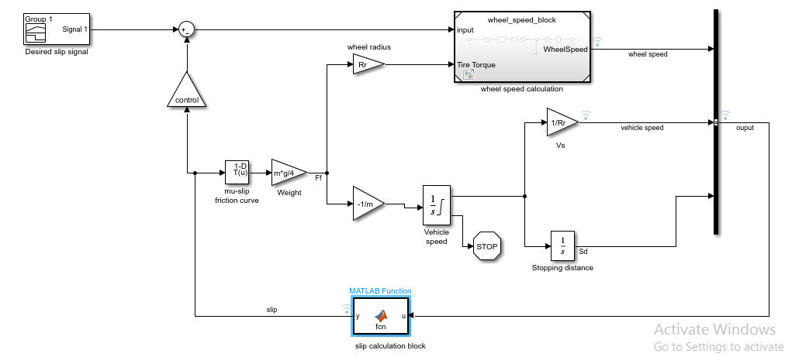

Main model for Antilock braking system(single wheel)

In the above model, desired slip signal(0.2 magnitude) is given to the model. Slip calculated from slip calculation block is given to sum block, output from the sum block is given as input to wheel speed calculation. Tire torque calculated from block weight and 1D look up table (mu slip) is given as input to wheel speed calculation block. The control block determines whether ABS is controlled (control==1) or not controlled(control==0). Vehicle speed and wheel speed are the outputs of this model. These signals are logged in to view the output. Here, 1D look up table (mu slip curve) contains the slip values corresponding to the friction coefficients. When slip calculated from the slip calculation block, is given to the 1D look up table, corresponding friction coefficient is used to calculate the weight and tire torque.

Demonstration of the skills

* Call backs

In this model, model call back preload function is used to pass the parameters required for the model. In this model explorer, call back is there. In that, preload function is defined with parameters and also close function for the clearing the variables at the time closing the model.

The below are images for the model call backs,

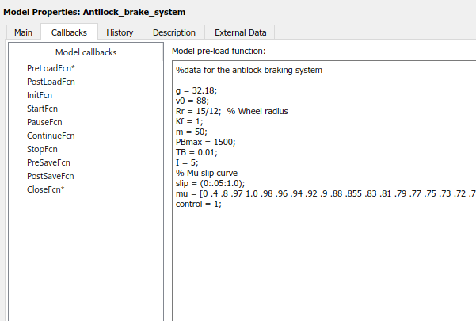 Preload function (defined)

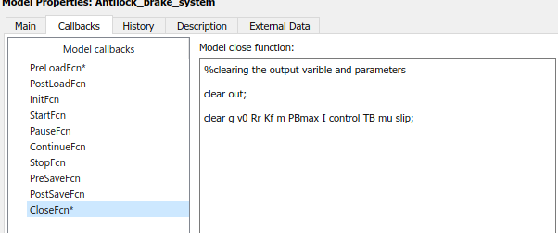

Close function(defined)

* Data inspector

This functionality is used to compare the outputs and verify the model working by logging in the input and output data. Here , in the model vehicle speed, wheel speed and slip are logged in to view the graphs of signals. By viewing the graphs, model is tested and verified with working.

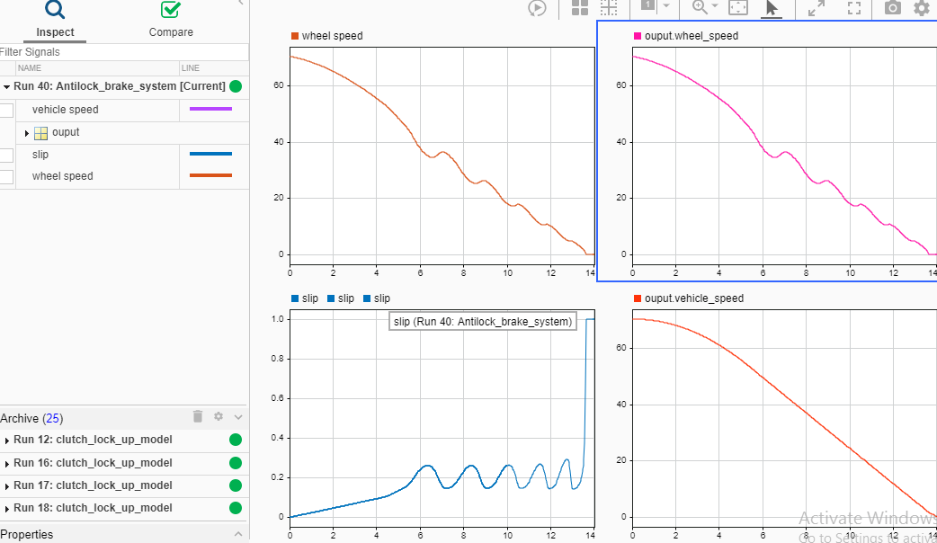

Data inspector output waveforms

In the above graph, slip, vehicle speed and wheel speed are viewed in data inspector by logging in those signals. It is observed that when braking force is applied with present of ABS system, less than 15 seconds vehicle speed goes to zero and slip becoming zero (indicating that wheel is locked by the brakes). Even this model is tested with control =0, there it is observed that, vehicle speed is becoming zero after the 15 seconds and slip curve is also one at the initial stage and continues to be in that state only until vehicle speed becomes zero. It is shown in the graph as below,

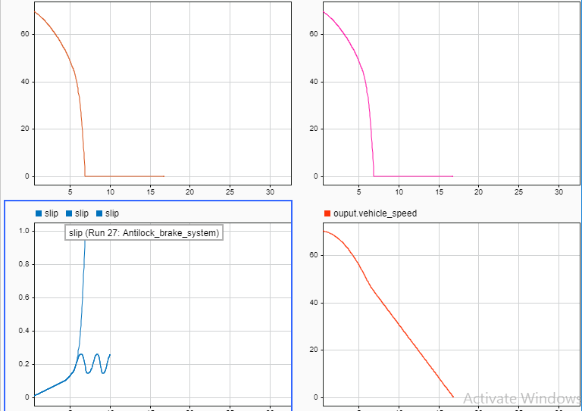

Data inspector output(control==0)

* Matlab functionality

Matlab functionality is used for the calculation of the slip required to calculate the wheel speed and for the control.



Matlab function block



Function defined to calculate the slip

* Solver selection strategy

As it is known, ODE 45 solver performs well with almost ODE problems. And there are other solvers such as ODE23s (stiff solver ), ODE 15s(stiff solver) and others. ODE 45 is non stiff solver with medium precision and without tolerance levels. There are some points to select the solver for the model upon which solver for this ABS model is selected.

1. Solvers ODE 23s and ODE 15s are selected when there is requirement of high precision and problem with looser or tighter tolerance levels.
2. If there is stiffness in the problem, then it is an ideal choice to go for the ODE 23s and ODE 15s solvers.

Considering the above points and analysis of the problem, ODE 45 solver is best for this model. As it is identified that, by simulating with solver ODE 45,it runs easily without time lag and even same model is simulated with solver selected ODE 23s ,same runs easily without time lag. On comparison of both solvers, if there is requirement of precision, then ODE 23s is chosen otherwise ODE 45 is chosen. For this model, there is no such requirements, ODE 45 solver is selected. In the given below graph, comparison is done between both solvers ODE 45 and ODE 23s. It is observed there is tolerance level introduced.

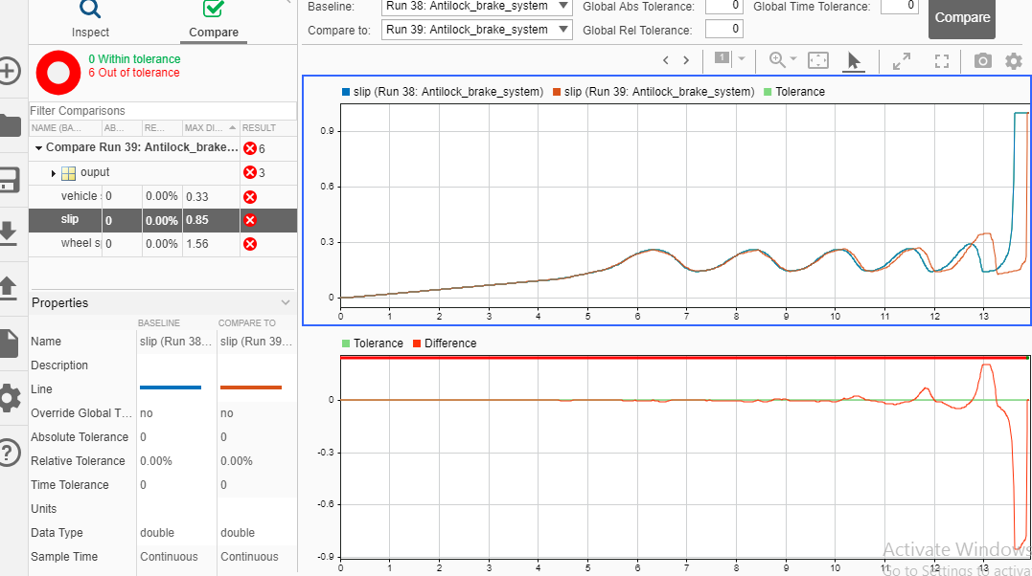 slip comparison given by both solvers

* Look up table

In this model, 1-D look up table is used. Here the friction coefficients and slip are used as table data and break points to generate the corresponding friction coefficients. This output is involved in calculation of both tire torque and wheel speed. Data table is shown below,

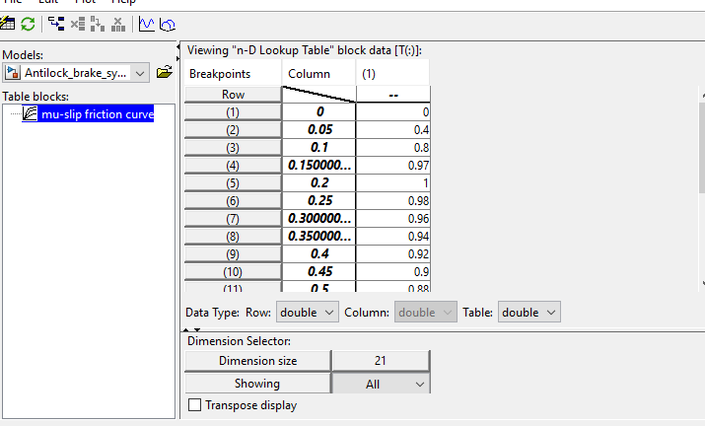

Data table

* Signal builder

Here the desired slip is given as input to the model through this signal builder functionality. Below is image of signal desired slip. And tested with this input signal.



* Conclusion

Clearly the model is simulated with controller=0 and controller=1 and compared the outputs. Here are below graph images ,

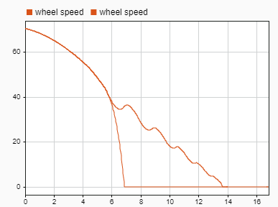

Wheel speed graphs with control=1 and control=0

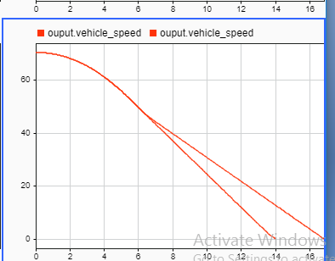

vehicle speed graphs with control=1 and control=0

References:

1. <https://www.mathworks.com/help/simulink/slref/modeling-an-anti-lock-braking-system.html;jsessionid=4d4cb59de1e84742dfb619d0f134>
2. <https://ieeexplore.ieee.org/document/6957376>
3. <https://ieeexplore.ieee.org/document/7342222>