LibPlayer user guide

日期 | 版本 | 修改者 | 说明
2011-1-20 | V1.0 | Rongle：lee.rong@amlogic.com | 创建

目录
1. Player框图 3
2. Player流程图 5
3. LibPlayer库使用说明 6
4. 示例源码 16
5. player 库依赖关系 19

Player框图
  - 本地播放器

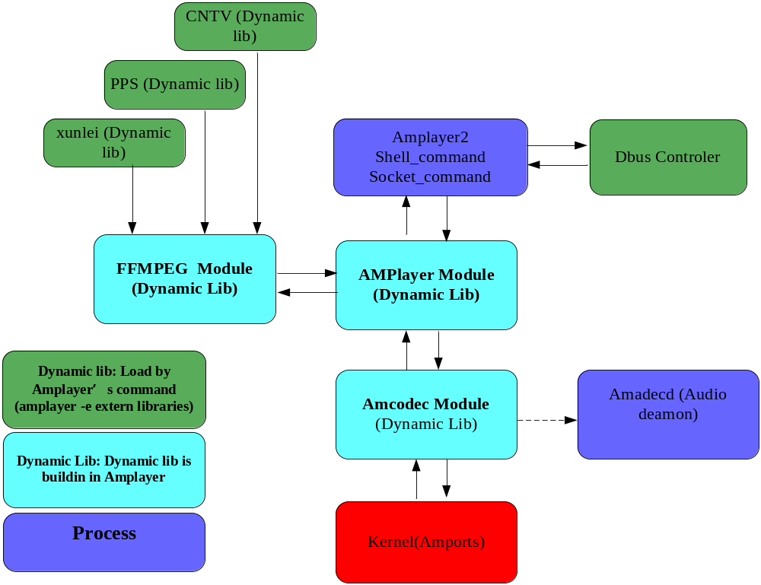

  - DVB TS流播放的应用

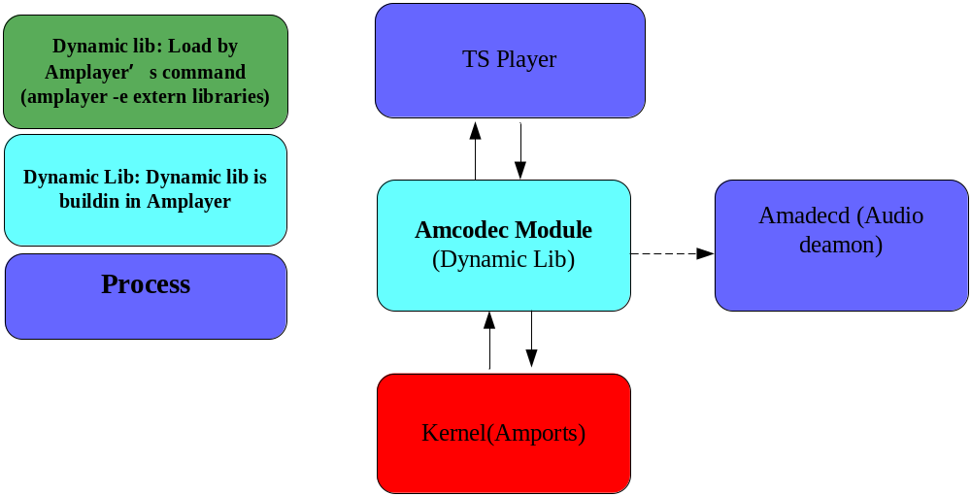
  - 嵌入式UI进程模式

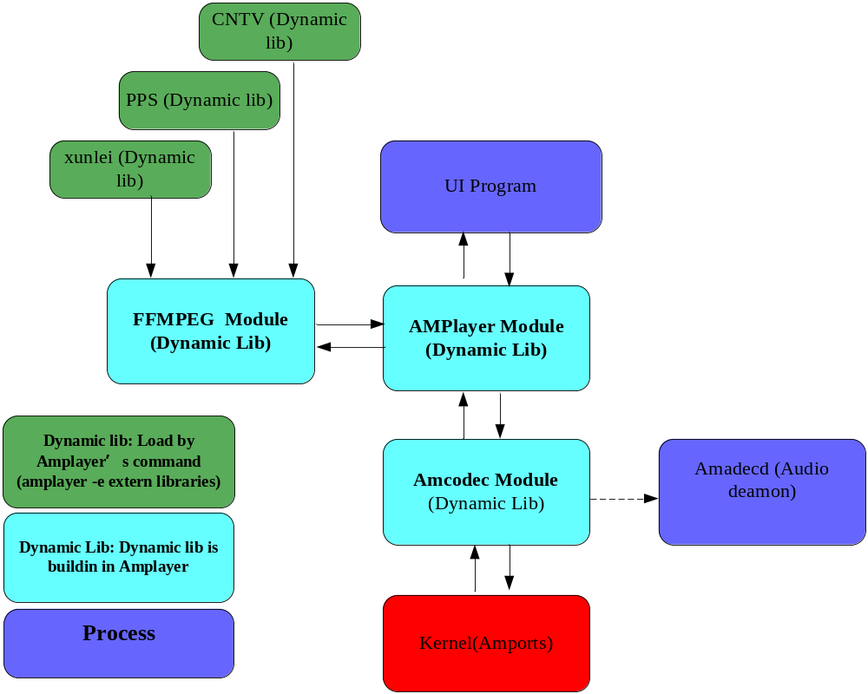

Player流程图
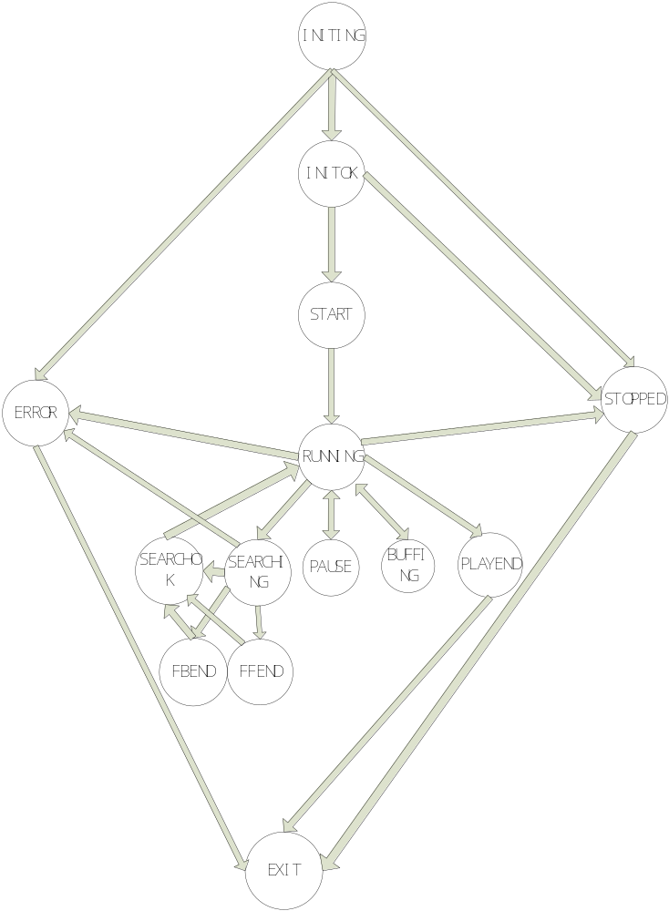

LibPlayer库使用说明
  - Libamcodec使用说明
    - 驱动必要条件
amcodec是实现驱动跟上层player的中间层，封装了codec的所有驱动操作。
与之相对应的kernel驱动的关键代码是：
kernel/drivers/amlogic/amports/amstream.c
为了应用层可以使用驱动，在文件系统里面对应的设备节点是：
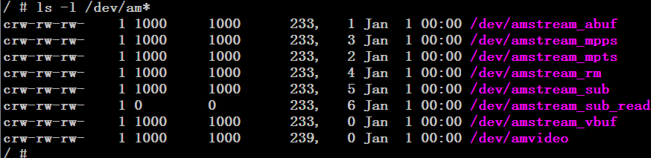
同时确认kernel使能了amstream 驱动，注意下图中的设备号为233和239的驱动一定要使能，否则请重新配置kernel
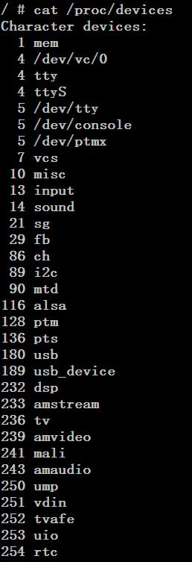
    - 核心结构体和枚举
codec_para_t
【描述】
Codec控制器结构体

【定义】
typedef struct
{
CODEC_HANDLE handle;
CODEC_HANDLE cntl_handle;
CODEC_HANDLE sub_handle;
stream_type_t stream_type;
unsigned int has_video:1;
unsigned int has_audio:1;
unsigned int has_sub:1;
unsigned int noblock:1;
int video_type;
int audio_type;
int sub_type;
int video_pid;
int audio_pid;
int sub_pid;
int audio_channels;
int audio_samplerate;
int vbuf_size;
int abuf_size;
dec_sysinfo_t am_sysinfo;
audio_info_t audio_info; // pass to audiodsp
int packet_size;
}codec_para_t;

【参数】
参数 | 类型 | 描述
handle | CODEC_HANDLE
cntl_handle | CODEC_HANDLE
stream_type | stream_type | stream 的编码格式
has_video | unsigned int | 是否存在 video 的标志
has_audio | unsigned int | 是否存在 audio 的标志
video_type | int | video 的类型，对应于 vformat_t
audio_type | int | audio 的类型，对应于 aformat_t
video_pid | int | ps，ts 等需要设置 video pid
audio_pid | int | ps，ts 等需要设置 audio pid
audio_channels | int | Pcm 解码时需要设置
audio_samplerate | int | Pcm 解码时需要设置
vbuf_size | int | 修改 video buffer 的大小，0 表示使用默认size
abuf_size | int | 修改 video buffer 的大小，0 表示使用默认size
am_sysinfo | dec_sysinfo_t | 系统解码辅助信息

【枚举】
typedef enum
{
STREAM_TYPE_UNKNOW,
STREAM_TYPE_ES_VIDEO,
STREAM_TYPE_ES_AUDIO,
STREAM_TYPE_ES_SUB,
STREAM_TYPE_PS,
STREAM_TYPE_TS,
STREAM_TYPE_RM,
}stream_type_t;

【参数】
参数 | 描述
STREAM_TYPE_UNKNOW | 未知流类型
STREAM_TYPE_ES_VIDEO | ES 视频流
STREAM_TYPE_ES_AUDIO, | ES 音频流
STREAM_TYPE_PS | PS 流
STREAM_TYPE_TS | TS 流
STREAM_TYPE_RM | RM 流

dec_sysinfo_t

【描述】
编码信息结构体
【定义】
typedef struct
{
unsigned int format;
unsigned int width;
unsigned int height;
unsigned int rate;
unsigned int extra;
unsigned int status;
unsigned int ratio;
void * param;
} dec_sysinfo_t;

【参数】
参数 | 类型 | 描述
format | unsigned int | 视频编码格式
width | unsigned int | 视频帧宽度（像素点）
height | unsigned int | 视频帧高度（像素点）
rate | unsigned int | 视频帧率
extra | unsigned int | 视频编码附加信息
status | unsigned int | 视频状态
ratio | unsigned int | 视频显示比例
param | void * | 其他参数

    - libamcodec头文件解析
- int codec_init(codec_para_t *);
功能：根据 codec_para_t->stream_type的值打开
/dev/amstream_vbu
/dev/amstream_abuf
/dev/amstream_mpts
/dev/amstream_mpps
/dev/amstream_rm
/dev/amstream_sub
获得设备描述符并保存到codec_para_t->handle
Example code:

codec_para_t *pcodec = NULL;
pcodec = av_mallocz(sizeof(codec_para_t))
pcodec->video_pid = 851;
pcodec->audio_pid = 852;
pcodec->video_type = VFORMAT_H264;
pcodec->audio_type = AFORMAT_AC3;
pcodec->has_video = 1;
pcodec->has_audio = 1;
pcodec->stream_type = STREAM_TYPE_TS;
ret = codec_init(pcodec);
if (ret != CODEC_ERROR_NONE) {
printf("codec init failed, ret=-0x%x", -ret);
return -1;
} else {
printf("codec init ok!\n");
}

- int codec_write(codec_para_t *pcodec,void *buffer,int len);
功能：根据 codec_para_t->stream_type的值打开

static char filename[256] = "ahmei-1_feicui.ts";
static int file_fd = -1;

file_fd = open(filename, O_RDWR, 0666);
if (file_fd < 0) {
printf("can't open file:%s\n", filename);
return -1;
}
printf("open file:%s ok!\n", filename);

len = read(file_fd, buffer, size);
if (len > 0) {
size = 0;
do {
ret = codec_write(pcodec, buffer, len);
if (ret < 0) {
printf("codec_write ret=%d errno=%d\n", ret, errno);
if (errno != EAGAIN) {
printf("codec_write failed! ret=-0x%x errno=%d\n", -ret, -errno);
return -2;
} else {
continue;
}
} else {
size += ret;
if (size == len) {
//printf("write %d bytes data\n",ret);
break;
} else if (size < len) {
continue;
} else {
printf("write failed, want %d bytes, write %d bytes\n", len, size);
return -3;
}
}
} while (1);

} else if (len == 0) {
printf("read eof\n");
sleep(10);
break;
} else {
printf("read failed! len=%d errno=%d\n", len, errno);
break;
}

- int codec_close(codec_para_t *);
功能：关闭所有codec；

- void codec_close_audio(codec_para_t *);
功能：关闭audio codec；

- void codec_resume_audio(codec_para_t *, unsigned int);
功能：audio codec；

- int codec_reset(codec_para_t *);
功能： 复位 codec， 与codec_init的区别多了先关闭设备代码
example code:
Same as codec_init

- int codec_init_sub(codec_para_t *);
功能： 打开设备/dev/amstream_sub获取描述符并保存到codec_para_t->sub_handle
example code:
if(pcodec->has_sub) {
r=codec_init_sub(pcodec);
if(r<0) {
codec_r = system_error_to_codec_error(r);
print_error_msg(codec_r, __FUNCTION__, __LINE__);
return CODEC_OPEN_HANDLE_FAILED;
}
pcodec->handle = pcodec->sub_handle;
}

- int codec_open_sub_read(void);
功能： 打开设备/dev/amstream_sub并返回设备描述符

- int codec_close_sub(codec_para_t *);
功能： 关闭设备/dev/amstream_sub

- int codec_close_sub_fd(CODEC_HANDLE);
功能： 关闭设备/dev/amstream_sub的描述符

- int codec_reset_subtile(codec_para_t *pcodec);
功能： 复位subtitle

- int codec_poll_sub(codec_para_t *);
功能： 等待subtitle数据写入完成

- int codec_poll_sub_fd(CODEC_HANDLE sub_fd, int timeout)
功能： 与codec_poll_sub近似，只是输入参数是设备描述符和timeout值

- int codec_get_sub_size(codec_para_t *);
功能： 获得subtitle的大小

- int codec_get_sub_size_fd(CODEC_HANDLE);
功能： 与codec_get_sub_size近似，只是输入参数是设备描述符

- int codec_read_sub_data(codec_para_t *, char *, unsigned int);
功能： 从subtitle buffe中读取subtitle数据

- int codec_read_sub_data_fd(CODEC_HANDLE, char *, unsigned int);
功能： 与codec_read_sub_data近似，只是输入参数是设备描述符

- int codec_write_sub_data(codec_para_t *, char *, unsigned int);
功能：通过/dev/amstream_sub调用驱动写入subtitle数据，
Example code:

unsigned char sub_header[20] = {0x41, 0x4d, 0x4c, 0x55, 0xaa, 0};
sub_type = para->sstream_info.sub_type;
if(sub_type==0x17000)
{
sub_type=0x1700a;
}
sub_header[5] = (sub_type >> 16) & 0xff;
sub_header[6] = (sub_type >> 8) & 0xff;
sub_header[7] = sub_type & 0xff;
sub_header[8] = (data_size >> 24) & 0xff;
sub_header[9] = (data_size >> 16) & 0xff;
sub_header[10] = (data_size >> 8) & 0xff;
sub_header[11] = data_size & 0xff;
sub_header[12] = (sub_pts >> 24) & 0xff;
sub_header[13] = (sub_pts >> 16) & 0xff;
sub_header[14] = (sub_pts >> 8) & 0xff;
sub_header[15] = sub_pts & 0xff;
sub_header[16] = (last_duration >> 24) & 0xff;
sub_header[17] = (last_duration >> 16) & 0xff;
sub_header[18] = (last_duration >> 8) & 0xff;
sub_header[19] = last_duration & 0xff;
write_bytes = codec_write_sub_data(pkt->codec,
(char*)&sub_header, sizeof(sub_header)));

- int codec_init_cntl(codec_para_t *);
功能：打开/dev/amvideo获得文件描述符并保存在codec_para_t-> cntl_handle，
Example code:

a_codec=codec_alloc();
if(!a_codec){
if(vinfo->has_video && v_codec)
codec_release(v_codec);
return PLAYER_EMPTY_P;
}
MEMSET(a_codec, 0, sizeof(codec_para_t));
if (codec_init_cntl(a_codec) != 0)
goto error2;

- int codec_close_cntl(codec_para_t *);
功能：关闭之前打开/dev/amvideo所获得的文件描述符codec_para_t-> cntl_handle

- int codec_poll_cntl(codec_para_t *);
功能：等待对/dev/amvideo的操作完成，中断处理后唤醒。
Example code：Kernel/drivers/amlogic/amports/video.c

- int codec_get_cntl_state(codec_para_t *);
功能：等待对/dev/amvideo的操作完成，中断处理后唤醒。

- int codec_set_cntl_mode(codec_para_t *, unsigned int);
功能：设置trick_mode模式。

- int codec_set_cntl_avthresh(codec_para_t *, unsigned int);
功能： 设置avsync的时间门限。如果超过这个值就变换为TSYNC_MODE_VMASTER

- int codec_reset_audio(codec_para_t *pcodec);
功能：复位audio port。

- int codec_set_audio_pid(codec_para_t *pcodec);
功能：选择多路音轨中的某路音轨。
Example code：
Pcodec-> audio_pid = 0; //选则第一个音轨
codec_set_audio_pid(pcodec);

- int codec_set_sub_id(codec_para_t *pcodec);
功能：选择多路字幕中的某路字幕。

- int codec_audio_reinit(codec_para_t *pcodec);
功能：调用驱动ioctl
AMSTREAM_IOC_AFORMAT
AMSTREAM_IOC_AID
AMSTREAM_IOC_SAMPLERATE
AMSTREAM_IOC_ACHANNEL
重新初始化audio
- int codec_set_dec_reset(codec_para_t *pcodec);
功能：调用驱动ioctl
AMSTREAM_IOC_SET_DEC_RESET
设置tsync_dec_reset_flag
驱动在tsync_avevent(VIDEO_START,
(vf->pts) ? vf->pts : timestamp_vpts_get());
时完成DAC复位操作

- int codec_checkin_pts(codec_para_t *pcodec, unsigned long pts);
功能：调用驱动ioctl
AMSTREAM_IOC_TSTAMP
设置硬件pts
- int codec_get_vbuf_state(codec_para_t *,struct buf_status *);
功能：调用驱动ioctl
AMSTREAM_IOC_VB_STATUS
获得video buffer的状态
返回值存放于buf_status *buf中

- int codec_get_abuf_state(codec_para_t *,struct buf_status *);
功能：调用驱动ioctl
AMSTREAM_IOC_AB_STATUS
获得audio buffer的状态
返回值存放于buf_status *buf中

- int codec_get_vdec_state(codec_para_t *,struct vdec_status *);
功能：调用驱动ioctl
AMSTREAM_IOC_VDECSTAT
获得video decoder buffer的状态
返回值存放于vdec_status *buf中

- int codec_get_adec_state(codec_para_t *,struct adec_status *);
功能：调用驱动ioctl
AMSTREAM_IOC_ADECSTAT
获得audio decoder buffer的状态
返回值存放于adec_status *buf中

- int codec_pause(codec_para_t *);
功能：通过向/sys/class/tsync/event写入 "AUDIO_PAUSE"来暂停audio
调用驱动ioctl
AMSTREAM_IOC_VPAUSE
来暂停video

- int codec_resume(codec_para_t *);
功能：通过向/sys/class/tsync/event写入 "AUDIO_RESUME"来恢复audio
调用驱动ioctl
AMSTREAM_IOC_VPAUSE
来恢复video

示例源码
/**************************************************
* example based on amcodec
**************************************************/
#include <sys/types.h>
#include <sys/stat.h>
#include <fcntl.h>
#include <stdio.h>
#include <stdlib.h>
#include <string.h>
#include <signal.h>
#include <errno.h>
#include <adecproc.h>
#include <codec.h>
//#include <getopt.h>
static codec_para_t ts_codec_para;
static codec_para_t *pcodec;
static char filename[256] = "ahmei-1_feicui.ts";
static int file_fd = -1;

int osd_blank(char *path, int cmd)
{
int fd;
char bcmd[16];
fd = open(path, O_CREAT | O_RDWR | O_TRUNC, 0644);
if (fd >= 0) {
sprintf(bcmd, "%d", cmd);
write(fd, bcmd, strlen(bcmd));
close(fd);
return 0;
}
return -1;
}

static void signal_handler(int signum)
{
printf("Get signum=%x\n", signum);
codec_close(pcodec);
close(file_fd);
signal(signum, SIG_DFL);
raise(signum);
}

int main(int argc, char *argv[])
{
#define READ_SIZE (32 * 1024)
int ret = CODEC_ERROR_NONE;
char buffer[READ_SIZE];
int len = 0;
long long pos = 0;
int size = READ_SIZE;
uint32_t cnt = 0;

printf("\n*********CODEC PLAYER DEMO************\n\n");
pcodec = &ts_codec_para;
memset(pcodec, 0, sizeof(codec_para_t *));
pcodec->video_pid = 851;
pcodec->audio_pid = 852;
pcodec->video_type = VFORMAT_H264;
pcodec->audio_type = AFORMAT_AC3;
pcodec->has_video = 1;
pcodec->has_audio = 1;
pcodec->stream_type = STREAM_TYPE_TS;

osd_blank("/sys/class/graphics/fb0/blank", 1);
osd_blank("/sys/class/graphics/fb1/blank", 0);
memset(buffer, 0, READ_SIZE);
file_fd = open(filename, O_RDWR, 0666);
if (file_fd < 0) {
printf("can't open file:%s\n", filename);
return -1;
}
printf("open file:%s ok!\n", filename);
if (pcodec->has_audio || pcodec->has_video) {
again:
ret = codec_init(pcodec);
if (ret != CODEC_ERROR_NONE) {
printf("codec init failed, ret=-0x%x", -ret);
return -1;
}
printf("codec init ok!\n");
pos = lseek(file_fd, 0, SEEK_SET);
printf("seek pos:%lld\n", pos);
cnt = 0;
do {
cnt++;
if (cnt >= 500) {
printf("[amplayer] stephen: test codec close --> init --> close\n");
codec_close(pcodec);
osd_blank("/sys/class/graphics/fb0/blank", 1);
osd_blank("/sys/class/graphics/fb1/blank", 0);
goto again;
}
len = read(file_fd, buffer, size);
if (len > 0) {
size = 0;
do {
ret = codec_write(pcodec, buffer, len);
if (ret < 0) {
printf("codec_write ret=%d errno=%d\n", ret, errno);
if (errno != EAGAIN) {
printf("codec_write failed! ret=-0x%x errno=%d\n", -ret, -errno);
return -2;
} else {
continue;
}
} else {
size += ret;
if (size == len) {
//printf("write %d bytes data\n",ret);
break;
} else if (size < len) {
continue;
} else {
printf("write failed, want %d bytes, write %d bytes\n", len, size);
return -3;
}
}
} while (1);

} else if (len == 0) {
printf("read eof\n");
sleep(10);
break;
} else {
printf("read failed! len=%d errno=%d\n", len, errno);
break;
}
} while (1);

} else {
printf("No audio and No video!\n");
}
error:
printf("will exit!!!!!!!!!!!!\n");
codec_close(pcodec);
close(file_fd);
return 0;

}

Makefile
Andoid.mk

LOCAL_PATH := $(call my-dir)

include $(CLEAR_VARS)
LOCAL_MODULE := cplayer
LOCAL_SRC_FILES := cplayer.c
LOCAL_ARM_MODE := arm
LOCAL_C_INCLUDES := $(LOCAL_PATH)/../amplayer/player/include \
$(LOCAL_PATH)/../amplayer/control/include \
$(LOCAL_PATH)/../amcodec/include \
$(LOCAL_PATH)/../amadec/include \
$(LOCAL_PATH)/../amffmpeg \
$(JNI_H_INCLUDE)

LOCAL_STATIC_LIBRARIES := libamplayer libamcontroler libamplayer libamcodec libavformat libavcodec libavutil libamadec
LOCAL_SHARED_LIBRARIES += libutils libmedia

include $(BUILD_EXECUTABLE)

player 库依赖关系
libz.so.1 => /usr/lib/libz.so.1 (0x40028000)
libavutil.so.50 => /usr/lib/libavutil.so.50 (0x40040000)
libavformat.so.52 => /usr/lib/libavformat.so.52 (0x4005e000)
libavcodec.so.52 => /usr/lib/libavcodec.so.52 (0x400f0000)
libm.so.6 => /lib/libm.so.6 (0x4099c000)
libpthread.so.0 => /lib/libpthread.so.0 (0x40a3d000)
libamcodec.so => /usr/lib/libamcodec.so (0x40a5d000)
libdl.so.2 => /lib/libdl.so.2 (0x40a6a000)
libamplayer.so => /usr/lib/libamplayer.so (0x40a77000)
libamcontroler.so => /usr/lib/libamcontroler.so (0x40aa0000)
libgcc_s.so.1 => /lib/libgcc_s.so.1 (0x40ab2000)
libc.so.6 => /lib/libc.so.6 (0x40ac5000)
/lib/ld-linux.so.3 (0x40000000)

