B TREE- SOLVED PROBLEMS
- The left sub tree of the node will have lesser values than the right side of the sub tree. This means that the nodes are also sorted in ascending order from left to right.
- If order of the tree is P;
  - Maximum No.of Keys =P-1
  - Minimum No.of Keys = [P/2]-1
  - Minimum No.of Children =P/2
  - Maximum No.of Children =P
Example 1:
Assume order is 4 ---------------8,9,10,11,15,16,17,18,20,23,12
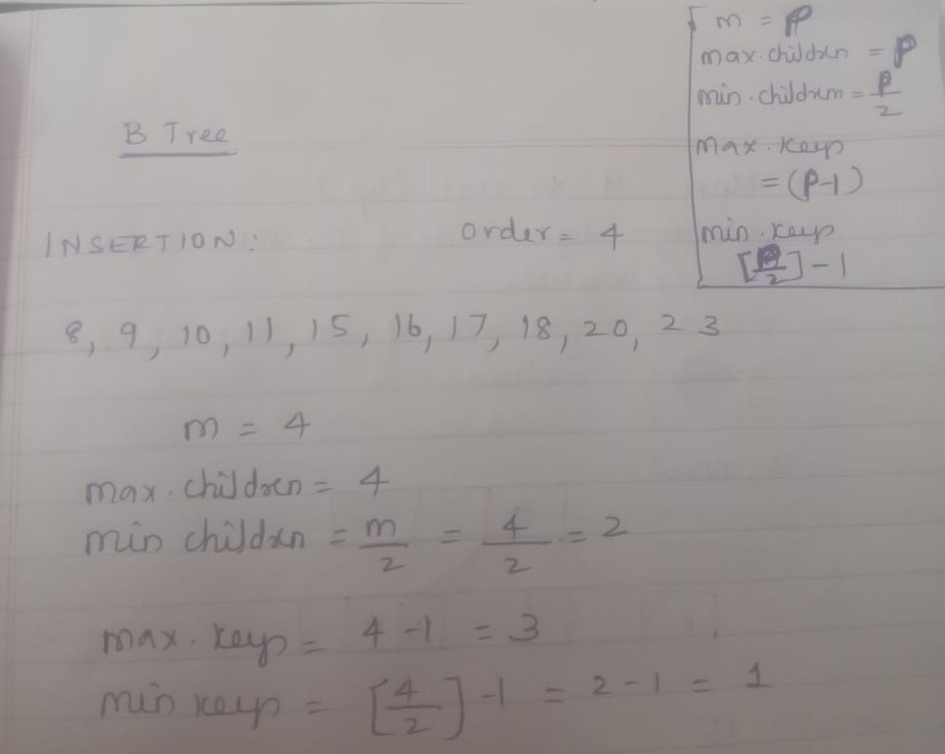
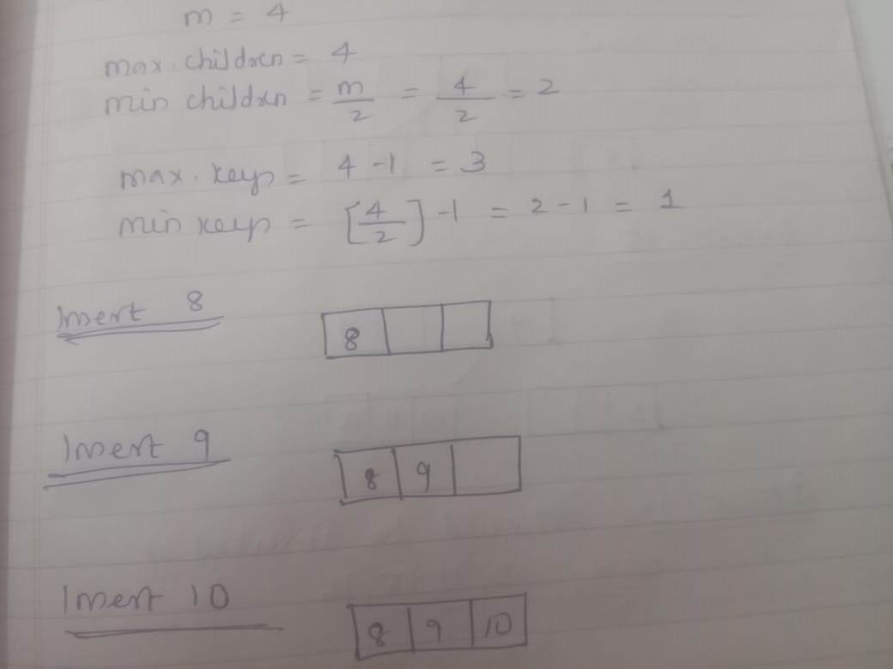
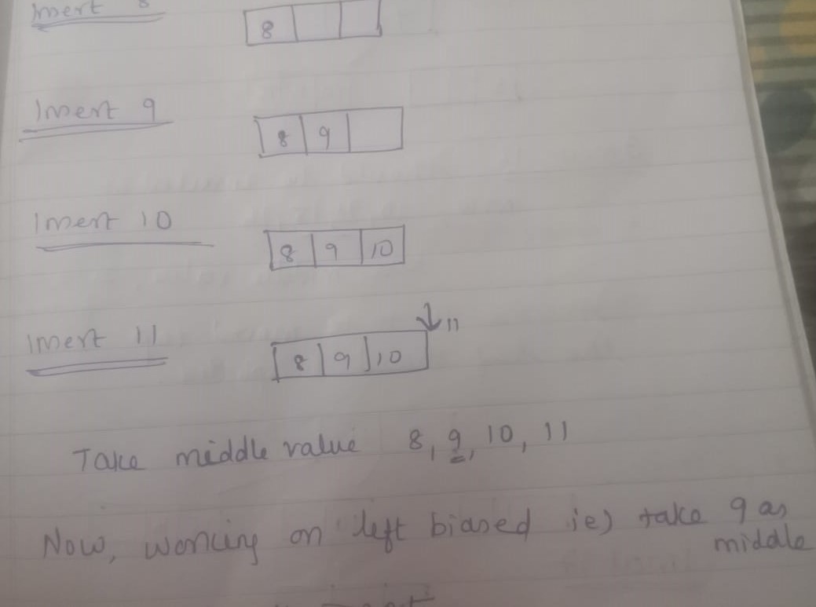
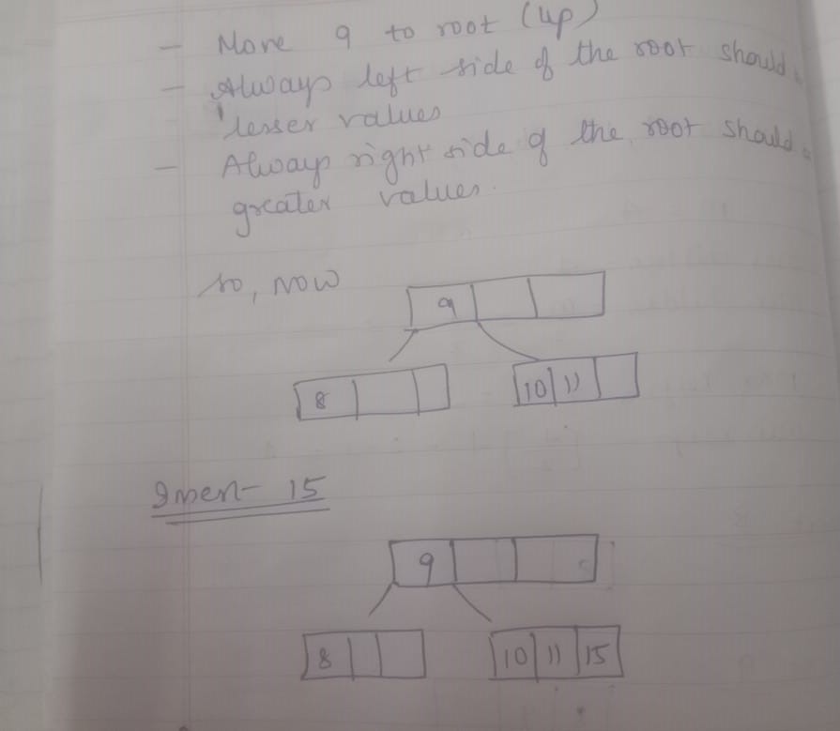
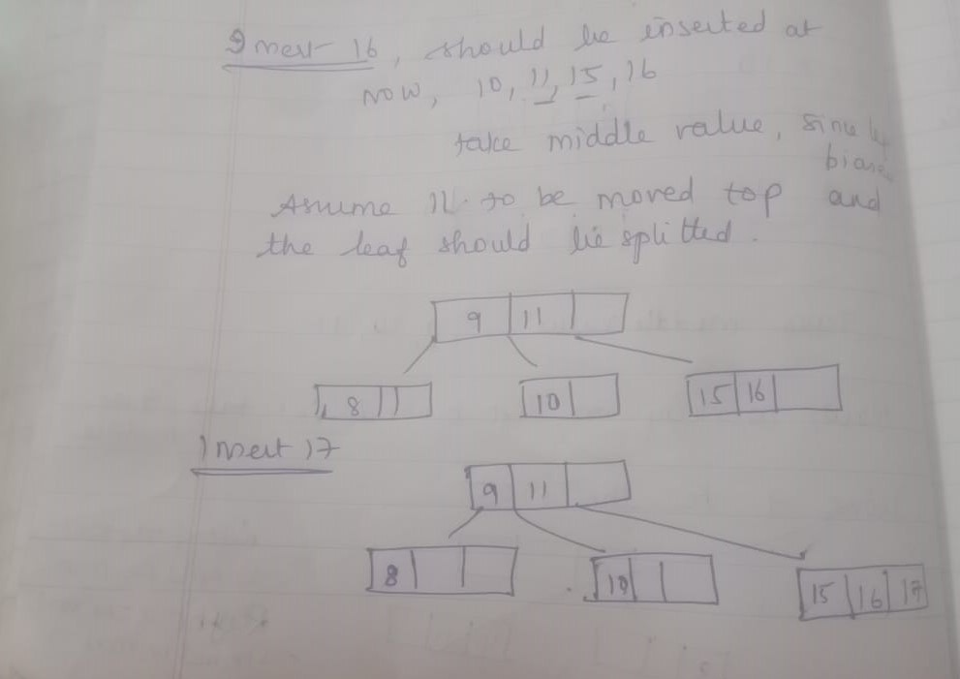
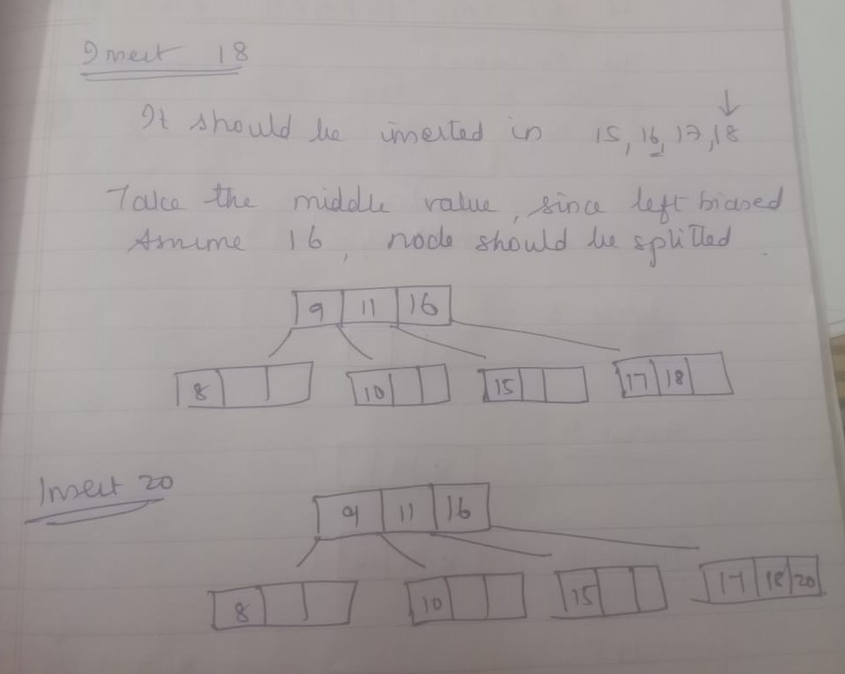
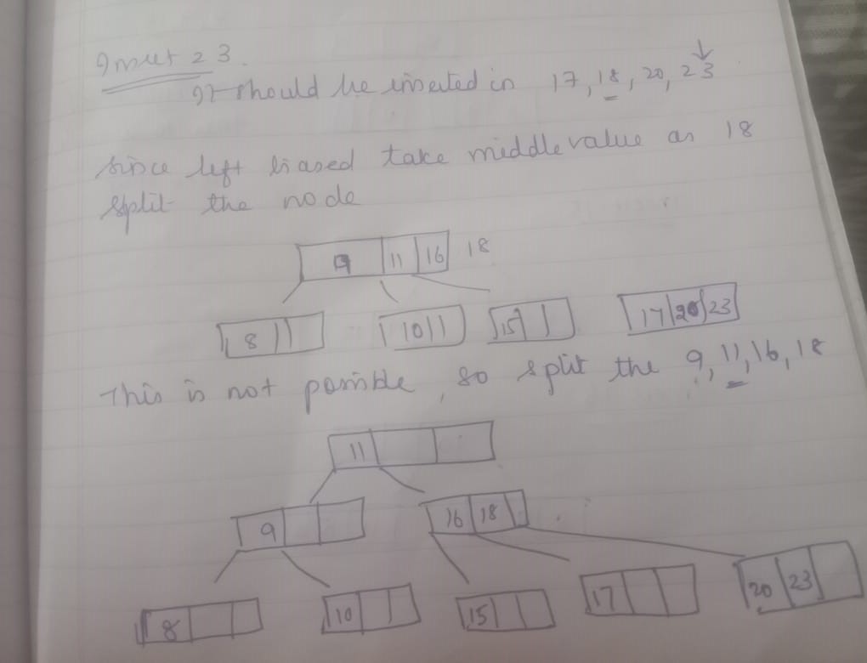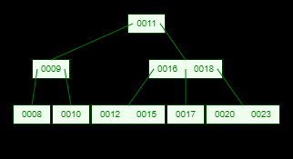
Example 2
Assume th order 4…….
