***Module 1***

**Q1. Determine whether the following signals are energy signal or power signal and calculate their energy and power.**

$x\left(t\right)= \sin^{2} ω_{0}t$

$x\left(t\right)=rect(\frac{t}{τ})$

$x\left(t\right)=u(t)$

$x\left(t\right)=t u(t)$

**Solution:**

1. $E=\int_{-∞}^{∞}{x^{2}(t)dt}=$ $\lim_{T→∞}{\int_{-T}^{T}{x^{2}(t)dt}}$ (Hint: When $\sin^{2} or \cos^{2}$ are in equation)



$\lim_{T→∞}{\int_{-T}^{T}{x^{2}(t)dt}}=\lim_{T→∞}{\int_{-T}^{T}{\sin^{4} ω_{0}tdt}}$

$$=\lim_{T→∞}{\int_{-T}^{T}{{\left[\frac{1-cos 2 ω_{0}t}{2}\right]}^{2}dt}}$$

$$=\lim_{T→∞}{\frac{1}{4}\int_{-T}^{T}{(1+\cos^{2}2ω_{0}t-2\cos{2 ω_{0}t})dt}}$$

$$=\frac{1}{4}\lim_{T→∞}\int_{-T}^{T}{(1+\frac{1+cos 4ω_{0}t}{2}-2\cos{2 ω_{0}t})dt}$$

$$=\frac{1}{4}\lim_{T→∞}\int_{-T}^{T}{(\frac{3}{2}+\frac{1}{2}cos 4ω_{0}t-2\cos{2 ω_{0}t})dt}$$

$=\frac{1}{4}$ $\lim_{T→∞} [\frac{3}{2} 2T+\frac{1}{2} \frac{1}{4ω_{0}}{\left\{\sin\left(4 \frac{2π}{T}t\right)\right\}}_{-T}^{T}- \frac{2}{2ω_{0}}{\left\{\sin\left(2 \frac{2π}{T}t\right)\right\}}_{-T}^{T}]$

$=\frac{1}{4} \lim_{T→∞}\frac{3}{2} 2T=∞$

$x\left(t\right)=rect(\frac{t}{τ})$

$$E=\int_{-∞}^{∞}{x^{2}(t)dt}=\int_{\frac{-τ}{2}}^{\frac{τ}{2}}{dt= }τ Joules$$

$$P=\lim_{T→∞}{\frac{1}{2T}\int_{-T}^{T}{x^{2}(t)dt}}=\lim_{T→∞}\frac{1}{2T}\int_{\frac{-τ}{2}}^{\frac{τ}{2}}{dt}= \lim_{T→∞}\frac{1}{2T} τ=0$$

**This is an energy signal.**



$x\left(t\right)=u(t)$

$$E=\int_{-∞}^{∞}{x^{2}(t)dt}=\int_{0}^{∞}{dt= ∞}$$

$P=\lim_{T→∞}{\frac{1}{2T}\int_{-T}^{T}{x^{2}(t)dt}}=\lim_{T→∞}\frac{1}{2T}\int_{0}^{T}{dt}$ = $\frac{1}{2}W$

**It is a power signal.**



$x\left(t\right)=t u(t)$

It is neither an energy signal nor a power signal as at t= $∞$, the amplitude will be $∞$. It’s not a time bounded signal.



$$E=\int_{-∞}^{∞}{x^{2}(t)dt}$$

$$=\int_{0}^{∞}{t^{2}dt}={\left[\frac{t^{3}}{3}\right]}_{0}^{∞}=∞$$

$$P=\lim_{T→∞}{\frac{1}{2T}\int_{-T}^{T}{x^{2}(t)dt}}=\lim_{T→∞}\frac{1}{2T}\int_{0}^{T}{t^{2}dt}= \lim_{T→∞}\frac{1}{2T} \frac{T^{3}}{3}=∞$$

**Show that the functions $\sin{nω_{0}t}$ and $\cos{mω_{0}t}$ are orthogonal over interval $(t_{0},t_{0}+\frac{2π}{ω_{0}})$ for any integers value of m, n.**

**Solution:**

If two vectors are Orthogonal, then

V1. V2 = 0

If two signals f1(t) and f2(t) in interval t1<t<t2 are orthogonal, then

$$\int_{t1}^{t2}{f1\left(t\right)f2(t)dt}=0$$

$$I=\int_{t0}^{t0+\frac{2π}{ω_{0}}}{\sin{nω_{0}t}\cos{mω_{0}t}dt}$$

$$2\sin{A}\cos{B}=\sin\left(A+B\right)+sin⁡(A-B)$$

So,

$$I=\frac{1}{2}\int_{t0}^{t0+\frac{2π}{ω_{0}}}{2 \sin{nω_{0}t}\cos{mω_{0}t}dt}$$

$$=>I=\frac{1}{2}\int_{t0}^{t0+\frac{2π}{ω_{0}}}{\left[\sin\left(n+m\right)ω_{0}t+\sin{(n-m)ω_{0}t}\right]dt}$$

$$=> I=\frac{1}{2}\int_{t0}^{t0+\frac{2π}{ω_{0}}}{\sin\left(n+m\right)ω_{0}tdt}+\frac{1}{2}\int_{t0}^{t0+\frac{2π}{ω_{0}}}{\sin\left(n-m\right)ω_{0}tdt}$$

$$=> -\frac{1}{2\left(n+m\right)ω_{0}}{\left\{\cos\left(n+m\right)ω_{0}t\right\}}_{t0}^{t0+\frac{2π}{ω_{0}}}-\frac{1}{2\left(n-m\right)ω_{0}}{\left\{\cos\left(n-m\right)ω_{0}t\right\}}_{t0}^{t0+\frac{2π}{ω_{0}}}$$

$$=>-\frac{1}{2\left(n+m\right)ω_{0}}\left\{\cos\left[\left(n+m\right)ω_{0}\left(t_{0}+\frac{2π}{ω_{0}}\right)\right]-\cos{(n+m)}ω_{0}t_{0}\right\}$$

$$-\frac{1}{2\left(n-m\right)ω_{0}}\left\{\cos\left[\left(n-m\right)ω_{0}\left(t_{0}+\frac{2π}{ω_{0}}\right)\right]-\cos{(n-m)}ω_{0}t_{0}\right\}$$

$$=-\frac{1}{2\left(n+m\right)ω_{0}}\left\{\cos\left[2π\left(n+m\right)+\left(n+m\right)ω_{0}t_{0}\right]-\cos\left(n+m\right)ω_{0}t_{0}\right\}$$

$$-\frac{1}{2\left(n-m\right)ω_{0}}\left\{\cos\left[2π\left(n-m\right)+\left(n-m\right)ω_{0}t_{0}\right]-\cos\left(n-m\right)ω_{0}t_{0}\right\}$$

For any integer value of m and n,

$$2π\left(n+m\right) will always be an even multiple of π, so \cos\left[2π\left(n+m\right)+\left(n+m\right)ω_{0}t_{0}\right] will be \cos\left(n+m\right)ω_{0}t_{0}$$

$$=>I=-\frac{1}{2\left(n+m\right)ω_{0}}\left\{\cos\left(n+m\right)ω_{0}t_{0}-\cos\left(n+m\right)ω_{0}t_{0}\right\}$$

$$-\frac{1}{2\left(n-m\right)ω_{0}}\left\{\cos\left(n-m\right)ω_{0}t_{0}-\cos\left(n-m\right)ω_{0}t_{0}\right\}$$

$$=>I=0$$

Hence, $\sin{nω_{0}t}$ and $\cos{mω_{0}t}$ are orthogonal over interval $(t_{0},t_{0}+\frac{2π}{ω_{0}})$ for any integers value of m, n.

$ω_{0}=\frac{2π}{T}$, => $T=\frac{2π}{ω_{0}}$

So the interval can be written as, $(t_{0},t_{0}+T)$.

**Find the fundamental period of**

$$x\left(t\right)=A\sin\left(ω_{0}t+θ\right)$$

**Solution:**

$$x\left(t\right)=A sin⁡(ω_{0}t+θ)$$

$$x\left(t+T\right)=A\sin\left(ω_{0}\left(t+T\right)+θ\right)=A\sin\left(ω_{0}t+ω_{0}T+θ\right)$$

We need to prove x(t) = x(t+T), where T is the fundamental period.

Let $ω_{0}T=2π$

$$x\left(t+T\right)=A sin⁡(2π+ω_{0}T+θ)$$

$$\sin\left(2π+θ\right)=sinθ$$

$=>x\left(t+T\right)=A\sin\left(ω_{0}T+θ\right)=x(t)$,

The fundamental period is $T=\frac{2π}{ω_{0}}$.

$$E= \sum_{n=-∞}^{∞}{{\left|x[n]\right|}^{2}}$$

**Ex: Find energy of signal**

|  |  |  |  |  |
| --- | --- | --- | --- | --- |
| **n** | **0** | **1** | **2** | **3** |
| **x[n]** | **1** | **2** | **3** | **4** |

**Solution:**

$$E= 1^{2}+2^{2}+3^{2}+4^{2}=30 J$$

Note: All finite duration signals are energy signals.

**Solve : $x\left[n\right]=u\left(n+4\right)-u(n-2)$, where**

u[n] is

**Analogy between vectors and signals**

**Vector:** A vector contains magnitude and direction. Eg: Velocity, acceleration, force, electric field etc.

1. Consider two vectors V1 and V2.
2. Vector V1 can be represented in terms of V2 in many ways. One of them is by projecting V1 on V2.

V1

Ve1

C12V2

V2

V1 =C12V2+Ve1, where Ve1 is error vector.

The component of V1 along V2 = C12V2.

V1

$$θ$$

Ve1

V1 $\cos{θ}$

V2

1. V1 $\cos{θ}$ = C12V2
2. The dot product between two vectors V1 and V2 is

V1.V2 = $\left|V1\right|\left|V2\right| cosθ$

$\frac{V1.V2 }{\left|V2\right|}$ = $\left|V1\right| cosθ$

$\frac{V1.V2 }{\left|V2\right|}$ = C12V2

$$C12=\frac{V1.V2 }{{\left|V2\right|}^{2}}=\frac{V1.V2}{V2. V2}$$

V1 = C12 V2

C12 = $\frac{V1.V2 }{{\left|V2\right|}^{2}}$

If C12 = ; then V1.V2 = 0

I.e the vectors V1 and V2 are mutually perpendicular to each other. Therefore, there is no component of V1 along V2.

Ex:

V1 = 3 I +3j +3k

V2 = i+j+k

V1 = C12 V2

C12 = $\frac{V1.V2}{V2. V2}= \frac{3+3+3}{3}=3$

**Signals:**

1. The dot product between signals V1 and V2 is equivalent to

$V1.V2\sim \int_{t1}^{t2}{f1\left(t\right)f2(t)dt}$, where f1(t) and f2(t) are two signals in the interval t1 <t<t2

1. f1(t) can be approximated using f2(t) as,

$f1(t)≈C12f2(t)$; t1< t<t2

The error in this approximation is,

$$f_{e}\left(t\right)=f_{1}\left(t\right)-C_{12}f_{2}(t)$$

1. The mean square error in this approximation is,

$$ε=\frac{1}{(t_{2}-t_{1})}\int_{t1}^{t2}{{f_{e}}^{2}(t)dt}$$

$$=\frac{1}{(t_{2}-t_{1})}\int_{t1}^{t2}{{\left[f_{1}\left(t\right)-C_{12}f_{2}(t)\right]}^{2}dt}$$

$$=\frac{1}{(t_{2}-t_{1})}\int_{t1}^{t2}{[{f_{1}\left(t\right)}^{2}+{C_{12}}^{2}{f_{2}\left(t\right)}^{2}-2C_{12}f_{1}\left(t\right)f_{2}\left(t\right)]dt}$$

We want to minimize mean square error,

$f\left(x\right)=x^{3}-x^{2}+3x+1$, we differentiate and equate it to zero.

Similarly, for signal we have to find the value of C12 at which mean square error is minimum by calculating

$\frac{dϵ}{dC12}=$ 0

$\frac{d \frac{1}{(t_{2}-t_{1})}\int_{t1}^{t2}{[{f_{1}\left(t\right)}^{2}+{C_{12}}^{2}{f_{2}\left(t\right)}^{2}-2C_{12}f_{1}\left(t\right)f_{2}\left(t\right)]dt}}{dC12}$ =0

$$=> \int_{t1}^{t2}{[0+2C12{f_{2}\left(t\right)}^{2}-2}f_{1}\left(t\right)f_{2}\left(t\right)]dt=0$$

$$=>C12 \int_{t1}^{t2}{{f_{2}\left(t\right)}^{2}}dt=\int_{t1}^{t2}{f_{1}\left(t\right)f_{2}\left(t\right)dt}$$

$$=>C12= \frac{\int_{t1}^{t2}{f_{1}\left(t\right)f_{2}\left(t\right)dt}}{\int_{t1}^{t2}{{f_{2}\left(t\right)}^{2}}dt}$$

If C12 =0;

Then $\int_{t1}^{t2}{f_{1}\left(t\right)f_{2}\left(t\right)dt}=0;$

That means, similar to vectors $f_{1}\left(t\right)$ and $f_{2}\left(t\right)$ and orthogonal/ perpendicular to each other.

I.e. there is no component of $f_{2}\left(t\right)$ in $f_{1}\left(t\right)$.

**Solve:**

**Question 1.**

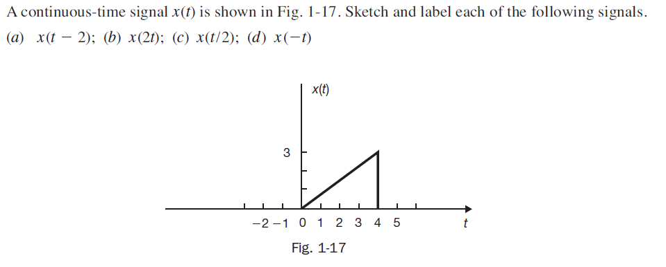

**Solution 1.**

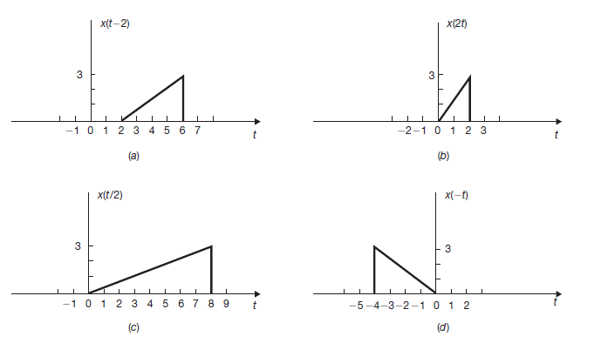

**Question 2.**

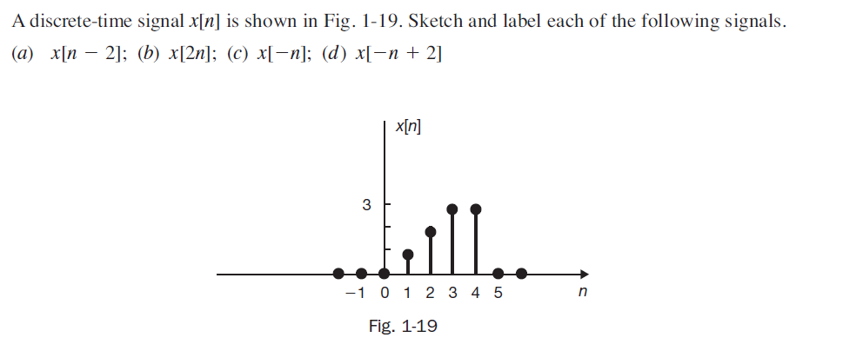

**Solution 2.**

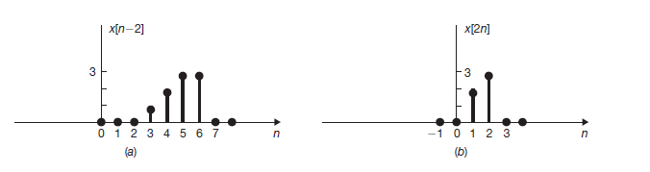

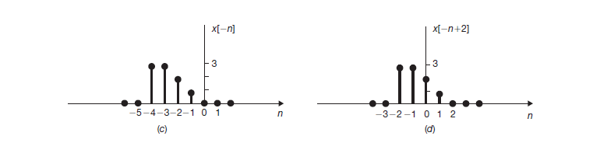

**Question 3.**

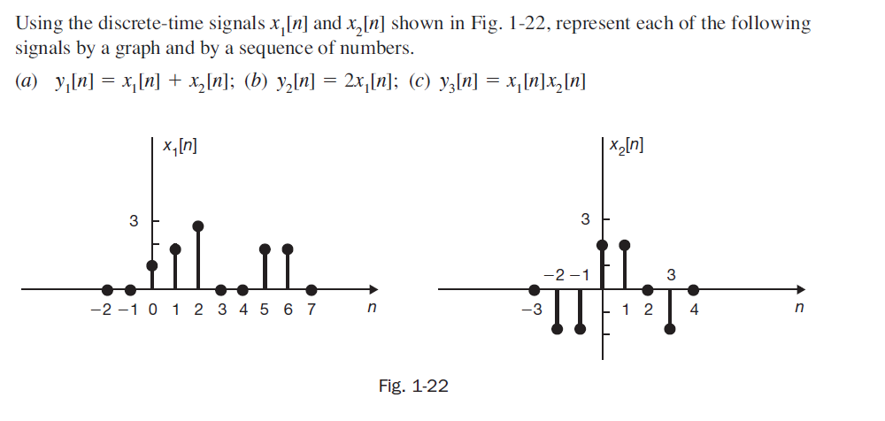

**Solution 3.**

