***Module 2:***

**Find the auto correlation of**

Solution: =[0, 3,8,14,8,3,0]

|  |  |  |  |  |
| --- | --- | --- | --- | --- |
|  | 3 | 2 | 1 | 0 |
| 0 | 0 | 0 | 0 | 0 |
| 1 | 3 | 2 | 1 | 0 |
| 2 | 6 | 4 | 2 | 0 |
| 3 | 9 | 6 | 3 | 0 |

**Find cross-correlation of ,**

Solution: = [0, 1, 4, 8, 9, 5,3]

|  |  |  |  |  |
| --- | --- | --- | --- | --- |
|  | 1 | 2 | 1 | 1 |
| 0 | 0 | 0 | 0 | 0 |
| 1 | 1 | 2 | 1 | 1 |
| 2 | 2 | 4 | 2 | 2 |
| 3 | 3 | 6 | 3 | 3 |

**Find whether the following differential equations are representing the equations for LTI systems or not:**

and

The coefficients are constant so TI.

The given system is LTI, if the initial conditions are zero

Here, and

The coefficients are constant so TI.

The given system is LTI, if the initial conditions are zero

As one of the coefficients is t which is not constant, its not a LTI system.

**Difference Equation**: Represent discrete time LTI systems



The standard difference equation is represented by:

The generalized form:

**Q1. , coefficients are constant and it’s a linear equation. So its LTI.**

**Q2. , constant coefficient and linear equation so LTI.**

**Find the auto correlation function of**

**Solution:**

. Evaluate step response of a system

(Formula: )

**Convolution**

**Q. Find convolution of two signals.**

(Sliding window method)



Standard method:



**Q2.**



Convoluted signal limits are,

Sum of lower limits <t<Sum of Upper Limits

-2+(-3) <t<2+3

-5<t<5

Q. **A linear System with input and output related as**

, where . Find when

Solution:

when -> , here k=2

at n=0

at n=2

==

Q. **A linear System with input and output related as**

, where . Find when

Solution:

=

**Discrete Convolution:**

Q. **x(n) = {1, 2, 3, 4}, h(n)={1,1,-1,1}**

Find z(n)=x(n)* h(n)

If Length of x(n) is m and length of h(n) is n, then total length is m+n-1.

Solution:

|  |  |  |  |  |
| --- | --- | --- | --- | --- |
|  | 1 | 2 | 3 | 4 |
| 1 | 1 | 2 | 3 | 4 |
| 1 | 1 | 2 | 3 | 4 |
| -1 | -1 | -2 | -3 | -4 |
| 1 | 1 | 2 | 3 | 4 |

z(n)=x(n)* h(n) = {1, 3, 4, 6, 3, -1,4}

Q. **x(n) = {1, 2, 3}, h(n)={1,-2}**

|  |  |  |  |
| --- | --- | --- | --- |
|  | 1 | 2 | 3 |
| 1 | 1 | 2 | 3 |
| -2 | -2 | -4 | -6 |

z(n)=x(n)* h(n) = {1, 0, -1,-6}

Q**. Find the overall response of the given LTI System**



Solution:

Q. 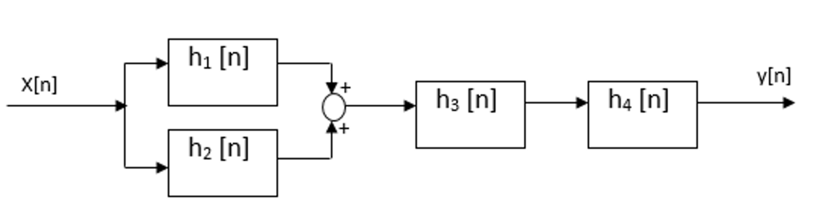

1. **Find the overall System response**
2. **Find y(n), if x(n) = {1, 2, 3, 4}, h(n)={1,1,-1,1}, where h1(n)=h(n-1), h2(n)=h(n), h3(n)=2h(n) and h3(n)= h(n+1)**

Solution:

1. Overall response : = [{**1**, 2, 3, 4}+{1,**1**,-1,1}]*{2,**2**,-2,2}*{1,1,**-1**,1}={1,**2**,1,4,4}*{2,**2**,-2,2}*{1,1,**-1**,1}

**Representation of signal in terms of unit step and unit ramp function.**



Solution:

**Q.**



**Q.**



**Q. Show that the following signals are orthogonal.**



**Solution:**

=

The signals are orthogonal.

Q. **Show that the following signals are orthogonal over the interval [0, 1].**

,

**Solution:**

==0

The signals are orthogonal.

EXAMPLES

***Memoryless***

1. y(t)=4∗x(t)y(t)
2. y[n]=x2[n]y[n]

***Non-memoryless Systems***

1. for

EXAMPLES

***Invertible Systems***

1. y(t)=4x(t)
   * x(t)=y(t) is the *inverse*

***Non-invertible Systems***

1. y(t)=x2(t)

cannot determine sign of input from knowledge of output so the system in *not invertible*

**Find if is causal or non-causal.**

Solution: If ,

**System is dependent upon present and past input so it’s causal.**

Ex2: is causal

Ex3: is non causal

Ex4: is non causal

All non-causal systems are dynamic systems, but all dynamic systems are noncausal.

All static systems are causal but all causal systems are not static.

**Solution:**

, invertible

**Ex2.**

**Solution:**

invertible

Ex2. is non-invertible

**Q. Ex: , are bounded systems**

**Q. Ex: is unstable system.**

**Answer:**

Linearity :

**Q.**

**Answer:**

Linear time variant system.

**Q.**

**Answer:**

Linear time invariant signal.

, It is a static signal

**Ex.**

, It is a static signal

**Ex. , Dynamic**

**Ex. , Dynamic**

**Ex. , Dynamic**

**Q. Find a system is linear or non-linear.**

**Ans:**

, so its violating **superposition** principle. So it’s a **Non-Linear system**.

**Q. Find a system is linear or non-linear.**

**Ans:**

, so it satisfies **superposition** principle. So it’s a **Linear system**.