 |  |  |  |  | Reg. No.:
 |  |  |  |  | Name :

Continuous Assessment Test II – October 2022
Programme |  |  | : | B.Tech (ECE/ECM) |  | Semester |  |  | : | FS 2022-23
Course |  |  | : | Signals and Systems |  | Code |  |  | : | BECE202L
 |  |  | : |  |  | Class Nbr |  |  | : | CH2022231001098  CH2022231001099  CH2022231001101  CH2022231001100  CH2022231001097
Faculty |  |  | : | Dr. Ashok Mondal  Dr. Florence Gnana Poovathy J  Dr. E. Sathish  Dr. Sheena Christabel Pravin  Dr. Jeetashree Aparajeeta |  | Slot |  |  | : | G1+TG1
Time |  |  | : | 90 Minutes |  | Max. Marks |  |  | : | 50
Answer ALL the questions

Q.No. | Sub. Sec. | Questions |  |  |  |  |  | Marks |  |  | Module No. | Level | Hot? | CO’s
1. |  | Find the convolution of the $x_{1}(t)$ and $x_{2}(t)$, where  (i) $x_{1}(t)=e^{-2t}u(t)$ and $x_{2}(t) = e^{-4t}u(t)$  (ii) $x_{1}(t)$ = t$u(t)$ and $x_{2}(t)$ = t $u(t)$ |  |  |  |  |  | 10 |  |  |  | E | Y
Key |  | Convolution of two signals $x_{1}(t)$ and $x_{2}(t)$ is,  $x_{1}(t)*x_{2}(t) = \int_{-∞}^{∞}{}x_{1}(τ)x_{2}(t-τ)dτ$  (i) $x_{1}(t)*x_{2}(t)$=$\int_{-∞}^{∞}{}e^{-2τ}u(τ)e^{-4(t-τ)}u(t-τ)dτ$  $=\int_{0}^{t}{}e^{-2τ}e^{-4(t-τ)}dτ =e^{-4t}\int_{0}^{t}{}e^{2τ}dτ=\frac{e^{-4t}}{2}{\left\{e^{2τ}\right\}}_{0}^{t} =\frac{e^{-4t}}{2}(e^{2t}-1)$  $=\frac{1}{2}(e^{-2t}-e^{-4t})$ for $t≥0$  $x_{1}(t)*x_{2}(t)=\frac{1}{2}(e^{-2t}-e^{-4t})u(t)$  (ii) $x_{1}(t)*x_{2}(t) = \int_{-∞}^{∞}{}x_{1}(τ)x_{2}(t-τ)dτ$  =$\int_{-∞}^{∞}{}tu(t)(t-τ)u(t-τ)dτ$  $=\int_{0}^{t}{}τ$(t-$τ$)d$τ={\left[ t\frac{τ^{2}}{2}-\frac{τ^{3}}{3}\right]}_{0}^{t}=\frac{t^{3}}{2}-\frac{t^{3}}{3}=\frac{t^{3}}{6}; t≥0$  $x_{1}(t)*x_{2}(t)=\frac{t^{3}}{6}u(t)$
2 |  | Determine the natural response for the system described by the differential equation,  $\frac{d^{2}y}{dt^{2}}+2\frac{dy}{dt}+2y=\frac{dx}{dt};$ $y(0)=1$, $\frac{dy}{dt}|_{t=0}=0$ |  |  |  |  |  | 10 |  |  |  | D | Y
Key |  | $D^{2}y+2Dy+2y=0$  $(D^{2}+2D+2)y=0$  $The roots are \frac{-2±\sqrt{4-4*2}}{2}=\frac{-2}{2}±\sqrt{\frac{4-8}{4}}=-1±-1=-1±j$  solution :  If the roots are complex conjugate then  $y^{(n)}(t)=(k_{1}cos bt +k_{2}sin bt)e^{at}$  $y^{(n)}(t)=(k_{1}cos t +k_{2}sin t)e^{-t}$  t = 0  1 = $(k_{1}cos 0 +k_{2}sin 0)e^{-0}=k_{1}$  $\frac{dy}{dt}=-(k_{1}cos t +k_{2}sin t)e^{-t}+e^{-t}(-k_{1}sin t+k_{2} cos t)$  initial condition,  0=-$k_{1}$+$k_{2}$  $k_{2}$=$k_{1}$=1  so the solution is,  $y^{(n)}(t)=(cos t +sin t)e^{-t}$
3. |  | Find the Fourier Series of the signal  $x\left(t\right)= \{1,\left|t\right|< π/4 0,\left|t\right|≥ π/4$  What is the sum of squares of the Fourier coefficients? |  |  |  |  |  | 10 |  |  |  | C | Y
Key |  | 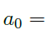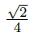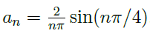  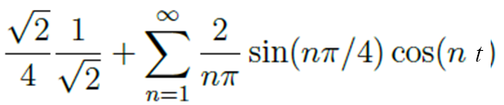
4 |  | - Convolution of two functions in time domain is equivalent to  multiplication of their Fourier coefficients in frequency domain. Express how this is true in the case of Fourier series. (7 marks)  - DIfferentiating a function with respect to ‘t’ in the time domain is equivalent to multiplying the phase value with the Fourier coefficients in the frequency domain. Prove this with necessary derivation. (3 marks) |  |  |  |  |  | 10
Key |  | a.  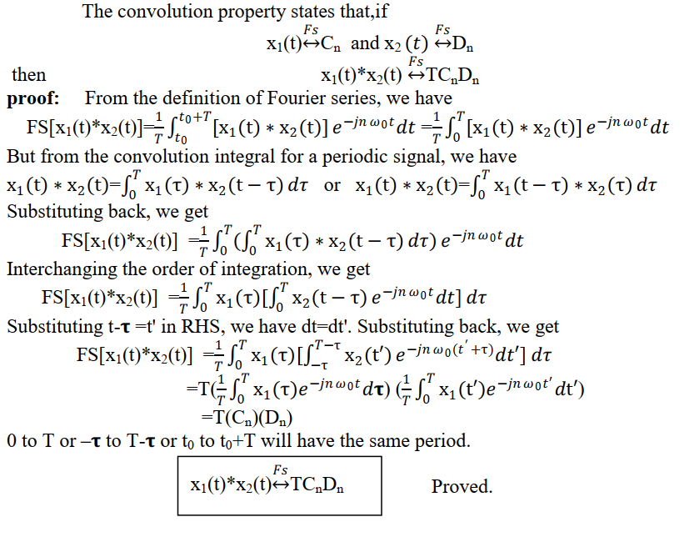  b. 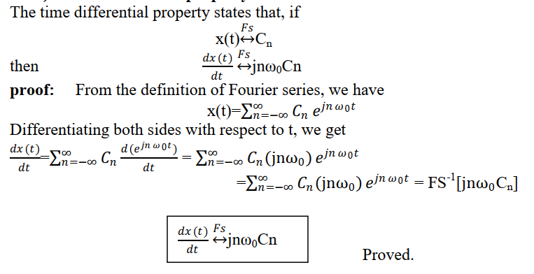
5 |  | a)State with reasons whether Fourier Transform exists for the following signals:  (i)$sin \left(\frac{1}{x}\right)$  (ii) $e^{x}$  b) Find the Fourier Transform of $x\left(t\right)=e^{-at^{2}}, a>0$ |  |  |  |  |  | 10 |  |  |  | D | Y
Key |  | a)  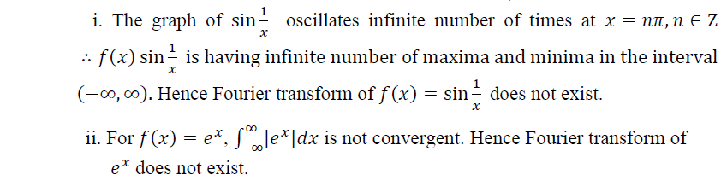  b)$X\left(ω\right)=\sqrt{\frac{π}{a}}e^{-\frac{ω^{2}}{4a}}$

Course Faculty
⬄⬄⬄

