Module 1

**Expected Course Outcomes:** Differentiate between various types of signals and understand the implication of operations of signals

**Reference books**

Signals and systems, second edition-Alan. V. Oppenheim, Alan. S. Willsk,S. Hamid Nawab, PHI learning Pvt ltd,2001

Signals and systems, second edition - Simon Haykin, Barry VanVeen, Wiley, Wiley India, 2007.

**Introduction to Signals**

A signal is represented as a function of one or multiple variables to convey information from one end (transmitter) to other end (receiver).

For eg.

Natural Signals: Human voice, Heartbeat, rustling of trees, temperature variations, birds chirping etc.

Artificial signals: playing of musical instruments, honking, traffic signal, voltage and current variations in electrical circuit etc.

**Signal Representation**

Magnitude is A

at time t1

t

x(t)

A

t1 11111

Fig.1

1. **Classification of Signals**
2. Continuous-time signal versus discrete-time signal
3. Deterministic signal versus random signal
4. Even signal versus odd signal
5. Periodic signal versus aperiodic signal
6. Energy signal versus power signal
7. **Continuous-time signal vs. discrete-time signal**

**Continuous-Time (CT) signal**

* A signal x(t) is specified for all value of time t.
* The signal is continuous in amplitude and time.

The signal in Fig.1 is an example for CT signal.

Eg. Speech, EEG signal, sinusoidal signal etc.

**Discrete Time (DT) Signal**

* A signal x[n] is specified only for discrete (integer) value of n.
* The signal is continuous in amplitude but discrete in time.
* Derived from continuous time signal by *sampling* it at uniform rate, x(t) at t = nT.

Denoted by x(nT) or simply x[n]

The signal in Fig.2 is an example for DT signal.

Eg. Temperature measured on day/hour basis, stock measure, etc.

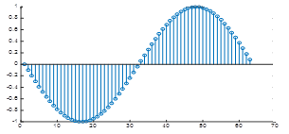 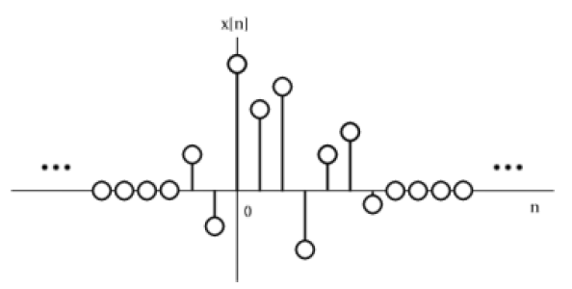

n

x[n]

Fig. 2

The functional representation of DT signal is given as





; ;

|  |  |  |  |  |  |
| --- | --- | --- | --- | --- | --- |
| **n** | **-3** | **-2** | **-1** | **0** | **1** |
| X[n] | -5 | 0 | 2 | -2 | 9 |

1. **Deterministic signal vs. random signal**

**Deterministic signal**

* A signal in which magnitude can be determined for any given time.
* Usually represented by a mathematical expression.

Eg. Sin10πt, e-0.1t, u[n],…

x(t)

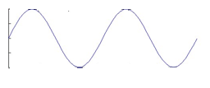Fig.3

t

**Random Signal**

* A random signal cannot be predicted and has uncertainty about its behavior.
* The future values of a random signal cannot be accurately predicted and can usually only be guessed based on the probabilistic approach.

Eg. Speech, rainfall, stoch exchange data

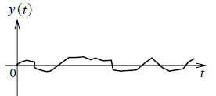

Fig.4

1. **Even signal versus odd signal**

**Even Signal**

* A signal x(t) that satisfies the condition x(t) = x(-t) ; x[n]=x[-n]
* Even signals are symmetric about the vertical axis or time origin

Eg. Cosine signal

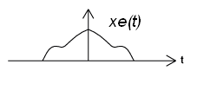

Fig.5

**Odd Signal**

* A signal x(t) that satisfies the condition x(t) = -x(-t) ; x[n]=-x[-n]
* Odd signals are anti-symmetric about the time origin

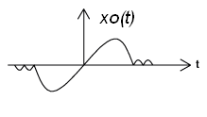

Fig.6

Any deterministic signal x(t) can be expressed as a sum of an even signal and an odd signal:

x(t) = xe(t) + xo(t)

where

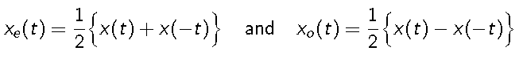

**Ex.** Show that x(t) = Asin(2πf0t) is an odd signal

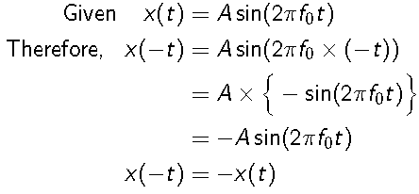Hence it is an odd signal.

x(t) = cos(t) + sin(t) cos(t)

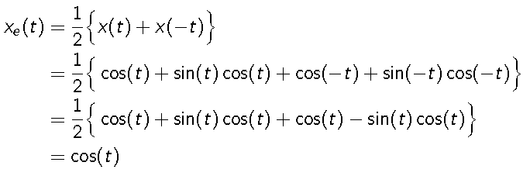

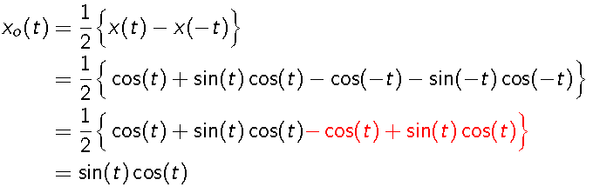

**Ex.** Find the even and odd components of the signal



Then,

**

*xe[n]= {x[n]+x[-n]}/2*



**

*xo[n]= {x[n]-x[-n]}/2*



1. **Periodic signal versus aperiodic signal**

A periodic signal *x(t)* is a function that satisfies the condition,   
 *x(t) = x(t+T)* for all *t*

* + *T* that satisfied the above equation is called fundamental period of *x(t)*
  + The reciprocal of fundamental period is called fundamental frequency, *f=1/T.*
  + The angular frequency is measured in radians per second,
  + Any signal *x(t)* for which there is no value of *T* to satisfy the previous slide equation is called aperiodic or non-periodic signal

**Eg.** For periodic signals: All sinusoidal signals

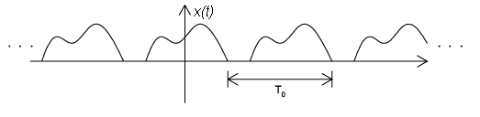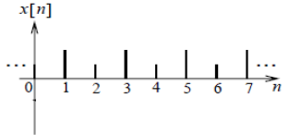

Fig.7

**Eg.** For Aperiodic signals: All random signals

 

Fig.8

**Ex.** Find periodicity of the signal x(t) = sin (50 π t)

T = 2 π / ω0

= 2 π / 50 π = 1/ 25 =0.04 s

**Ex.** Find periodicity of the signal x(t) = sin (50 π t) u(t)

As u(t) is not periodic signal, the given signal is Aperiodic

**Periodicity for combination signals**

* Let x1(t) and x2(t) be periodic signals with fundamental periods T1 and T2 respectively
* x1(t) = x1(t+T1) = x1(t+mT1), m = +ve integer
* x2(t) = x2(t+T2) = x2(t+kT2), k = +ve integer
* x(t) = x1(t+mT1) + x2(t+kT2)
* x(t) is periodic with period T
* x(t) = x(t+T) = x1(t+T) + x2(t+T)
* mT1 = kT2 = T 🡪
* Sum of two periodic signals is periodic only if the ratio ( T1/ T2) is a rational number or ratio of two integers
* The fundamental period is the LCM of T1 and T2
* If T1/T2 is irrational no, then x1(t) and x2(t) do not have common period and hence x(t) is not periodic
* Sum of two periodic sequences will always periodic

**Ex.** Find the periodicity of the given signal x(t) = 2 cos (10t + 1 ) – sin (4t-1). If periodic, find Time period.

x(t) = 2 cos (10t + 1 ) – sin (4t-1)

T1 = 2 π / ω0

= 2 π / 10 = π /5

T2 = 2 π / ω0

= 2 π / 4 = π /2

Then, T1/ T2 = 2/5 (rational) Hence, the signal is periodic.

The fundamental period T=LCM(π /5 , π /2) = π

**Periodicity in discrete signals**

* Condition: x[n] = x[n+N]
* X[n] = A Sin(ω0n+θ)
* X[n+N] = A Sin[ω0(n+N)+θ] = A sin [ω0n+ω0N + θ]
* So, ω0N = 2π*m where m = integer



**Ex.** Find the periodicity of the given signal x[n] = 12 cos (20n)



It is irrational, so the given signal is Aperiodic

1. **Energy signal versus power signal**

**Energy signal**

* A signal x(t) or x[n] that has a finite energy *Ex* such that *0 < Ex < 1*
* For CT signals,

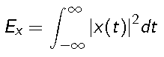

* For DT signals,

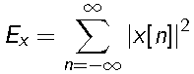

* The power of an Energy signal will be zero.

**Power signal**

* A signal x(t) or x[n] that has infinite power *Px* such that 0 *< Px <* 1 where
* For CT signals,



* For DT signals,



* The energy of a power-type signal will be infinity.

VIT-Chennai

**Condition for energy & power signal**

* For energy signal, total energy E is finite, average power = 0.
* For power signal, average power is finite, total energy E=∞.
* Signals do not satisfy the above conditions are neither energy nor power signal.
* Energy and power signals are mutually exclusive.

**Example of an energy signal**

**.** 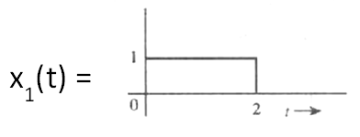

x1(t) is time limited and bounded. Hence **Energy Signal**

**Example of a power signal**

**x(t)=Cos ω0t**

**x(t)** is not time limited and bounded. Hence **Power signal**.

**Another example**

**x(t)=et**

**x(t)** is not time limited and bounded.

The signal is **neither energy nor power signal.**

**Ex.** Determine the energy and power of the signal x(t) = Acos(2πf0t).

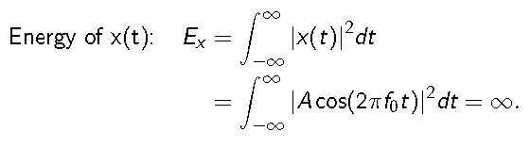

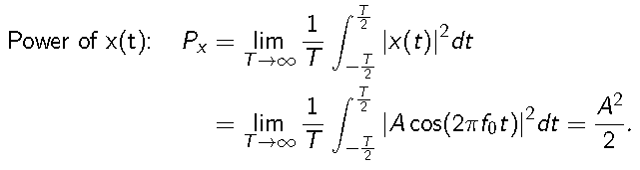

As the signal has finite power and infinite Energy , it is a Power signal

1. **Causal and Anti-Causal signals**

* A signal is causal if,

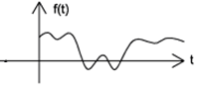

* A signal is Anti-causal if

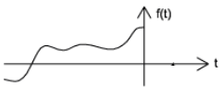

**Elementary Signals**

* Unit impulse or impulse signal
* Unit step or step signal
* Ramp
* Sinusoidal
* Exponential

**Impulse signal**

Denoted as δ(t) for CT and δ[n] for DT signals. Also called as dirac delta function.





**Step signal**

Denoted as u(t) or u[n] and defined as

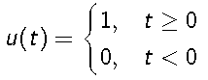

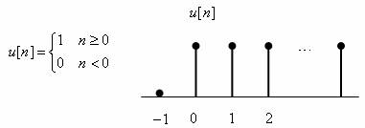

**Ramp Signal**

A signal *r(t)* defined as

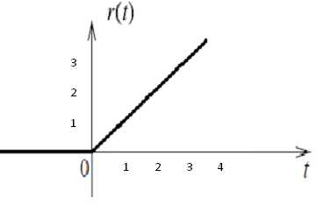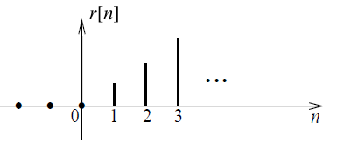

**Sinusoidal signal**

Signal is denoted as

*x(t) = Acos(2πf0t + φ*) or

*x(t) = Asin(2πf0t + φ)*

where *A* is the amplitude, *f0* is the frequency (in Hertz) and *φ* is the phase angle (in radian).



**Exponential Signal**

* For CT Signal, denoted as *x(t) = exp(at)* where 0 < |a| < 1 is a non-zero constant.
* For a > 0, x(t) is growing
* For a < 0, x(t) is decaying



* For DT signal, denoted as *x[n]=c*an,* if ‘c’ and ‘a’ are real then it will be real exponential

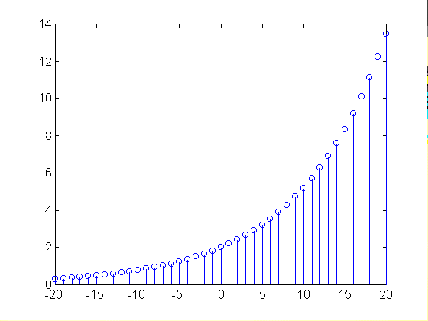 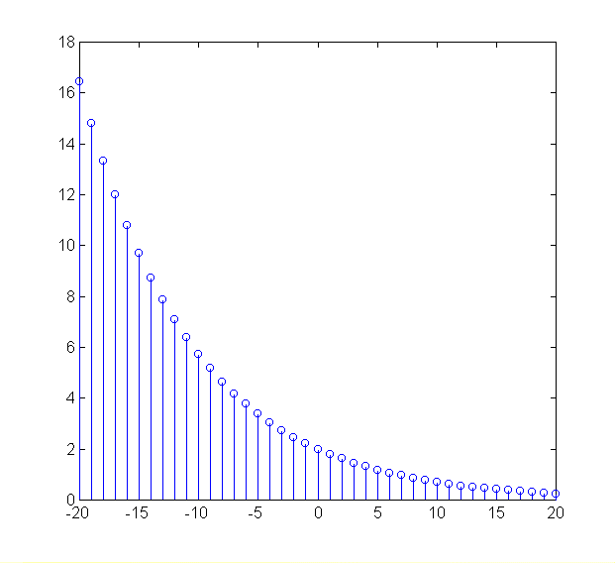

For 0 < *a < 1*

For *a>1*

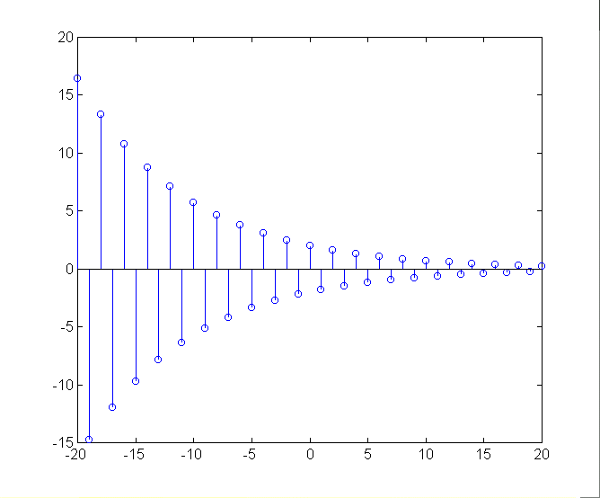 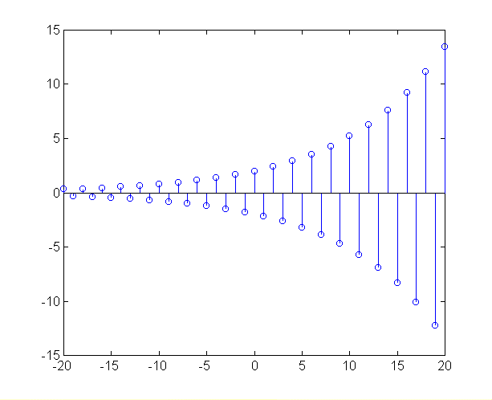

For *a < -1*

For -1 < *a < 0*

**Complex Exponential Signals**

* + 





* + Then
  + 
  + 
  + 

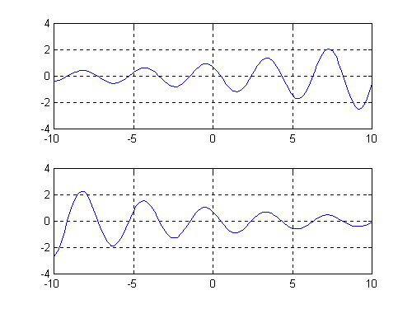

r < 0

r > 0

**Transformation in dependent variables of a signal**

* Signal addition and multiplication
* Amplitude scaling

**Signal addition**

* Sum of two continuous time signals can be obtained by adding their values at every instant.
  + Example: y(t)=x1(t)+ x2(t)

y(t)=x1[n]+ x2[n]

* Similarly the subtraction / multiplication of two CT signals can be obtained by subtracting / multiplying their values at every instant.

**Amplitude scaling**

Signal x(t) is fed to an amplifier with a gain ‘c’. the output will be

y(t) = c * x(t)

y[n] = c * x[n]

**Transformation in independent variables of a signal**

* **Time reversal**
* **Time scaling**
* **Time shifting**

**Time reversal**

X(t) is a CT signal, y(t) is obtained by replacing t by ‘-t’

y(t) = x(-t)

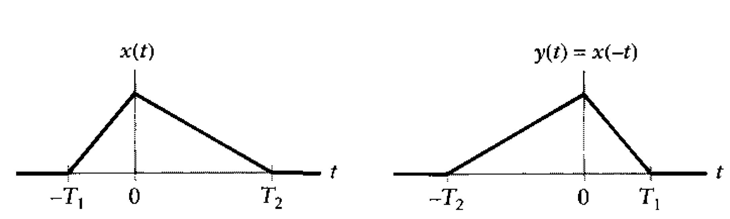 

**Time Scaling**

**Time scaling in CT:**

* The operation x(at) is to scale the time-axis of x(t) by a constant a
* a > 1 contracts/shrinks the function horizontally
* A proper fraction 0 < a < 1 (for example: 1/2 and 1/3 ) expands the function horizontally.
* a < 0 leads to time inversion or time reversal



Time scaling in DT:

* The operation x[kn] is to scale the discrete time-axis of x[n] by a integer K
* k > 1 contracts/shrinks the function horizontally
* A proper fraction 0 < k < 1 (for example: 1/2 and 1/3 ) expands the function horizontally
* k < 0 leads to time inversion or time reversal



**Time shifting**

* The operation x(t - t0) or x[n - k] is to shift x(t) (or x[n]) by an amount t0 (or k)
  + If t0 > 0 y(t) is shifted to right side
  + If t0 < 0 y(t) is shifted to left side

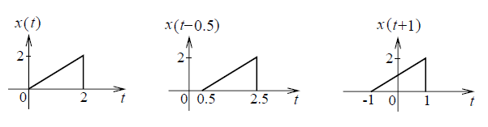

* Similarly for DT signals

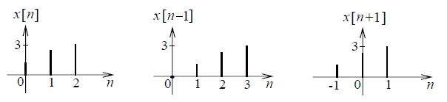

**Ex.** Sketch the waveform x(t) = 2u(t) - u(t - 2)

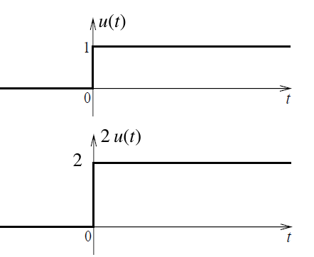

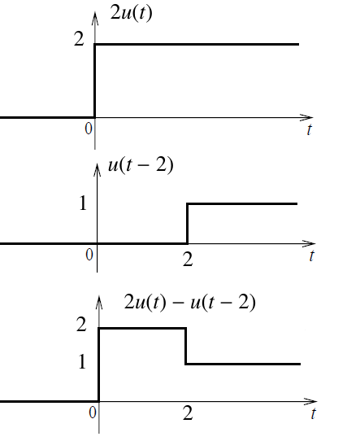

**Precedence rule for time shifting and time scaling**

* x(t) is a CT signal, y(t) is obtained by y(t) = x (at – b)
* Order of precedence
  + Time shifting
    - in intermediate signal v(t) = x(t-b)
  + Time scaling

Done on intermediate signal v(t) , replacing ‘t’ by ‘at’  
🡺 y(t) = v(at)  
 🡺 y(t) = x (at – b)

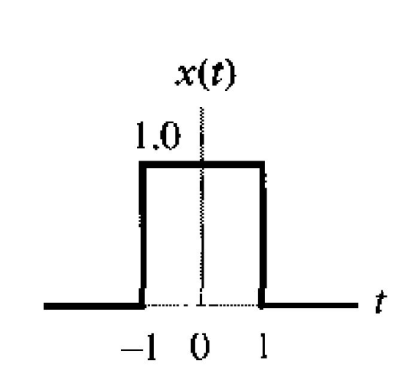**Ex.** Find y(t) = x(2t + 3 )

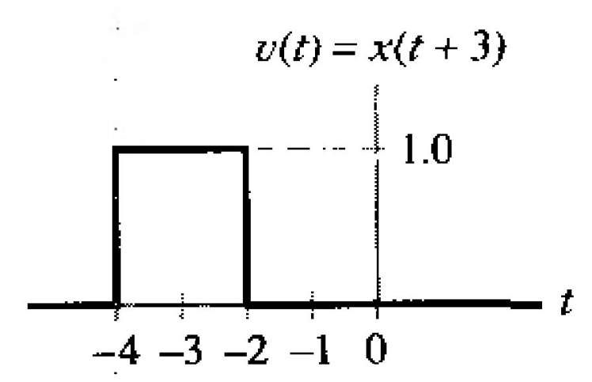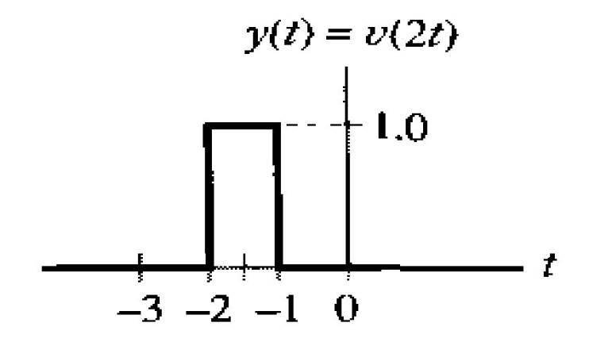

**Practice problems**

* Book Authors: Oppenheim and Wilsky
* Problem no: 1.3 , 1.9, 1.10, 1.11, 1.21, 1.22, 1.24, 1.25, 1.26
* Book Authors: simon haykin and Barry van veen
* Problem no: 1.52, 1.54, 1.56