**Module 5**

**Expected Course Outcomes:** Usefulness of convolution for analysing the LTI systems and understand the concepts of power spectral density through correlation.

.

**Reference books**

Signals and systems, second edition-Alan. V. Oppenheim, Alan. S. Willsk,S. Hamid Nawab, PHI learning Pvt ltd,2001

Signals and systems, second edition - Simon Haykin, Barry VanVeen, Wiley, Wiley India, 2007.

**Convolution and Correlation**

**Linear Time Invariant Systems**

* A system satisfying both the **linearity** and the **time-invariance** property
* LTI systems are mathematically easy to analyze and characterize, and consequently, easy to design.
* Many physical process have linearity and time invariant property, so it can be modeled as Linear Time Invariant (LTI) systems
* Any linear time-invariant system (LTI) system, continuous-time or discrete-time, can be uniquely characterized by its
  + **Impulse response:** response of system to an impulse
  + **Frequency response**: response of system to a complex exponential e j 2 p f for all possible frequencies ‘f’.
  + **Transfer function**: Laplace transform of impulse response



* The property of superposition and time invariance, will allow us to develop a complete characterization of any LTI system in terms of responses to a unit impulse
* The response of a discrete-time system to a unit sample sequence {δ[*n*]} is called the **unit sample response** or simply, the **impulse response**, and is denoted by {*h*[*n*]}
* The response of a discrete-time system to a unit step sequence {u[n]} is called the unit step response or simply, the **step response**, and is denoted by {*s*[*n*]}.
* Every signal whether large or small can be represented in terms of linear combination of delayed impulses.

**Example**

A Discrete time signal x[n]

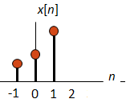

can be composed as:

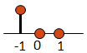****

 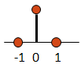

 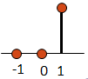

The input x[n] can be written as shifted, scaled impulses





Also can be written as

**Example** For the o/p

The impulse response of the system is obtained by setting *x*[*n*] = δ[*n*] resulting in

****The impulse response is thus a finite-length sequence of length 4 given by

**Properties of LTI systems**

* **Memoryless/Static LTI systems:** An LTI system is memoryless/static if and only if its impulse response is given by



where c is an arbitrary constant.

* **Causal LTI systems:** An LTI system is causal if and only if its impulse response satisfies the following condition



* **Stable LTI systems:** An LTI system is BIBO stable if and only if its impulse response satisfies the following condition

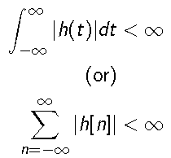

* **System Interconnections:** For parallel connection, the overall impulse response is the summation of subsystem impulse responses. For cascade connection, the overall impulse response is the convolution of subsystem impulse responses.
* **Shifting property:**
  + Shifting property represents x[n] as a superposition of scaled versions of a very simple set of elementary function (impulse).
  + The response of a linear system to x[n] will be the superposition of the scaled responses of the system to each of these shifted impulses.
* **Time invariance property:** responses of a time invariant system to the time shifted impulses are simply time shifted versions of one another

**Ex.** Determine whether the following CT LTI systems are memoryless, causal and BIBO stable.



**Soln:**

* The system is not memoryless
* The system is causal since h(t) = 0 for t < 0
* The system is BIBO stable since

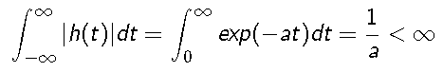

**Ex.** Determine whether the following CT LTI systems are memoryless, causal and BIBO stable.



**Soln:**

* The system is not memoryless
* The system is causal since h(t) = 0 for t < 0
* The system is BIBO stable since

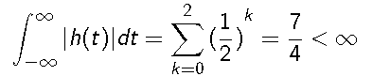

**System response of an LTI system**

System response can be written as



The input x[n] can be written as shifted, scaled impulses



Using Linearity Property,



As x[n] is constant at k



As the system is time invariant,



As



Then,

Therefore, output of an LTI system is given by a weighted sum of time shifted impulse response.

This expression is the **Convolution Sum**.

In general, the output of any LTI system is the convolution of the input signal and its impulse response.



`٭' denotes convolution

**Convolution Integral**

For the Continuous time system, the response of system is given by Convolution integral.

**Properties of convolution**

* Commutative

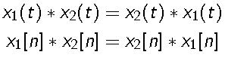

* Distributive

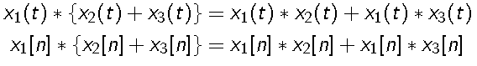

* Associative

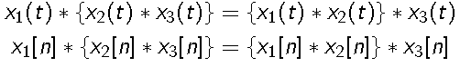

**CONVOLUTION SUM**

**Example**

Express the output of a system y[n] in terms of its input signal x[n] provided the system's impulse response is



soln

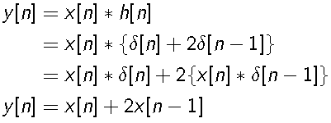

Steps involved are

**Step 1:** time reversal of either signal (e.g., *h(k)→h(-k)* )

**Step 2:** shift *h(-k)* by n samples to obtain *h(n-k)*

**Step 3:** multiply *x(k)* and h*(n-k)* for each *k*

**Step 4:** summation over k

**Ex.** Find the convolution

Soln:

First step is time reversal for h[n] and transformed to h[n-k],

Therefore, h[n] exist between ‘n-10’ to ‘n’ and x[n] from 0 to ∞

For **n < 0**; x[n] doesn’t exist. Therefore **y[n] = 0**.

For **0 ≤ n < 9**







For **n≥9**

Let m=k-n+9, then





**CONVOLUTION INTEGRAL**



**Example**

Evaluate and sketch the output of a system when its input, x(t), and its impulse response, h(t).



First step, time reversal, h(t) to h(-τ).

h(-τ)

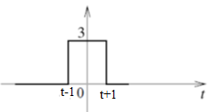

h(-τ) is shifted along x-axis,

For t+1< -1 i.e., for **t < -2** no overlap, hence y(t)=0

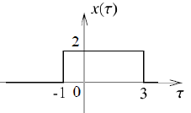 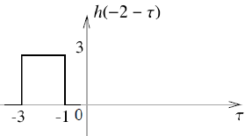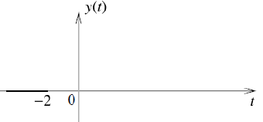



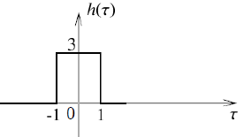 



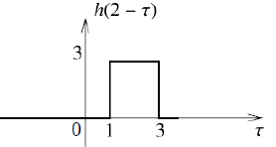 



 



**Practice Problems**

1. Find the convolution of x(t) = u(t+1) and h(t) = u(t-2)
2. Find the convolution of x(t) = e-atu(t) , a>0 and h(t) = u(t)
3. Find the convolution for the following sequences x[n] = {1, -2, 3, -2}and

h(n) = { 2, -3, 4 }

**CORRELATION**

* Correlation between two signals is a measure of the degree which two signals are similar
* Quantitatively, amount of the information of one signal contained in the other signal.
* If x1(t) and x2(t) are two waveforms, then the waveform x1(t) contains an amount of *R*12 in x2(t).
* For example, consider, a radar signal transmitted to detect presence of an object. The signal will be reflected from the object and reach the receiver antenna. Along with it other signals also received including noise. To detect the signal the correct reception of the transmitted signal, correlation is performed to measure the degree of similarity.

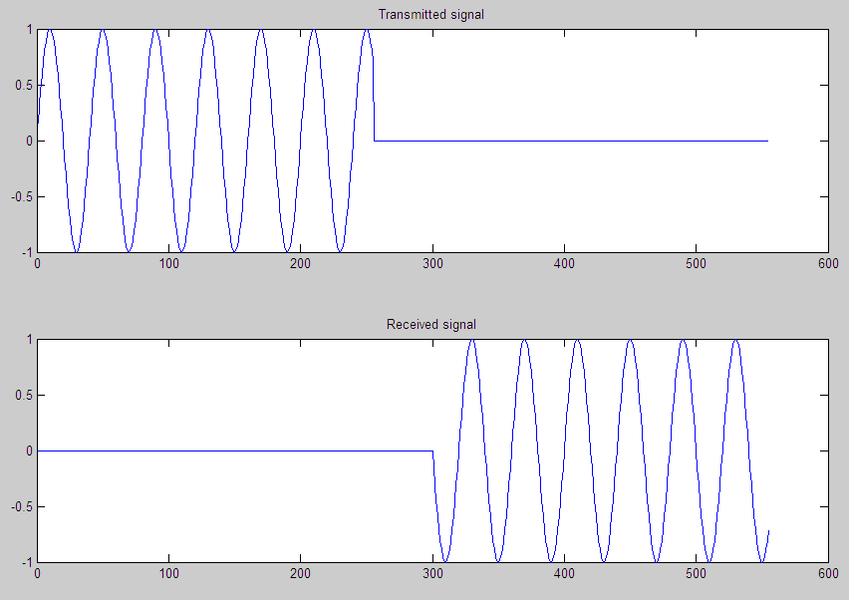

* For the case given in Figure above, *R12*=0. i.e., there is no similarity between transmitted and received signal.
* If there is shift in one signal w.r.t. other then, the time shift can be deducted.

**Two types of correlation functions**

* Cross correlation: correlation between two different signal/functions



* Autocorrelation function:correlation of a function with itself.



For Energy signals:



For Power signals:



**Example**

Find the cross correlation function between the two signals x(t)=exp(j2πf0t) and y(t)=exp (j4πf0t).

**Soln**: Since x(t) and y(t) are power-type signals,

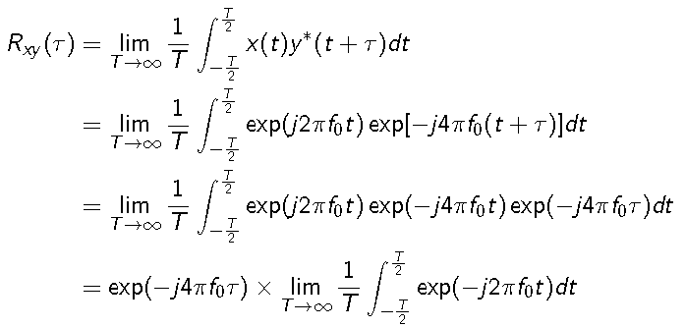

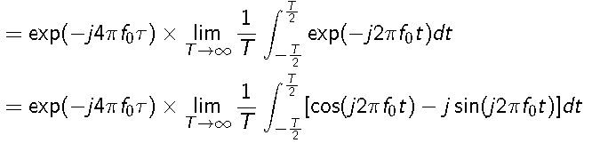 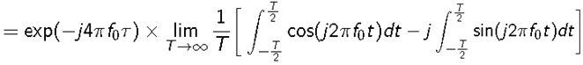



This implies x(t) and y(t) are **uncorrelated** and hence, they are **orthogonal**.

**Properties of autocorrelation**

* The peak of the autocorrelation function occurs at the zero shift

For τ ≠ 0; Rxx(τ) ≤ Rxx(0)

* Autocorrelation function is an even function

Rxx(τ) = Rxx(-τ)

* A time shift in the signal does not change its autocorrelation function. In other words, the autocorrelation functions of *x(t)* and *x(t - T)* are the same.

**Example**

Find the autocorrelation function and power of the sinusoidal signal *x(t) = Asin(2πf0t)*

Soln: 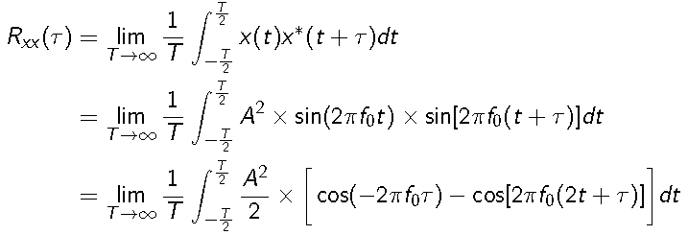

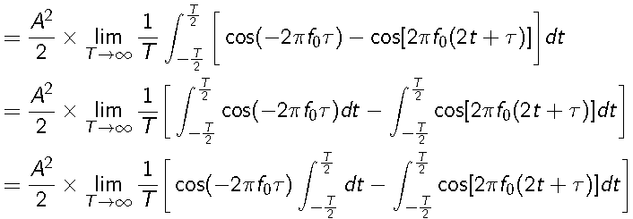

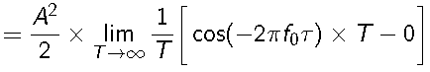

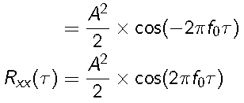

Power of the signal x(t)

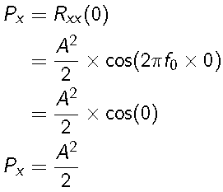

**Energy spectral density and power spectral density**

Consider a continuous-time signal x(t).

* The spectral density of x(t) and the autocorrelation of x(t) form a Fourier transform pair.
* In other words, Fourier transform of the autocorrelation of x(t) gives the spectral density

of x(t).

* This result is known as Wiener-Khinchin theorem.
* Two types of spectral densities:

**Energy spectral density (ESD):**

Fourier transform of the autocorrelation of x(t) where x(t) is an energy-type signal

**Power spectral density (PSD):**

Fourier transform of theautocorrelation of x(t) where x(t) is an power-type signal

* For computing PSD or ESD of x(t) or x[n], appropriate definitions of autocorrelation function should be used.

VIT-Chennai - SENSE FALL 2019-20 Semester

**Practice Problem**

1. Find auto correlation of x(t)=e-2t u(t)