**Module 7**

**Expected Course Outcomes:** Solve differential and difference equations with initial conditions using Laplace and Z transforms.

.

.

**Reference books**

Signals and systems, second edition- Alan. V. Oppenheim, Alan. S. Willsk,S. Hamid Nawab, PHI learning Pvt ltd,2001

Signals and systems, second edition - Simon Haykin, Barry VanVeen, Wiley, Wiley India, 2007.

**System Analysis using z-Transform**

* Similar to Laplace transform (LT), for Discrete Time (DT) signals and systems, z-Transform (ZT) is applied.
* Discrete Time Fourier Transform (DTFT) can be applied only to the function satisfying Dirichlet’s condition. ZT can be applied to the signals not converging also by identifying the ROC.
* The system function for LT is defined as









* Similarly, the system function for ZT is defined by

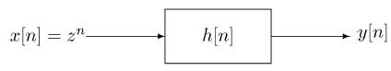





* In LT, **s=σ+jω**, in ZT the eigen function is defined in polar coordinate ***z* = *re−jω***



* The equation can be seen as DTFT when |z| = 1, i.e., *r=1*.

**Region of Convergence (ROC)**

* **Z plane**

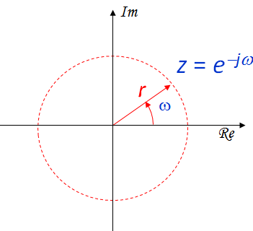

* + z plane is represented in polar coordinate.
  + The radius, r from origin represents magnitude and ω, the angular frequency
  + When r =1; ZT DTFT, This implies that the unit circle represents DTFT.
  + This unit circle in the z-plane is analogous to the imaginary axis in the s-plane.
  + Inside the unit circle corresponds to σ<0 part of s-plane and outside the unit circle corresponds to σ>0 part of s-plane.

!

* The ROC of the z-transform of x[n] consists of the values of z = rejω for which x[n]r-n is absolutely summable.
* The convergence depends only on r = |z|. Therefore, the ROC will consist of concentric rings.
* The ROC does not contain any poles. Because at poles, the signal will become unbounded.
* ROC is bounded by poles or extends to infinity.
* If the signal is of finite duration and absolutely integrable, then ROC includes entire z-plane.
* An LTI system is stable if and only if the ROC of its system function H(z) includes the unit circle.
* For Causality, the ROC is in the right half plane i.e., outside the circle. Because r-n will be bounded only for positive values of r.

**Example:** Obtain ZT for x[n]= an u[n].



$=\frac{1}{1- {az}^{-1}}=\frac{z}{z- a^{ }}$

The signal will converge if ||<1, i.e., |z|>|a|.

The specification |z|>|a| defines the **region of convergence (ROC).** The ROC plot is exterior of circle. The signal is causal

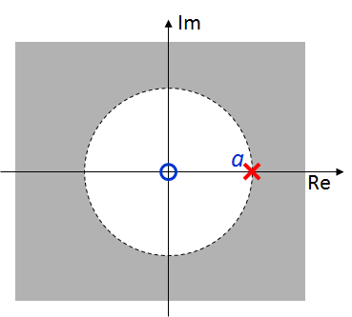

**Example:** Obtain ZT for









****For the signal to be bounded, i.e.,

The required condition to be satisfied is implies

The specification |z|<|a| defines the **region of convergence (ROC).** The ROC plot is interior of circle. The signal is anticausal.

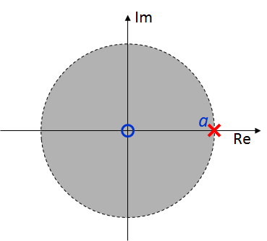



**Example:** Obtain ZT for





For the pole -1/3, |z|>|1/3| and for the pole 1/2, |z|<|1/2|. Hence,ROC is bounded by poles and is a ring and ROC does not include any pole.

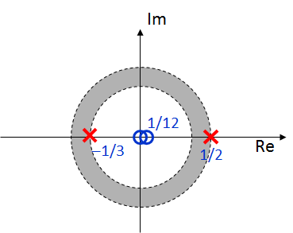

**Example: Obtain ZT for x[n]=cos(ωn)**









**The ROC is entire plane as DTFT exists for sinusoidal signals.**

**Example:** **Find the *z*-transform of the following sequence*****x* [n] = {2, -3, 7, 4, 0, 0, ……..}**





**The ROC is the entire z-plane except the origin.**

**z-Transforms of some standard functions**

* Unit impulse function: δ(n) 1 ROC for all z
* Unit step function: u(n) z / z-1 for |z|>1.

-u(-n-1) z / z-1 for |z|<1

  

  

  

**Properties of z-Transform**

**Linearity:**



If with ROC= R1 and with ROC= R2

 Then

and ROC= R1∩R2

**Time shifting:**



**ROC doesn’t change**

**Time reversal (folding):**



**ROC doesn’t change**

**Frequency shifting:**



**ROC doesn’t change**



**Conjugation:**

**ROC doesn’t change**

**Convolution:**

If with ROC= R1 and with ROC= R2



Thenand ROC= R1∩R2

**Time Differentiation**

$x\left[n\right]-x[n-1]↔\left(1-z^{-1}\right)X(z)$**ROC doesn’t change**

**Differentiation in z domain:**



**ROC doesn’t change**

**Example:** Find the z-transform of the signal



Soln:





Using the time shifting property,



 The ROC of X(z) is |z|>1/5

**Rational z Transform**

* 1. For z-Transform in the ratio form, it is generally represented as
  + ****The roots of the denominator, **D**(s) are called the ***poles*** and itdetermines the response and stability of the system.
  + The *m* roots of the numerator, **N**(s), are called the ***zeros.***
  1. partial fractions expansion with the method of residues to determine the inverse transform
  2. *order of dmr* >=*order of nmr* (need proper rational) i.e., No. of poles should be greater than the no. of zeros or else it is unstable.

**Inverse z Transform**

1. Power series expansion
   1. This method is based on expansion of basic z-Transform equation.
   2. This method doesn’t produce a closed-form expression for *x*[*n*]
2. Long division method
   1. Write *X*(*z*) as a normalized rational polynomial
   2. Perform long division of the numerator by the denominator to produce the quotient polynomial *q*(*z* -1)
   3. Identify coefficients using the power series definition of *X* (*z)*
3. Partial Fraction method

**Example:** Find the inverse z- transform of





Equating coefficients



**Example:** Find the inverse z- transform using long division method



Soln:

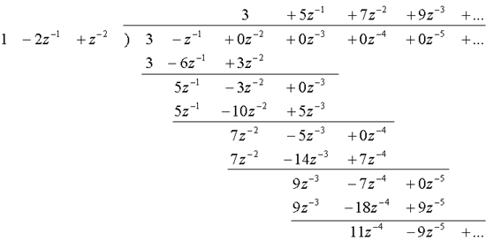



Equating coefficients



**Example:** Find the inverse z- transform using partial fraction method



if the ROC is (i) |z|>1/3 (ii) |z| < 1/4 (iii) 1/4 < |z| >1/3.

Using partial fraction, X(s) can be expressed as





The system has two poles at{1/4 and 1/3}.

1. ROC is |z|>1/3; This implies that for both the terms ROC is in right half plane of z-plane and exterior to circle. Also it covers unity circle.

Hence,



The signal is causal, stable.

1. ROC is |z| < 1/4; this implies that for both the terms ROC is in Left half plane and interior to circle.

Hence,



The signal is Anti-causal, Unstable.

1. **ROC is** 1/4 < |z| >1/3**;** for pole at 1/4,ROC is in right half plane and for pole at 1/3,ROC is in Left half plane.



The signal is not causal, and unstable.

**Analysis of LTI system using z-Transform**

The general differential equation for LTI system is given by



Applying zT using differentiation property

The zT of the input and the output of an LTI system are related as



where X(z), Y(z) and H(z) are ZT of input, output and impulse response of the system respectively.

The transfer function H(s) is defined by



* **Causality**

For causal LTI system the impulse response is zero for n<0. The ROC associated with the system function for a causal system is a right half plane.

* **Stability**

LTI system is stable if and only if the ROC of its system function H(z) includes the unity circle.

**Example:** Consider an LTI system by the difference equation



Evaluate the impulse response for the stable system.

**Soln:** Taking z-transform on both sides of the difference equation











Using partial fraction



Since H(z) corresponds to a stable system, its ROC has to be 1/3 < |z| < 3, and therefore, the impulse response



**Practice Problems**

1. Evaluate the z-transform of the signal
   1. 
   2. 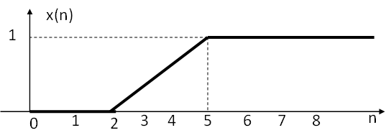
   3. 
2. Consider an LTI system that produces the output



when the input is



Determine the constant-coeffcient difference equation that characterizes

the system.

1. Find the output of the system characterized by  
     
   for the input unit step signal