**Multirate Signal Processing:**

System that employ multiple sampling rates in the processing of digital signals are called multirate digital signal processing systems.

**Up-sampler:**

* An up-sampler with an up-sampling factor L, where L is a positive integer, develops an output sequence $x_{u}[n]$ with a sampling rate that is L times larger than that of the input sequence x[n], digital anti-aliasing filter h1(k).

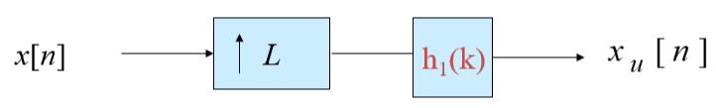

**Interpolation:**

* In practice, the zero-valued samples inserted by the up-sampler are replaced with appropriate nonzero values using some type of filtering process and this process is called interpolation.

**Down-sampler:**

* An down-sampler with a down-sampling factor M, where M is a positive integer, develops an output sequence y[n] with a sampling rate that is (1/M)-th of that of the input sequence x[n]

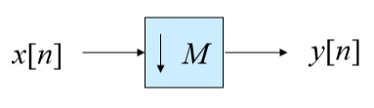

**Decimation:**

* Down-sampling operation is implemented by keeping every M-th sample of x[n] and M – 1 in-between samples to generate y[n] and this process is called Decimation.

**Aliasing Effect and Anti-Aliasing:**

* The plots of the two terms have an overlap, and hence, in general, the original “shape” of $x(e^{jω})$ is lost when x[n] is down-sampled.
* This overlap causes the aliasing that takes place due to under-sampling.
* By adding an anti-aliasing filter we can avoid the aliasing effect.

**Sampling Rate Conversions:**

* A complex *multirate system* is formed by an interconnection of the up-sampler, the down-sampler, and the components of an LTI digital filter mostly in cascade form.
* An interchange of the positions of the branches in a cascade often can lead to a computationally efficient realization.

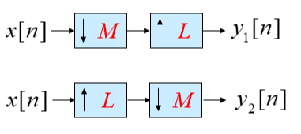

If the decimation and interpolation factors are coprime to each other, even if we interchange the blocks we will get the same result.

**Polyphase Structure:**

It involves dividing the input signal into multiple sub-signals, each representing a different "phase" of the original signal. By doing so, computations can be simplified, and significant computational savings can be achieved.

Polyphase Decomposition: The input signal is divided into multiple branches, each containing a fraction of the samples. This is done using a process called polyphase decomposition.

Efficient Processing: Each branch undergoes separate processing, which can often be simpler and faster compared to processing the entire signal at once. This is especially beneficial when certain operations are sparse or can be represented with fewer coefficients.

Reassembly: After the separate processing, the output of each branch is combined (re-sampled and possibly interpolated) to reconstruct the final output signal.

**Applications:**

Professional audio systems use 48 kHz rate, but consumer CD players use 44.1 kHz , for broadcasting 32 KHz; when audio professionals transfer their recorded music to CDs, they need to do a rate conversion. But the most common reason is that multirate DSP can greatly increase processing efficiency which reduces DSP system cost.

**Wavelet Transform:**

* A wavelet is a waveform of effectively limited duration that has an average value of zero.
* Wavelet analysis is the breaking up of a signal into shifted and scaled versions of the original (or mother) wavelet
* Representing the Same Signal, but all Corresponding to Different Frequency Bands.

**Properties:**

* Short time localized waves with zero integral value.
* Possibility of time shifting.
* Flexibility.

**Continuous Wavelet Transform:**

CWT is defined as sum over all time of the signal multiplied by scaled, shifted versions of the wavelet function Ψ.

It is continuous in terms of shifting during computation, the analyzing wavelet is shifted smoothly over the full domain of the analyzed function.

**Discrete Wavelet Transform:**

* The discrete wavelet transform (DWT), on the other hand, provides sufficient information both for analysis and synthesis of the original signal, with a significant reduction in the computation time.
* The DWT is considerably easier to implement when compared to the CWT.

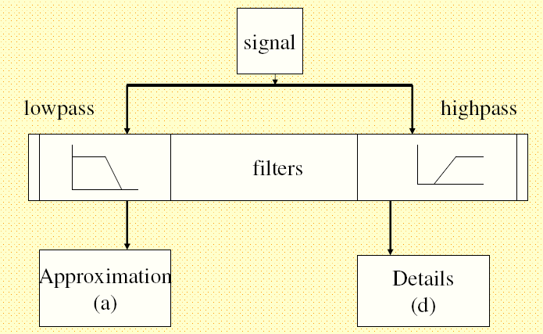

**Applications (Image Processing):**

* Decompose the image into wavelet domain
* Alter the wavelet coefficients, according to your applications such as de noising, compression, edge enhancement, etc.
* Reconstruct the image with the altered wavelet coefficients.

**Other Applications:**

* Data and image compression
* Pattern recognition
* Texture analysis
* Noise reduction(Denoising)
* Image resizing
* Image retrieval
* Object tracking