**BECE320E Embedded C Programming**  **Digital Assignment – I**

Class no: CH2024250102674 Fall 2024-25 Submission date: 21-08-2024

Handwritten answers need to be scanned and uploaded to Teams.

Write your Reg. Number and Name on top right corner of every page.

Common to all set

1. Which of the following are invalid variable names and why?

B’day int $hello

#HASH dot. number

totalArea _main() temp_in_Deg

total% 1st stack-queue

variable name %name% salary

2. Match the following:

(a) \n Literal

(b) 3.145 Statement terminator

(c) -6513 Character constant

(d) ’D’ Escape sequence

(e) 4.25e-3 Input function

(f) main() Function

(g) %f, %d, %c Integer constant

(h); Address of operator

(i) Constant Output function

(j) Variable Format specifier

(k) & Exponential form

(l) printf( ) Real constant

(m) scanf( ) Identifier

3.

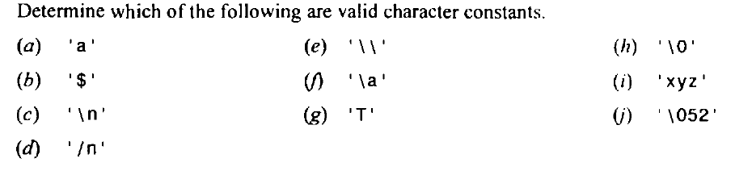

From Schaum’s series book,

4. 4.75

5. Either 4.80 or 4.81 (anyone)

6. 7.35

7. 9.29 (a,b,c,d,e only)

8. 9.46

9. Example 10.31 (Simply copy the answer alone)

10. 10.45

11. Either 10.47 (upto g only) or 10.46 (anyone)

12. 10.53

13. (b) State whether the following statements are True or False:

1. The variables commonly used in C functions are available to all the functions in a program.

2. To return the control back to the calling function we must use the keyword **return**.

3. The same variable names can be used in different functions without any conflict.

4. Every called function must contain a **return** statement.

5. A function may contain more than one **return** statements.

6. Each **return** statement in a function may return a different value.

7. A function can still be useful even if you don’t pass any arguments to it and the function doesn’t return any value back.

8. Same names can be used for different functions without any conflict.

9. A function may be called more than once from any other function.

10. It is necessary for a function to return some value.

14.

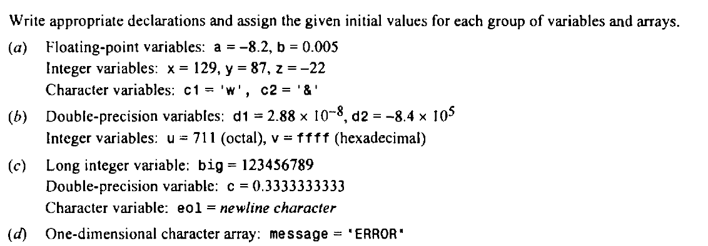

15. Write an interactive program that will read in a positive integer value and determine the following:

***(i)*** If the integer is a prime number.

***(ii)*** If the integer is a Fibonacci number.

Write the program in such a manner that it will execute repeatedly, until a zero value is detected for the input quantity.

16. What are function pointers and how are they used? Explain with example.

17.

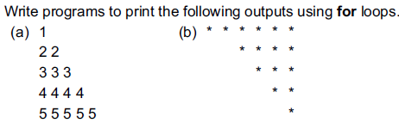

1. Determine the value of each of the following logical expressions if a = 5, b = 10 and c = –6

(a) a > b && a < c

(b) a < b && a > c

(c) a == c || b > a

(d) b > 15 && c < 0 || a > 0

(e) (a/2.0 == 0.0 && b/2.0 != 0.0) || c < 0.0

1. Write a program to print the size of various data types in C

20. State errors, if any, in the following input statements.

(a) scanf(“%c%f%d”, city, &price, &year);

(b) scanf(“%s%d”, city, amount);

(c) scanf(“%f, %d, &amount, &year);

(d) scanf(\n”%f”, root);

(e) scanf(“%c %d %ld”, *code, &count, Root);

Set 1

1. What are the main features that differentiate C from other programming languages?
2. Explain bitwise operators in C with examples.
3. Summarize the rules governing the use of the return statement. Can multiple expressions be included in a return statement? Can multiple return statements be included in a function?
4. Write a simple C program that reads two integers and prints their sum, difference, product, and quotient.
5. Schaum’s series 3.40

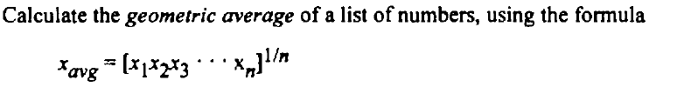--

1. Calculate the mass of air in an automobile tire, using the formula

*PV=* ***0.37m(T+ 460)***

where P = pressure, pounds per square inch (psi)

V = volume, cubic feet

***m*** = mass of air, pounds

***T*** = temperature, degrees Fahrenheit

The tire contains **2** cubic feet of air. Assume that the pressure is **32** psi at room temperature.

1. Write a C program to print all the ASCII values and their equivalent characters using a while loop. The ASCII values vary from 0 to 255.
2. What will be the value of x when the following segment is executed?

int x = 10, y = 15;

x = (x<y)? (y+x) : (y-x) ;

10.Point out the errors, if any, in the following programs:

(a) # include <stdio.h>

int main( )

{

int suite = 1 ;

switch ( suite ) ;

{

case 0 ;

printf ( "Club\n" ) ;

case 1 ;

printf ( "Diamond\n" ) ;

}

return 0 ;

}

(b) # include <stdio.h>

void message( ) ;

int main( )

{

int a ;

a = message( ) ;

return 0 ;

}

void message( )

{

printf ( "Viruses are written in C\n" ) ;

return ;

}

11.What will be the output of the following programs:

(a) # include <stdio.h>

void display( ) ;

int main( )

{

printf ( "Learn C\n" ) ;

display( ) ;

return 0 ;

}

void display( )

{

printf ( "Followed by C++, C# and Java!\n" ) ;

main( ) ;

}

(b) # include <stdio.h>

int main( )

{

int n[ 3 ][ 3 ] = {

2, 4, 3,

6, 8, 5,

3, 5, 1

} ;

int i, j ;

for ( i = 0 ; i <= 2 ; i++ )

for ( j = 0 ; j <= 2 ; j++ )

printf ( "%d %d\n", n[ i ][ j ], *( *( n + i ) + j ) ) ;

return 0 ;

}

12. What is the output of the following code?

int n = 0, m = 1 ;

do

{

printf(m) ;

m++ ;

}

while (m <= n) ;

13. What is printed when the following is executed?

for (m = 0; m <3; ++m)

printf(“%d/n”, (m%2) ? m: m+2);

14. Write a C program to read two integer values m and n and to decide and print whether m is a multiple of n.

15. C program for Floyd’s triangle upto a given number

16. C program to print left half pyramid of stars upto a given row number