Set 3

1. What are the major components of a C program? What significance is attached to the name main?
2. What do you mean by declaration and definition of a variable or a function?
3. The distance between two cities (in km.) is input through the keyboard. Write a C program to convert and print this distance in meters, feet, inches and centimeters
4. Schuam’s series 4.57

Calculate the sum of the first ***n*** odd integers using C program

6.

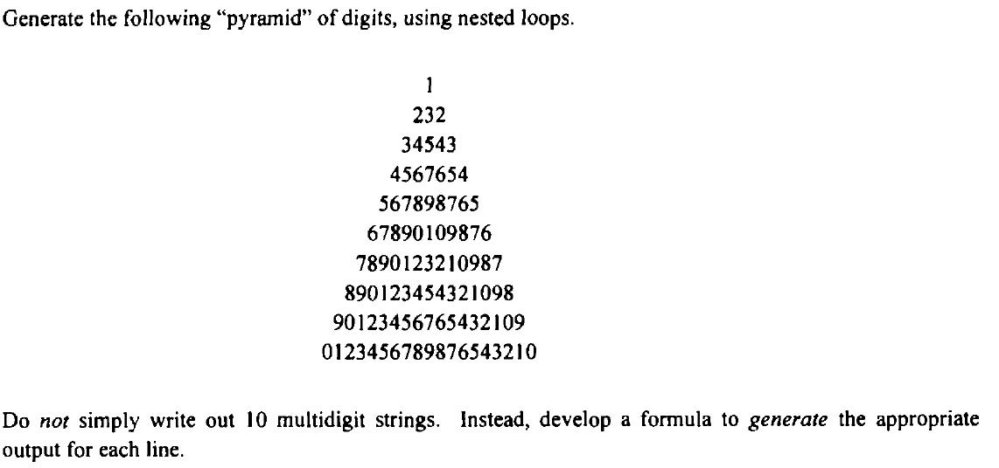

**7.** Point out the errors, if any, in the following programs:

# include <stdio.h>

int main( )

{

float a = 3.5 ;

switch ( a )

{

case 0.5 :

printf ( "The art of C\n" ) ; break ;

case 1.5 :

printf ( "The spirit of C\n" ) ; break ;

case 2.5 :

printf ( "See through C\n" ) ; break ;

case 3.5 :

printf ( "Simply c\n" ) ;

}

return 0 ;

}

8.Point out the errors, if any, in the following programs:

# include <stdio.h>

int addmult ( int, int )

int main( )

{

int i = 3, j = 4, k, l ;

k = addmult ( i, j ) ;

l = addmult ( i, j ) ;

printf ( "%d %d\n", k, l ) ;

return 0 ;

}

int addmult ( int ii, int jj )

{

int kk, ll ;

kk = ii + jj ;

ll = ii * jj ;

return ( kk, ll ) ;

}

9. What will be the output of the following programs:

(a)

#include <stdio.h>

int main( )

{

int i = 4, j = -1, k = 0, w, x, y, z ;

w = i || j || k ;

x = i && j && k ;

y = i || j && k ;

z = i && j || k ;

printf ( "w = %d x = %d y = %d z = %d\n", w, x, y, z ) ;

return 0 ;

}

(b)

# include <stdio.h>

int main( )

{

int x = 20, y = 40, z = 45 ;

if ( x > y && x > z )

printf ( "biggest = %d\n", x ) ;

else if ( y > x && y > z )

printf ( "biggest = %d\n", y ) ;

else if ( z > x && z > y )

printf ( "biggest = %d\n", z ) ;

return 0 ;

}

10. What will be the output of the following programs:

# include <stdio.h>

int main( )

{

int i = 1 ;

while ( i <= 10 ) ;

{

printf ( "%d\n", i ) ;

i++ ;

}

return 0 ;

}

11. What will be the output of the following programs:

(a) # include <stdio.h>

int main( )

{

int n[ 3 ][ 3 ] = {

2, 4, 3,

6, 8, 5,

3, 5, 1

} ;

printf ( "%d %d %d\n", *n, n[ 3 ][ 3 ], n[ 2 ][ 2 ] ) ;

return 0 ;

}

12. What will be output of the following segment when executed?

int a = 10, b = 5;

if (a > b)

{

if(b > 5)

printf(“%d”, b);

}

else

printf(“%d”, a);

13. What is the output of the following program?

main ( )

{

int m = 5 ;

if (m < 3) printf(“%d” , m+1) ;

else if(m < 5) printf(“%d”, m+2);

else if(m < 7) printf(“%d”, m+3);

else printf(“%d”, m+4);

}

14, Write a C program using while loop to reverse the digits of the number

15. Write a C program to print inverted left half pyramid of stars till a given row number

16. Name some common string handling functions in C and their uses.