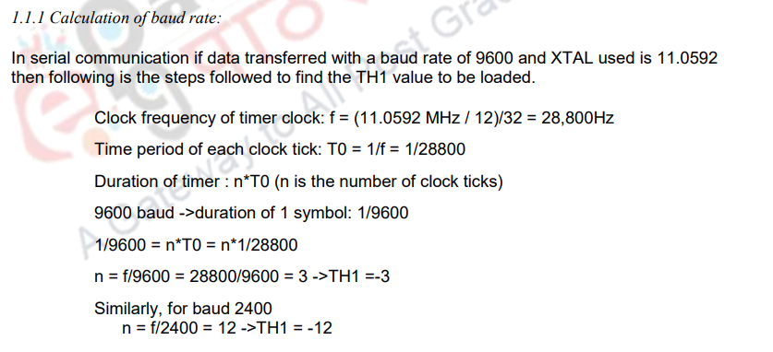

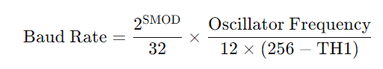



The baud rate is determined by how frequently **Timer 1 overflows**, and the overflow rate depends on how fast the 8051 processes machine cycles