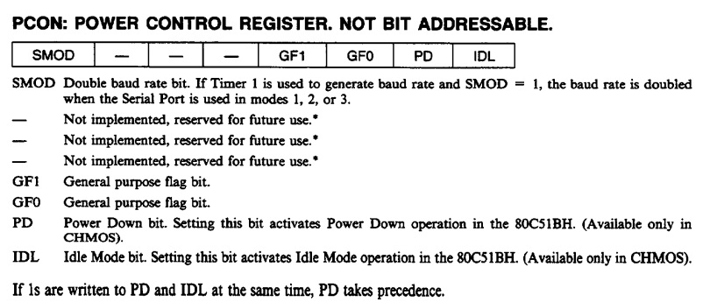

The **8051 microcontroller** has two primary low-power modes to conserve energy: **Idle Mode** and **Power-Down Mode**. These modes allow the 8051 to reduce power consumption when full functionality is not needed, making it useful for battery-operated and power-sensitive applications.

**1. Idle Mode**

In **Idle Mode**, the 8051 stops the CPU while keeping the peripherals (such as timers, serial ports, and interrupts) active. This mode is useful when the system needs to maintain communication or continue timing operations but doesn’t require processing data immediately.

**Key Features of Idle Mode:**

* **CPU is halted**, but the peripherals (Timers, Serial Port, Interrupt system) continue to function.
* The contents of the CPU registers, stack, program counter (PC), and special function registers (SFRs) are retained.
* **Oscillator and clock** are active, meaning the 8051 continues to receive and generate clock pulses for its peripherals.
* The 8051 can be brought out of Idle Mode by:
  + An **enabled interrupt**: When an interrupt is triggered, the 8051 will exit Idle Mode, service the interrupt, and resume normal operation.
  + A **hardware reset**: This will also reset the 8051 and restart normal operation from the beginning of the program.

**Power Savings:**

* **Moderate power saving** since the CPU is inactive, but the rest of the system remains active.

**Entering Idle Mode:**

To enter Idle Mode, the **IDLE bit** (bit 0) in the **PCON register** is set to 1.

**Exiting Idle Mode:**

The microcontroller exits Idle Mode either when:

* An interrupt occurs, or
* A reset signal is received (in which case the 8051 restarts from the reset vector).

**2. Power-Down Mode**

In **Power-Down Mode**, the 8051 stops both the CPU and the oscillator. This is a deep-sleep mode in which the entire system, including timers and the clock, is shut down, leading to **maximum power savings**.

**Key Features of Power-Down Mode:**

* **CPU, oscillator, and all peripherals are stopped**. No clock signal is generated or used.
* The contents of the internal **RAM and SFRs** (Special Function Registers) are retained.
* **Clock stops** completely, and no internal operations are possible during this mode.
* The only way to exit Power-Down Mode is by using a **hardware reset**. Upon resetting, the microcontroller starts from the reset vector, just like a normal power-up.

**Power Savings:**

* **Maximum power savings** are achieved because all operations, including the clock, are halted.

**Entering Power-Down Mode:**

To enter Power-Down Mode, the **PD bit** (bit 1) in the **PCON register** is set to 1.

**Exiting Power-Down Mode:**

The 8051 can only exit Power-Down Mode through:

* A **hardware reset**: A reset will restart the oscillator and initialize the microcontroller, losing the current state and starting execution from the reset vector.

**Comparison of Idle Mode and Power-Down Mode**

| **Feature** | **Idle Mode** | **Power-Down Mode** |
| --- | --- | --- |
| **CPU** | Halted | Halted |
| **Oscillator** | Active | Stopped |
| **Peripherals** | Active (Timers, serial port, interrupts) | Stopped |
| **Power Consumption** | Moderate power savings | Maximum power savings |
| **Wake-up Sources** | Interrupt or hardware reset | Hardware reset only |
| **Registers/RAM** | Retained | Retained |
| **Usage** | Useful when the CPU is not needed but peripherals are active | Deep-sleep mode for maximum power conservation |

**Summary:**

* **Idle Mode**: Stops the CPU but keeps the oscillator and peripherals running. The 8051 can wake up from Idle Mode using interrupts or a reset, and the system resumes where it left off.
* **Power-Down Mode**: Stops everything, including the oscillator, for maximum power savings. The only way to exit Power-Down Mode is by a reset, and the 8051 restarts the program from the beginning.

These modes are important for power-sensitive applications, allowing the system to conserve energy while maintaining functionality when needed.