Programs on producing time delay using mode 1 and mode 2

**Timer0 Mode 1 Programming**

#include<reg51.h>

void delaytimer(void);

void main(void)

{

while(1)

{

P1=0x55;

delaytimer();

P1=0xAA;

delaytimer();

}

}

void delaytimer(void)

{

TMOD=0X01;

TL0=0X00;

TH0=0X35;

TR0=1;

while(TF0==0);

TR0=0;

TF0=0;

}

**Timer1 Mode 1 Programming**

#include<reg51.h>

void delaytimer(void);

void main(void)

{

while(1)

{

P1=0x55;

delaytimer();

P1=0xAA;

delaytimer();

}

}

void delaytimer(void)

{

TMOD=0X10;

TL1=0X00;

TH1=0X35;

TR1=1;

while(TF1==0);

TR1=0;

TF1=0;

}

**Timer 0 Mode 2**

#include<reg51.h>

void delaytimer(void);

void main(void)

{

TMOD=0X02;

TH0=0Xa3;

TR0=1;

while(1)

{

P1=0x55;

delaytimer();

P1=0xAA;

delaytimer();

}

}

void delaytimer(void)

{

while(TF0==0);

TF0=0;

}

**Timer 1 Mode 2**

#include<reg51.h>

void delaytimer(void);

void main(void)

{

TMOD=0X20;

TH1=0Xa3;

TR1=1;

while(1)

{

P1=0x55;

delaytimer();

P1=0xAA;

delaytimer();

}

}

void delaytimer(void)

{

while(TF1==0);

TF1=0;

}

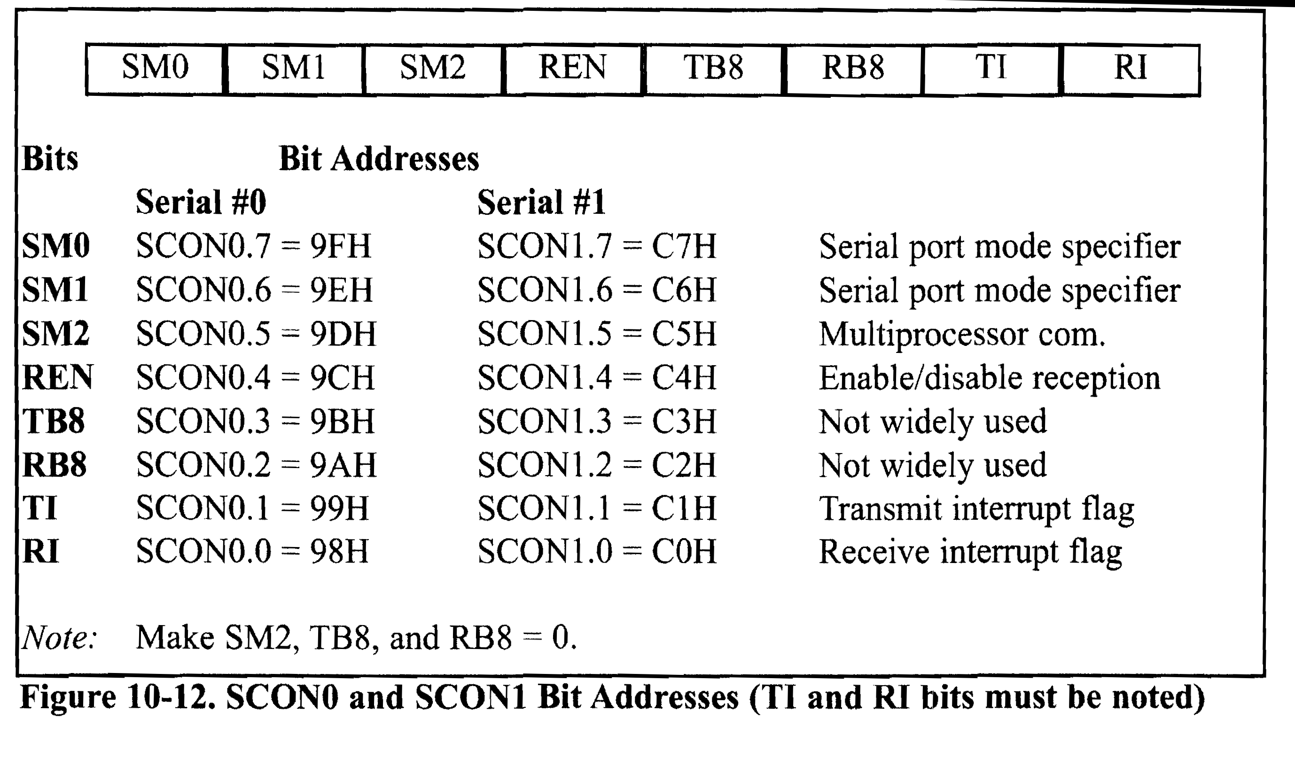

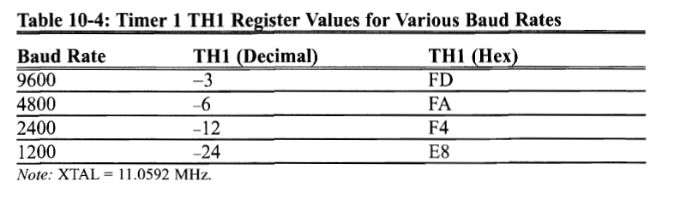

**Serial Communication - Transmit**

#include<reg51.h>

void main(void)

{

TMOD=0X20;

TH1=-3;

SCON=0X50;

TR1=1;

while(1)

{

SBUF='A';

while(TI==0);

TI=0;

}

}

**Serial Communication - Transmit**

#include<reg51.h>

void serialtrans(unsigned char);

void main(void)

{

TMOD=0X20;

TH1=-6;

SCON=0X50;

TR1=1;

while(1)

{

serialtrans('V');

serialtrans('I');

serialtrans('T');

}

}

void serialtrans(unsigned char x)

{

SBUF=x;

while(TI==0);

TI=0;

}

**Serial Communication - Receive**

#include<reg51.h>

void serialtrans(unsigned char);

void main(void)

{

unsigned char z;

TMOD=0X20;

TH1=-6;

SCON=0X50;

TR1=1;

P1=0;

while(1)

{

while(RI==0);

z=SBUF;

P1=z;

RI=0;

}

}

**Interrupts**

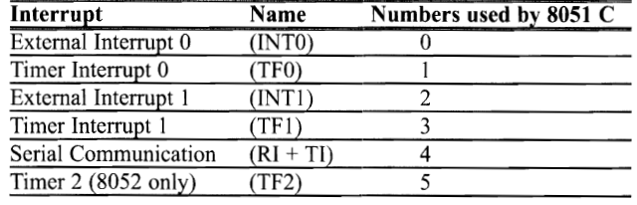

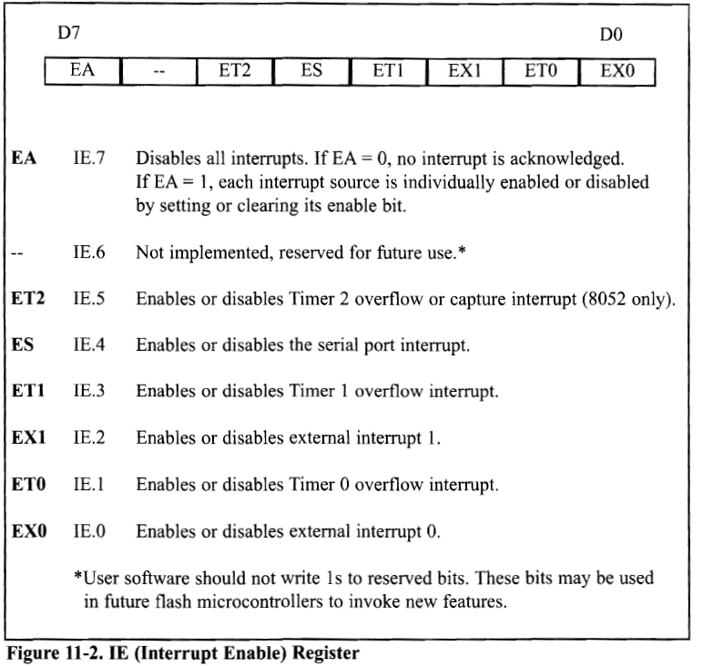

**Timer 0 Mode 1 interrupt**

#include<reg51.h>

void main(void)

{

P1=0X00;

TMOD=0X01;

TL0=0xa3;

TH0=0xff;

TR0=1;

IE=0X82;

while(1);

}

void timerint0(void) interrupt 1

{

TL0=0xa3;

TH0=0xff;

P1^=0xff;

}

**Timer 1 Mode 1 interrupt**

#include<reg51.h>

void main(void)

{

P1=0X00;

TMOD=0X10;

TL1=0xa3;

TH1=0xff;

TR1=1;

IE=0X88;

while(1);

}

void timerint1(void) interrupt 3

{

TL1=0xa3;

TH1=0xff;

P1^=0xff;

}

**Timer 1 Mode 1 interrupt & Timer 0 Mode 1 interrupt**

#include<reg51.h>

void main(void)

{

P1=0X00;

TMOD=0X11;

TL1=0xa3;

TH1=0xff;

TL0=0xa3;

TH0=0xff;

TR1=1;

TR0=1;

IE=0X8a;

while(1);

}

void timerint1(void) interrupt 3

{

TL1=0xa3;

TH1=0xff;

P1^=0xff;

}

void timerint0(void) interrupt 1

{

TL0=0xa3;

TH0=0xff;

P2^=0xff;

}

**Timer 1 Mode 1 interrupt & Timer 0 Mode 1 interrupt and Transfer Data from P0 to P2**

#include<reg51.h>

sbit mybit0=P1^1;

sbit mybit1=P1^7;

void main(void)

{

unsigned char z;

P1=0X00;

P0=0XFF;

P3=0X00;

TMOD=0X11;

TL1=0xa3;

TH1=0xff;

TL0=0xa3;

TH0=0xff;

TR1=1;

TR0=1;

IE=0X8a;

while(1)

{

z=P0;

P2=z;

}

}

void timerint1(void) interrupt 3

{

TL1=0xa3;

TH1=0xff;

mybit1^=1;

}

void timerint0(void) interrupt 1

{

TL0=0xa3;

TH0=0xff;

mybit0^=1;

}

**Transfer data from P2.0 to 2.7, waveform at P1.1, if anything gets received send it to P0**

#include<reg51.h>

sbit mybit0=P1^1;

sbit my_inputbit4=P2^0;

sbit my_outputbit5=P2^7;

void main(void)

{

TMOD=0X22;

SCON=0X50;

TH0=0xa3;

TH1=-3;

TR0=1;

TR1=1;

IE=0X92;

while(1)

{

my_outputbit5=my_inputbit4;

}

}

void timerint0(void) interrupt 1

{

mybit0^=1;

}

void serailrx(void) interrupt 4

{

unsigned char x;

x=SBUF;

P0=x;

RI=0;

}

**Transfer data from P2.0 to 2.7, waveform at P1.1, if anything gets received send it to P0, Transmit the data VIT only once**

#include<reg51.h>

void serial_transmit(unsigned char);

sbit mybit0=P1^1;

sbit my_inputbit4=P2^0;

sbit my_outputbit5=P2^7;

void main(void)

{

TMOD=0X22;

SCON=0X50;

TH0=0xa3;

TH1=-3;

TR0=1;

TR1=1;

IE=0X92;

serial_transmit('V');

serial_transmit('I');

serial_transmit('T');

while(1)

{

my_outputbit5=my_inputbit4;

}

}

void serial_transmit(unsigned char x)

{

SBUF=x;

while(TI==0);

TI=0;

}

void timerint0(void) interrupt 1

{

mybit0^=1;

}

void serailrx(void) interrupt 4

{

unsigned char x;

x=SBUF;

P0=x;

RI=0;

}

**TCON register**



************************************************

**External Interrupt 0 - Level Triggered**

#include<reg51.h>

void externalint0(void);

void main(void)

{

P1=0x00;

IE=0x81;

while(1);

}

void externalint0(void) interrupt 0

{

P1++;

}

************************************************

**External Interrupt 1 - Level Triggered**

#include<reg51.h>

void externalint1(void);

void main(void)

{

P1=0x00;

IE=0x84;

while(1);

}

void externalint1(void) interrupt 2

{

P1++;

}

***************************************************

**External Interrupt 0 - Edge Triggered**

#include<reg51.h>

void externalint0(void);

void main(void)

{

P1=0x00;

IT0=1;

IE=0x81;

while(1);

}

void externalint0(void) interrupt 0

{

P1++;

}

***************************************************

**External Interrupt 1 - Edge Triggered**

#include<reg51.h>

void externalint1(void);

void main(void)

{

P1=0x00;

IT1=1;

IE=0x84;

while(1);

}

void externalint1(void) interrupt 2

{

P1++;

}

**********************************************

**Counter 1 Program**

#include<reg51.h>

sbit cntpin=P3^5;

void main(void)

{

cntpin=1;

TMOD=0x60;

TR1=1;

TH1=0;

P1=0x00;

while(1)

{

while(TF1==0)

P1=TL1;

TF1=0;

}

}

**********************************************

**Counter 0**

#include<reg51.h>

sbit cntpin=P3^4;

void main(void)

{

cntpin=1;

TMOD=0X06;

TR0=1;

TH0=0;

P1=0x00;

while(1)

{

while(TF0==0)

P1=TL0;

TF0=0;

}

}

**Write an 8051 C program that uses interrupts to toggle P1.7 every 20 ms (use timer 0 in mode 1) and P1.1 every 0.1 ms (use timer 1 in mode 2) simultaneously.**

Write an 8051 C program using interrupts to generate a clock signal of frequency 100kHz (use timer 0 in mode 2) at P2.2 while simultaneously monitoring P1.3 and sending it to P2.5.

**Write an 8051 C program using interrupts to count the pulses at EXT0 in level-triggered mode and display them on P1. Simultaneously, serially transmit the letter ‘V’ at a 4800 baud rate.**

An LED is connected to pin P1.2 and two switches are connected at P2.1 and P2.2. Activate the LED only when

Both the switches are closed

Any one or both the switches are closed

Any one of the switches is closed