**Experiment – 1**

Display a string and current time using Node Red

Node-RED is a programming tool for wiring together hardware devices, APIs and online services in new and interesting ways.

It provides a browser-based editor that makes it easy to wire together flows using the wide range of nodes in the palette that can be deployed to its runtime in a single-click.

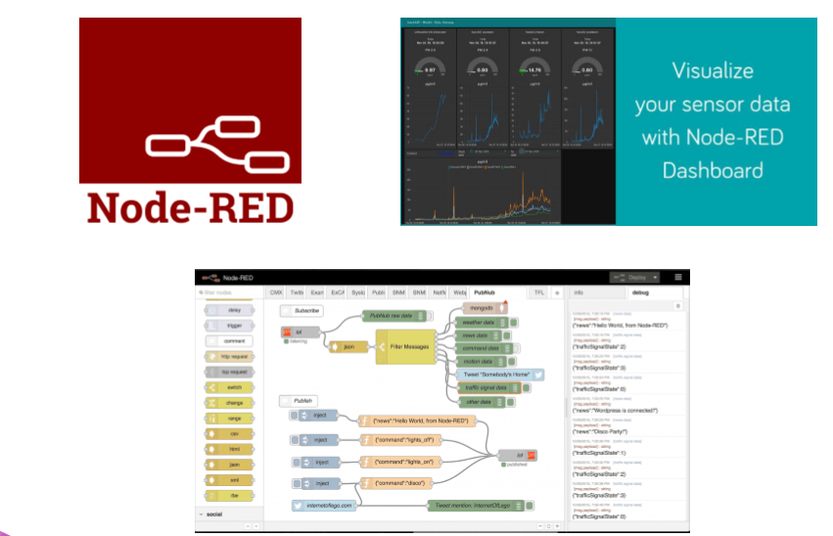

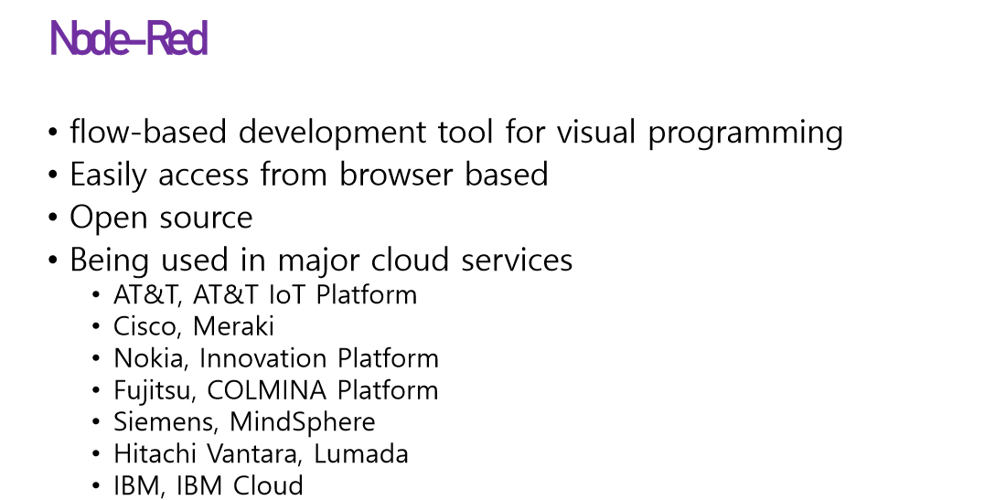 

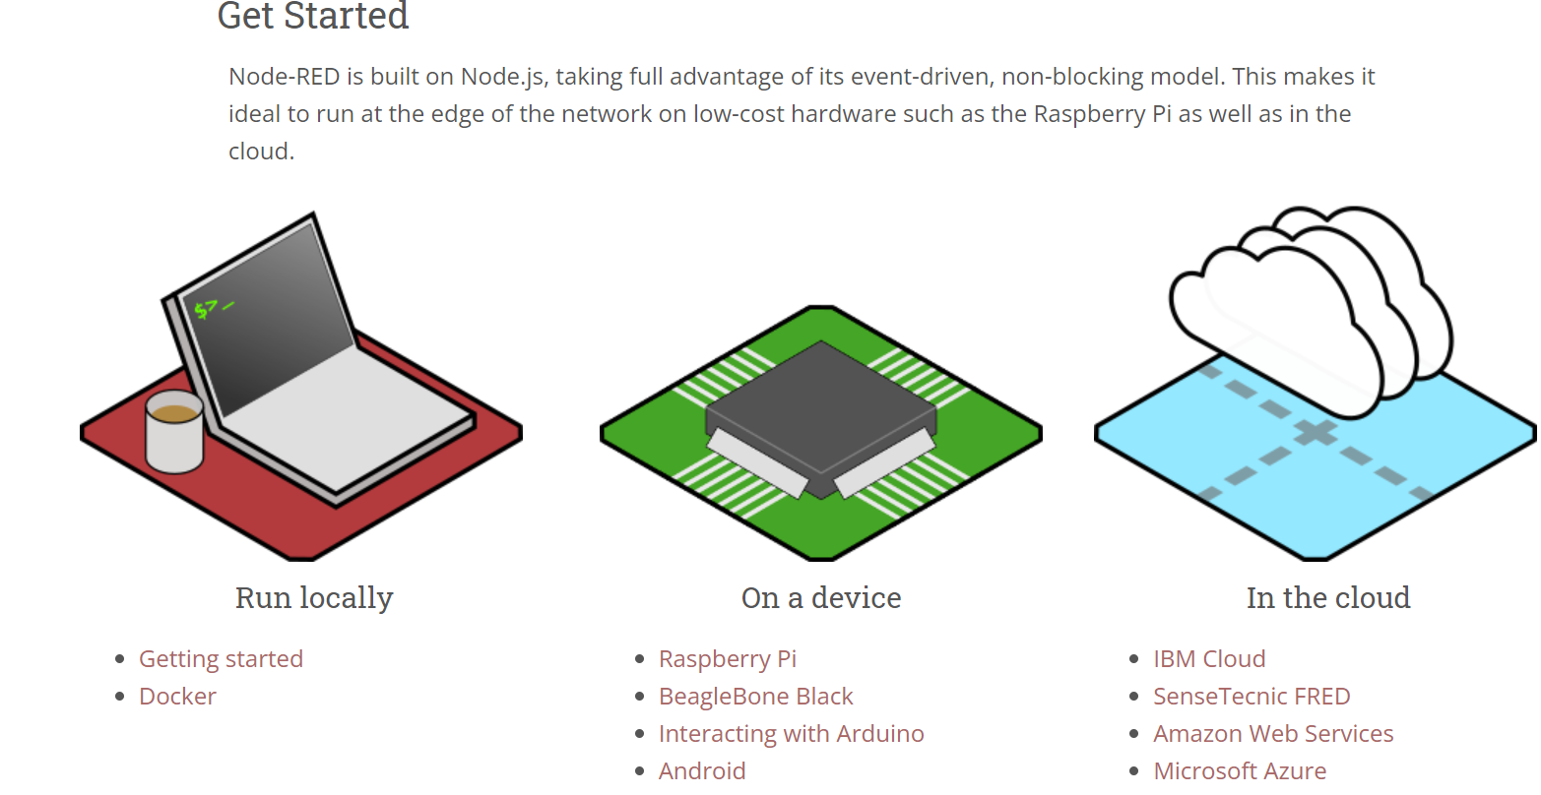

**Installation Steps**

To Install Node js

Type Node js.org on the web browser

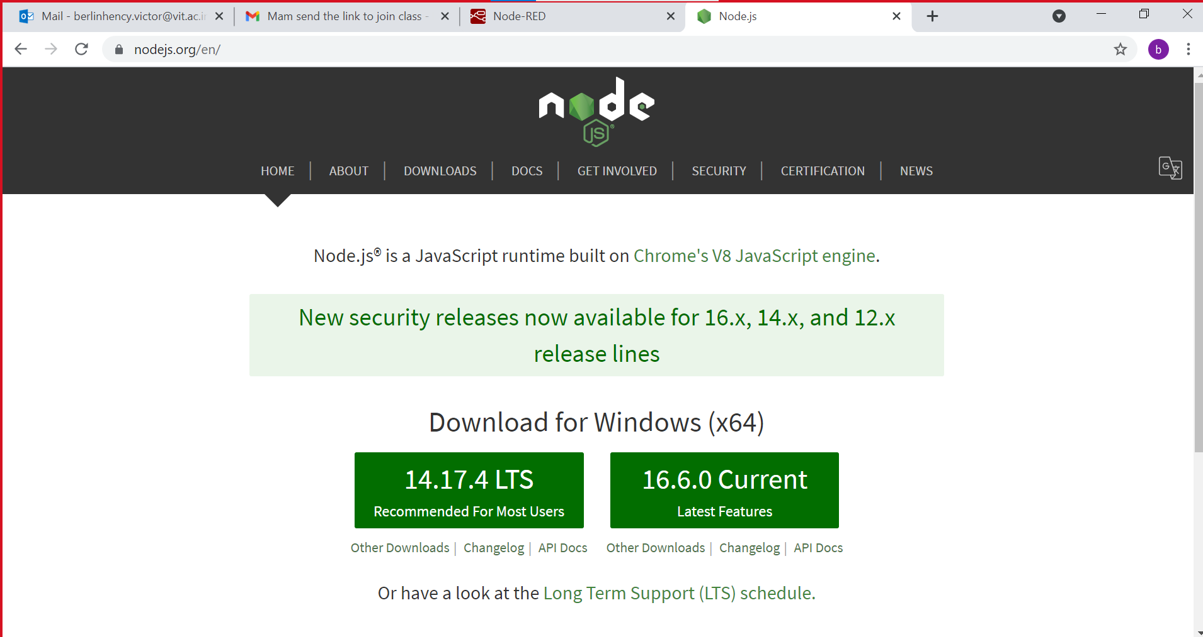

Down load 16.6.0 current latest features and install

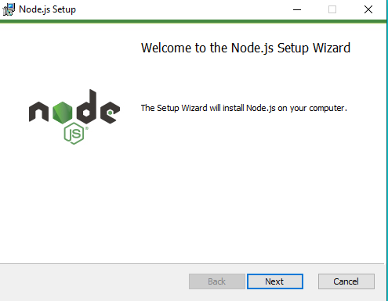

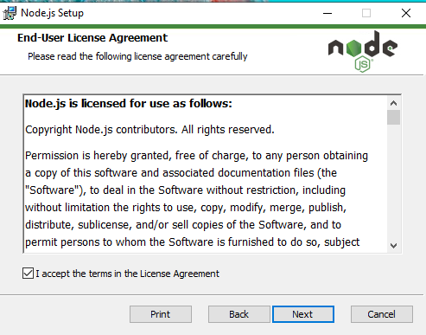

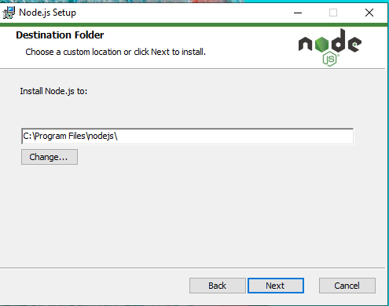

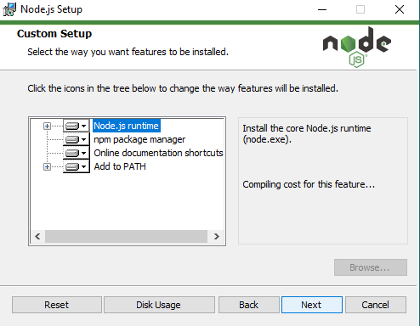

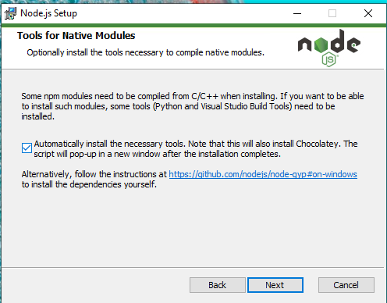

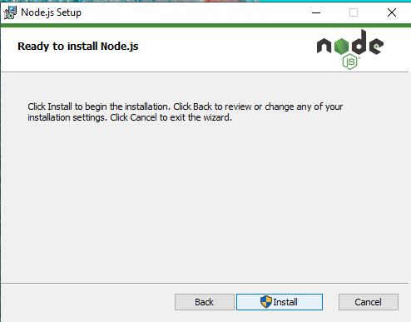

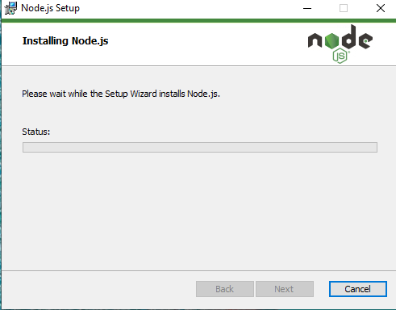

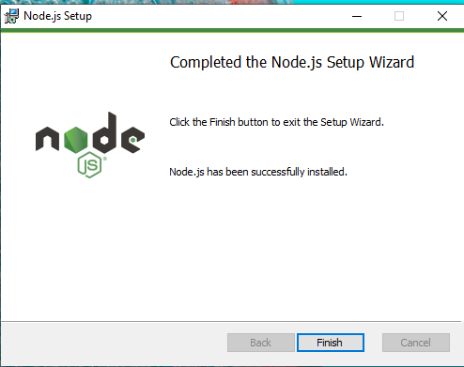

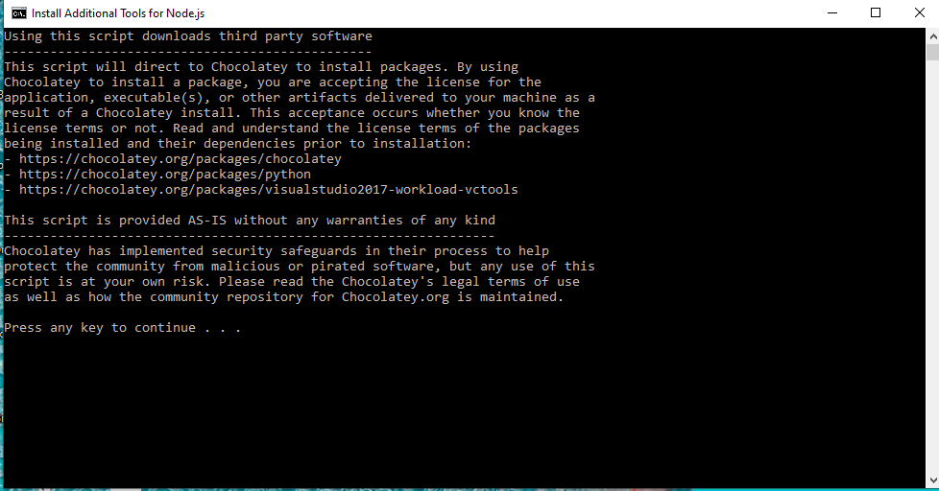type enter twice

Go To command prompt

Type Cmd

Type node -v

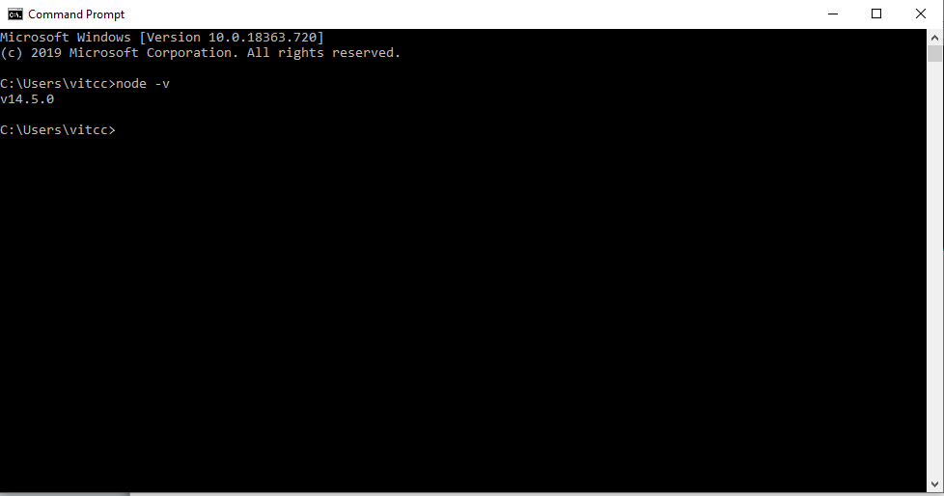

Type

npm install -g node-red

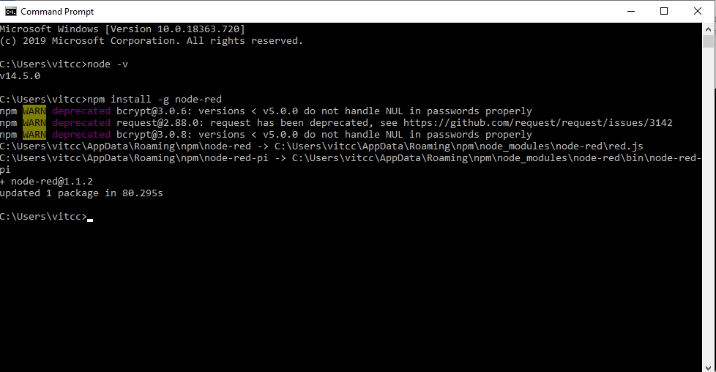

Ignore the error

Type

node-red -v

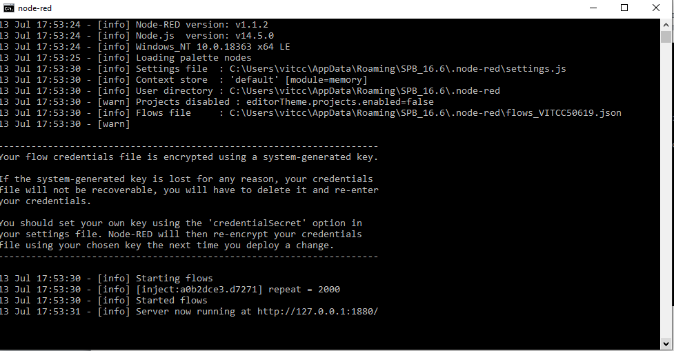

Go to web browser

<http://127.0.0.1:1880/>

Java code

var dateNow = new Date();

var timeAsString = dateNow.toLocaleTimeString();

msg.payload = msg.payload+'The Current time is'+timeAsString+'.';

return msg;

cmd

* npm i node-red-dashboard
* npm install node-red-contrib-ui-artless-gauge