**Op-Amp –Integrator and Differentiator- Numericals**

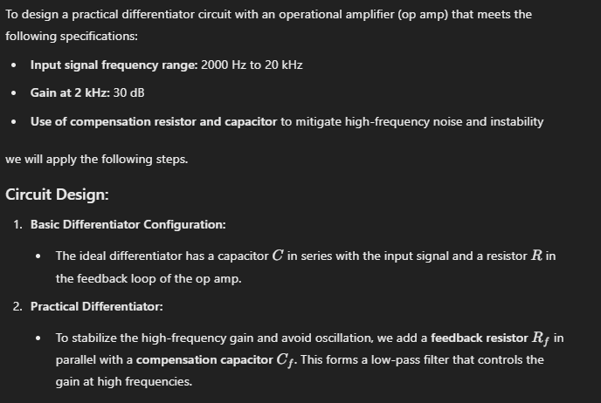

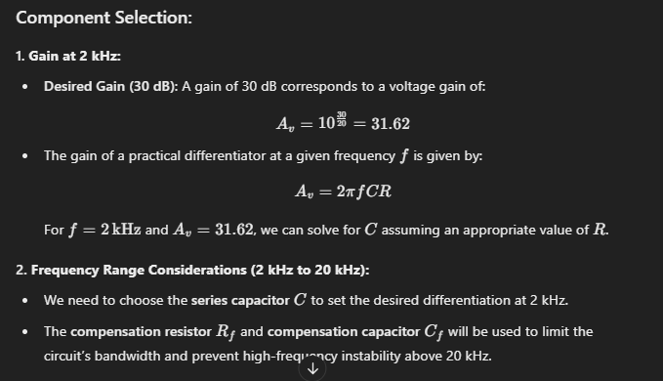

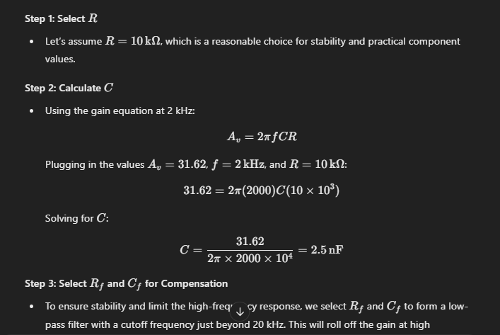

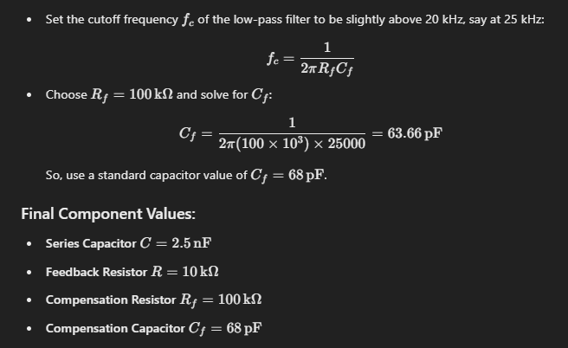

Design an integrator circuit using an operational amplifier (Op

Amp) that satisfies the following specifications:

The input signal is a sine wave with peak amplitude of 2 V and a frequency of 2 kHz.

The integrator should output a triangular wave with peak amplitude of 10 V.

Use a power supply of ±12 V for the Op Amp.

