**Calculus Lab Assignment**

**Name of the Student:** Rahul Karthik S

**Registration Number:** 21BME1059

Addition, Subtraction, Multiplication, element-wise multiplication, element-wise left and right division, transpose, squares, determinants, trace and comments:

Editor Window:  
clc

clear all

c = [3 5 6; 4 0 -7; 1 7 11]

d = [9 0 5; 2 1 3; 0 12 -4]

e = [1 2 3; 4 5 6; 7 8 9]

f = c + d

g = c - d

h = c * d

i = c .* d

j = c ./ d

k = c .\ d

l = c / d

m = c \ d

n = inv(c)

o = c'

p = transpose(c)

q = c.^2

r = det(c)

s = trace(e)

% comments

Command Window:

c =

3 5 6

4 0 -7

1 7 11

d =

9 0 5

2 1 3

0 12 -4

e =

1 2 3

4 5 6

7 8 9

f =

12 5 11

6 1 -4

1 19 7

g =

-6 5 1

2 -1 -10

1 -5 15

h =

37 77 6

36 -84 48

23 139 -18

i =

27 0 30

8 0 -21

0 84 -44

j =

0.3333 Inf 1.2000

2.0000 0 -2.3333

Inf 0.5833 -2.7500

k =

3.0000 0 0.8333

0.5000 Inf -0.4286

0 1.7143 -0.3636

l =

-0.2667 2.7000 0.1917

1.3667 -4.1500 0.3458

-1.1667 5.7500 0.1042

m =

6.9167 -7.2167 5.7667

-6.7500 9.4500 -5.9000

3.6667 -4.2667 2.8667

n =

0.8167 -0.2167 -0.5833

-0.8500 0.4500 0.7500

0.4667 -0.2667 -0.3333

o =

3 4 1

5 0 7

6 -7 11

p =

3 4 1

5 0 7

6 -7 11

q =

9 25 36

16 0 49

1 49 121

r =

60

s =

15

Linspace, 2D Plotting, Axis Equal, XLable, YLable and Title:

Editor Window:

clc

clear all

u = linspace(0,2*pi,200)

plot(1+cos(u),3+2*sin(u),'g.')

axis equal

xlabel('x-axis')

ylabel('y-axis')

title('Circle')

Command Window:

u =

Columns 1 through 13

0 0.0316 0.0631 0.0947 0.1263 0.1579 0.1894 0.2210 0.2526 0.2842 0.3157 0.3473 0.3789

Columns 14 through 26

0.4105 0.4420 0.4736 0.5052 0.5368 0.5683 0.5999 0.6315 0.6630 0.6946 0.7262 0.7578 0.7893

Columns 27 through 39

0.8209 0.8525 0.8841 0.9156 0.9472 0.9788 1.0104 1.0419 1.0735 1.1051 1.1367 1.1682 1.1998

Columns 40 through 52

1.2314 1.2630 1.2945 1.3261 1.3577 1.3892 1.4208 1.4524 1.4840 1.5155 1.5471 1.5787 1.6103

Columns 53 through 65

1.6418 1.6734 1.7050 1.7366 1.7681 1.7997 1.8313 1.8629 1.8944 1.9260 1.9576 1.9891 2.0207

Columns 66 through 78

2.0523 2.0839 2.1154 2.1470 2.1786 2.2102 2.2417 2.2733 2.3049 2.3365 2.3680 2.3996 2.4312

Columns 79 through 91

2.4628 2.4943 2.5259 2.5575 2.5891 2.6206 2.6522 2.6838 2.7153 2.7469 2.7785 2.8101 2.8416

Columns 92 through 104

2.8732 2.9048 2.9364 2.9679 2.9995 3.0311 3.0627 3.0942 3.1258 3.1574 3.1890 3.2205 3.2521

Columns 105 through 117

3.2837 3.3152 3.3468 3.3784 3.4100 3.4415 3.4731 3.5047 3.5363 3.5678 3.5994 3.6310 3.6626

Columns 118 through 130

3.6941 3.7257 3.7573 3.7889 3.8204 3.8520 3.8836 3.9152 3.9467 3.9783 4.0099 4.0414 4.0730

Columns 131 through 143

4.1046 4.1362 4.1677 4.1993 4.2309 4.2625 4.2940 4.3256 4.3572 4.3888 4.4203 4.4519 4.4835

Columns 144 through 156

4.5151 4.5466 4.5782 4.6098 4.6413 4.6729 4.7045 4.7361 4.7676 4.7992 4.8308 4.8624 4.8939

Columns 157 through 169

4.9255 4.9571 4.9887 5.0202 5.0518 5.0834 5.1150 5.1465 5.1781 5.2097 5.2413 5.2728 5.3044

Columns 170 through 182

5.3360 5.3675 5.3991 5.4307 5.4623 5.4938 5.5254 5.5570 5.5886 5.6201 5.6517 5.6833 5.7149

Columns 183 through 195

5.7464 5.7780 5.8096 5.8412 5.8727 5.9043 5.9359 5.9674 5.9990 6.0306 6.0622 6.0937 6.1253

Columns 196 through 200

6.1569 6.1885 6.2200 6.2516 6.2832

Figure with Axis Equal:

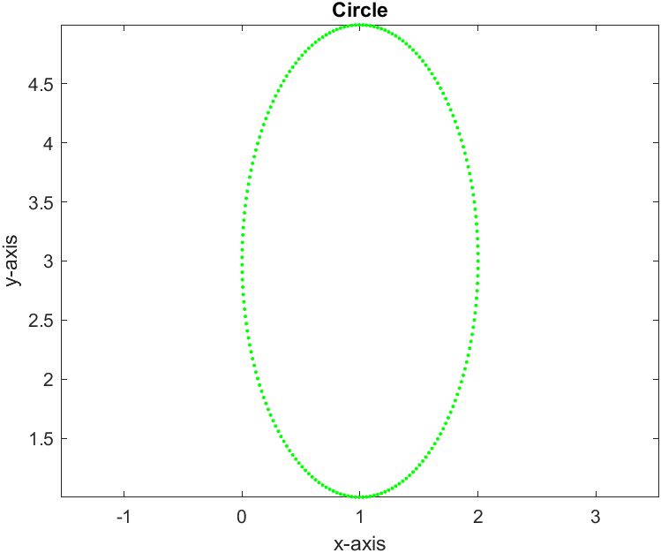

Figure without Axis Equal:

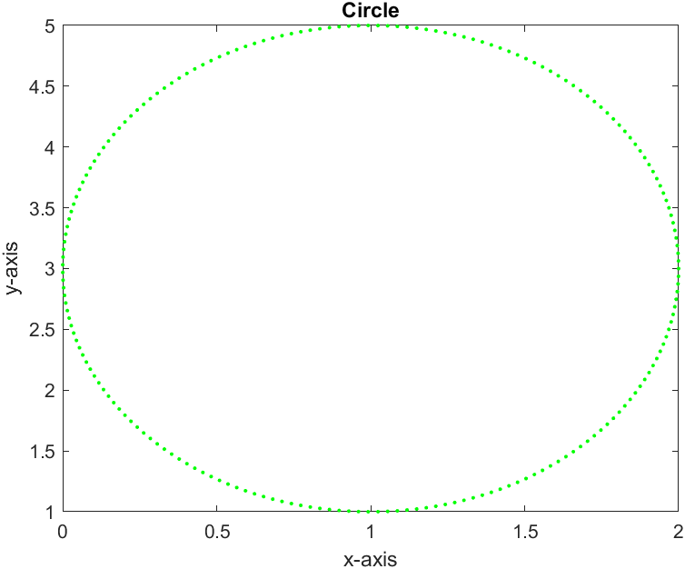

Legend

Editor Window:

clc

clear all

u = linspace(0,2*pi,200)

plot(cos(u))

legend('cos x','location','northeast')

Command Window:

u =

Columns 1 through 13

0 0.0316 0.0631 0.0947 0.1263 0.1579 0.1894 0.2210 0.2526 0.2842 0.3157 0.3473 0.3789

Columns 14 through 26

0.4105 0.4420 0.4736 0.5052 0.5368 0.5683 0.5999 0.6315 0.6630 0.6946 0.7262 0.7578 0.7893

Columns 27 through 39

0.8209 0.8525 0.8841 0.9156 0.9472 0.9788 1.0104 1.0419 1.0735 1.1051 1.1367 1.1682 1.1998

Columns 40 through 52

1.2314 1.2630 1.2945 1.3261 1.3577 1.3892 1.4208 1.4524 1.4840 1.5155 1.5471 1.5787 1.6103

Columns 53 through 65

1.6418 1.6734 1.7050 1.7366 1.7681 1.7997 1.8313 1.8629 1.8944 1.9260 1.9576 1.9891 2.0207

Columns 66 through 78

2.0523 2.0839 2.1154 2.1470 2.1786 2.2102 2.2417 2.2733 2.3049 2.3365 2.3680 2.3996 2.4312

Columns 79 through 91

2.4628 2.4943 2.5259 2.5575 2.5891 2.6206 2.6522 2.6838 2.7153 2.7469 2.7785 2.8101 2.8416

Columns 92 through 104

2.8732 2.9048 2.9364 2.9679 2.9995 3.0311 3.0627 3.0942 3.1258 3.1574 3.1890 3.2205 3.2521

Columns 105 through 117

3.2837 3.3152 3.3468 3.3784 3.4100 3.4415 3.4731 3.5047 3.5363 3.5678 3.5994 3.6310 3.6626

Columns 118 through 130

3.6941 3.7257 3.7573 3.7889 3.8204 3.8520 3.8836 3.9152 3.9467 3.9783 4.0099 4.0414 4.0730

Columns 131 through 143

4.1046 4.1362 4.1677 4.1993 4.2309 4.2625 4.2940 4.3256 4.3572 4.3888 4.4203 4.4519 4.4835

Columns 144 through 156

4.5151 4.5466 4.5782 4.6098 4.6413 4.6729 4.7045 4.7361 4.7676 4.7992 4.8308 4.8624 4.8939

Columns 157 through 169

4.9255 4.9571 4.9887 5.0202 5.0518 5.0834 5.1150 5.1465 5.1781 5.2097 5.2413 5.2728 5.3044

Columns 170 through 182

5.3360 5.3675 5.3991 5.4307 5.4623 5.4938 5.5254 5.5570 5.5886 5.6201 5.6517 5.6833 5.7149

Columns 183 through 195

5.7464 5.7780 5.8096 5.8412 5.8727 5.9043 5.9359 5.9674 5.9990 6.0306 6.0622 6.0937 6.1253

Columns 196 through 200

6.1569 6.1885 6.2200 6.2516 6.2832

Figure:

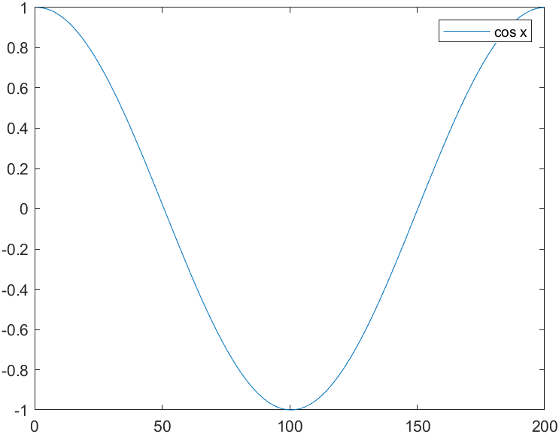

Comet3:

Editor Window:

clc

clear all

t = linspace(1, 100, 100)

x = cos(t)

y = sin(t)

z = sin(5*t)

comet3(x,y,z)

xlabel('x-axis')

ylabel('y-axis')

zlabel('z-axis')

title('3D Curve')

Command Window:

u =

Columns 1 through 13

0 0.0316 0.0631 0.0947 0.1263 0.1579 0.1894 0.2210 0.2526 0.2842 0.3157 0.3473 0.3789

Columns 14 through 26

0.4105 0.4420 0.4736 0.5052 0.5368 0.5683 0.5999 0.6315 0.6630 0.6946 0.7262 0.7578 0.7893

Columns 27 through 39

0.8209 0.8525 0.8841 0.9156 0.9472 0.9788 1.0104 1.0419 1.0735 1.1051 1.1367 1.1682 1.1998

Columns 40 through 52

1.2314 1.2630 1.2945 1.3261 1.3577 1.3892 1.4208 1.4524 1.4840 1.5155 1.5471 1.5787 1.6103

Columns 53 through 65

1.6418 1.6734 1.7050 1.7366 1.7681 1.7997 1.8313 1.8629 1.8944 1.9260 1.9576 1.9891 2.0207

Columns 66 through 78

2.0523 2.0839 2.1154 2.1470 2.1786 2.2102 2.2417 2.2733 2.3049 2.3365 2.3680 2.3996 2.4312

Columns 79 through 91

2.4628 2.4943 2.5259 2.5575 2.5891 2.6206 2.6522 2.6838 2.7153 2.7469 2.7785 2.8101 2.8416

Columns 92 through 104

2.8732 2.9048 2.9364 2.9679 2.9995 3.0311 3.0627 3.0942 3.1258 3.1574 3.1890 3.2205 3.2521

Columns 105 through 117

3.2837 3.3152 3.3468 3.3784 3.4100 3.4415 3.4731 3.5047 3.5363 3.5678 3.5994 3.6310 3.6626

Columns 118 through 130

3.6941 3.7257 3.7573 3.7889 3.8204 3.8520 3.8836 3.9152 3.9467 3.9783 4.0099 4.0414 4.0730

Columns 131 through 143

4.1046 4.1362 4.1677 4.1993 4.2309 4.2625 4.2940 4.3256 4.3572 4.3888 4.4203 4.4519 4.4835

Columns 144 through 156

4.5151 4.5466 4.5782 4.6098 4.6413 4.6729 4.7045 4.7361 4.7676 4.7992 4.8308 4.8624 4.8939

Columns 157 through 169

4.9255 4.9571 4.9887 5.0202 5.0518 5.0834 5.1150 5.1465 5.1781 5.2097 5.2413 5.2728 5.3044

Columns 170 through 182

5.3360 5.3675 5.3991 5.4307 5.4623 5.4938 5.5254 5.5570 5.5886 5.6201 5.6517 5.6833 5.7149

Columns 183 through 195

5.7464 5.7780 5.8096 5.8412 5.8727 5.9043 5.9359 5.9674 5.9990 6.0306 6.0622 6.0937 6.1253

Columns 196 through 200

6.1569 6.1885 6.2200 6.2516 6.2832

Figure:

