**Experiment 1: Plotting of curves and surfaces**

**Rahul Karthik S: 21BME1059**

1. Draw a circle with centre (1, 3)

Code:

clc

clear all

x = 1

y = 3

t = linspace(0,2*pi,100)

x_axis = 5*cos(t) + x

y_axis = 5*sin(t) + y

plot(x_axis, y_axis)

axis equal

Figure:

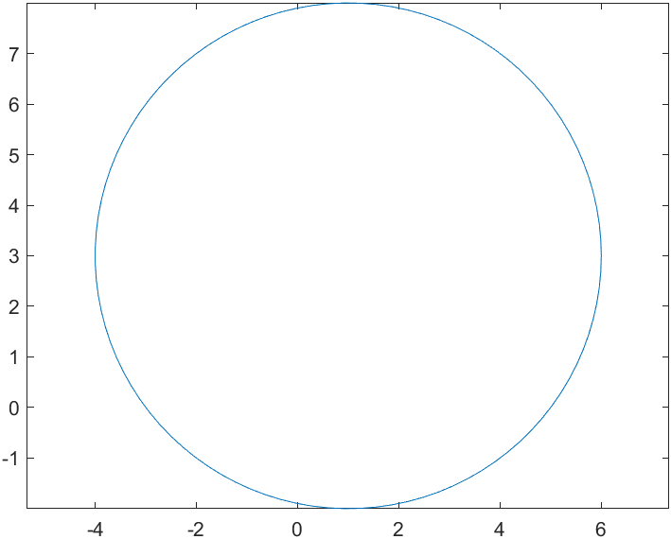

2. Draw the graph by using without hold on function

Code:

clc

clear all

x = 1

y = 3

t = linspace(0,2*pi,100)

x_axis = 5*cos(t) + x

y_axis = 5*sin(t) + y

plot(x_axis, y_axis)

axis equal

Figure:



3. Draw a surface by using plot3.

Code:

clc

clear all

a = linspace(0,100,100)

x = sin(a)

y = cos(a)

plot3(x,y,a)

Figure:

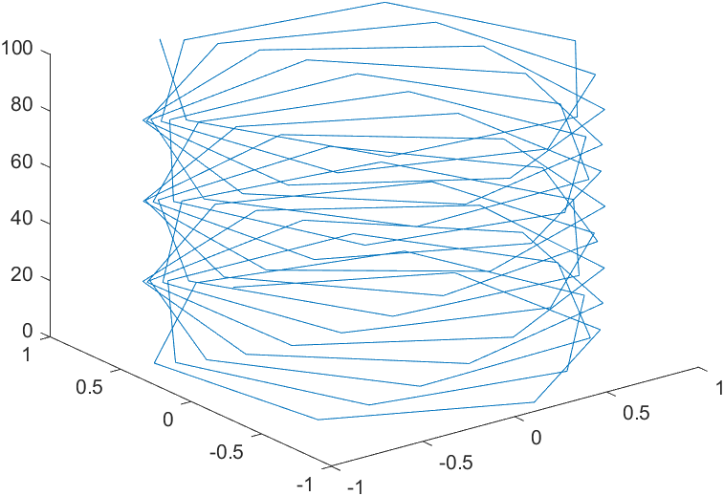

4. Draw the four curves sin 2x, cos x, e-2x, sin 3x in one window.

Code:

clc

clear all

x = linspace(0,2*pi,100)

a = sin(2*x)

b = cos(x)

c = exp(-2*x)

d = sin(3*x)

plot(x,a,'r--',x,b,'g*',x,c,'y.',x,d)

Figure:

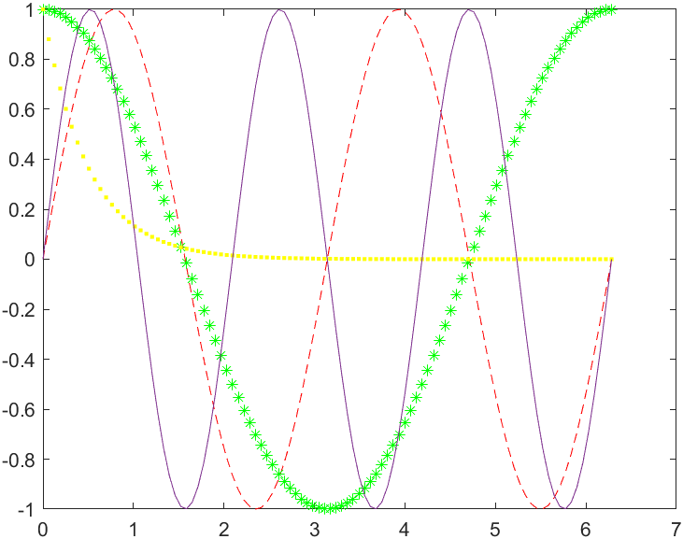

5. Draw a surface using ezplot and ezsurf.

Code:

clc

clear all

syms x y

ezsurf(x^2 + y^2)

Figure:

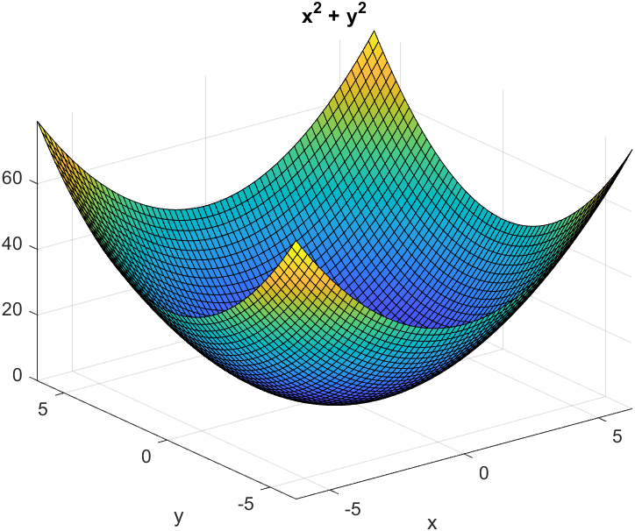

Code:

clc

clear all

syms x y

ezplot(x^2)

Figure:

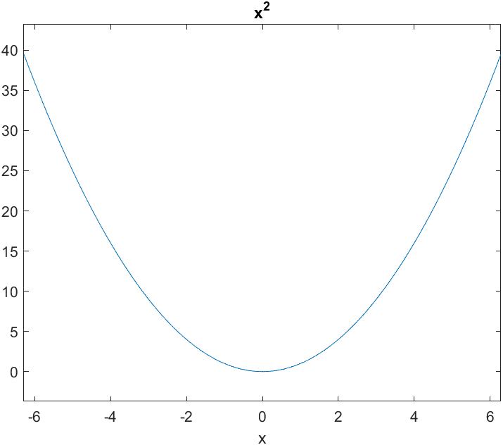

6. Draw the ezplot for the function $x^{2}+2x-6$.

Code:

clc

clear all

syms x y

ezplot(x^2 - 2*x +6)

Figure:

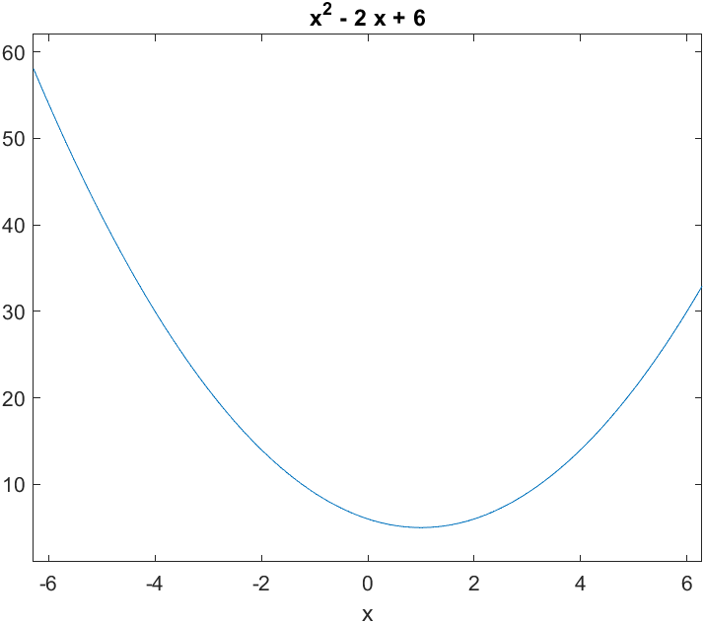

7. Find the equation of the tangent to the curve $y=4-x^{2}$ at $(-1,3)$

Code:

clc

clear all

clear fig

syms x y

f=4-x^2

fx=diff(f,x)

slope=subs(fx,-1)

y=3+slope*(x+1)

sprintf('The equation of tangent is',y)

disp(y)

Output:

ans =

'The equation of tangent is'

2*x + 5

8. Find the equation of the tangent to the curve $y=2\sqrt{x}$ at $(1,2)$

Code:

clc

clear all

clear fig

syms x y

f=2*(x)^0.5

fx=diff(f,x)

slope=subs(fx,1)

y=2+slope*(x+1)

sprintf('The equation of tangent is',y)

disp(y)

Output:

ans =

'The equation of tangent is'

x + 3

9. Find the equation of the tangent to the curve $y=x^{3}$ at $(-2,-8)$

Code:

clc

clear all

clear fig

syms x y

f=x^3

fx=diff(f,x)

slope=subs(fx,-2)

y=-8+slope*(x+1)

sprintf('The equation of tangent is',y)

disp(y)

Output:

ans =

'The equation of tangent is'

12*x + 4