**Calculus Lab Assignment 2 Part 2**

**Rahul Karthik S**

**21BME1059**

1. Obtain the maximum and minimum values of f(x,y)=2(x2-y2)-x4+y4

Program Code:

clc

clear all

format compact

syms x y k T3 real

f = 2*(x^2 - y^2)- x^4 + y^4

fx = diff(f,x);

fy = diff(f,y);

[ax ay] = solve(fx,fy);

fxx = diff(fx,x);

D = fxx*diff(fy,y) - diff(fx,y)^2;

r=1;

a1=max(double(ax))

a2=min(double(ax))

b1=max(double(ay))

b2=min(double(ay))

ezsurf(f,[a2-.5,a1+.5,b2-.5,b1+.5])

colormap('turbo');

shading interp

hold on

for r1=1:size(ax)

T1=subs(subs(D,x,ax(r1)),y,ay(r1));

T2=subs(subs(fxx,x,ax(r1)),y,ay(r1));

if (double(T1) == 0)

sprintf('The point (x,y) is (%d,%d) and need further investigation', double(ax(r1)),double(ay(r1)))

elseif (double(T1) < 0)

T3=subs(subs(f,x,ax(r1)),y,ay(r1))

sprintf('The point (x,y) is (%d,%d) a saddle point', double(ax(r1)),double(ay(r1)))

plot3(double(ax(r1)),double(ay(r1)),double(T3),'r.','markersize',30);

else

if (double(T2) < 0)

sprintf('The maximum point(x,y) is (%d, %d)', double(ax(r1)),double(ay(r1)))

T3=subs(subs(f,x,ax(r1)),y,ay(r1))

sprintf('The value of the function is %d', double(T3))

plot3(double(ax(r1)),double(ay(r1)),double(T3),'g+','markersize',30);

else

sprintf('The minimum point(x,y) is (%d, %d)', double(ax(r1)),double(ay(r1)))

T3=subs(subs(f,x,ax(r1)),y,ay(r1))

sprintf('The value of the function is %d', double(T3))

plot3(double(ax(r1)),double(ay(r1)),double(T3),'b*','markersize',30);

end

end

end

Output:

f =

- x^4 + 2*x^2 + y^4 - 2*y^2

a1 =

1

a2 =

-1

b1 =

1

b2 =

-1

T3 =

0

ans =

'The point (x,y) is (0,0) a saddle point'

ans =

'The maximum point(x,y) is (-1, 0)'

T3 =

1

ans =

'The value of the function is 1'

ans =

'The maximum point(x,y) is (1, 0)'

T3 =

1

ans =

'The value of the function is 1'

ans =

'The minimum point(x,y) is (0, -1)'

T3 =

-1

ans =

'The value of the function is -1'

ans =

'The minimum point(x,y) is (0, 1)'

T3 =

-1

ans =

'The value of the function is -1'

T3 =

0

ans =

'The point (x,y) is (-1,-1) a saddle point'

T3 =

0

ans =

'The point (x,y) is (1,-1) a saddle point'

T3 =

0

ans =

'The point (x,y) is (-1,1) a saddle point'

T3 =

0

ans =

'The point (x,y) is (1,1) a saddle point'

Figure Window:

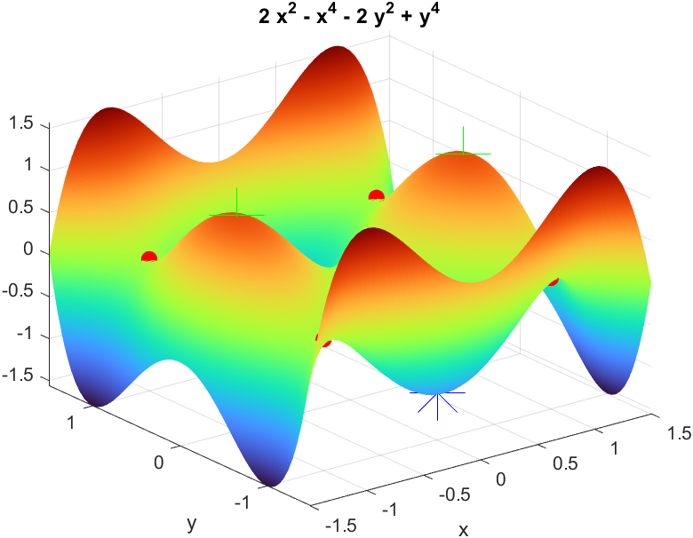

4. Find the maximum and minimum value of the following function F(x,y)= 2x3+xy2+5x2+y2

Program Code:

clc

clear all

format compact

syms x y k T3 real

f = 2*x^3+x*y^2+5*x^2+y^2;

fx = diff(f,x);

fy = diff(f,y);

[ax ay] = solve(fx,fy);

fxx = diff(fx,x);

D = fxx*diff(fy,y) - diff(fx,y)^2;

r=1;

a1=max(double(ax))

a2=min(double(ax))

b1=max(double(ay))

b2=min(double(ay))

ezsurf(f,[a2-.5,a1+.5,b2-.5,b1+.5])

colormap('jet');

shading interp

hold on

for r1=1:size(ax)

T1=subs(subs(D,x,ax(r1)),y,ay(r1));

T2=subs(subs(fxx,x,ax(r1)),y,ay(r1));

if (double(T1) == 0)

sprintf('The point (x,y) is (%d,%d) and need further investigation', double(ax(r1)),double(ay(r1)))

elseif (double(T1) < 0)

T3=subs(subs(f,x,ax(r1)),y,ay(r1))

sprintf('The point (x,y) is (%d,%d) a saddle point', double(ax(r1)),double(ay(r1)))

plot3(double(ax(r1)),double(ay(r1)),double(T3),'b.','markersize',30);

else

if (double(T2) < 0)

sprintf('The maximum point(x,y) is (%d, %d)', double(ax(r1)),double(ay(r1)))

T3=subs(subs(f,x,ax(r1)),y,ay(r1))

sprintf('The value of the function is %d', double(T3))

plot3(double(ax(r1)),double(ay(r1)),double(T3),'r+','markersize',30);

else

sprintf('The minimum point(x,y) is (%d, %d)', double(ax(r1)),double(ay(r1)))

T3=subs(subs(f,x,ax(r1)),y,ay(r1))

sprintf('The value of the function is %d', double(T3))

plot3(double(ax(r1)),double(ay(r1)),double(T3),'m*','markersize',30);

end

end

end

Output:

a1 =

0

a2 =

-1.6667

b1 =

2

b2 =

-2

ans =

'The minimum point(x,y) is (0, 0)'

T3 =

0

ans =

'The value of the function is 0'

T3 =

3

ans =

'The point (x,y) is (-1,-2) a saddle point'

T3 =

3

ans =

'The point (x,y) is (-1,2) a saddle point'

ans =

'The maximum point(x,y) is (-1.666667e+00, 0)'

T3 =

125/27

ans =

'The value of the function is 4.629630e+00'

Figure Window:

