**Assignment 2: Plotting of Curves**

**Rahul Karthik S**

**21BME1059**

1. Find two positive numbers whose sum is 300 and whose product is a maximum.

Program Code:

clc

clear all

syms x

f = x*(300-x);

fx = diff(f,x)

c = solve(fx);

y = 300-c;

display(c)

display(y)

Output:

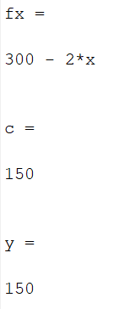

2. Find local maxima and minima for $y=\frac{x^{3}}{3}-\frac{x^{2} }{2}-2x+13$ and visualize the concavity.   
  
Program Code:   
  
clc

syms x real

f= (x^3)/3 - (x^2)/2 - 2*x + 13;

fx = diff(f,x)

c = solve(fx)

cmin = min(double(c));

cmax = max(double(c));

figure(1)

ezplot(f,[cmin-2,cmax+2])

hold on

fxx = diff(fx,x)

for i = 1:1:size(c)

T1 = subs(fxx, x ,c(i) );

T3= subs(f, x, c(i));

if (double(T1)==0)

sprintf('The test fails at x = %d' ,double (c(i)))

else

if (double(T1) < 0)

sprintf('The maximum point x is %d', double(c(i)))

sprintf('The value of the function is %d', double (T3))

else

sprintf('The minimum point x is %d', double(c(i)))

sprintf('The value of the function is %d', double (T3))

end

end

plot(double(c(i)), double(T3), 'r*', 'markersize', 15);

end

de = polynomialDegree(fxx);

if(de==0)

sprintf('the given polynomial is second degree or less')

else

d = solve(fxx) % finding inflection points

for i = 1:1:size(d)

T2 = subs(f, x ,d(i) );

R1=sign(subs(fxx,x,d(i)+0.0001));

L1=sign(subs(fxx,x,d(i)-0.0001));

check=abs(L1-R1)

if (check==2)

sprintf('The point x=%d is a point of inflection',double (d(i)))

else

sprintf('The point x=%d is not a point of inflection',double (d(i)))

end

plot(double(d(i)), double(T2), 'g*', 'markersize', 15);

end

end

figure(2)

ezplot(fx,[cmin-2,cmax+2])

title('Plotting first derivative of f and critical points')

hold on

for i = 1:1:size(c)

T4 = subs(fx, x ,c(i) );

plot(double(c(i)), double(T4), 'r*', 'markersize', 15);

end

figure(3)

ezplot(fxx,[cmin-2,cmax+2])

hold on

if(de==0)

sprintf('the given polynomial is second degree or less, second derivative plot is not possible')

else

for i = 1:1:size(d)

T4 = subs(fxx, x ,d(i) );

plot(double(d(i)), double(T4), 'r*', 'markersize', 15);

end

title('Plotting second derivative of f and inflection points ')

end

Output:

fx =

x^2 - x - 2

c =

-1

2

fxx =

2*x - 1

ans =

'The maximum point x is -1'

ans =

'The value of the function is 1.416667e+01'

ans =

'The minimum point x is 2'

ans =

'The value of the function is 9.666667e+00'

d =

1/2

check =

2

ans =

'The point x=5.000000e-01 is a point of inflection'

Figure Window:

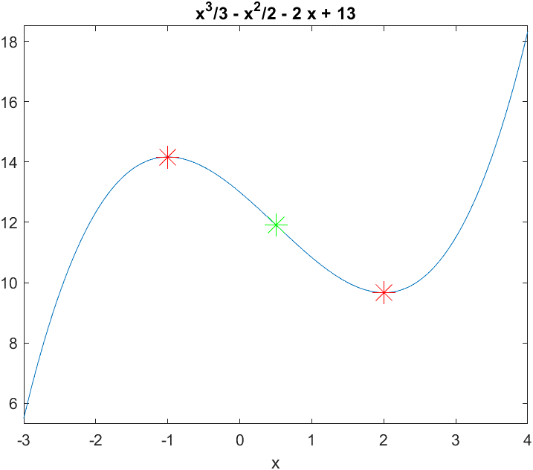

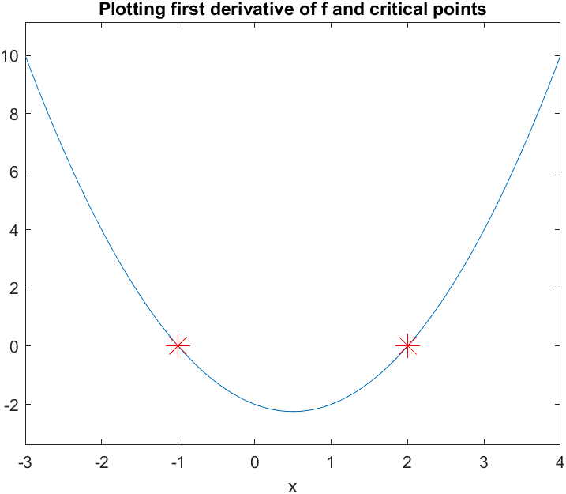

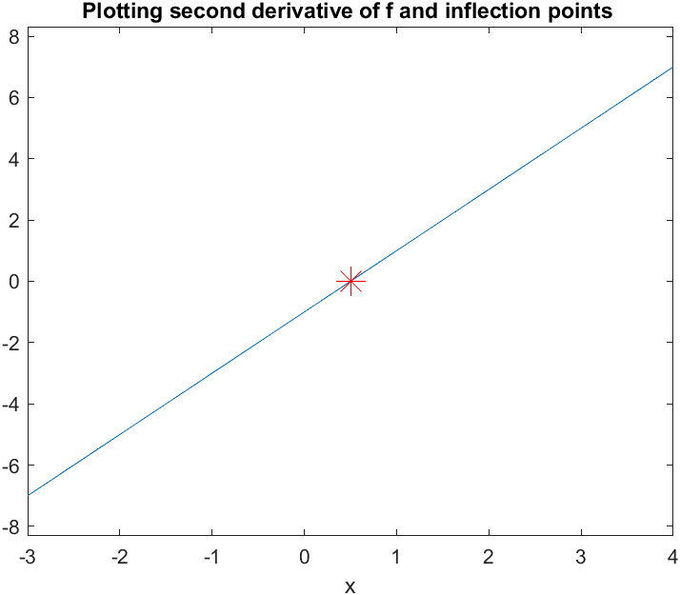

3. Obtain the maximum and minimum values of f(x,y)=2(x2-y2)-x4+y4

Program Code:

clc

clear all

format compact

syms x y k T3 real

f = 2*(x^2 - y^2)- x^4 + y^4

fx = diff(f,x);

fy = diff(f,y);

[ax ay] = solve(fx,fy);

fxx = diff(fx,x);

D = fxx*diff(fy,y) - diff(fx,y)^2;

r=1;

a1=max(double(ax))

a2=min(double(ax))

b1=max(double(ay))

b2=min(double(ay))

ezsurf(f,[a2-.5,a1+.5,b2-.5,b1+.5])

colormap('turbo');

shading interp

hold on

for r1=1:size(ax)

T1=subs(subs(D,x,ax(r1)),y,ay(r1));

T2=subs(subs(fxx,x,ax(r1)),y,ay(r1));

if (double(T1) == 0)

sprintf('The point (x,y) is (%d,%d) and need further investigation', double(ax(r1)),double(ay(r1)))

elseif (double(T1) < 0)

T3=subs(subs(f,x,ax(r1)),y,ay(r1))

sprintf('The point (x,y) is (%d,%d) a saddle point', double(ax(r1)),double(ay(r1)))

plot3(double(ax(r1)),double(ay(r1)),double(T3),'r.','markersize',30);

else

if (double(T2) < 0)

sprintf('The maximum point(x,y) is (%d, %d)', double(ax(r1)),double(ay(r1)))

T3=subs(subs(f,x,ax(r1)),y,ay(r1))

sprintf('The value of the function is %d', double(T3))

plot3(double(ax(r1)),double(ay(r1)),double(T3),'g+','markersize',30);

else

sprintf('The minimum point(x,y) is (%d, %d)', double(ax(r1)),double(ay(r1)))

T3=subs(subs(f,x,ax(r1)),y,ay(r1))

sprintf('The value of the function is %d', double(T3))

plot3(double(ax(r1)),double(ay(r1)),double(T3),'b*','markersize',30);

end

end

end

Output:

f =

- x^4 + 2*x^2 + y^4 - 2*y^2

a1 =

1

a2 =

-1

b1 =

1

b2 =

-1

T3 =

0

ans =

'The point (x,y) is (0,0) a saddle point'

ans =

'The maximum point(x,y) is (-1, 0)'

T3 =

1

ans =

'The value of the function is 1'

ans =

'The maximum point(x,y) is (1, 0)'

T3 =

1

ans =

'The value of the function is 1'

ans =

'The minimum point(x,y) is (0, -1)'

T3 =

-1

ans =

'The value of the function is -1'

ans =

'The minimum point(x,y) is (0, 1)'

T3 =

-1

ans =

'The value of the function is -1'

T3 =

0

ans =

'The point (x,y) is (-1,-1) a saddle point'

T3 =

0

ans =

'The point (x,y) is (1,-1) a saddle point'

T3 =

0

ans =

'The point (x,y) is (-1,1) a saddle point'

T3 =

0

ans =

'The point (x,y) is (1,1) a saddle point'

Figure Window:  
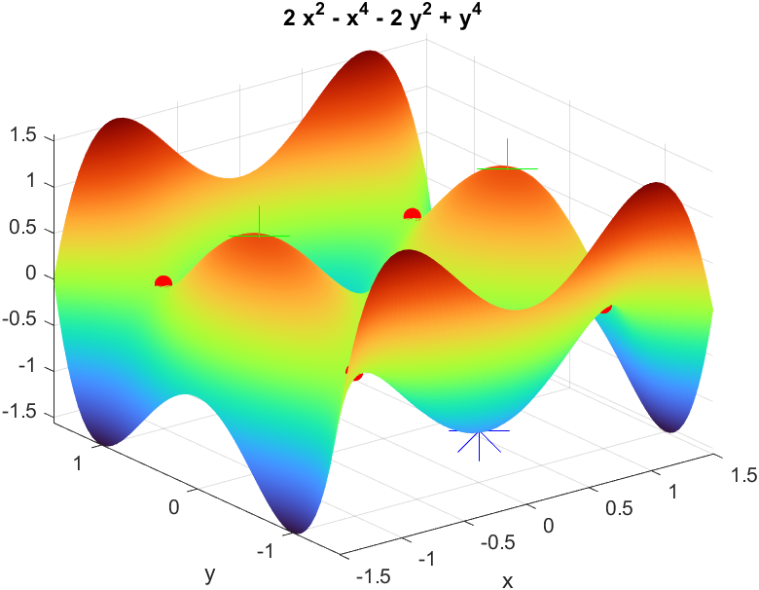

4. Find the maximum and minimum value of the following function F(x,y)= 2x3+xy2+5x2+y2

Program Code:

clc

clear all

format compact

syms x y k T3 real

f = 2*x^3+x*y^2+5*x^2+y^2;

fx = diff(f,x);

fy = diff(f,y);

[ax ay] = solve(fx,fy);

fxx = diff(fx,x);

D = fxx*diff(fy,y) - diff(fx,y)^2;

r=1;

a1=max(double(ax))

a2=min(double(ax))

b1=max(double(ay))

b2=min(double(ay))

ezsurf(f,[a2-.5,a1+.5,b2-.5,b1+.5])

colormap('jet');

shading interp

hold on

for r1=1:size(ax)

T1=subs(subs(D,x,ax(r1)),y,ay(r1));

T2=subs(subs(fxx,x,ax(r1)),y,ay(r1));

if (double(T1) == 0)

sprintf('The point (x,y) is (%d,%d) and need further investigation', double(ax(r1)),double(ay(r1)))

elseif (double(T1) < 0)

T3=subs(subs(f,x,ax(r1)),y,ay(r1))

sprintf('The point (x,y) is (%d,%d) a saddle point', double(ax(r1)),double(ay(r1)))

plot3(double(ax(r1)),double(ay(r1)),double(T3),'b.','markersize',30);

else

if (double(T2) < 0)

sprintf('The maximum point(x,y) is (%d, %d)', double(ax(r1)),double(ay(r1)))

T3=subs(subs(f,x,ax(r1)),y,ay(r1))

sprintf('The value of the function is %d', double(T3))

plot3(double(ax(r1)),double(ay(r1)),double(T3),'r+','markersize',30);

else

sprintf('The minimum point(x,y) is (%d, %d)', double(ax(r1)),double(ay(r1)))

T3=subs(subs(f,x,ax(r1)),y,ay(r1))

sprintf('The value of the function is %d', double(T3))

plot3(double(ax(r1)),double(ay(r1)),double(T3),'m*','markersize',30);

end

end

end

Output:

a1 =

0

a2 =

-1.6667

b1 =

2

b2 =

-2

ans =

'The minimum point(x,y) is (0, 0)'

T3 =

0

ans =

'The value of the function is 0'

T3 =

3

ans =

'The point (x,y) is (-1,-2) a saddle point'

T3 =

3

ans =

'The point (x,y) is (-1,2) a saddle point'

ans =

'The maximum point(x,y) is (-1.666667e+00, 0)'

T3 =

125/27

ans =

'The value of the function is 4.629630e+00'

Figure Window:

