**Experiment 3: Definite Integrals, Riemann sums and finding the area between the curves using integration**

**Rahul Karthik S  
21BME1059**

1. Evaluate 0 $<x<2π$.

Program Code:  
clc

clear all

syms x

f = sin(x);

ll = 0

ul = 2*pi

n = 10;

z=int(f,ll,ul)

value=0;

dx=(ul-ll)/n;

for k=1:n

c=ll+k*dx;

d=subs(f,x,c);

value=value+d;

end

value=dx*value

ezplot(f,[ll,ul])

z=int(f,ll,ul)

rsums(f,ll,ul)

Output:

ll =

0

ul =

6.2832

z =

0

value =

0

z =

0  
  
Figure:  
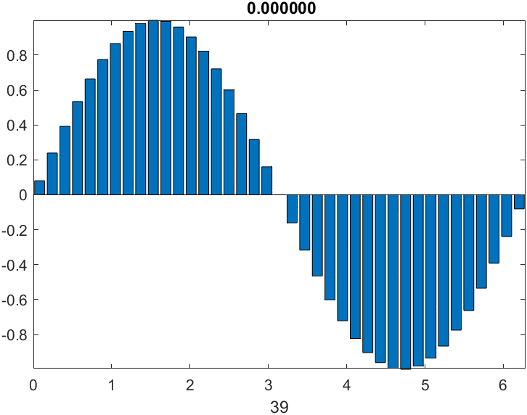

1. Find the area of the regions enclosed by the curves 

Program Code:  
  
clc

clear all

syms x y

y1 = x;

y2 = x^2-2*x;

fg = figure;

ax = axes;

ez1 = ezplot(char(y1));

hold on

ez2 = ezplot(char(y2));

hold on

t = solve(y1-y2)

f = int(y1-y2,t(1),t(2))

kokler = double(t)

x1 = linspace(kokler(1),kokler(2));

yy1 = subs(y1,x,x1);

yy2 = subs(y2,x,x1);

x1 = [x1,x1];

yy = [yy1,yy2];

fill(x1,yy,'g')

grid on

f = int(y1-y2,t(1),t(2))

Output:

t =

0

3

f =

9/2

kokler =

0

3

f =

9/2  
  
Figure:  
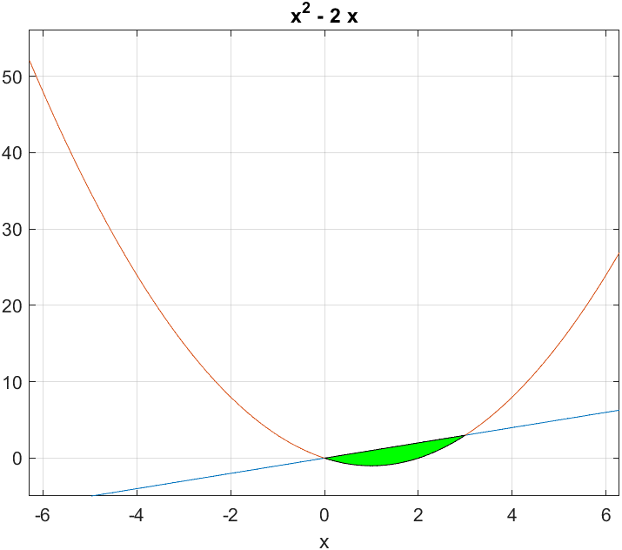

1. Find the area of the regions enclosed by the curves 

Program Code:  
clc

clear all

syms x y

y1 = -x^2+4*x;

y2 = x^2;

fg = figure;

ax = axes;

ez1 = ezplot(char(y1));

hold on

ez2 = ezplot(char(y2));

hold on

t = solve(y1-y2)

f = int(y1-y2,t(1),t(2))

kokler = double(t)

x1 = linspace(kokler(1),kokler(2));

yy1 = subs(y1,x,x1);

yy2 = subs(y2,x,x1);

x1 = [x1,x1];

yy = [yy1,yy2];

fill(x1,yy,'g')

grid on

f = int(y1-y2,t(1),t(2))  
Output:

t =

-2

0

f =

8/3

kokler =

-2

0

f =

8/3

Figure:  
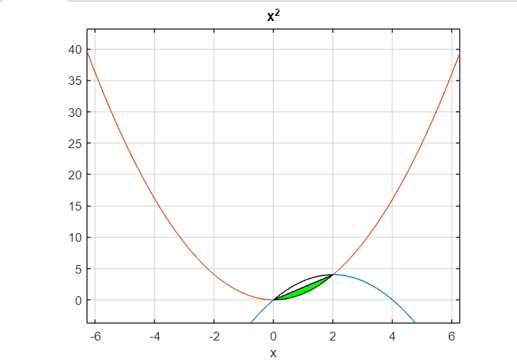

1. Find the area of the regions enclosed by the curves 

Program Code:  
clc

clear all

syms x y

y1 = 7-2*x^2;

y2 = x^2 + 4;

fg = figure;

ax = axes;

ez1 = ezplot(char(y1));

hold on

ez2 = ezplot(char(y2));

hold on

t = solve(y1-y2)

f = int(y1-y2,t(1),t(2))

kokler = double(t)

x1 = linspace(kokler(1),kokler(2));

yy1 = subs(y1,x,x1);

yy2 = subs(y2,x,x1);

x1 = [x1,x1];

yy = [yy1,yy2];

fill(x1,yy,'g')

grid on

f = int(y1-y2,t(1),t(2))  
Output:

t =

-1

1

f =

4

kokler =

-1

1

f =

4

Figure:

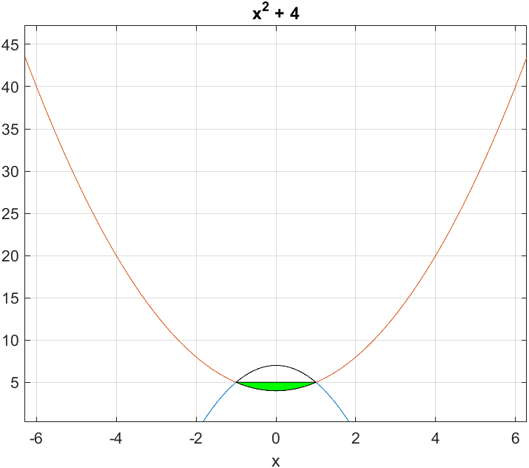

1. Find the volume of the solid generated by revolving the region bounded by y=√x and the lines y= 1,x= 4 about the line y= 1.

Program Code:

clc

clear vars

syms x

f = x^(1/2);

fL = [0 4];

yr = 1;

iL = [1 4];

Volume = pi*int((f-yr)^2,iL(1),iL(2));

disp(['Volume is: ', num2str(double(Volume))])

fx = inline(vectorize(f))

xvals = linspace(fL(1),fL(2),201)

xvalsr = fliplr(xvals)

xivals = linspace(iL(1),iL(2),201)

xivalsr = fliplr(xivals)

xlim = [fL(1) fL(2)+0.5]

ylim = fx(xlim)

figure('Position',[100 200 560 420])

subplot(2,1,1)

hold on

plot(xvals,fx(xvals),'b','LineWidth',2)

fill([xvals xvalsr],[fx(xvals) ones(size(xvalsr))*yr],[0.8 0.8 0.8],'FaceAlpha',0.8)

plot([fL(1) fL(2)],[yr yr],'r','LineWidth',2)

legend('Function Plot','Filled Region','Axis of Rotation','Location','Best')

title('Function y=f(x) and Region')

set(gca,'XLim',xlim)

xlabel('x−axis')

ylabel('y−axis')

subplot(2,1,2)

hold on;

plot(xivals,fx(xivals),'b','LineWidth',2)

fill([xivals xivalsr],[fx(xivals) ones(size(xivalsr))*yr],[0.8 0.8 0.8],'FaceAlpha',0.8)

fill([xivals xivalsr],[ones(size(xivals))*yr -fx(xivalsr)+2*yr],[1 0.8 0.8],'FaceAlpha',0.8)

plot(xivals,-fx(xivals)+2*yr,'-m','LineWidth',2)

plot([iL(1) iL(2)],[yr yr],'r','LineWidth',2)

title('Rotated Region in xy−Plane')

set(gca,'XLim',xlim)

xlabel('x−axis')

ylabel('y−axis')

[X,Y,Z] = cylinder(fx(xivals)-yr,100)

figure('Position',[700 200 560 420])

Z = iL(1) + Z.*(iL(2)-iL(1));

surf(Z,Y+yr,X,'EdgeColor','none','FaceColor','flat','FaceAlpha',0.6)

hold on;

plot([iL(1) iL(2)],[yr yr],'r','LineWidth',2)

xlabel('X−axis');

ylabel('Y−axis');

zlabel('Z−axis');

view(22,11)

Output:

Volume is: 3.6652

Figure:

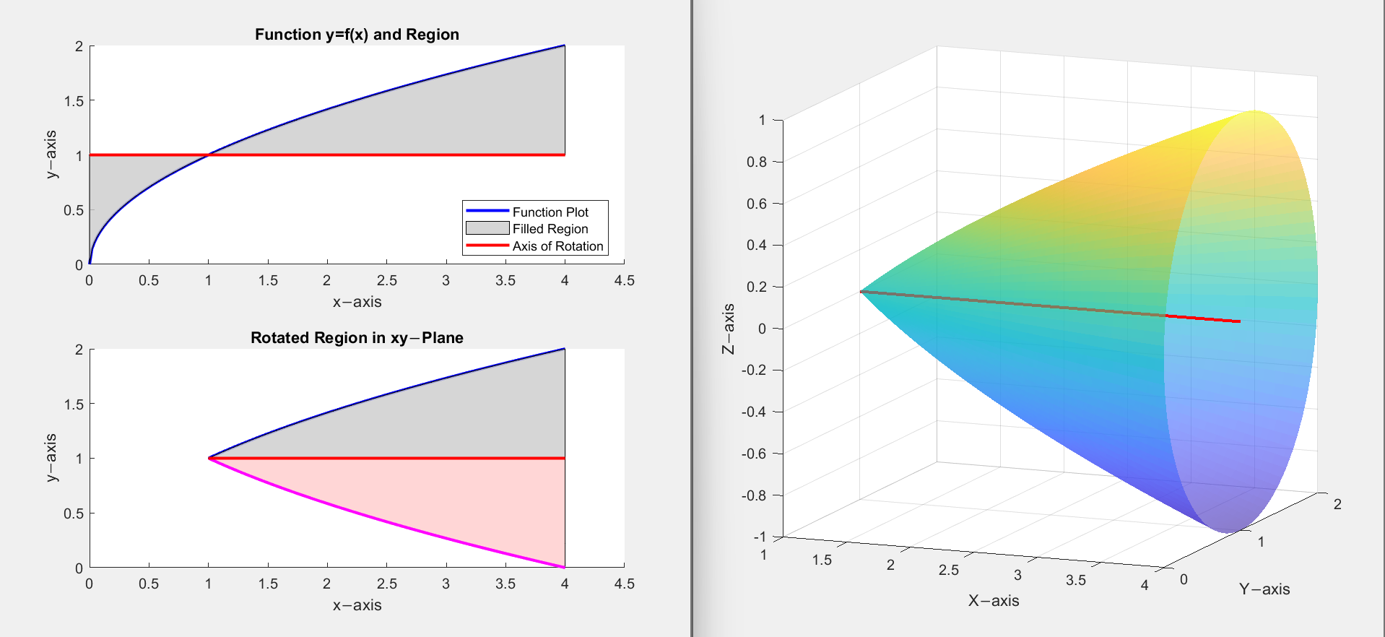

1. Find the volume of the solid generated by revolving the region bounded by y=√x 0≤x≤4 about the line y= 1.

Program Code:  
clc

clear vars

syms x

f = sqrt(x)

fL = [0 4]

yr = 1

iL = [0 4]

Volume = pi*int((f-yr)^2,iL(1),iL(2))

disp(['Volume is: ', num2str(double(Volume))])

fx = inline(vectorize(f))

xvals = linspace(fL(1),fL(2),201)

xvalsr = fliplr(xvals)

xivals = linspace(iL(1),iL(2),201)

xivalsr = fliplr(xivals)

xlim = [fL(1) fL(2)+0.5]

ylim = fx(xlim)

figure('Position',[100 200 560 420])

subplot(2,1,1)

hold on

plot(xvals,fx(xvals),'b','LineWidth',2)

fill([xvals xvalsr],[fx(xvals) ones(size(xvalsr))*yr],[0.8 0.8 0.8],'FaceAlpha',0.8)

plot([fL(1) fL(2)],[yr yr],'r','LineWidth',2)

legend('Function Plot','Filled Region','Axis of Rotation','Location','Best')

title('Function y=f(x) and Region')

set(gca,'XLim',xlim)

xlabel('x−axis')

ylabel('y−axis')

subplot(2,1,2)

hold on;

plot(xivals,fx(xivals),'b','LineWidth',2)

fill([xivals xivalsr],[fx(xivals) ones(size(xivalsr))*yr],[0.8 0.8 0.8],'FaceAlpha',0.8)

fill([xivals xivalsr],[ones(size(xivals))*yr -fx(xivalsr)+2*yr],[1 0.8 0.8],'FaceAlpha',0.8)

plot(xivals,-fx(xivals)+2*yr,'-m','LineWidth',2)

plot([iL(1) iL(2)],[yr yr],'r','LineWidth',2)

title('Rotated Region in xy−Plane')

set(gca,'XLim',xlim)

xlabel('x−axis')

ylabel('y−axis')

[X,Y,Z] = cylinder(fx(xivals)-yr,100)

figure('Position',[700 200 560 420])

Z = iL(1) + Z.*(iL(2)-iL(1));

surf(Z,Y+yr,X,'EdgeColor','none','FaceColor','flat','FaceAlpha',0.6)

hold on;

plot([iL(1) iL(2)],[yr yr],'r','LineWidth',2)

xlabel('X−axis');

ylabel('Y−axis');

zlabel('Z−axis');

view(22,11)  
Output:

f =

x^(1/2)

fL =

0 4

yr =

1

iL =

0 4

Volume =

(4*pi)/3

Volume is: 4.1888

fx =

Inline function:

fx(x) = x.^(1./2)

xvals =  
Figure:  
