**Calculus Lab Digital Assignment 4: Constrained Maxima and Minima**

**Rahul Karthik S  
21BME1059**

1. Find the extreme values of the function $f(x,y) =$ $x^{2}+2y^{2}$ on the circle $x^{2}+y^{2}=1$

Program Code:

clc

clear all

format compact

syms x y lam real

f = input("Enter the function f(x, y) to be extremized: ");

g = input("Enter the constraint function g(x, y): ");

F = f - lam*g

Fd = jacobian(F,[x,y,lam]);

[ax, ay, alam]=solve(Fd,x,y,lam);

ax=double(ax);

ay=double(ay);

T = double(subs(f,{x,y},{ax,ay}));

expl = min(ax);

expr = max(ax);

eypl = min(ay);

eypu = max(ay);

D = [expl-0.5 expr+0.5 eypl-0.5 eypu+0.5]

ezcontourf(f,D)

hold on

h = ezplot(g,D);

set(h,'Color',[1,0.7,0.9])

for i = 1:length(T)

fprintf('The critical point (x,y) is (%1.3f,%1.3f) and ',ax(i),ay(i))

fprintf('the value of the function is %1.3f\n',T(i))

plot(ax(i),ay(i),'r.','markersize',10)

end

t = sort(T);

f_min = t(1);

f_max = t(end);

Command Window:

Enter the function f(x, y) to be extremized: x^2+2*y^2

Enter the constraint function g(x, y): x^2+y^2-1

F =

x^2 + 2*y^2 - lam*(x^2 + y^2 - 1)

D =

-1.5000 1.5000 -1.5000 1.5000

The critical point (x,y) is (-1.000,0.000) and the value of the function is 1.000

The critical point (x,y) is (1.000,0.000) and the value of the function is 1.000

The critical point (x,y) is (0.000,-1.000) and the value of the function is 2.000

The critical point (x,y) is (0.000,1.000) and the value of the function is 2.000

Figure Window:

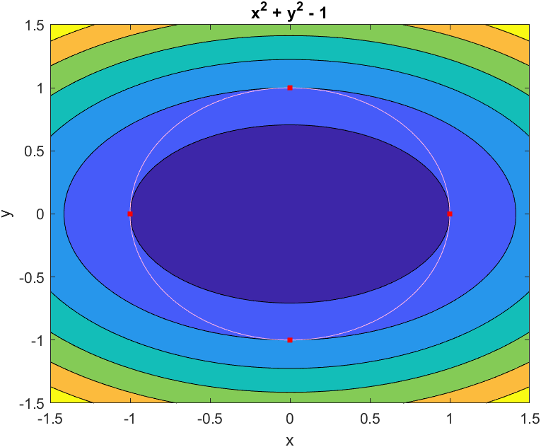

1. Find the extreme values of the function f(x,y) = $3x+4y$ on the circle $x^{2}+y^{2}=1$

Program code:

clc

clear all

format compact

syms x y lam real

f = input("Enter the function f(x, y) to be extremized: ");

g = input("Enter the constraint function g(x, y): ");

F = f - lam*g

Fd = jacobian(F,[x,y,lam]);

[ax, ay, alam]=solve(Fd,x,y,lam);

ax=double(ax);

ay=double(ay);

T = double(subs(f,{x,y},{ax,ay}));

expl = min(ax);

expr = max(ax);

eypl = min(ay);

eypu = max(ay);

D = [expl-0.5 expr+0.5 eypl-0.5 eypu+0.5]

ezcontourf(f,D)

hold on

h = ezplot(g,D);

set(h,'Color',[1,0.7,0.9])

for i = 1:length(T)

fprintf('The critical point (x,y) is (%1.3f,%1.3f) and ',ax(i),ay(i))

fprintf('the value of the function is %1.3f\n',T(i))

plot(ax(i),ay(i),'r.','markersize',10)

end

t = sort(T);

f_min = t(1);

f_max = t(end);

Command Window:

Enter the function f(x, y) to be extremized: 3*x+4*y

Enter the constraint function g(x, y): x^2+y^2-1

F =

3*x + 4*y - lam*(x^2 + y^2 - 1)

D =

-1.1000 1.1000 -1.3000 1.3000

The critical point (x,y) is (-0.600,-0.800) and the value of the function is -5.000

The critical point (x,y) is (0.600,0.800) and the value of the function is 5.000

Figure Window:

