**MATLAB 10**

**VECTOR FIELD**

**AIM:**

* To write the MATLAB code to visualize the vector field of 2-dimension as well as 3-dimension.

**Quiver function** (x,y,u,v): It displays the vectors with components (u,v) at the points (x,y)

1.Visualize the vector xi+yj

CODE:

clc

clear all

syms x y;

[x,y]=meshgrid([-1:0.25:1]);

u=x

v=y

quiver(x,y,u,v)

COMMAND WINDOW

u =  
  
 -1.0000 -0.7500 -0.5000 -0.2500 0 0.2500 0.5000 0.7500 1.0000  
 -1.0000 -0.7500 -0.5000 -0.2500 0 0.2500 0.5000 0.7500 1.0000  
 -1.0000 -0.7500 -0.5000 -0.2500 0 0.2500 0.5000 0.7500 1.0000  
 -1.0000 -0.7500 -0.5000 -0.2500 0 0.2500 0.5000 0.7500 1.0000  
 -1.0000 -0.7500 -0.5000 -0.2500 0 0.2500 0.5000 0.7500 1.0000  
 -1.0000 -0.7500 -0.5000 -0.2500 0 0.2500 0.5000 0.7500 1.0000  
 -1.0000 -0.7500 -0.5000 -0.2500 0 0.2500 0.5000 0.7500 1.0000  
 -1.0000 -0.7500 -0.5000 -0.2500 0 0.2500 0.5000 0.7500 1.0000  
 -1.0000 -0.7500 -0.5000 -0.2500 0 0.2500 0.5000 0.7500 1.0000  
  
  
v =  
  
 -1.0000 -1.0000 -1.0000 -1.0000 -1.0000 -1.0000 -1.0000 -1.0000 -1.0000  
 -0.7500 -0.7500 -0.7500 -0.7500 -0.7500 -0.7500 -0.7500 -0.7500 -0.7500  
 -0.5000 -0.5000 -0.5000 -0.5000 -0.5000 -0.5000 -0.5000 -0.5000 -0.5000  
 -0.2500 -0.2500 -0.2500 -0.2500 -0.2500 -0.2500 -0.2500 -0.2500 -0.2500  
 0 0 0 0 0 0 0 0 0  
 0.2500 0.2500 0.2500 0.2500 0.2500 0.2500 0.2500 0.2500 0.2500  
 0.5000 0.5000 0.5000 0.5000 0.5000 0.5000 0.5000 0.5000 0.5000  
 0.7500 0.7500 0.7500 0.7500 0.7500 0.7500 0.7500 0.7500 0.7500  
 1.0000 1.0000 1.0000 1.0000 1.0000 1.0000 1.0000 1.0000 1.0000

OUTPUT:

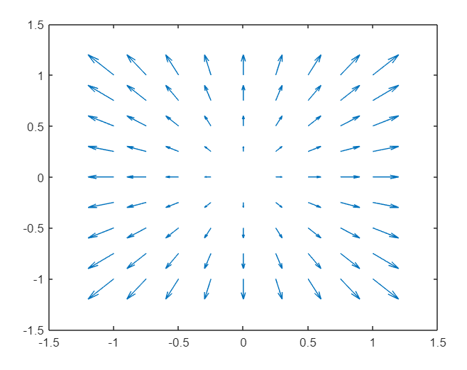

2.Visualize the vector yi-xj

CODE:

clc

clear all

syms x y;

[x,y]=meshgrid([-1:0.25:1]);

u=y

v=-x

quiver(x,y,u,v)

COMMAND WINDOW:

u =  
  
 -1.0000 -1.0000 -1.0000 -1.0000 -1.0000 -1.0000 -1.0000 -1.0000 -1.0000  
 -0.7500 -0.7500 -0.7500 -0.7500 -0.7500 -0.7500 -0.7500 -0.7500 -0.7500  
 -0.5000 -0.5000 -0.5000 -0.5000 -0.5000 -0.5000 -0.5000 -0.5000 -0.5000  
 -0.2500 -0.2500 -0.2500 -0.2500 -0.2500 -0.2500 -0.2500 -0.2500 -0.2500  
 0 0 0 0 0 0 0 0 0  
 0.2500 0.2500 0.2500 0.2500 0.2500 0.2500 0.2500 0.2500 0.2500  
 0.5000 0.5000 0.5000 0.5000 0.5000 0.5000 0.5000 0.5000 0.5000  
 0.7500 0.7500 0.7500 0.7500 0.7500 0.7500 0.7500 0.7500 0.7500  
 1.0000 1.0000 1.0000 1.0000 1.0000 1.0000 1.0000 1.0000 1.0000  
  
  
v =  
  
 1.0000 0.7500 0.5000 0.2500 0 -0.2500 -0.5000 -0.7500 -1.0000  
 1.0000 0.7500 0.5000 0.2500 0 -0.2500 -0.5000 -0.7500 -1.0000  
 1.0000 0.7500 0.5000 0.2500 0 -0.2500 -0.5000 -0.7500 -1.0000  
 1.0000 0.7500 0.5000 0.2500 0 -0.2500 -0.5000 -0.7500 -1.0000  
 1.0000 0.7500 0.5000 0.2500 0 -0.2500 -0.5000 -0.7500 -1.0000  
 1.0000 0.7500 0.5000 0.2500 0 -0.2500 -0.5000 -0.7500 -1.0000  
 1.0000 0.7500 0.5000 0.2500 0 -0.2500 -0.5000 -0.7500 -1.0000  
 1.0000 0.7500 0.5000 0.2500 0 -0.2500 -0.5000 -0.7500 -1.0000  
 1.0000 0.7500 0.5000 0.2500 0 -0.2500 -0.5000 -0.7500 -1.0000

OUTPUT:

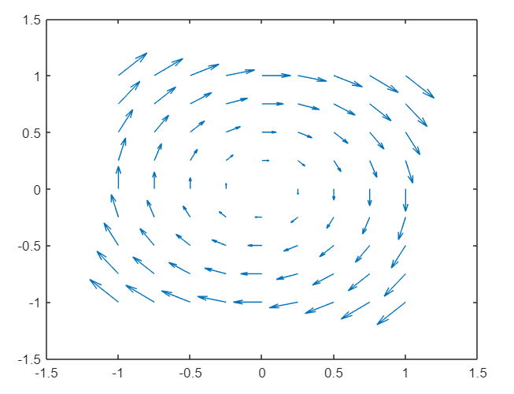

3.Visualize the vector (x+cos(4x) +3)i+(sin(4x)-sin(2y))j-zk

CODE:

clc

clear all

syms x y z;

[x,y,z]=meshgrid([-1.5:0.5:1.5]);

u=x+cos(4*x)+3;

v=sin(4*x)-sin(2*y);

w=-z;

quiver3(x,y,z,u,v,w)

OUTPUT:

