**MATLAB 4**

**DEFINITE INTEGRALS AND ITS APPLICATIONS**

**NAME: SANTHOSH KUMAR M**

**REGISTER NUMBER: 21BAI1336**

**AIM**

* To evaluate the definite integrals, Riemann sums and compare it.
* To find the area of the regions enclosed by curves and visualize it.

REIMANN SUM:

clc

clear all

syms x

f=input('enter the function of f(x): ')

a=input('enter the lower limit of x:')

b=input('enter the upper limit of x:')

n=input('number of intervals:')

z=int(a,f,b)

value=0;

dx=(b-a)/n;

for k=1:n

c=a+k*dx;

d=subs(f,x,c);

value=value+d;

end

valude=dx*value

ezplot(f,[a,b])

rsums(f,a,b)

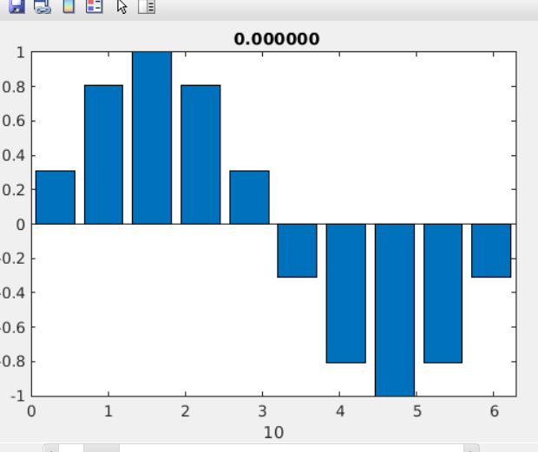

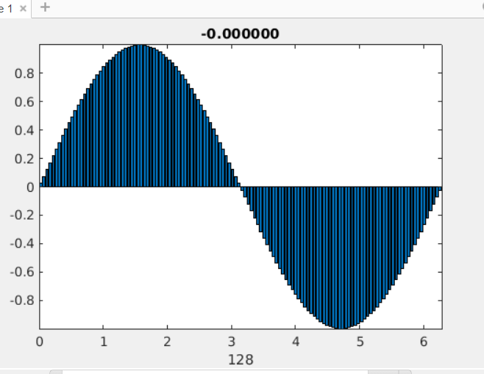

2.FIND THE AREA OF REGION ENCLOSED BY CURVES Y=X AND Y=X^2-2*X

clc

clear all

syms x y

y1=input("enter the y1 region value:")

y2=input("enter the y2 region values:")

ezl=ezplot(y1);

hold on

ez2=ezplot(y2);

hold on

t=solve(y1-y2);

f=int(y1-y2,t(1),t(2))

koler=double(t)

x1=linspace(kokler(1),kokler(2));

yy1=subs(y1,x,x1);

yy2=subs(y2,x,x1);

x1=[x1,x1];

yy=[yy1,yy2];

fill(xq,yy,'g')

grid on

f=int(y1-y2,t(1),t(2))

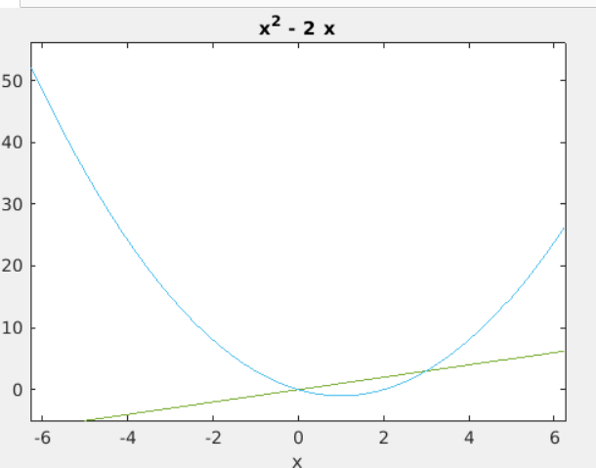

**PRACTICE PROBLEMS**

1.FIND THE AREA OF REGION ENCLOSED BY CURVES Y=-X^+4*X AND Y=X^2

clc

clear all

syms x y

y1=input("enter the y1 region value:")

y2=input("enter the y2 region values:")

ezl=ezplot(y1);

hold on

ez2=ezplot(y2);

hold on

t=solve(y1-y2);

f=int(y1-y2,t(1),t(2))

koler=double(t)

x1=linspace(kokler(1),kokler(2));

yy1=subs(y1,x,x1);

yy2=subs(y2,x,x1);

x1=[x1,x1];

yy=[yy1,yy2];

fill(xq,yy,'g')

grid on

f=int(y1-y2,t(1),t(2))

enter the y1 region value:

-x^2+4*x

y1 =  
   
- x^2 + 4*x  
   
enter the y2 region values:

x^2

y2 =  
   
x^2

f =  
   
8/3  
   
  
koler =  
  
 0  
 2

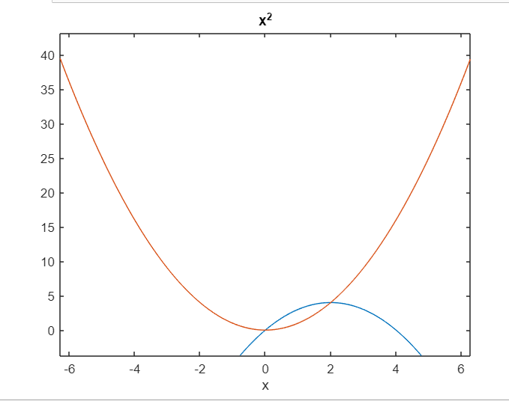

2.FIND THE AREA OF REGION ENCLOSED BY CURVES Y=7-2*X^2 AND Y=X^2+4

clc

clear all

syms x y

y1=input("enter the y1 region value:")

y2=input("enter the y2 region values:")

ezl=ezplot(y1);

hold on

ez2=ezplot(y2);

hold on

t=solve(y1-y2);

f=int(y1-y2,t(1),t(2))

koler=double(t)

x1=linspace(kokler(1),kokler(2));

yy1=subs(y1,x,x1);

yy2=subs(y2,x,x1);

x1=[x1,x1];

yy=[yy1,yy2];

fill(xq,yy,'g')

grid on

f=int(y1-y2,t(1),t(2))

enter the y1 region value:

7-2*x^2

y1 =  
   
7 - 2*x^2  
   
enter the y2 region values:

x^2+4

y2 =  
   
x^2 + 4

f =  
   
4  
   
  
koler =  
  
 -1  
 1

