**MATLAB 6**

**PARTIAL DERIVATIVES**

**NAME:** SHARAN N

**REGISTER NUMBER:** 20BCE1676

**AIM**

To write MATLAB code to find partial derivative of a given function f(x,y) at a given point (x1,y1) and also visualize it.

1.Find the partial derivative of the function F(x,y)= $4{-x}^{2}-2*y*2$ with respect to x at the point (1,1) and visualize it.

clc

clear all

syms x y

z=input("Enter the tow dimensional function f(x,y): ")

x1=input("enter the x value at which the derivative has to be evaluated: ");

y1=input("enter the y value at which the derivative has to be evaluated: ");

z1=subs(subs(z,x,x1),y,y1)

ezsurf(z,[x1-2 x1+2])

f1=diff(z,x)

slopex=subs(subs(f1,x,x1),y,y1);

[x2,z2]=meshgrid(x1-2:.25:x1+2,0:0.5:10);

y2=y1*ones(size(x2));

hold on

surf(x2,y2,z2);

t=linspace(-1,1);

x3=x1+t;

y3=y1*ones(size(t));

z3=z1+slope*t;

line(x3,y3,z3,'color','blue,''linewidth',2)

COMMAND WINDOW:

Enter the tow dimensional function f(x,y):

4-x^2-2*y^2

z =  
   
- x^2 - 2*y^2 + 4  
   
enter the x value at which the derivative has to be evaluuated: 1

enter the y value at which the derivative has to be evaluated: 1   
z1 =1   
f1 = -2*x

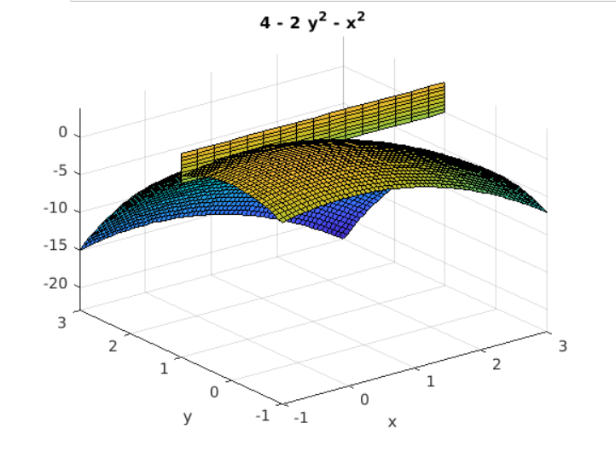

INFERENCE:

The curve in which the plane y=1 intersects the paraboloid is the parabola z=2-x^2 ,y=1

and the slope of the tangent line at (1,1,1) if fx(1,1)= -2.

PRACTICE PROBLEMS

1.Find the partial derivative of  with respect to x at the point (1,2)

clc

clear all

syms x y

z=input("Enter the tow dimensional function f(x,y): ")

x1=input("enter the x value at which the derivative has to be evaluuated: ");

y1=input("enter the y value at which the derivative has to be evaluated: ");

z1=subs(subs(z,x,x1),y,y1)

ezsurf(z,[x1-2 x1+2])

f1=diff(z,x)

slopex=subs(subs(f1,x,x1),y,y1);

[x2,z2]=meshgrid(x1-2:.25:x1+2,0:0.5:10);

y2=y1*ones(size(x2));

hold on

surf(x2,y2,z2);

t=linspace(-1,1);

x3=x1+t;

y3=y1*ones(size(t));

z3=z1+slope*t;

line(x3,y3,z3,'color','blue,''linewidth',2)

COMMAND WINDOW

Enter the two dimensional function f(x,y):

sin(x/(1+y))

z =sin(x/(y + 1))  
   
enter the x value at which the derivative has to be evaluated:

1

enter the y value at which the derivative has to be evaluated:

2

z1 =sin(1/3)  
f1 =cos(x/(y + 1))/(y + 1)

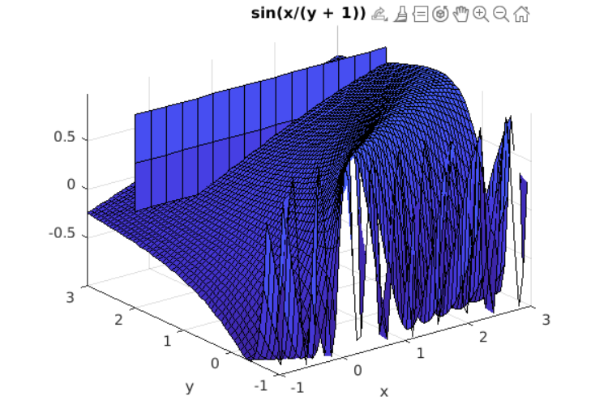

2. Find the partial derivative  with respect to y at the point (1,1)

clc

clear all

syms x y

z=input("Enter the two dimensional function f(x,y): ")

x1=input("enter the x value at which the derivative has to be evaluated: ");

y1=input("enter the y value at which the derivative has to be evaluated: ");

z1=subs(subs(z,x,x1),y,y1)

ezsurf(z,[x1-2 x1+2])

f1=diff(z,y)

slopex=subs(subs(f1,x,x1),y,y1);

[x2,z2]=meshgrid(x1-2:.25:x1+2,0:0.5:10);

y2=y1*ones(size(x2));

hold on

surf(x2,y2,z2);

t=linspace(-1,1);

x3=x1+t;

y3=y1*ones(size(t));

z3=z1+slope*t;

line(x3,y3,z3,'color','blue,''linewidth',2)

COMMAND WINDOW

Enter the two dimensional function f(x,y):

x^3+y^3+6*x*y-1

z =x^3 + 6*x*y + y^3 - 1  
enter the x value at which the derivative has to be evaluated:

1

enter the y value at which the derivative has to be evaluated:

1  
z1 =7  
f1 = 3*y^2 + 6*x

