**MATLAB 5**

**LOCAL MAXIMA AND MINIMA**

**NAME: SANTHOSH KUMAR M**

**REGISTER NUMBER: 21BAI1336**

**AIM:**

* To write MATLAB code to evaluate and visualize the critical points, maximum point, minimum points and saddle points of the function f(x,y)

1.Investigate maximum and minimum for the following function 

CODE:

clc

clear all

syms x y real

f=input("Enter the function f(x,y)");

fx=diff(f,x);

fy=diff(f,y);

[ax ay]=solve(fx,fy);

fxx=diff(fx,x);

fyy=diff(fy,y);

fxy=diff(fx,y);

d=fxx*fyy-fxy^2;

for i=1:1:size(ax)

figure

t1=subs(subs(d,x,ax(i)),y,ay(i));

t2=subs(subs(fxx,x,ax(i)),y,ay(i));

t3=subs(subs(f,x,ax(i)),y,ay(i));

if (double(t1)==0)

sprintf("the point (x,y) is (%d,%d) need further investigation",double(ax(i)),double(ay(i)))

elseif(double(t1)<0)

sprintf("the point (x,y) is (%d,%d) is saddle point",double(ax(i)),double(ay(i)))

else

if(double(t2)<0)

sprintf("the maximum point (x,y) is (%d,%d)",double(ax(i)),double(ay(i)))

sprintf("the value of the function is %d",double(t3))

else

sprintf("the minimum point (x,y) is (%d,%d)",double(ax(i)),double(ay(i)))

sprintf("the value of the function is %d",double(t3))

end

end

ezsurf(f,[double(ax(i))-2,double(ax(i))+2,double(ay(i))-2,double(ay(i))+2]);

hold on

plot3(double(ax(i)),double(ay(i)),double(t3),'r*','markersize',15);

end

COMMAND WINDOW

Enter the function f(x,y)

x^4+y^4-4*x*y+1

ans = "the point (x,y) is (0,0) is saddle point"

ans = "the minimum point (x,y) is (-1,-1)"  
  
  
ans = "the value of the function is -1"

ans = "the minimum point (x,y) is (1,1)"  
  
  
ans = "the value of the function is -1"

OUTPUT

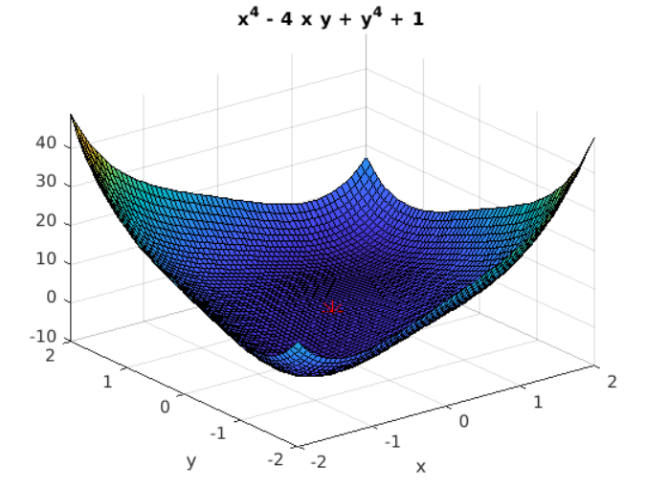

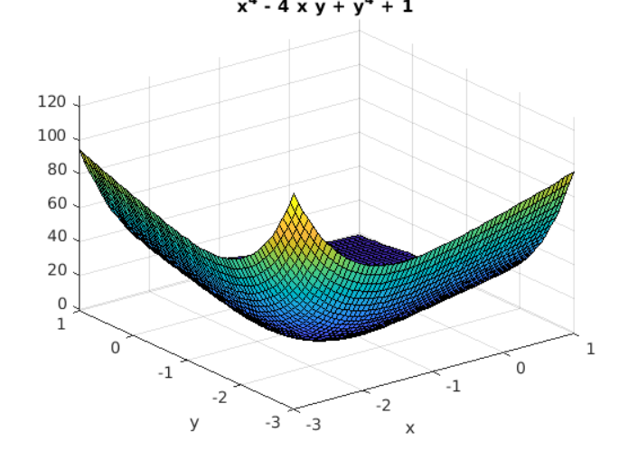

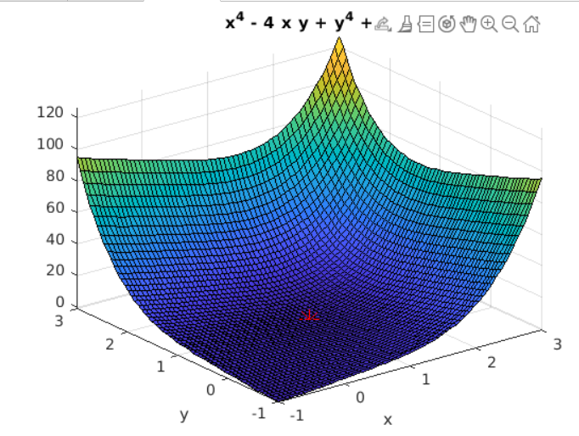

2. Find the maximum and minimum values of the function 

CODE:

clc

clear all

syms x y real

f=input("Enter the function f(x,y)");

fx=diff(f,x);

fy=diff(f,y);

[ax ay]=solve(fx,fy);

fxx=diff(fx,x);

fyy=diff(fy,y);

fxy=diff(fx,y);

d=fxx*fyy-fxy^2;

for i=1:1:size(ax)

figure

t1=subs(subs(d,x,ax(i)),y,ay(i));

t2=subs(subs(fxx,x,ax(i)),y,ay(i));

t3=subs(subs(f,x,ax(i)),y,ay(i));

if (double(t1)==0)

sprintf("the point (x,y) is (%d,%d) need further investigation",double(ax(i)),double(ay(i)))

elseif(double(t1)<0)

sprintf("the point (x,y) is (%d,%d) is saddle point",double(ax(i)),double(ay(i)))

else

if(double(t2)<0)

sprintf("the maximum point (x,y) is (%d,%d)",double(ax(i)),double(ay(i)))

sprintf("the value of the function is %d",double(t3))

else

sprintf("the minimum point (x,y) is (%d,%d)",double(ax(i)),double(ay(i)))

sprintf("the value of the function is %d",double(t3))

end

end

ezsurf(f,[double(ax(i))-2,double(ax(i))+2,double(ay(i))-2,double(ay(i))+2]);

hold on

plot3(double(ax(i)),double(ay(i)),double(t3),'r*','markersize',15);

end

COMMAND WINDOW

Enter the function f(x,y)

x^3*y+12*x^2-8*y

ans =   
  
 "the point (x,y) is (2,-4) is saddle point"

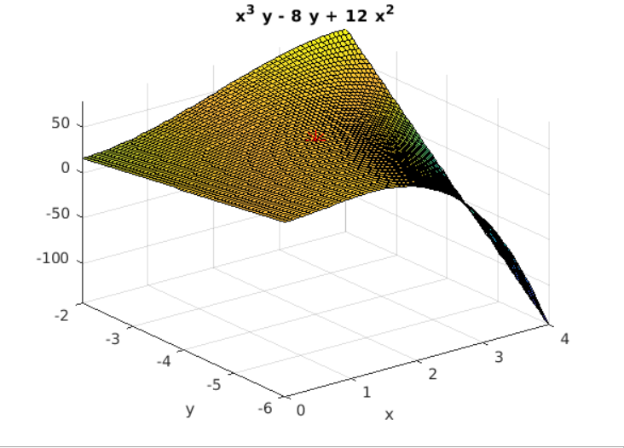

PRACTICE PROBLEMS

1.Find the maximum and minimum values of the function 

CODE:

clc

clear all

syms x y real

f=input("Enter the function f(x,y)");

fx=diff(f,x);

fy=diff(f,y);

[ax ay]=solve(fx,fy);

fxx=diff(fx,x);

fyy=diff(fy,y);

fxy=diff(fx,y);

d=fxx*fyy-fxy^2;

for i=1:1:size(ax)

figure

t1=subs(subs(d,x,ax(i)),y,ay(i));

t2=subs(subs(fxx,x,ax(i)),y,ay(i));

t3=subs(subs(f,x,ax(i)),y,ay(i));

if (double(t1)==0)

sprintf("the point (x,y) is (%d,%d) need further investigation",double(ax(i)),double(ay(i)))

elseif(double(t1)<0)

sprintf("the point (x,y) is (%d,%d) is saddle point",double(ax(i)),double(ay(i)))

else

if(double(t2)<0)

sprintf("the maximum point (x,y) is (%d,%d)",double(ax(i)),double(ay(i)))

sprintf("the value of the function is %d",double(t3))

else

sprintf("the minimum point (x,y) is (%d,%d)",double(ax(i)),double(ay(i)))

sprintf("the value of the function is %d",double(t3))

end

end

ezsurf(f,[double(ax(i))-2,double(ax(i))+2,double(ay(i))-2,double(ay(i))+2]);

hold on

plot3(double(ax(i)),double(ay(i)),double(t3),'r*','markersize',15);

end

COMMAND WINDOW

Enter the function f(x,y)

2*x^3+x*y^2+5*x^2+y^2

ans =   
  
 "the minimum point (x,y) is (0,0)"  
  
  
ans =   
  
 "the value of the function is 0"

ans =   
  
 "the point (x,y) is (-1,-2) is saddle point"

ans =   
  
 "the point (x,y) is (-1,2) is saddle point"

ans =   
  
 "the maximum point (x,y) is (-1.666667e+00,0)"  
  
  
ans =   
  
 "the value of the function is 4.629630e+00"

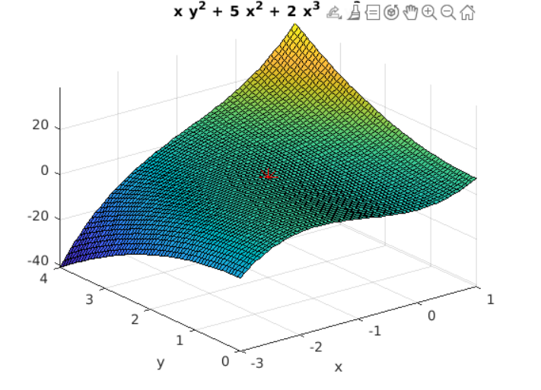

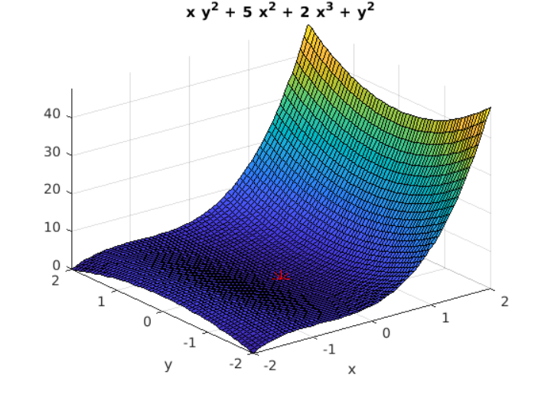 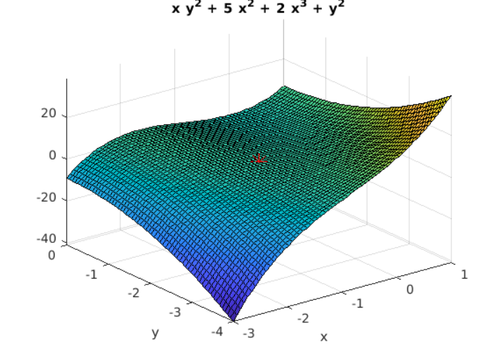

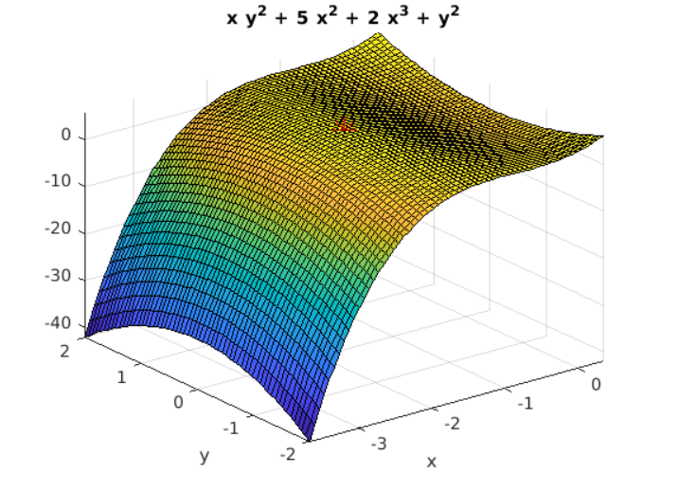

2.Investigate the maximum and minimum of the function 

CODE:

clc

clear all

syms x y real

f=input("Enter the function f(x,y)");

fx=diff(f,x);

fy=diff(f,y);

[ax ay]=solve(fx,fy);

fxx=diff(fx,x);

fyy=diff(fy,y);

fxy=diff(fx,y);

d=fxx*fyy-fxy^2;

for i=1:1:size(ax)

figure

t1=subs(subs(d,x,ax(i)),y,ay(i));

t2=subs(subs(fxx,x,ax(i)),y,ay(i));

t3=subs(subs(f,x,ax(i)),y,ay(i));

if (double(t1)==0)

sprintf("the point (x,y) is (%d,%d) need further investigation",double(ax(i)),double(ay(i)))

elseif(double(t1)<0)

sprintf("the point (x,y) is (%d,%d) is saddle point",double(ax(i)),double(ay(i)))

else

if(double(t2)<0)

sprintf("the maximum point (x,y) is (%d,%d)",double(ax(i)),double(ay(i)))

sprintf("the value of the function is %d",double(t3))

else

sprintf("the minimum point (x,y) is (%d,%d)",double(ax(i)),double(ay(i)))

sprintf("the value of the function is %d",double(t3))

end

end

ezsurf(f,[double(ax(i))-2,double(ax(i))+2,double(ay(i))-2,double(ay(i))+2]);

hold on

plot3(double(ax(i)),double(ay(i)),double(t3),'r*','markersize',15);

end

COMMAND WINDOW

Enter the function f(x,y)

x^3*y+12*x^2

ans =   
  
 "the point (x,y) is (0,0) need further investigation"

