**MATLAB 6**

**LAGRANGE’S MULTIPLIERS METHOD**

**NAME: SANTHOSH KUMAR M**

**REGISTER NUMBER: 21BAI1336**

**AIM:**

* To write the MATLAB code to find the maximum and minimum in Lagrange’s multipliers method.
* The method of Lagrange multipliers is named after French mathematician Joseph-Louis Lagrange. Lagrange first introduced the method of his famous paper on mechanics, written he was just 19 years old.
* Many optimization problems have restrictions, or constraints, on the values that van be used to produce the optimal solution. Such constraints tend to complicate optimization problems because the optimal solution can occur at a boundary point of the domain. In this section, we will study an ingenious technique for solving such problems. It is called the method of Lagrange multipliers.

1.Find the extreme values of the function f(x,y)= $x^{2}-y^{2}$ subject to constraints $2y-x^{2}=0$

CODE:

clc

clear all

syms x y lam real

f=input("enter the function to be maximised in terms of x and y:");

g=input("enter the constraints in terms of x and y:");

[alam,ax,ay]=solve(jacobian(f-lam*g,[x y lam]));

T=subs(f,{x,y},{ax,ay})

for i=1:1:size(T)

figure

sprintf('the point (x,y) is (%d,%d)',double(ax(i)),double(ay(i)))

sprintf('the value of the function is %d',double(T(i)))

[X1,Y1]=meshgrid(double(ax(i))-3:.2:double(ax(i))+3,double(ay(i))-3:.2:double(ay(i))+3);

zfun=@(x,y)eval(vectorize(f));

Z1=zfun(X1,Y1);

contour(X1,Y1,Z1,75)

hold on

h=ezplot(g,[double(ax(i))-3,double(ax(i))+3]);

set(h,'color',[1,0.7,0.9])

plot(double(ax(i)),double(ay(i)),'r.','markersize',12)

end

COMMAND WINDOW:

enter the function to be maximised in terms of x and y:

x^2-y^2

enter the constraints in terms of x and y:

2*y-x^2

T =  
   
0  
1  
1  
   
  
ans ='the point (x,y) is (0,0)'  
  
  
ans ='the value of the function is 0'

ans ='the point (x,y) is (1.414214e+00,1)'  
  
  
ans ='the value of the function is 1'

ans ='the point (x,y) is (-1.414214e+00,1)'  
  
  
ans ='the value of the function is 1'

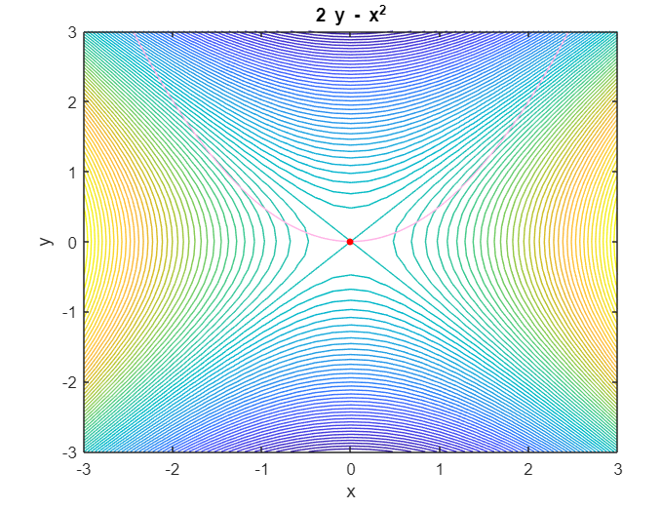

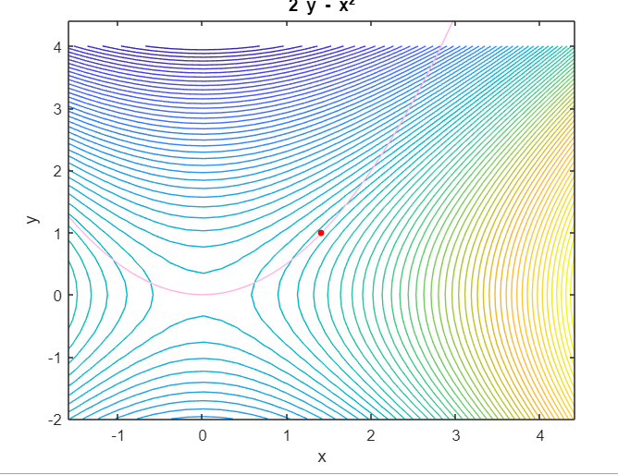

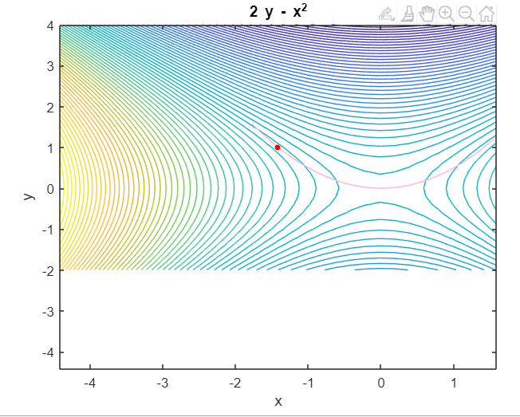

2.Find the extreme values of the function 2x+2xy+y which subject to constraints 2x+y=100

CODE:

clc

clear all

syms x y lam real

f=input("enter the function to be maximised in terms of x and y:");

g=input("enter the constraints in terms of x and y:");

[alam,ax,ay]=solve(jacobian(f-lam*g,[x y lam]));

T=subs(f,{x,y},{ax,ay})

for i=1:1:size(T)

figure

sprintf('the point (x,y) is (%d,%d)',double(ax(i)),double(ay(i)))

sprintf('the value of the function is %d',double(T(i)))

[X1,Y1]=meshgrid(double(ax(i))-3:.2:double(ax(i))+3,double(ay(i))-3:.2:double(ay(i))+3);

zfun=@(x,y)eval(vectorize(f));

Z1=zfun(X1,Y1);

contour(X1,Y1,Z1,75)

hold on

h=ezplot(g,[double(ax(i))-3,double(ax(i))+3]);

set(h,'color',[1,0.7,0.9])

plot(double(ax(i)),double(ay(i)),'r.','markersize',12)

end

COMMAND WINDOW:

enter the function to be maximised in terms of x and y:

2*x+2*x*y+y

enter the constraints in terms of x and y:

2*x+y-100

T =  
   
2600  
   
  
ans ='the point (x,y) is (25,50)'  
  
  
ans ='the value of the function is 2600

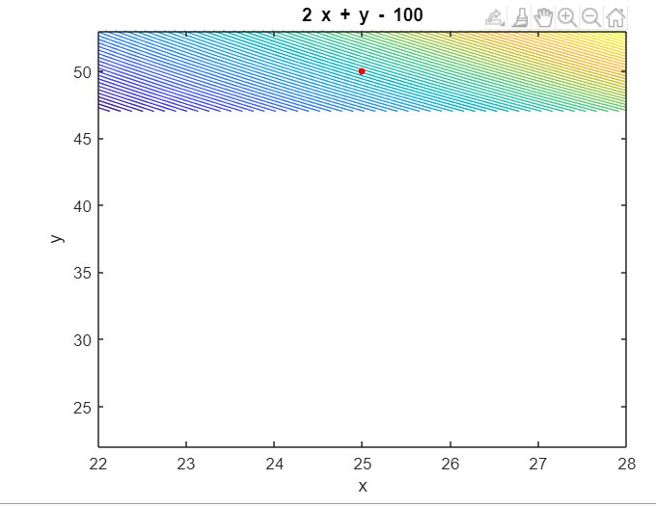

PRACTICE PROBLEMS

3.find the extreme values of the function x^+y^2 which subject to constraints xy=1

CODE:

clc

clear all

syms x y lam real

f=input("enter the function to be maximised in terms of x and y:");

g=input("enter the constraints in terms of x and y:");

[alam,ax,ay]=solve(jacobian(f-lam*g,[x y lam]));

T=subs(f,{x,y},{ax,ay})

for i=1:1:size(T)

figure

sprintf('the point (x,y) is (%d,%d)',double(ax(i)),double(ay(i)))

sprintf('the value of the function is %d',double(T(i)))

[X1,Y1]=meshgrid(double(ax(i))-3:.2:double(ax(i))+3,double(ay(i))-3:.2:double(ay(i))+3);

zfun=@(x,y)eval(vectorize(f));

Z1=zfun(X1,Y1);

contour(X1,Y1,Z1,75)

hold on

h=ezplot(g,[double(ax(i))-3,double(ax(i))+3]);

set(h,'color',[1,0.7,0.9])

plot(double(ax(i)),double(ay(i)),'r.','markersize',12)

end

COMMAND WINDOW:

enter the function to be maximised in terms of x and y:

x^2+y^2

enter the constraints in terms of x and y:

x*y-1

T =  
   
2  
2

ans ='the point (x,y) is (-1,-1)'  
  
  
ans ='the value of the function is 2'

ans= 'the point (x,y) is (1,1)'  
  
  
ans ='the value of the function is 2'

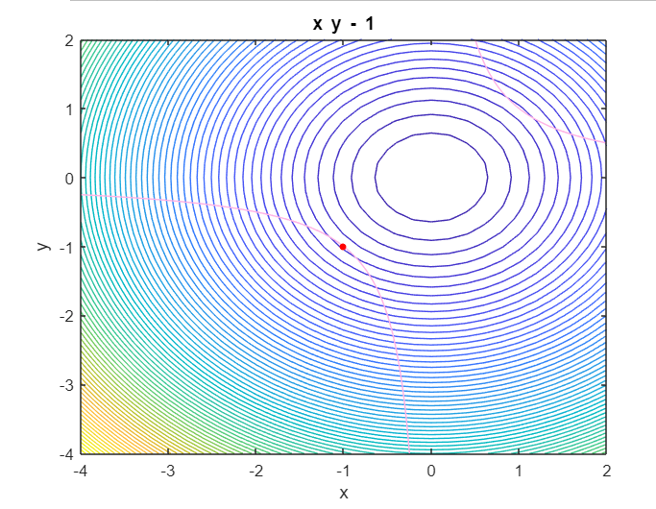

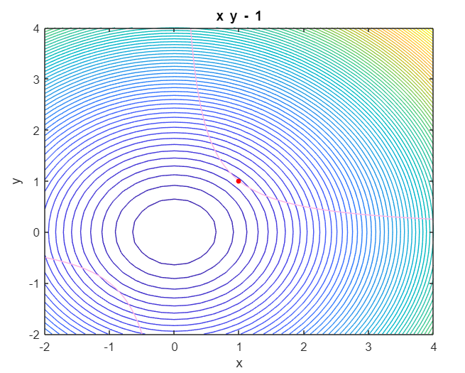

4.Find the extreme values of the function 4x+6y which subject to constraints x^2+y^2=1

CODE:

clc

clear all

syms x y lam real

f=input("enter the function to be maximised in terms of x and y:");

g=input("enter the constraints in terms of x and y:");

[alam,ax,ay]=solve(jacobian(f-lam*g,[x y lam]));

T=subs(f,{x,y},{ax,ay})

for i=1:1:size(T)

figure

sprintf('the point (x,y) is (%d,%d)',double(ax(i)),double(ay(i)))

sprintf('the value of the function is %d',double(T(i)))

[X1,Y1]=meshgrid(double(ax(i))-3:.2:double(ax(i))+3,double(ay(i))-3:.2:double(ay(i))+3);

zfun=@(x,y)eval(vectorize(f));

Z1=zfun(X1,Y1);

contour(X1,Y1,Z1,75)

hold on

h=ezplot(g,[double(ax(i))-3,double(ax(i))+3]);

set(h,'color',[1,0.7,0.9])

plot(double(ax(i)),double(ay(i)),'r.','markersize',12)

end

COMMAND WINDOW:

enter the function to be maximised in terms of x and y:

4*x+6*y

enter the constraints in terms of x and y:

x^2+y^2-1

T =  
   
-2*13^(1/2)  
 2*13^(1/2)  
   
  
ans ='the point (x,y) is (-5.547002e-01,-8.320503e-01)'  
  
  
ans ='the value of the function is -7.211103e+00'

ans ='the point (x,y) is (5.547002e-01,8.320503e-01)'  
  
  
ans ='the value of the function is 7.211103e+00'

