**MATLAB 7**

**Double integrals**

**NAME:** SANTHOSH KUMAR M

**REGISTER NUMBER:** 21BAI1336

**AIM:**

* Toevaluate double and triple integrals and visualize them
* Visualize the volume under the surface z= f(x,y) above and below the plane z=0

1. Evaluate

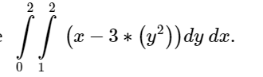

CODE:

clc

clear all

syms x y z

viewSolid(z, 0+0*x+y*0, x-3*y^2+0*y,y,1+0*x, 2+0*x,x,0,2)

int(int(x-3*y^2+0*y,y,1,2),x,0,2)

COMMAND WINDOW:

ans =  
   
-12

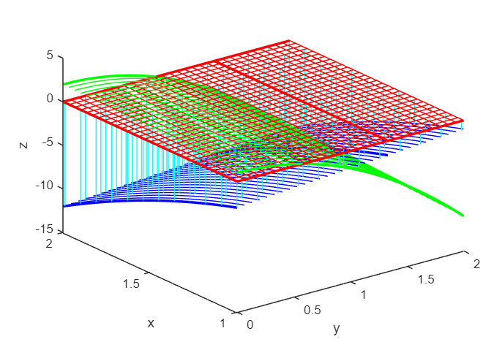

2. Evaluate

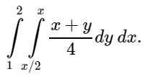

CODE:  
syms x y z;

int(int((x+y)/4, y,x/2,x),x,1,2)

viewSolid(z,0+0*x+0*y,(x+y)/4, y,x/2,x,x,1,2)

COMMAND WINDOW:

ans =  
   
49/96

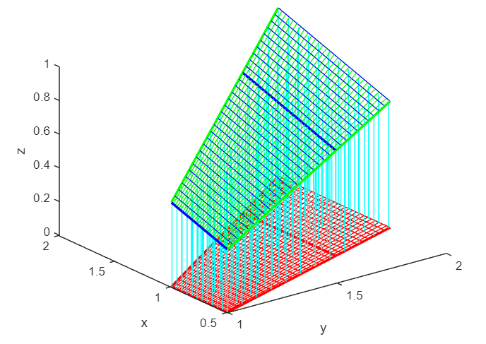

3. Evaluate

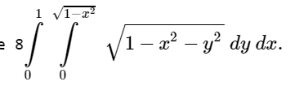

CODE

syms x y z;

V=8*int(int(sqrt(1-x^2-y^2),y,0+0*x,sqrt(1-x^2)),x,0,1)

viewSolid(z,0+0*x+0*y,sqrt(1-x^2-y^2),y,0+0*x,sqrt(1-x^2),x,0,1)

COMMAND WINDOW:

V =  
   
(4*pi)/3

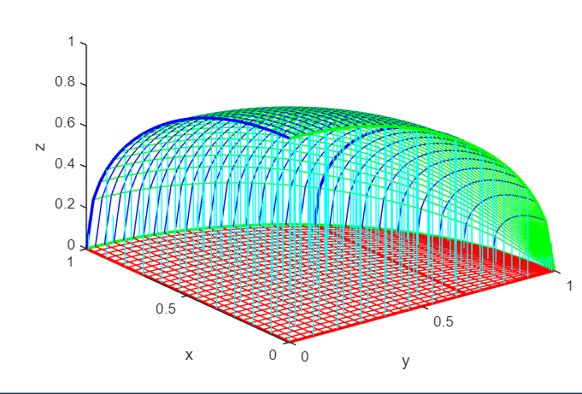

4.Evaluate

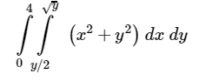

CODE:

clc

clear all

syms x y z

vol = int(int(x^2+y^2, x,y/2,sqrt(y)), y, 0, 4)

viewSolidone(z,0+0*x*y,x^2+y^2,x,y/2,sqrt(y),y,0,4)

COMMAND WINDOW:

vol =  
   
216/35

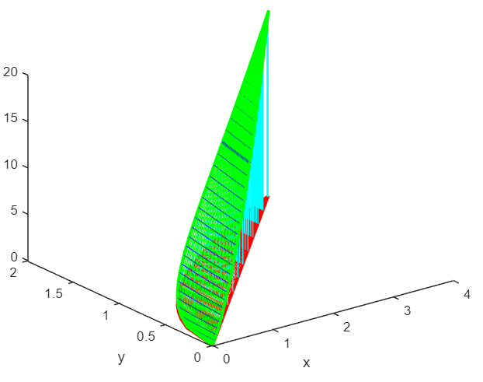

5.Evaluate

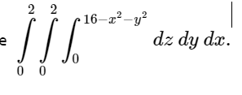

CODE:

syms x y z

int(int(int( 1,z,0,16-x^2-y^2),y,0,2),x,0,2)

viewSolid(z,0,16-x^2-y^2,y,0+0*x,2+0*x,x,0,2)

COMMAND WINDOW:

ans =  
   
160/3

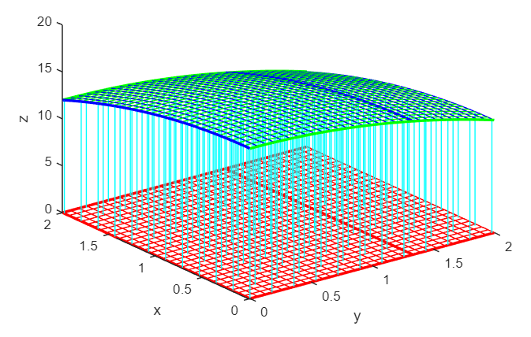

6.Evaluate

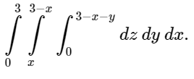

CODE:

syms x y z

int(int(int( 1,z,0,3-x-y),y,x,3-x),x,0,3)

viewSolid(z,0,3-x-y,y,x,3-x,x,0,3)

COMMAND WINDOW:

ans =  
   
9/2

