**MATLAB 2**

**PLOTTING OF CURVES AND SURFACES**

**NAME:** SANTHOSH KUMAR M

**REGISTER NUMBER: 21BAI1336**

x=1:0.01:10

x =  
  
 Columns 1 through 20  
  
 1.0000 1.0100 1.0200 1.0300 1.0400 1.0500 1.0600 1.0700 1.0800 1.0900 1.1000 1.1100 1.1200 1.1300 1.1400 1.1500 1.1600 1.1700 1.1800 1.1900  
  
 Columns 21 through 40  
  
 1.2000 1.2100 1.2200 1.2300 1.2400 1.2500 1.2600 1.2700 1.2800 1.2900 1.3000 1.3100 1.3200 1.3300 1.3400 1.3500 1.3600 1.3700 1.3800 1.3900  
  
 Columns 41 through 60  
  
 1.4000 1.4100 1.4200 1.4300 1.4400 1.4500 1.4600 1.4700 1.4800 1.4900 1.5000 1.5100 1.5200 1.5300 1.5400 1.5500 1.5600 1.5700 1.5800 1.5900  
  
 Columns 61 through 80  
  
 1.6000 1.6100 1.6200 1.6300 1.6400 1.6500 1.6600 1.6700 1.6800 1.6900 1.7000 1.7100 1.7200 1.7300 1.7400 1.7500 1.7600 1.7700 1.7800 1.7900  
  
 Columns 81 through 100  
  
 1.8000 1.8100 1.8200 1.8300 1.8400 1.8500 1.8600 1.8700 1.8800 1.8900 1.9000 1.9100 1.9200 1.9300 1.9400 1.9500 1.9600 1.9700 1.9800 1.9900  
  
 Columns 101 through 120  
  
 2.0000 2.0100 2.0200 2.0300 2.0400 2.0500 2.0600 2.0700 2.0800 2.0900 2.1000 2.1100 2.1200 2.1300 2.1400 2.1500 2.1600 2.1700 2.1800 2.1900  
  
 Columns 121 through 140  
  
 2.2000 2.2100 2.2200 2.2300 2.2400 2.2500 2.2600 2.2700 2.2800 2.2900 2.3000 2.3100 2.3200 2.3300 2.3400 2.3500 2.3600 2.3700 2.3800 2.3900  
  
 Columns 141 through 160  
  
 2.4000 2.4100 2.4200 2.4300 2.4400 2.4500 2.4600 2.4700 2.4800 2.4900 2.5000 2.5100 2.5200 2.5300 2.5400 2.5500 2.5600 2.5700 2.5800 2.5900  
  
 Columns 161 through 180  
  
 2.6000 2.6100 2.6200 2.6300 2.6400 2.6500 2.6600 2.6700 2.6800 2.6900 2.7000 2.7100 2.7200 2.7300 2.7400 2.7500 2.7600 2.7700 2.7800 2.7900  
  
 Columns 181 through 200  
  
 2.8000 2.8100 2.8200 2.8300 2.8400 2.8500 2.8600 2.8700 2.8800 2.8900 2.9000 2.9100 2.9200 2.9300 2.9400 2.9500 2.9600 2.9700 2.9800 2.9900  
  
 Columns 201 through 220  
  
 3.0000 3.0100 3.0200 3.0300 3.0400 3.0500 3.0600 3.0700 3.0800 3.0900 3.1000 3.1100 3.1200 3.1300 3.1400 3.1500 3.1600 3.1700 3.1800 3.1900  
  
 Columns 221 through 240  
  
 3.2000 3.2100 3.2200 3.2300 3.2400 3.2500 3.2600 3.2700 3.2800 3.2900 3.3000 3.3100 3.3200 3.3300 3.3400 3.3500 3.3600 3.3700 3.3800 3.3900  
  
 Columns 241 through 260  
  
 3.4000 3.4100 3.4200 3.4300 3.4400 3.4500 3.4600 3.4700 3.4800 3.4900 3.5000 3.5100 3.5200 3.5300 3.5400 3.5500 3.5600 3.5700 3.5800 3.5900  
  
 Columns 261 through 280  
  
 3.6000 3.6100 3.6200 3.6300 3.6400 3.6500 3.6600 3.6700 3.6800 3.6900 3.7000 3.7100 3.7200 3.7300 3.7400 3.7500 3.7600 3.7700 3.7800 3.7900  
  
 Columns 281 through 300  
  
 3.8000 3.8100 3.8200 3.8300 3.8400 3.8500 3.8600 3.8700 3.8800 3.8900 3.9000 3.9100 3.9200 3.9300 3.9400 3.9500 3.9600 3.9700 3.9800 3.9900  
  
 Columns 301 through 320  
  
 4.0000 4.0100 4.0200 4.0300 4.0400 4.0500 4.0600 4.0700 4.0800 4.0900 4.1000 4.1100 4.1200 4.1300 4.1400 4.1500 4.1600 4.1700 4.1800 4.1900  
  
 Columns 321 through 340  
  
 4.2000 4.2100 4.2200 4.2300 4.2400 4.2500 4.2600 4.2700 4.2800 4.2900 4.3000 4.3100 4.3200 4.3300 4.3400 4.3500 4.3600 4.3700 4.3800 4.3900  
  
 Columns 341 through 360  
  
 4.4000 4.4100 4.4200 4.4300 4.4400 4.4500 4.4600 4.4700 4.4800 4.4900 4.5000 4.5100 4.5200 4.5300 4.5400 4.5500 4.5600 4.5700 4.5800 4.5900  
  
 Columns 361 through 380  
  
 4.6000 4.6100 4.6200 4.6300 4.6400 4.6500 4.6600 4.6700 4.6800 4.6900 4.7000 4.7100 4.7200 4.7300 4.7400 4.7500 4.7600 4.7700 4.7800 4.7900  
  
 Columns 381 through 400  
  
 4.8000 4.8100 4.8200 4.8300 4.8400 4.8500 4.8600 4.8700 4.8800 4.8900 4.9000 4.9100 4.9200 4.9300 4.9400 4.9500 4.9600 4.9700 4.9800 4.9900  
  
 Columns 401 through 420  
  
 5.0000 5.0100 5.0200 5.0300 5.0400 5.0500 5.0600 5.0700 5.0800 5.0900 5.1000 5.1100 5.1200 5.1300 5.1400 5.1500 5.1600 5.1700 5.1800 5.1900  
  
 Columns 421 through 440  
  
 5.2000 5.2100 5.2200 5.2300 5.2400 5.2500 5.2600 5.2700 5.2800 5.2900 5.3000 5.3100 5.3200 5.3300 5.3400 5.3500 5.3600 5.3700 5.3800 5.3900  
  
 Columns 441 through 460  
  
 5.4000 5.4100 5.4200 5.4300 5.4400 5.4500 5.4600 5.4700 5.4800 5.4900 5.5000 5.5100 5.5200 5.5300 5.5400 5.5500 5.5600 5.5700 5.5800 5.5900  
  
 Columns 461 through 480  
  
 5.6000 5.6100 5.6200 5.6300 5.6400 5.6500 5.6600 5.6700 5.6800 5.6900 5.7000 5.7100 5.7200 5.7300 5.7400 5.7500 5.7600 5.7700 5.7800 5.7900  
  
 Columns 481 through 500  
  
 5.8000 5.8100 5.8200 5.8300 5.8400 5.8500 5.8600 5.8700 5.8800 5.8900 5.9000 5.9100 5.9200 5.9300 5.9400 5.9500 5.9600 5.9700 5.9800 5.9900  
  
 Columns 501 through 520  
  
 6.0000 6.0100 6.0200 6.0300 6.0400 6.0500 6.0600 6.0700 6.0800 6.0900 6.1000 6.1100 6.1200 6.1300 6.1400 6.1500 6.1600 6.1700 6.1800 6.1900  
  
 Columns 521 through 540  
  
 6.2000 6.2100 6.2200 6.2300 6.2400 6.2500 6.2600 6.2700 6.2800 6.2900 6.3000 6.3100 6.3200 6.3300 6.3400 6.3500 6.3600 6.3700 6.3800 6.3900  
  
 Columns 541 through 560  
  
 6.4000 6.4100 6.4200 6.4300 6.4400 6.4500 6.4600 6.4700 6.4800 6.4900 6.5000 6.5100 6.5200 6.5300 6.5400 6.5500 6.5600 6.5700 6.5800 6.5900  
  
 Columns 561 through 580  
  
 6.6000 6.6100 6.6200 6.6300 6.6400 6.6500 6.6600 6.6700 6.6800 6.6900 6.7000 6.7100 6.7200 6.7300 6.7400 6.7500 6.7600 6.7700 6.7800 6.7900  
  
 Columns 581 through 600  
  
 6.8000 6.8100 6.8200 6.8300 6.8400 6.8500 6.8600 6.8700 6.8800 6.8900 6.9000 6.9100 6.9200 6.9300 6.9400 6.9500 6.9600 6.9700 6.9800 6.9900  
  
 Columns 601 through 620  
  
 7.0000 7.0100 7.0200 7.0300 7.0400 7.0500 7.0600 7.0700 7.0800 7.0900 7.1000 7.1100 7.1200 7.1300 7.1400 7.1500 7.1600 7.1700 7.1800 7.1900  
  
 Columns 621 through 640  
  
 7.2000 7.2100 7.2200 7.2300 7.2400 7.2500 7.2600 7.2700 7.2800 7.2900 7.3000 7.3100 7.3200 7.3300 7.3400 7.3500 7.3600 7.3700 7.3800 7.3900  
  
 Columns 641 through 660  
  
 7.4000 7.4100 7.4200 7.4300 7.4400 7.4500 7.4600 7.4700 7.4800 7.4900 7.5000 7.5100 7.5200 7.5300 7.5400 7.5500 7.5600 7.5700 7.5800 7.5900  
  
 Columns 661 through 680  
  
 7.6000 7.6100 7.6200 7.6300 7.6400 7.6500 7.6600 7.6700 7.6800 7.6900 7.7000 7.7100 7.7200 7.7300 7.7400 7.7500 7.7600 7.7700 7.7800 7.7900  
  
 Columns 681 through 700  
  
 7.8000 7.8100 7.8200 7.8300 7.8400 7.8500 7.8600 7.8700 7.8800 7.8900 7.9000 7.9100 7.9200 7.9300 7.9400 7.9500 7.9600 7.9700 7.9800 7.9900  
  
 Columns 701 through 720  
  
 8.0000 8.0100 8.0200 8.0300 8.0400 8.0500 8.0600 8.0700 8.0800 8.0900 8.1000 8.1100 8.1200 8.1300 8.1400 8.1500 8.1600 8.1700 8.1800 8.1900  
  
 Columns 721 through 740  
  
 8.2000 8.2100 8.2200 8.2300 8.2400 8.2500 8.2600 8.2700 8.2800 8.2900 8.3000 8.3100 8.3200 8.3300 8.3400 8.3500 8.3600 8.3700 8.3800 8.3900  
  
 Columns 741 through 760  
  
 8.4000 8.4100 8.4200 8.4300 8.4400 8.4500 8.4600 8.4700 8.4800 8.4900 8.5000 8.5100 8.5200 8.5300 8.5400 8.5500 8.5600 8.5700 8.5800 8.5900  
  
 Columns 761 through 780  
  
 8.6000 8.6100 8.6200 8.6300 8.6400 8.6500 8.6600 8.6700 8.6800 8.6900 8.7000 8.7100 8.7200 8.7300 8.7400 8.7500 8.7600 8.7700 8.7800 8.7900  
  
 Columns 781 through 800  
  
 8.8000 8.8100 8.8200 8.8300 8.8400 8.8500 8.8600 8.8700 8.8800 8.8900 8.9000 8.9100 8.9200 8.9300 8.9400 8.9500 8.9600 8.9700 8.9800 8.9900  
  
 Columns 801 through 820  
  
 9.0000 9.0100 9.0200 9.0300 9.0400 9.0500 9.0600 9.0700 9.0800 9.0900 9.1000 9.1100 9.1200 9.1300 9.1400 9.1500 9.1600 9.1700 9.1800 9.1900  
  
 Columns 821 through 840  
  
 9.2000 9.2100 9.2200 9.2300 9.2400 9.2500 9.2600 9.2700 9.2800 9.2900 9.3000 9.3100 9.3200 9.3300 9.3400 9.3500 9.3600 9.3700 9.3800 9.3900  
  
 Columns 841 through 860  
  
 9.4000 9.4100 9.4200 9.4300 9.4400 9.4500 9.4600 9.4700 9.4800 9.4900 9.5000 9.5100 9.5200 9.5300 9.5400 9.5500 9.5600 9.5700 9.5800 9.5900  
  
 Columns 861 through 880  
  
 9.6000 9.6100 9.6200 9.6300 9.6400 9.6500 9.6600 9.6700 9.6800 9.6900 9.7000 9.7100 9.7200  9.7300 9.7400 9.7500 9.7600 9.7700 9.7800 9.7900  
  
 Columns 881 through 900  
  
 9.8000 9.8100 9.8200 9.8300 9.8400 9.8500 9.8600 9.8700 9.8800 9.8900 9.9000 9.9100 9.9200 9.9300 9.9400 9.9500 9.9600 9.9700 9.9800 9.9900  
  
 Column 901  
  
 10.0000

x=0:11

x =  
  
 0 1 2 3 4 5 6 7 8 9 10 11

x=0:3:10

x =  
  
 0 3 6 9

x=linspace(0,10,100)

x =  
  
 Columns 1 through 20  
  
 0 0.1010 0.2020 0.3030 0.4040 0.5051 0.6061 0.7071 0.8081 0.9091 1.0101 1.1111 1.2121 1.3131 1.4141 1.5152 1.6162 1.7172 1.8182 1.9192  
  
 Columns 21 through 40  
  
 2.0202 2.1212 2.2222 2.3232 2.4242 2.5253 2.6263 2.7273 2.8283 2.9293 3.0303 3.1313 3.2323 3.3333 3.4343 3.5354 3.6364 3.7374 3.8384 3.9394  
  
 Columns 41 through 60  
  
 4.0404 4.1414 4.2424 4.3434 4.4444 4.5455 4.6465 4.7475 4.8485 4.9495 5.0505 5.1515 5.2525 5.3535 5.4545 5.5556 5.6566 5.7576 5.8586 5.9596  
  
 Columns 61 through 80  
  
 6.0606 6.1616 6.2626 6.3636 6.4646 6.5657 6.6667 6.7677 6.8687 6.9697 7.0707 7.1717 7.2727 7.3737 7.4747 7.5758 7.6768 7.7778 7.8788 7.9798  
  
 Columns 81 through 100  
  
 8.0808 8.1818 8.2828 8.3838 8.4848 8.5859 8.6869 8.7879 8.8889 8.9899 9.0909 9.1919 9.2929 9.3939 9.4949 9.5960 9.6970 9.7980 9.8990 10.0000

x=0:2:10;

y=x;

plot(x,y)

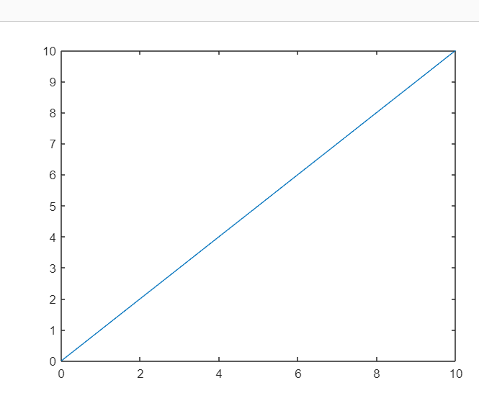

x=0:0.01:10;

y=sin(x);

g=cos(x);

plot(x,y,x,g,'.-')

legend('sin(x)','cos(x)')

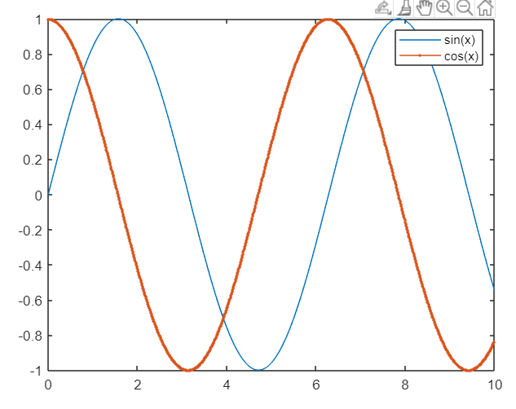

1.DRAW A CIRCLE OF RADIUS 2.

clc

clear all

t = linspace(0, 2*pi, 101);

x = 1 +2*cos(t)

y = 3 +2*sin(t)

plot(x,y,'r.')

axis equal

xlabel('xaxis')

ylabel('yaxis')

title("Circle")

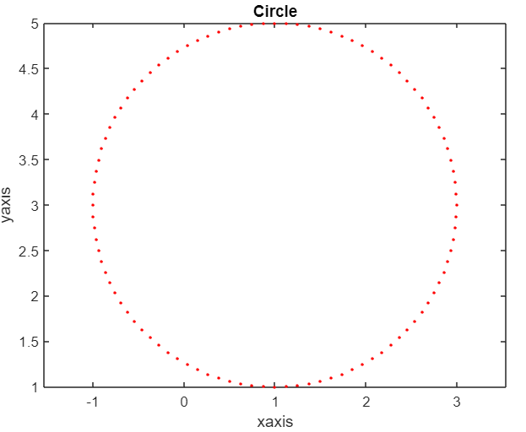

2.DRAW A GRAPH WITHOUT HOLD ON FUNCTION

y = linspace(-10, 10, 1000)

plot(y,cos(y),'b.',y,cos(2*y),'g.')

xlabel('xaxis')

ylabel('yaxis')

legend('cos(x)','cos(2x)','location','Northeast')

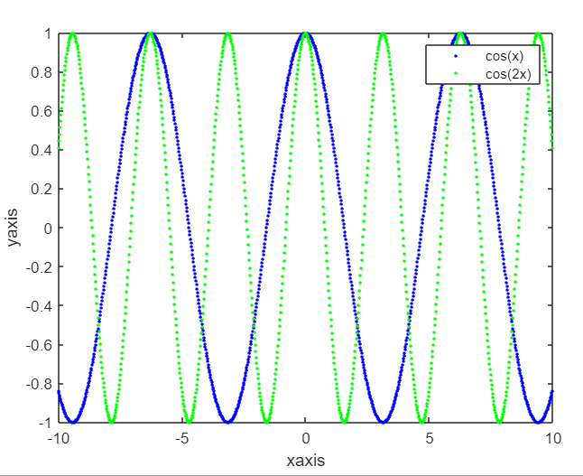

4.DRAW THE SURFACE BY USING PLOT3.

clear all

t= linspace(0, 2*pi, 500);

x=cos(t);

y= sin(t);

z= sin(5*t);

comet3(x,y,z)

plot3(x,y,z,'g*','markersize',7)

xlabel('x-axis')

ylabel('y-axis')

zlabel('z-axis')

title('3D Curve')

clc

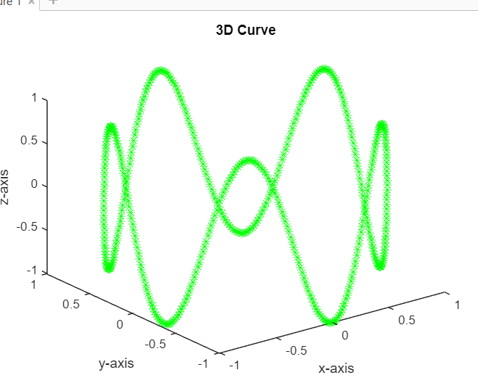

5.DRAW THE FOUR CURVES SIN(X),COS(X),E-X,SIN(3X) IN ON WINDOW’

clc

clear all

x=0:0.1:2*pi;

subplot(2,2,1);

plot(x,sin(x),'b*');

title("sin(x)")

subplot(2,2,2);

plot(x,cos(x),'r-o');

title("cos(x)")

subplot(2,2,3)

plot(x,exp(-x),'g*');

title("exp(-x)")

subplot(2,2,4);

plot(x,sin(3*x),'m-o');

title('sin(3x)')

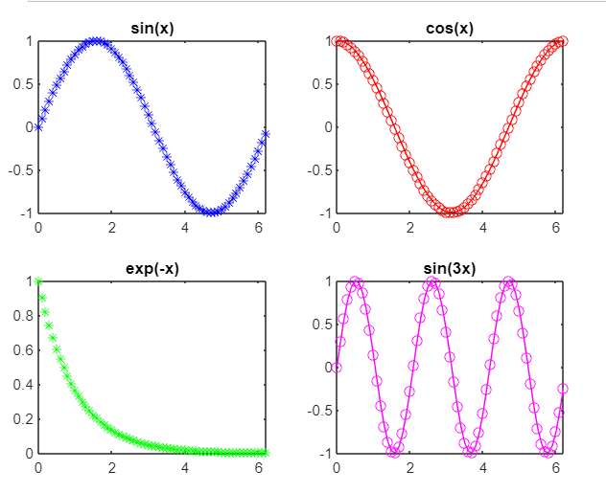

6.DRAW THE SURFACE USING EZ SURF.

clc

clear all

syms x y

f=2*(x^2+y^2)

ezsurf(f)

colormap cool

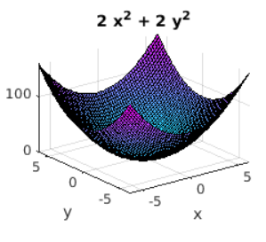

7.DRAW THE EZ PLOT FOR THE FUNCTION X^2+2X-6.

clc

clear all

syms x

y=x^2+2*x-6

ezplot(y)

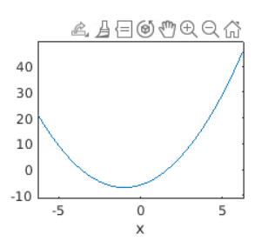

8.DRAW A SURFACE PLOT USING MESH GRID

clc

clear all

x=-1:0.05:1;

y=-1:0.05:1;

[x,y]=meshgird(x,y);

z=x.*y.^2-x.^3

surf(x,y,z);

colormap spring

shading interp

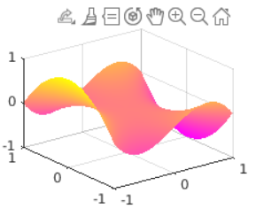

**ASSIGNMENT**

1.DRAW THE CURVES SIN(t),COS(t),E-X,X+1.

clc

clear all

t=0:0.1:2*pi;

x=0:0.1:2*pi;

subplot(2,2,1);

plot(t,sin(t),'b*');

title("sin(t)")

subplot(2,2,2);

plot(t,cos(t),'g*');

title("cos(t)")

subplot(2,2,3);

plot(x,exp(-x),'r-o');

title("e-x")

subplot(2,2,4);

plot(x,x+1,'m-o')

title("x+1")

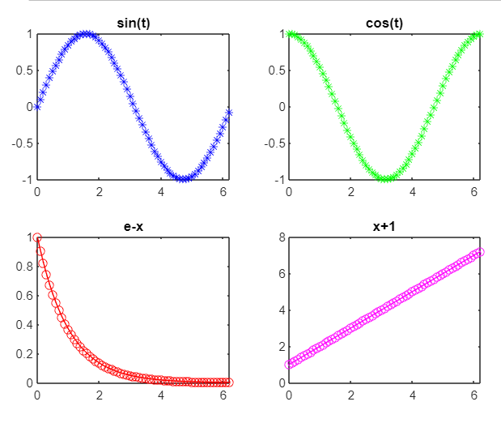

2. DRAW THE CURVES COS(4T),SIN(5T) USING WITHOUT HOLD ON.

clc

clear all

t = linspace(-10, 10, 1000)

plot(t,cos(4*t),'b.',t,sin(5*t),'g.')

xlabel("x-axis")

ylabel("y-axis")

legend('cos(4*t)','sin(5*t)','location','Northeast')

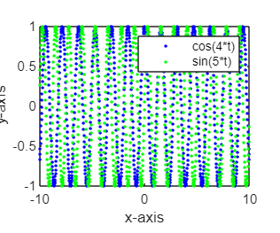

3.DRAW THE CURVE X^2+3*Y^2 BY USING EZSURF

clc

clear all

syms x y

f=x^2+3*y^2

ezsurf(f)

colormap cool

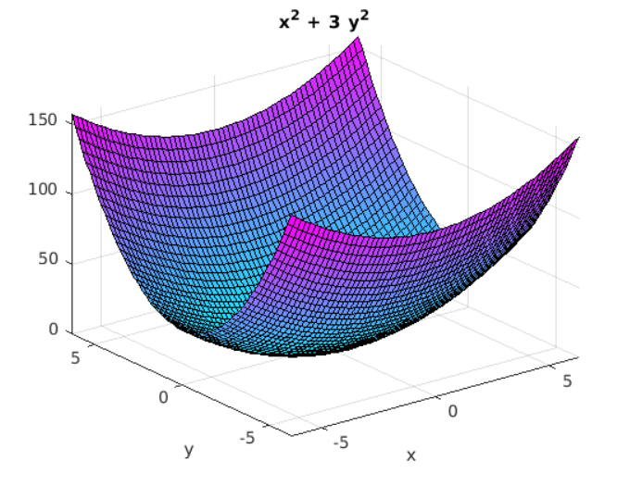

4.DRAW THE SUEFACE USING X*Y^3-Y*X^3

clc

clear all

syms x y

f=x*y^3-y*x^3

ezsurf(f)

colormap cool

