**.. MATLAB 3**

**APPLICATIONS OF DERIVATIVES**

**NAME:** SHARAN N

**REGISTER NUMBER:**20BCE1676

**AIM**

* To find the equation of tangent and visualize it.
* To find the maximum and minimum by using second derivative test and visualize the curve with maximum point and the minimum point.

FINDING THE EQUATION OF THE TANGENT AND VISUALIZE IT

syms x

y=input('enter the function f in terms of x:')

x1=input('enter the value at which tangent:')

ezplot 4-x^2(y,[x1-2 x1+2])

hold on

y_derivative=diff(y,x);

slope=subs(y_derivative,x,x1);

y1=subs(y,x,x1);

plot(x1,y1,'r-*');

tgt_line=slope*(x-x1)+y1

h=ezplot(tgt_line,[x1-2 x1+2])

set(h,'color','r')

hold off

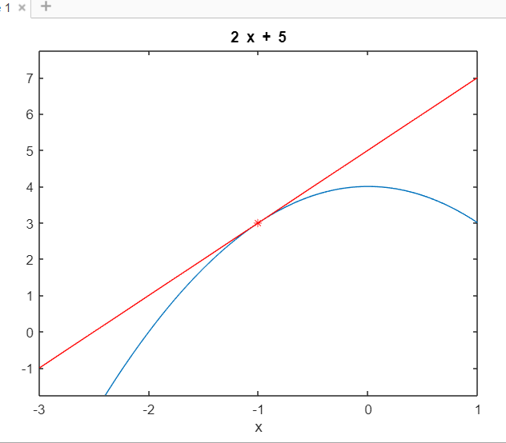

FIND THE EQUATION OF TANGENT TO THE CURVE Y=2*SQRT(X) AT (1,2)

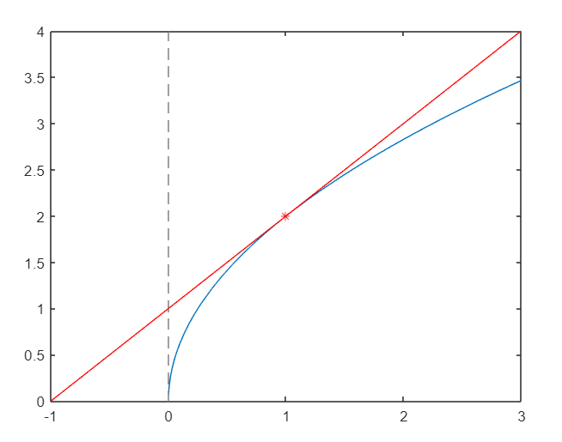

FIND THE EQUATION OF TANGENT TO THE CURVE Y=X^3 AT (-2,-8)

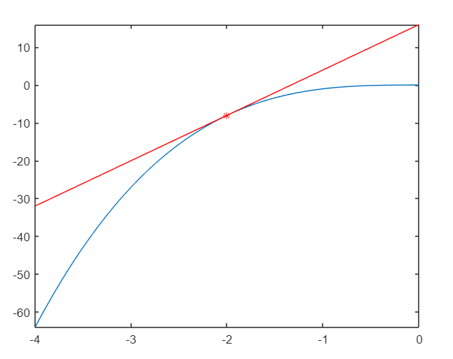

**MAXIMUM AND MINIMUM FOR A SINGLE VARIABLE**

syms x real

f=input('enter the function:')

fx=diff(f,x)

c=solve(fx)

cmin=min(double(c));

cmax=max(double(c));

ezplot(f,[cmin-2,cmin+2])

hold on

fxx=diff(fx,x)

for i = 1:1:size(c)

T1=subs(fxx,i,c(i));

T3=subs(f,x,c(i));

if (double(T1)==0)

sprintf("the points x is %d infelxion point",double(c(i)))

else

if (double(T1)<0)

sprintf('the maximum point x is %d',double(c(i)))

sprintf('the value of the function is %d',doublr(T3))

else

sprintf('the minimum point x is %d',double(c(i)))

sprintf('the value of the function is %d',double(T3))

end

end

plot(double(c(i)),double(T3),'markersize',15)

end

pause

h=ezplot(fx,[cmin-2,cmin+2])

set(h,'color','r')

hold on

pause

e=ezplot(fxx,[cmin-4,cmin+4])

set(e,'color','g')

hold off

enter the function:

4*x^3-48*x^2+144*x

f =  
   
4*x^3 - 48*x^2 + 144*x  
   
   
fx =  
   
12*x^2 - 96*x + 144  
   
   
c =  
   
2  
6

fxx =  
   
24*x - 96  
   
  
ans =  
  
 'the maximum point x is 2'  
  
  
ans =  
  
 'the value of the function is 128'  
  
  
ans =  
  
 'the minimum point x is 6'  
  
  
ans =  
  
 'the value of the function is 0'

