**MATLAB 5**

**LAPLACE TRANSFORM**

**NAME:** SHARAN N

**REGISTER NUMBER:** 20BCE1676

**AIM**

* To visualize the time and frequency functions using Laplace transform.
* To find the Laplace transform of periodic functions and to visualize periodic functions

**MATHEMATICAL FORM**

The Laplace transform denoted by F(s)=f(s)=L[f(t)], it is a linear operator of a function with a real argument t(t>=0) that transforms f(t) to a function F(s) with a complex argument s.

**LAPLACE TRANSFORM**

The Laplace transform of a function y(t), defined for all real numbers t>=0 is the function Y(s) defined by

Y(s)=L[Y(t)] = $\int_{0}^{∞}{e^{-st}y\left(t\right)dx}$. The parameter s is a complex number.

Let Y(s) be the Laplace transform of the function y(t). Then Y(t) is given by the formula

y(t)= $L^{-1}[Y\left(s\right)]$ = $\int_{0}^{∞}{e^{-st}Y(s)dx}$

1.FIND THE LAPLACE TRANSFORM OF COS(T)

syms t s

f=input("enter the function in terms of t:")

F=laplace(f)

enter the function in terms of t:

cos(t)  
f =  
   
cos(t)   
F =  
   
s/(s^2 + 1)

2.FIND THE LAPLACE TRANSFORM OF (1+2*SQRT(T)+3/SQRT(T))

syms t s

f=input("enter the function in terms of t:")

F=laplace(f)

enter the function in terms of t:

1+2*sqrt(t)+3/sqrt(t)   
f =  
   
3/t^(1/2) + 2*t^(1/2) + 1   
F =  
   
1/s + (3*pi^(1/2))/s^(1/2) + pi^(1/2)/s^(3/2)

3.FIND THE LAPLACE TRANSFORM 

syms t s

f=input("enter the function in terms of t:")

F=laplace(f)

enter the functions in terms of t:

t^2*(heaviside(t-0)-heaviside(t-2))+(t-1)*(heaviside(t-2)-heaviside(t- 3))+7*(heaviside(t-3))

f =  
   
7*heaviside(t - 3) - t^2*(heaviside(t - 2) - heaviside(t)) + (heaviside(t - 2) - heaviside(t - 3))*(t - 1)

F =  
   
(7*exp(-3*s))/s - (4*exp(-2*s))/s - (4*exp(-2*s))/s^2 - (2*exp(-2*s))/s^3 + 2/s^3 - (exp(-3*s)*(2*s - exp(s) - s*exp(s) + 1))/s^2

**LAPLACE TRANSFORM OF PERIODIC FUNCTION AND VISUALIZATION OF PERIODIC FUNCTION:**

1.FIND THE LAPLACE TRANSFORM OF TRIANGULAR WAVE OF PERIOD 2 GIVEN BY

,FOR ALL T

clc

clear all

syms t s

T=input("enter the period of periodic function:")

n=input("enter the number of partition in one period:")

fun=0*t;

for i=1:n

a(i)=input("enter the left interval of the ith sub interval:")

b(i)=input("enter the right interval of the ith sub interval:")

f(i)=input("enter the function f(i):")

fun=fun+f(i)*(heavisde(t-a(i))-heaviside(t-b(i)));

end

ezplot(fun,[a(1) b(n)])

sum=0;

for i=1:n

sum=sum+int(f(i)*exp(-s*t),t,a(i),b(i))

end

g=(1/(1-exp(s*T)))*sum

g1=simplify(g)

figure

ezplot(g1,[0,b(n)])

enter the period of periodic function:

2

T =  
  
 2  
  
enter the number of partition in one period:

2

n =  
  
 2  
  
enter the left interval of the ith sub interval:

0

a =  
  
 0  
  
enter the right interval of the ith sub interval:

1

b =  
  
 1  
  
enter the function f(i):

t

f =  
   
t  
   
enter the left interval of the ith sub interval:

1

a =  
  
 0 1  
  
enter the right interval of the ith sub interval:

2

b =  
  
 1 2  
  
enter the function f(i):

t

f =  
   
[t, t]

sum =  
   
1/s^2 - (exp(-s)*(s + 1))/s^2

sum =  
   
1/s^2 - (exp(-2*s)*(2*s + 1))/s^2  
   
   
g =  
   
-(1/s^2 - (exp(-2*s)*(2*s + 1))/s^2)/(exp(2*s) - 1)

g1 =  
   
-(1/s^2 - (exp(-2*s)*(2*s + 1))/s^2)/(exp(2*s) - 1)

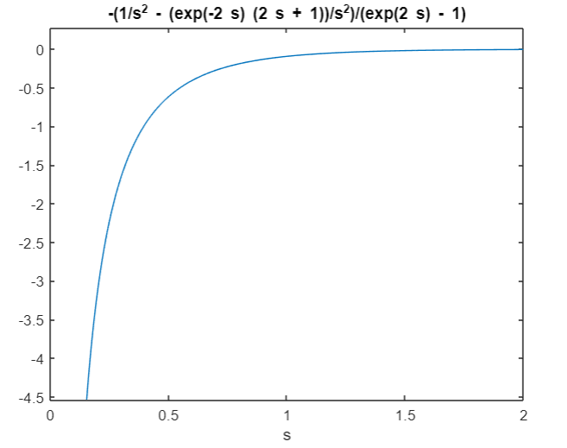

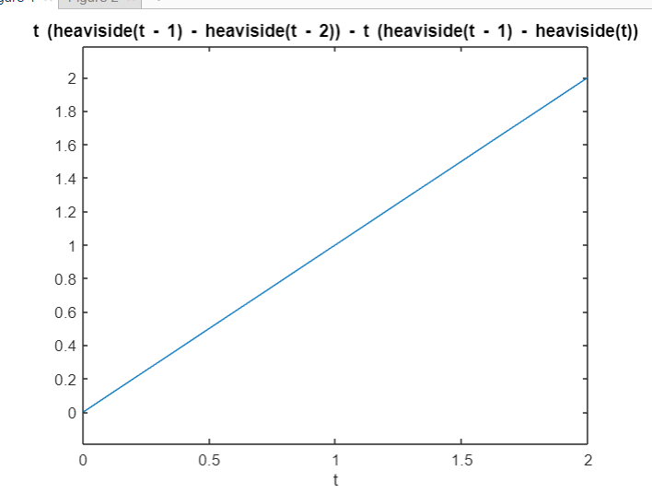

**PRACTICE PROBLEMS**

1.Find the Laplace transform of a square wave****for all t.

clc

clear all

syms t s

T=input("enter the period of periodic function:")

n=input("enter the number of partition in one period:")

fun=0*t;

for i=1:n

a(i)=input("enter the left interval of the ith sub interval:")

b(i)=input("enter the right interval of the ith sub interval:")

f(i)=input("enter the function f(i):")

fun=fun+f(i)*(heavisde(t-a(i))-heaviside(t-b(i)));

end

ezplot(fun,[a(1) b(n)])

sum=0;

for i=1:n

sum=sum+int(f(i)*exp(-s*t),t,a(i),b(i))

end

g=(1/(1-exp(s*T)))*sum

g1=simplify(g)

figure

ezplot(g1,[0,b(n)])

enter the period of periodic function:

2

T =  
  
 2  
  
enter the number of partition in one period:

2

n =  
  
 2  
  
enter the left interval of the ith sub interval:

0

a =  
  
 0  
  
enter the right interval of the ith sub interval:

pi

b =  
  
 3.1416  
  
enter the function f(i):

t

f =  
   
t  
   
enter the left interval of the ith sub interval:

pi

a =  
  
 0 3.1416  
  
enter the right interval of the ith sub interval:

2*pi

b =  
  
 3.1416 6.2832  
  
enter the function f(i):

t

f =  
[t, t]   
sum =  
   
1/s^2 - (exp(-pi*s)*(pi*s + 1))/s^2  
   
sum =  
   
1/s^2 - (exp(-2*pi*s)*(2*pi*s + 1))/s^2  
   
g =  
   
-(1/s^2 - (exp(-2*pi*s)*(2*pi*s + 1))/s^2)/(exp(2*s) - 1)  
  
g1 =  
   
-(1/s^2 - (exp(-2*pi*s)*(2*pi*s + 1))/s^2)/(exp(2*s) - 1)

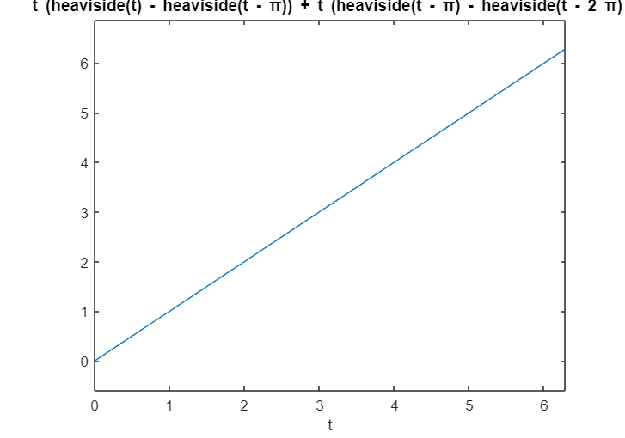

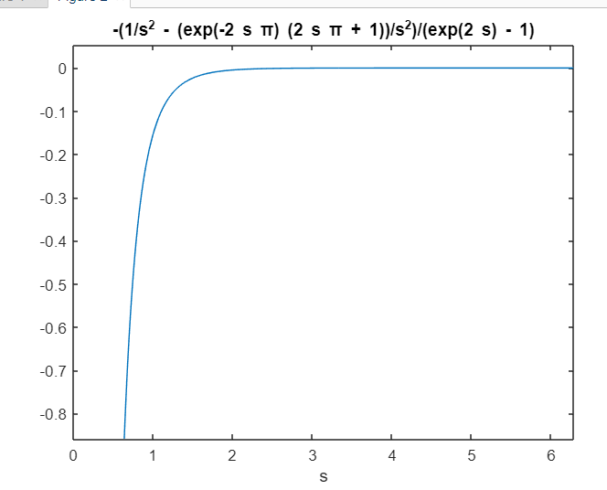

2. Find the Laplace transform of a square wavefor all t.

clc

clear all

syms t s

T=input("enter the period of periodic function:")

n=input("enter the number of partition in one period:")

fun=0*t;

for i=1:n

a(i)=input("enter the left interval of the ith sub interval:")

b(i)=input("enter the right interval of the ith sub interval:")

f(i)=input("enter the function f(i):")

fun=fun+f(i)*(heavisde(t-a(i))-heaviside(t-b(i)));

end

ezplot(fun,[a(1) b(n)])

sum=0;

for i=1:n

sum=sum+int(f(i)*exp(-s*t),t,a(i),b(i))

end

g=(1/(1-exp(s*T)))*sum

g1=simplify(g)

figure

ezplot(g1,[0,b(n)])

enter the period of periodic function:

2

T =  
  
 2  
  
enter the number of partition in one period:

2

n =  
  
 2  
  
enter the left interval of the ith sub interval:

0

a =  
  
 0  
  
enter the right interval of the ith sub interval:

3.14

b =  
  
 3.1400  
  
enter the function f(i):

t

f =  
   
t  
   
enter the left interval of the ith sub interval:

3.14

a =  
  
 0 3.1400  
  
enter the right interval of the ith sub interval:

2*3.14

b =  
  
 3.1400 6.2800  
  
enter the function f(i):

t

f =  
   
[t, t]

sum =  
   
1/s^2 - (exp(-(157*s)/50)*((157*s)/50 + 1))/s^2

sum =  
   
1/s^2 - (exp(-(157*s)/25)*((157*s)/25 + 1))/s^2  
   
   
g =  
   
-(1/s^2 - (exp(-(157*s)/25)*((157*s)/25 + 1))/s^2)/(exp(2*s) - 1)

g1 =  
   
-(1/s^2 - (exp(-(157*s)/25)*((157*s)/25 + 1))/s^2)/(exp(2*s) - 1)

