Module-2_ 3rd Sept 2022

Q5 The kms X in thousands of kms which car owners get with a certain kind of tyre ia a random variable having probability density function:



Find the probabilities that one of these tyres will last (i) atmost 10,000 kms (ii) anywhere from 16,000 to 24, 000 kms and (iii) at least 30,000 kms.











Q1. Let X be a continuous random variable with p.d.f. given by:



Determine the constant k (ii) Determine c.d.f

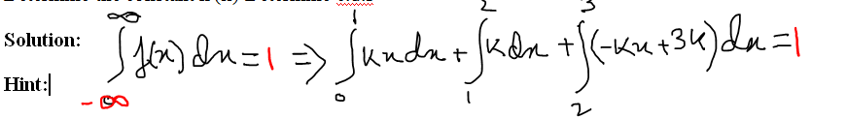

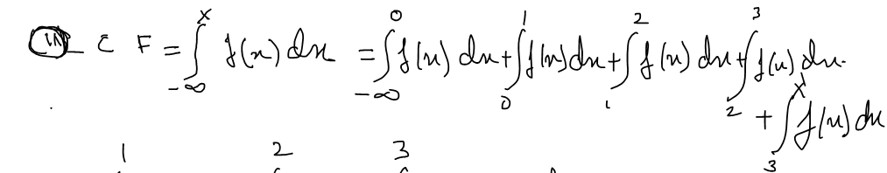

**Problems for Practice**

Q1. The probability distribution of a r.v. X is:  Determine the constant k

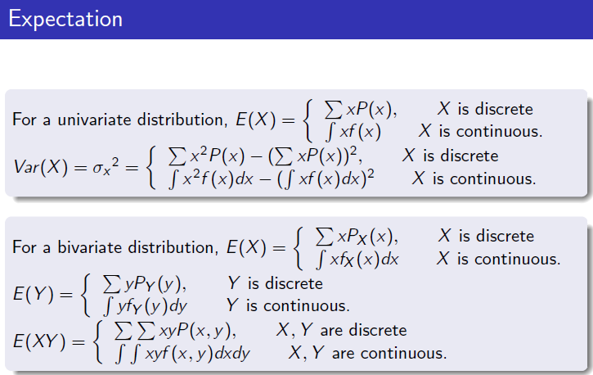



1. If X is a random variable with probability distribution as follows:

|  |  |  |  |
| --- | --- | --- | --- |
| x | -1 | 1 | 2 |
| P(x) |  |  |  |

Find E[X] and E(X2)?

Hint:

and 