MODULE-4
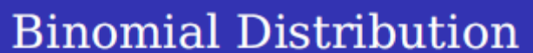
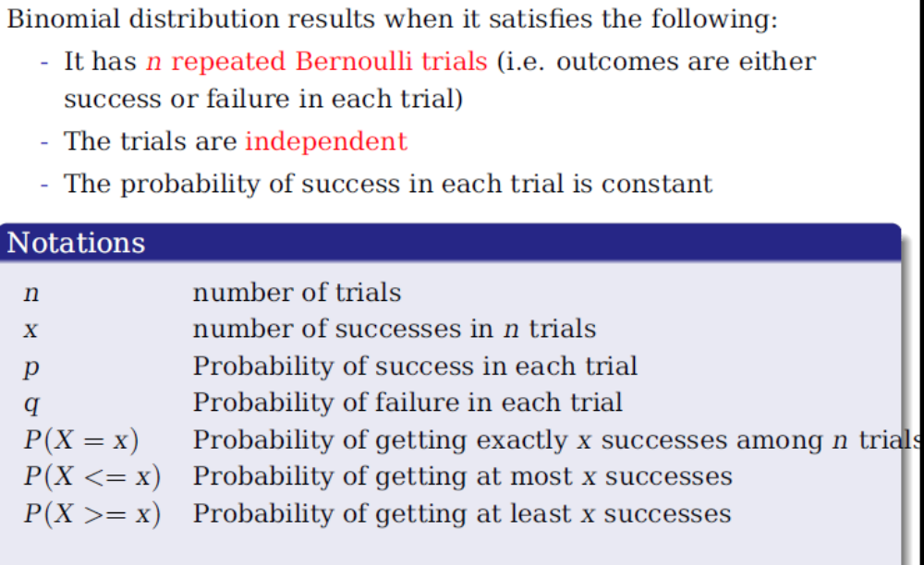
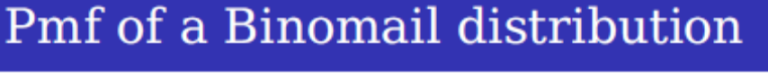
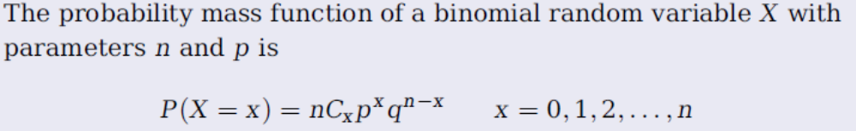
MEAN: E[X]=np
Variance V[X]=npq, where q=1-p
Mode=(n+1)p
-Moment Generating function
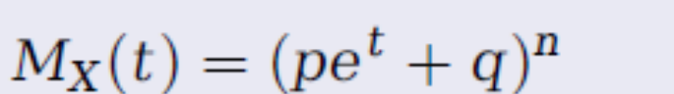
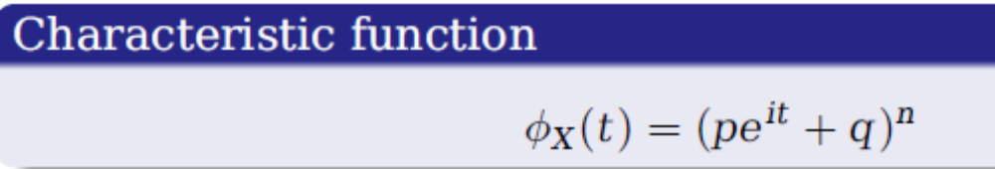
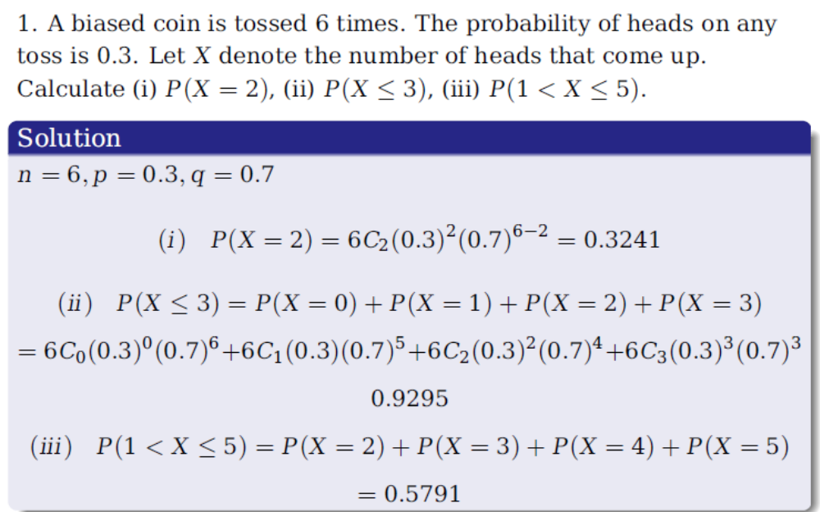
2. The mean and variance of binomial distribution are 4 and 4/3 respectively. Find P(X≥1).
Solution: Mean=np=4 ………(1)
Var(X)= npq=4/3………….(2)
Divide (2)by (1), we get q=1/3 this implies p=1-q=2/3
Now from (1), n=6.
So P(X≥1)=1-P(X=0)=1-q^{n}=0.99863.
3. Determine binomial distribution for which mean is 4 and variance 3. Hence find its mode
Solution: Mean=np=4 ………(1)
Var(X)= npq=3………….(2)
Mode=(n+1)p=(16+1)*1/4=17/4=4.25, which is not integer. Hence unique mode of binomial distribution is 4, so integral part is (n+1)p.
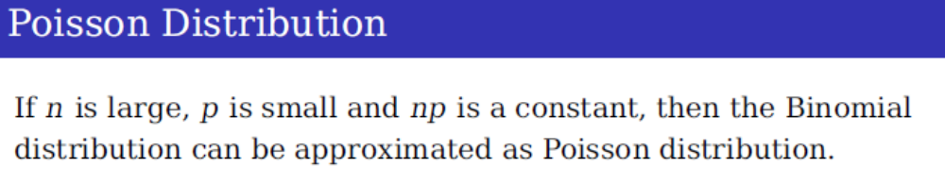
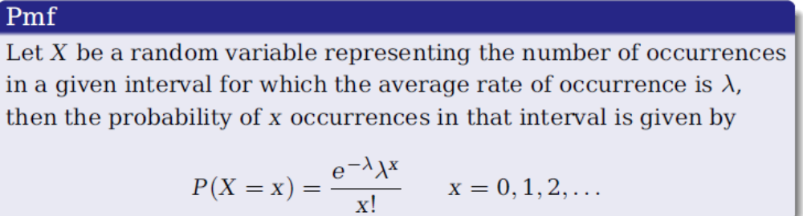
Mean and Variance both are equal to 
Mode=λ/x
MGF and CF for poisson distributions are as follows:
