Module 1
Introduction to Statistics

Syllabus: Introduction to statistics and data analysis-Measures of central tendency –Measures of variability-[Moments-Skewness-Kurtosis (Concepts only)].
Books:
- Probability and Statistics for engineers and scientists, R.E.Walpole, R.H.Myers,S.L.Mayers and K.Ye, 9th Edition, Pearson Education (2012).
- Applied Statistics and Probability for Engineers, Douglas C. Montgomery, George C. Runger, 6th Edition, John Wiley & Sons (2016).
- Reliability Engineering, E.Balagurusamy, Tata McGraw Hill, Tenth reprint 2017.
- Probability and Statistics, J.L.Devore, 8th Edition, Brooks/Cole, Cengage Learning (2012).
- Probability and Statistics for Engineers, R.A.Johnson, Miller Freund’s, 8th edition, Prentice Hall India (2011).
- Probability, Statistics and Reliability for Engineers and Scientists, Bilal M. Ayyub and Richard H. McCuen, 3rd edition, CRC press (2011).

Measures of central tendency- They give us an idea about the concentration of the values in the central part of the distribution. Following are five measures of central tendency:
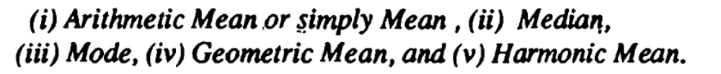
(i)Arithmetic Mean of a set of observations is their sum
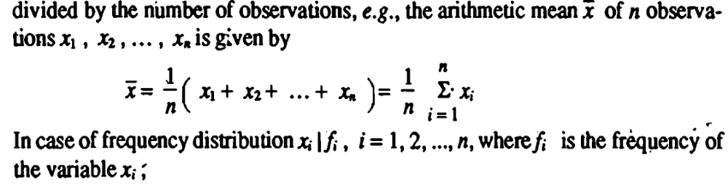
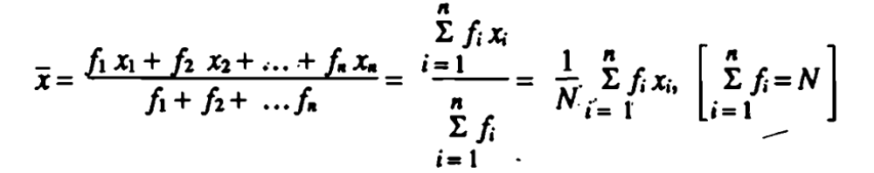
Frequency distribution, in statistics, a graph or data set organized to show the frequency of occurrence of each possible outcome of a repeatable event observed many times. Ex. is election returns etc

Example 1:Find the arithmetic mean of the following frequency distribution:

Solution:
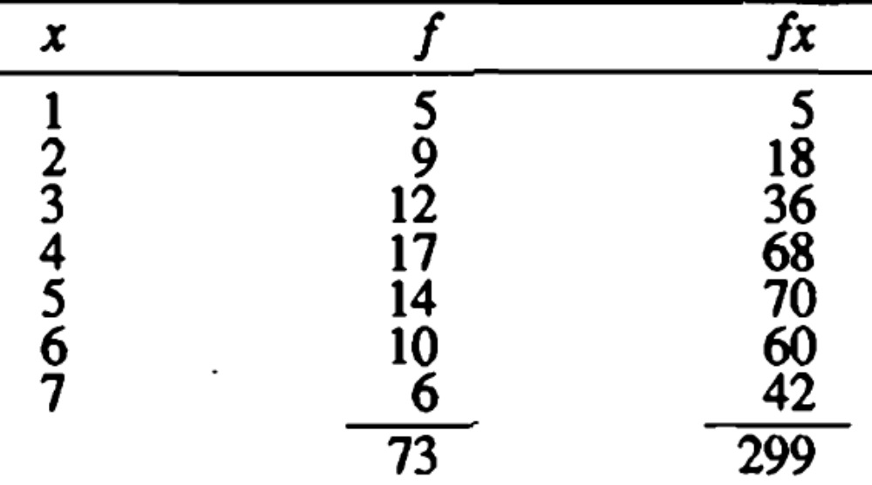
Thus,
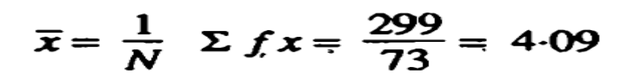

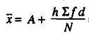


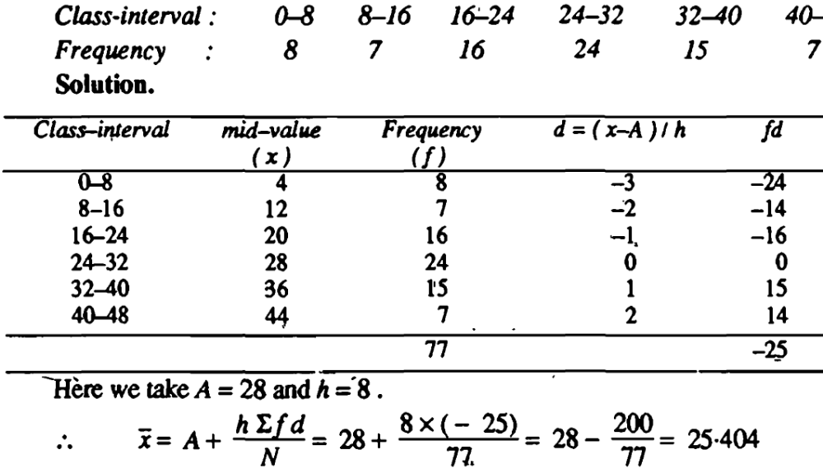
Property:
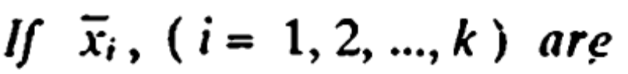
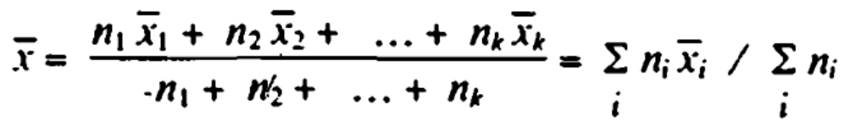


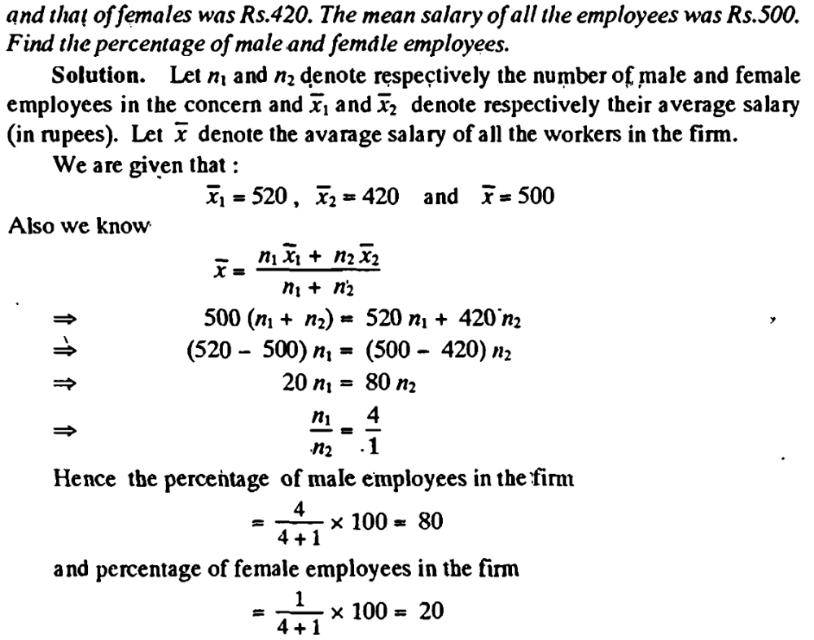

(ii) Median:
