Module-1 22nd Aug 22

Conversely, we get

Skewness
Measures of skewness help us to know to what degree and in which direction (positive or negative) the frequency distribution has a departure from symmetry.
Generally, If Mean > Mode, the skewness is positive. If Mean < Mode, the skewness is negative. If Mean = Mode, the skewness is zero.
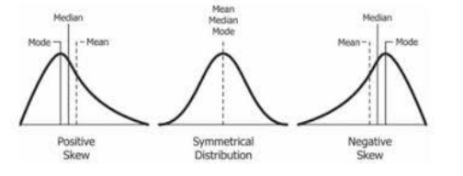
Skewness is measured in the following ways:
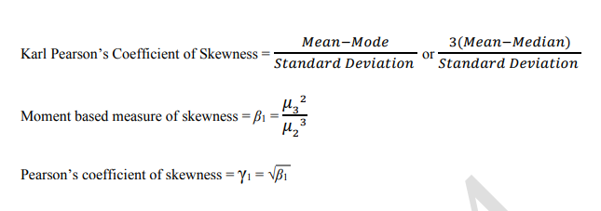
Bowleys’s Coefficient of Skewness
This method is based on quartiles. The formula for calculating coefficient of skewness is given by
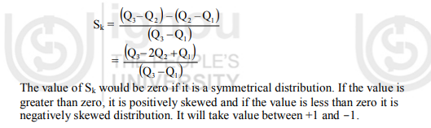
(Karl Pearson’s Measures of Kurtosis)
Q1. The first four raw moments of a distribution are 2, 136, 320, and 40,000. Find coefficients of skewness and kurtosis.
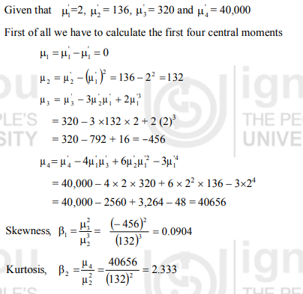
Q 2: First four moments about mean of a distribution are 0, 2.5, 0.7 and 18.75. Find coefficient of skewness and kurtosis.
Hint We have μ₁ = 0, μ₂ = 2.5, μ₃ = 0.7 and μ₄ = 18.75
Therefore, Skewness, β₁ = 0.031
Kurtosis, β₂ = 3. As β₂ is equal to 3, so the curve is mesokurtic.

