Module 3 Correlation and Regression
PROPERTIES
Regression
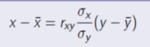 and 