Title: Genomic analyses reveal distinct demographic history and identify genetic changes underlying adaption, speciation and domestication in ducks
Rui Liu^{1,*}, Weiqing Liu^{2,3,*}, Enguang Rong¹, Xiaoxue Wang¹, Lizhi Lu⁴, Huifang Li⁵, Li Chen⁴, Yong Zhao^{3,6}, Huabin Cao⁷, Wenjie Liu¹, Chunhai Chen¹, Guangyi Fan^{2,6,8}, Weitao Song⁶, Huifang Lu³, Yingshuai Sun³, Wenbin Chen^{2,9}, Xin Liu^{2,6,9}, Xun Xu^{2,6,9}, Yinhua Huang^{1,#}, Ning Li^{1,#}
¹State Key Laboratory for Agrobiotechnology, China Agricultural University, Beijing, 100094, China. ²BGI-Shenzhen, Shenzhen 518083, China. ³BGI-Wuhan, Wuhan 430075, China. ⁴Institute of Animal Sciences and Veterinary Medicine, Zhejiang Academy of Agricultural Sciences, Hangzhou 310021, China. ⁵Institute of Poultry Science of Jiangsu, Yangzhou 225125, China. ⁶BGI-Qingdao, Qingdao 266555, China. ⁷Jiangxi Provincial Key Laboratory for Animal Health, Institute of Animal Population Health, College of Animal Science and Technology, Jiangxi Agricultural University, Nanchang 330045, China. ⁸State Key Laboratory of Quality Research in Chinese Medicine, Institute of Chinese Medical Sciences, University of Macau, Macao, China. ⁹China National GeneBank-Shenzhen
*These authors contributed equally
#Corresponding authors: Y.H.H. (cauhyh@cau.edu.cn) or N.L.(ninglcau@cau.edu.cn)
Abstract (250 words)
Background: Domestic ducks was considered to being tamed from the mallard or the descendant of the mallard and the spot-billed duck. Domestic ducks showed remarkable phenotypic variation in morphology, physiology and behavior. However, molecular genetics for ducks’ origin and their phenotypic variation are still poorly studied.
Results: Here we presented the mallard and the spot-billed genomes and performed whole-genome sequencing on eight domestic duck breeds and eight wild duck species. Surprisingly, Analyses on these data supports a model that domestic ducks diverged from their closely wild lineage (mallard duck and spot-billed duck) at the last glacial period (LGP, 100~200 kilo years ago (Kyr)). Wild lineage further speciated into mallard duck and spot-billed duck about 70 Kyr, whereas domestic lineage decreased their population size through the LGP. A scan of wild duck genomes by comparing with domestic duck genomes identified a number of locus that may have been affected by positive selection in ancestral wild ducks after their divergence from domestic lineages. Function analyses suggested that those genes usually affecting organs development and energy metabolism that may involving long-distance flight ability. Further selective sweep analyses identified two genes associated with egg production and three genes related to feeding modulation being under selection in domestic ducks.
Conclusions: These analyses unravel a distinct evolutionary pattern of ducks and two wild duck de novo genomes also provide a novel resource for speciation study.
Key Words: De novo assembly; Genomic analysis; Origin, speciation and domestication; Duck
Background
As two major concerns of evolutionary study, both domestication and speciation (or population divergence) benefited from the advance of sequencing technology(1-9). The genome assembly and characterizing of genetic variation in many domestic and wild animals have revealed their complex demographic history, which provides profound knowledges for both domestication and speciation studies (6-8, 10). We previously drew the draft of a Beijing duck genome and identified genomic variation within this assembly(11). However, as the most economical important waterfowl and one of the principal natural hosts of influenza A viruses, genetic variations of duck were not well characterized. And debates about domestic ducks being domesticated from the mallard duck or the descendant of mallard duck and spot-billed duck are still continuing.
Until now there are more than 140 wild duck species across the world and most of them can hybridize each other(12, 13). Phylogeographic structure of dabbling ducks using 5’-end sequencing of the mtDNA control region and ODC-6 of nuclear DNA demonstrated that the mallard duck diverged from its closely population (spot-billed duck) recently, implying they are good resource for speciation studies (14). Domestic ducks are considered to originated from East Asian and Europe and show broad phenotypic difference from these wild duck species, such as loss of flight and migration ability, reducing of brain size, increasing of body size and fertility(15-19). Previous studies based on similar outlooks habits and distributions provide two hypotheses about domestic ducks’ origin. One hypothesis suggested that domestic ducks were originated from the mallards, while the other argued that they were tamed from descents of the mallard (Anas platyrhynchos) and spot-billed (Anas zonorphymcha)(20). Until now, evolutionary patterns of wild and domestic ducks in genome-wide scale are poorly understand.
Here, we report high-quality drafts of the mallard duck and spot-billed duck respectively, and compare them to the genome of Beijing ducks and other birds. We also generate a total of 1,219 Gb whole-genome resequencing data of thirty-five wild ducks from eight species (gadwall (n=1), baikal teal (n=1), one pintail (n=1), falcated teal (n=1), common teal (n=1), wigeons (n=3), spot-billed duck (n=13) and mallard duck (n=14)), ninety-four domesticated ducks from six Chinese breeds, twenty ducks from two commercial breeds (Cherry and Campebell ducks), together with twenty individuals from two outgroups (ten Muscovy ducks and ten Taihu geese) to study genetic diversity, effective population size (Ne) and genomic regions under selection as well as to compare evolutionary patterns of wild ducks and domestic ducks. Our study will give a comprehensive understanding of the evolutionary history of ducks, that not only illustrates duck domestication processes but also would help to expose some central issues of animal domestication process and speciation process.
Results
We generated 262.45 Gb (~209-fold) pair-end reads of a female mallard duck and 275.20 Gb pair-end reads (~220-fold) of a female spot-billed duck, respectively (Fig. S2, S3, Table S1). Using methods similar to those applied to the Beijing duck genome(11), we generated a high-quality mallard assembly consisting of 61,591 scaffolds and covering 1.27 Gb, and estimated this assembly having a heterozygosity rate 3.61×10⁻³ higher than the corresponding in Beijing duck genome (2.40×10⁻³). The contig N50 and scaffold N50 values of the mallard genome assembly were 38.27 Kb and 2.49 Mb, respectively (Table 1; Table S2). We also generated a high-quality spot-billed genome assembly containing 67,685 scaffolds and covering 1.31 Gb. Similarly, we found that spot-billed assembly had a high heterozygosity rate (3.54×10⁻³). The contig N50 and scaffold N50 values of the spot-billed assembly were 33.06 Kb and 2.05 Mb, respectively (Table 1; Table S2). We then estimated coverage of the mallard duck and spot-billed duck assemblies with alignment to seven finished BACs (completed independently using Sanger sequencing technology) and 319,996 duck ESTs assembled in our previous duck genome project using BLAT (SI Appendix)(11, 21). This analysis suggested that 7 BACs covering 640 Kb on chromosomes 1, 3 and 4 were aligned over more than 92% of their lengths (Fig. S4, S5, Table S3), and greater than 98% of 319,996 ESTs were aligned to both the mallard duck and spot-billed duck assemblies (Table S4, S5). These data, together with our previous study, suggest that two wild duck assemblies presented here are comparative to our previous one domestic duck assembly (version 1.0) in coverage and provide a good resource for further analysis in this study.
More repeats in wild duck than Beijing duck
We annotated transposable elements (TE) of the mallard duck and spot-billed duck assemblies using a combined pipeline (SI Appendix). This effort found that the mallard duck and spot-billed duck assemblies contained ~136 Mb and ~139 Mb TE sequences, respectively, accounting for about 10% of their assemblies, respectively (Table S6). Among those TE elements, the LINE (long interspersed elements) type CR1 (chicken repeat 1) transposons are of the most abundance, a situation similar as ones in Beijing duck and chicken. Phylogenetic analysis of CR1 in mallard duck, spot-billed duck, Beijing duck and chicken revealed two duck-specific CR1 clades (clade 1 and 3), in which large variation of copy numbers were shown between the two wild ducks and Beijing duck. This implies that, as a main class of TE, CR1 evolved rapidly among different avian species and distinct duck lineages. (Fig. 1a; Fig. S6).
Evolution of gene families in domestic and wild ducks
We predicted 21,056 and 21,123 protein-coding genes, which constitutes approximately 2.21% of the mallard genome and 2.13% of the spot-billed genome, using the BGI pipelines (SI Appendix; Table S7). These numbers are slightly larger than the corresponding in the domestic duck (Beijing duck) genome (20,629 protein-coding genes) (Table 1). Of the 21,056 mallard genes, 12,817 were mapped to categories established by the Gene Ontology (GO) project, 15,878 had orthologs in the Kyoto Encyclopedia of Genes and Genomes (KEGG) database, and 14,894 were supported by the duck ESTs produced in our previous duck genome project (Fig. S7). These numbers are similar to these of the spot-billed, where 12,815 genes were mapped to GO project, 15,803 had orthologs in KEGG database and 14,827 were supported by the duck ESTs (Fig. S8).
We then constructed gene families using the above mallard duck and spot-billed reference gene sets, our previous Beijing duck gene set, together with a combined outgroup gene sets from chicken, turkey, flycatcher, ostrich, mouse and human (Fig. S9, Table S8). Interestingly, two wild ducks were similar and their ancestors were clustered to the domestic (Beijing) duck (Fig. 1b). We further examined large-scale differences in gene complements between one domestic duck and two wild ducks. We found that 1,305 gene families were specific to wild duck and this number was larger than the corresponding of Beijing duck (497 gene families) (Fig. S10). Among 19,405 gene families detected in the above three duck genomes, 25 were significantly expanded in wild duck. GO enrichment analysis showed that those expanded genes were significantly over represented in biological processes like chromatin organization, cell-cell adhesion, ATP synthesis and immune response. This implies enhanced genome regulation, energy metabolic activity and response to stimulation along with the speciation of the two wild ducks, which might be beneficial to their adaption to new environments (Table S9; Fig. 1c-d).
Domestic duck shared a comparative number of SNPs with the mallard duck and spot-billed duck
We performed whole genome sequences of 114 individuals from eight domestic duck breeds and 35 individuals from eight wild duck populations (Fig. S1). We generated 828.5 Gb 125-bp paired-end reads for 27 Beijing, 13 spot-billed and 14 mallard ducks, with an average of 14-fold genome coverage, and 372.4 Gb 100-bp paired-end reads of six pooled genomic DNA libraries, each representing one breed. We then detected SNPs using these 1,201 Gb reads together with 95.1 Gb 100-bp paired-end reads of 27 Shaoxing ducks (unpublished data). This effort totally detected 44,852,612 single nucleotide polymorphisms (SNPs) in those 10 duck populations (eight domestic duck breeds and two wild duck populations). Among them, 20,676,377 and 42,012,846 SNPs were detected in domestic ducks and two wild duck populations (the mallard duck and spot-billed duck), respectively (Table S10). Detailed analyses suggested that domestic ducks shared large numbers of SNPs (18,093,115) with wild duck, and hold comparative numbers of common SNPs with the mallard (15,904,435) and spot-billed (16,062,465) ducks. Moreover, we found that the numbers of mallard specific SNPs (heterozygous in mallard and homozygous in spot-billed) are comparative to the numbers of spot-billed specific SNPs (homozygous in mallard and heterozygous in spot-billed) in each of eight tested domestic duck breeds (Fig. S11).
Domestic duck originated a lineage distinct from the mallard duck and spot-billed duck
To investigate the evolutionary relationship between domestic and wild ducks, we first performed a principal component analysis (PCA) using genome wide SNPs from 27 Shaoxing, 27 Beijing ducks representing domestic ducks and 35 wild ducks (gadwall (n=1), pintail (n=1), falcated teal (n=1), baikal teal (n=1), common teal (n=1), wigeon (n=3), spot-billed duck (n=13) and mallard duck (n=14)). Expectedly, the domestic ducks (Shaoxing and Beijing ducks) clustered to the mallard duck and spot-billed ducks, while separated clearly from other wild species (Fig. 2a). Such genetic relationships were also observed when we performed the PCA analysis with a genome wide SNPs set from eight domestic duck breeds and three wild duck species (mallard, spot-billed and wigeon) having population data, together with muscovy ducks (Fig. S12). Similarly, A neighbor-joining tree that based on the IBS (identical by state) distance of those 89 individuals supported that mallard duck and spot-billed duck had a more closely genetic relationship with domestic populations than other wild species (Fig. 2b). Such phylogenetic relations among the domestic ducks and wild ducks, together with their relationships estimated on PCA analyses and comparisons in SNPs’ distribution, demonstrated that domestic ducks aren’t offspring of the mallards (SI Appendix).
We then asked whether domestic ducks were originated from descents of the mallards and spot-billed ducks (20). We performed a 3-population test for admixture by taking the mallard duck and spot-billed duck as ancestral populations, Beijing and Shaoxing as target populations through a Block Jackknife analysis that corrected for linkage disequilibrium among SNPs (22, 23). Surprisingly, this effort obtained significantly positive scores for these four groups (f3 = 0.007279, Z score = 23.834; Table S11) and did not support that domestic ducks were descents of the mallard duck and spot-billed ducks.
We further performed genetic structure analysis using the ADMIXTURE to estimate ancestry among individuals of the four populations (Beijing, Shaoxing, the mallard duck and spot-billed duck) with K (the number of ancestry components) ranging from two to seven(24). This analysis indicated that domestic ducks had a homogeneous genetic background and were subdivided into two populations (Beijing and Shaoxing, K = 3) following they separated from the wild ducks (the mallard duck and spot-billed duck) with low cross-validation error (K = 2). In contrast, the wild ducks showed a heterogeneous genetic background being consistent with PCA results, started to divide into the mallard duck and spot-billed when K were increased to four, and distinguished each other clearly until K were increased to seven (Fig. 2d; SI Appendix; Fig. S14). The difference in allele frequencies between the wild lineage and the domestic lineage was larger than the corresponding between two wild duck species (the mallard duck and spot-billed duck). These observations neither support domestic ducks were offspring of the mallard and spot-billed duck.
To eliminate the effect of population drift within each domestic population which may also lead the separation between domestic and wild ducks previous than the two wild ducks’ split in genetic structure analysis, and further confirm the tree topology of domestic duck and the two wild ducks, we randomly selected and polarized 20,333 unlinked SNPs from these 10 duck populations with two outgroups (Muscovy ducks) for a diffusion approach demographic simulation ($∂$a$∂$i)(Materials and Methods)(25). We estimated the divergent time of the domestic ducks (quantize all eight domestic breeds into one population) and two wild duck populations (the mallard duck and spot-billed duck) using two simple but informative models, which one took and the other did not take migration into account (Materials and Methods, Fig. 3a). One hundred bootstrap simulations of the two models support that both the divergent times between two wild duck populations and domestic duck were almost equal (100~300 Kyr) and longer than the corresponding one between the mallard duck and spot-billed duck (~70 Kyr, Fig. 3b-c; SI Appendix; Table S12, Fig. S15-16). These results further supported that the ancestor of domestic duck split from the ancestor of mallard duck and spot-billed duck before the two wild ducks’ divergence.
Moreover, we performed a haploid pairwise sequential Markovian coalescent (PSMC) analysis to reconstruct the demographic history and estimated the effective population size (N_{e}) change along time among the mallard, spot-billed, Beijing and Shaoxing duck. This analysis suggested that ancestors of these four populations hold a comparative level in effective population size before 110 Kyr ago (beginning of LGP). However, ancestors of the wild ducks and domestic ducks seemed to be under differently demographic histories after LGP. During this period, the effective populations of Beijing and Shaoxing duck ancestors decreased dramatically and continually. It is contrast to the case in the mallard and spot-billed duck ancestors, where their effective populations didn’t decrease or even experienced once or twice times of dramatic increasing (Fig. 3d; SI Appendix; Fig. S17). PSMC can also be informally used to infer divergent times when N_{e} trajectories that are overlapping diverge moving forward in time towards the present (26, 27). Interestingly, the divergent time was roughly coincident with the one inferred from $∂$a$∂$i. Such consistency further encouraged us to infer that the ancestor of domestic duck diverged from the ancestor of mallard duck and spot-billed duck at about the beginning of the LGP. Similar to N_{e} estimated by the PSMC analysis, we found that populations size of domestic population decreased whereas these of both the two wild duck species increased after split between wild and domestic population when using $∂$a$∂$i to simulated a more complex model (i.e. populations’ size change exponentially after split) of divergence between populations (SI Appendix).
The early mallard duck and spot-billed duck ancestors might benefit from adaptive selections
It is interesting that different tendency of population size change occurred after divergence between wild lineage and domestic lineage during LGP. One possibility might be that nature selection granted the mallard duck and spot-billed duck ancestors but not domestic duck ancestors new advantage traits to environment change after their split. Consequently, environment changes lead the domestic ancestor population size decreased, whereas wild ancestor population size even increased (Fig. 3d; SI Appendix; Fig. S17).We detected positive selections in the early ancestors of these two wild populations and identified a total of 625 putative selective sweep regions, with an average size of 25,888 bp, using thresholds of 4 and 1.5 standard deviations away from the mean for autosomes and sex-chromosome, respectively (Fig. 4a-b; Fig. S18；Materials and Methods)(28, 29). Among them, 246 selective sweeps harbored 336 protein coding genes, while the remained ones don’t contain annotated protein coding genes (SI Appendix; Table S13). Recent studies indicated that positive selections in intergenic and intragenic regions were associated with phenotypic variation (4, 7, 28). We then extended 180 kb in both upstream and downstream of the above 379 regions containing no annotated genes. This effort identified 309 closest genes in 228 of these extended regions (Table S13).
After that, we performed gene ontology (GO) analysis of 441 genes (48 of them detected in domestic selection were removed, Materials and Methods) in or closest (extended 180 kb in both upstream and downstream) to selective sweeps regions (SI Appendix) and highlighted 288 enriched categories related to 211 biological processes (Table S14, S15). Interestingly, the most remarked categories were related to a series of organs and system, such as morphogenesis and development of lung, heart, metanephros, aortic and cardiac muscle, and functions of blood circulatory system, respiratory system, peripheral nervous system and ventricular system development, rhythmic excitation (Table 2). Moreover, an overrepresented term of positive selection related to dorsal/ventral pattern formation was detected. Since long distance flight need adaptive changes in body shape, energy metabolism and spatial navigation, we proposed that selection on those genes associated with above functions might enhance the ability to fly long distance in the ancestor of the mallard duck and spot-billed duck.
We further investigated functions of genes in putative selective sweep regions by surveying published literature and listed several genes might be related to the flight activity. For example, Kinase Insert Domain Receptor (KDR) gene associated with lymph vessel development were required for lung inflation at birth and enhance the function of respiratory system(30). Selection of two genes including DNAJA1 stimulates ATP hydrolysis(31) and MRPS27 help in protein synthesis within the mitochondrion(32) might contribute to supply high energy for sustained flight. We also noted that PARK2 were under selection when use a lower threshold (S=-3). PARK2 promotes the autophagic degradation of dysfunctional depolarized mitochondria which might suggest an adaptation to facilitate degradation of damaged mitochondria caused by products of elevated metabolic rate(33). Previous studies found some genes play important roles in energic metabolism as a ferrous iron transporter (i.e SLC39A14) or positive regulation of fever generation (i.e. PTGS2)(33, 34). Positive selection on these genes in the early mallard duck and spot-billed duck ancestor might enhance their ability to transport oxygen in blood and adapt to cold and hypoxic environments of the high altitude during flying. Some cryptochrome-containing cells within the retina are active at night when the birds perform magnetic orientation. In some migratory birds, a distinct part of the forebrain, where primarily processes input from the eye, is highly active at night(35). We also found three genes associated with retinal ganglion cell axon guidance (EFNA5, ISL1 and EPHA7 (S=-3)) and two genes (CHRD and WNT7B) related to forebrain regionalization or development were under selection in the early mallard duck and spot-billed duck ancestor (Fig. 4d; Fig. S19)(36, 37). Gene family that function on short wavelength-sensitive opsin (Cryptochromes, which have been suggested to form the basis of light-dependent magnetic compass in birds, is excited by blue (short wavelength) light) expanded in wild ducks may also indicated an enhancement in magnetic navigation ability (Table S9)(35).
In addition, we found that at least 32 genes (e.g. IL11RA, PRKAA1, LPAR1, and NS1BP) involved into immune response to infections and three of them (i.e, ADAP, RIG-I and CX3CR1) played critical roles against influenza A virus infections (Table S15; Fig. S20)(38, 39). Therefore, it seemed that positive selections on immune genes might help the early mallard and spot-billed duck ancestor keep evolutionary equilibrium with influenza A viruses. In addition, we examined functional activity of four mutations locating in intron, UTR or downstream of Ephrin-A5 (EFNA5,2), ISL1 (1) and Mitochondrial Ribosomal Protein S27 (MRPS27,1), respectively. Three of the four sites with wild type showed significantly higher gene expression acidity than domestic genotype in luciferase activity assay (Fig. 4d; Table S22; Fig. S28).
The genomic islands of mallard duck and spot-billed duck divergence
We estimated that the mallard ducks diverged from the spot-billed ducks about 70 Kyrs using two split models (Fig. 3a-b). This divergent time was consistent with that one counted using mtDNA sequences, and even less than the corresponding one (about 340 Kyrs~2 Myrs) of two flycatcher species, which were studied extensively in speciation divergence(5, 10, 14). To elucidate genomic properties and speciation of these two wild duck species, we firstly calculated how many sites all mallard ducks homozygous for one allele and all spot-billed ducks homozygous for another (which we referred the density of these fixed difference sites as d_{f}) in 40kb sliding windows with 20kb step size along duck scaffolds (Materials and Methods). This effort found that a small number of dfs (4,386) and only 26 SNPs of these located within protein-coding regions distributed in small genomic regions (758 of totally 52,215 windows) between mallard and spot-billed. We refer the windows showing highly elevated divergence up to 50 times higher than the genomic mean as “divergent islands”. Divergent islands contain most (3,522, 80%) of these dfs that distribute in 348 (0.6% of the whole duck genome) windows. This is sharp contrast to the case in Ficedula flycatchers, where using the same criterion, that 25% (59,936) dfs were distributed in the large genomic divergent islands covering 2.7% of the flycatcher genome. Such large difference in number of dfs and the pattern of genomic divergent islands in two these species might due to that the wild duck (the mallard and spot-billed duck) has a shorter divergence time and is in an earlier stage than the Ficedula flycatcher(10). Surprisingly, detailed analysis of these genomic divergent islands suggested that all of them were homologous to the chicken “Z” chromosome (Discussion Section; Fig. S21).
In order to study the genomic divergence in duck autosomes, we then estimated the population differentiation, nucleotide diversity through calculating F_{ST} (fixation index), dxy (sequence divergence), π (nucleotide diversity) and Tajima’s D values in sliding window that homologous to chicken autosomes. (Materials and Methods; Fig. 5a; Table S16). Scaffolds homologous to chicken Z chromosome showed higher level of F_{ST} (5.5-fold) and Tajima’s D (1.5-fold), but smaller number of SNP density (0.5-fold) and lower level of π (0.6-fold) than autosomes (5, 41)(Table S16, Fig. S22). These observations are consistent with change of F_{ST}, Tajima’s D and SNP density in flycatcher and wild ducks (Mexican and mallard duck)(5, 40). Analysis on autosomal differentiation regions shows that the distribution of F_{ST} between the mallard duck and spot-billed ranged from -0.0157 to 0.7785 with an average of 0.04930346 and distributed in a narrow peak, lower than F_{ST} between the wild ducks and domestic ducks ranged from 0.0880 to 0.8912 with an average of 0.2100 and distributed in a wide peak (Fig. 5b). Detailed analysis indicates that small part of genomic regions of the mallard duck and spot-billed duck have F_{ST} values being away from the mean F_{ST} at least 4 standard deviations (we referred these regions as high differentiation islands). These higher F_{ST} regions showed lower level of nucleotide diversity (π mallard: 0.0024 ± 0.0022; π spot-billed: 0.0023 ± 0.0020) and SNP density (360 ± 305 and 334 ± 280 SNP per window in the mallard duck and spot-billed duck respectively) than genomic backgrounds (π mallard: 0.0076 ± 0.0042; π spot-billed: 0.0077 ± 0.0043. 1134 ± 569 and 1161 ± 597 SNP per window in the mallard duck and spot-billed duck respectively) in both mallard duck and spot-billed duck (Fig. 5c-f; Fig. S22; Table S17). This is similar to the case in flycatchers, Darwin’s finches and ducks, where high differentiation islands are characterized by reduced levels of nucleotide diversity and polymorphisms(5, 28, 40, 41). A noteworthy consequence of these coinciding features was that both Tajima’s D of these high differentiation islands was not reduced in both mallard duck and spot-billed, whereas it is different with the case in flycatchers that Tajima’s D of high differentiation islands was significantly reduced (Fig 5f; Table S17). Moreover, sequence divergence between mallard duck and spot-billed didn’t exceed background levels in high differentiation islands that is consistent with the observation in flycatchers, whereas Darwin’s finches’ study show elevated dxy in high differentiation islands (Discussion Section; Fig. S22)(41).
Identification of selective sweep regions in domestic duck
To detect genomic regions under domestic selection, we searched the duck genome for regions with reduced heterozygosity (Hp) and/or increased fixation index (F_{ST}) using methods similar to the chicken and dog genome (Materials and Methods)(3, 4). We Z-transformed the Hp (Z(Hp)) and F_{ST} (Z(F_{ST})) distributions of autosomes and sex-chromosomes separately, and focused on putatively selective sweep regions falling at least four/two standard deviations away from the mean of the genome-wide Z(Hp) and Z(F_{ST}) of autosomes and sex-chromosomes separately (Fig. S23-S25; Materials and Methods). This effort identified 137 regions with extremely low levels of Hp (average length = 63.6230 kb, average Hp = 0.2100 for autosomes; Hp = 0.2470 for sex-chromosomes), and 145 regions with significantly elevated F_{ST} values (average length = 58.7670 kb, average F_{ST} = 0.5390 for autosomes, average F_{ST} = 0.394 for sex-chromosomes). However, only a small proportion (17 regions covering 7.4 Mb and containing 36 genes; 9 of these regions located in autosomes) putative selective sweep regions were predicted using both extremely low levels of Hp and significantly elevated F_{ST} values (Fig. S26). Such observation might be partly attributed to that the domestic lineage and wild lineage were under different evolutionary patterns after they had diverged about 100 ~200 Kyrs. For example, the wild lineage (mallard duck and spot-billed ancestors) seemed to benefit from positive selection and dramatically increased their effective population sizes once or twice times, while the domestic lineage dramatically declined their effective population sizes during LGP (Fig. 3; Fig. S17). This complex demographic history of the domestic and wild lineage might affect the F_{ST} distribution. We therefore focused on these 137 candidate domestic regions (CDRs) showing extremely lower levels of heterozygosity (SI Appendix; Fig. S18). We found that 131 genes and 289 miRNAs contained in 80 of these CDRs, while 47 genes closest to one of 33 CDRs when we extended 180 kb in both upstream and downstream of each these 57 CDRs containing none annotated protein coding genes (Table S18, S20). Further gene ontology analysis indicated that 162 genes in or closest to these 137 CDRs were related to 145 biological process categories (p-value <0.05) representing developmental signaling and nervous system, lipid, carbohydrate and protein metabolic process, cell division and immune response (Table S21). Among them, two genes (NLGN1 and PER2) involve into circadian sleep/wake cycle or is associated with eggs production(42), three genes (MRAP2, MC4R and RMI1) are associated with the modulation of feeding behavior or reducing of food intake in response to dietary excess, and four genes (HSD17B4, HEXB, B4GALT1 and CYP19A1) are related to sexual characteristics, male courtship behavior or androgen metabolic process (43, 44)(Fig. S26).
Among these candidate domestication genes, we examined functional activity of two mutations locating in introns of GRIK1 and LYST, respectively. Domestic genotype of LYST mutation showed significantly higher gene expression acidity than wild genotype in luciferase activity assay (Fig. 4d; Table S21)
Reanalysis provide further evidence on evolutionary relationship of domestic duck, mallard wild duck and spot-billed wild duck
As the genomic average genetic distance between mallard and spot-billed (mean F_{ST}: 0.0637) is significantly lower than it in mallard/spot-billed vs domestic pairs (mean F_{ST}: 0.2832, 0.2498)(Fig. 5b). To further investigate whether this higher genomic ”similarity” between mallard and spot-billed is caused by hybridization or phylogeny as we inferred above. We stratified the genomic divergence values of each windows by ΔDAF (or absolute ΔDAF) (derived allele frequency difference between the two populations) bins. According to recent research on introgression issue in chimpanzee, the chance of derive alleles being introduced through gene flow increases with the frequency in the donor population. Gene flow should introduce into receptor populations at low frequencies (45). So, we may expect lower divergence value in these higher ΔDAF (absolute ΔDAF) bins as it represented more probability of introgression. We did find decreased genetic distance (F_{ST}, dxy) between mallard/spot-billed and domestic ducks in higher ΔDAF bins (Fig. S29 b). However, both F_{ST} and dxy between mallard and spot-billed is increased with the ΔDAF (Fig. S29 a). This observation suggested that this higher genomic “similarity” between the two wild duck species maybe not caused by introgression. Furthermore, we found that the mean ΔDAF value didn’t show significant difference between high differentiation regions and genomic background, which is consistent with recent research that gene flow is not the major factor in the formation of the genomic islands (Table S23) (41).
To further deciphering the introgression effect and It’s influence on evolutionary relationship inference of domestic and the two wild ducks, we performed ABBA-BABA test (assume that mallard, spot-billed, domestic duck is P1, P2, P3 respectively) using Muscovy duck as outgroup. It also suggested that genetic relationship between mallard and spot-billed duck are closer than it between the two wild species and domestic. We also found evidence of gene flow between domestic and wild ducks which is in consistent with above analysis. (D-statistics: -0.2972; jackknife std: 0.4189) (Fig. S30 a). In order to characterized the gene flow effect on the phylogenetic tree reconstruction, we used the same idea, ΔDAF, to test is there evidence that these derived allele sharing is caused by introgression (Fig. S30 b). We stratified the number of BBAA (ABBA, BABA) sites by the ΔDAF bins between mallard and spot-billed duck populations (spot-billed and domestic, mallard and domestic, respectively). The most majority proportion of BBAA sites were distributed in lower ΔDAF bins (-0.4 ~ 0.4), imply the major reason for excess derived allele sharing due to phylogeny rather than introgression. As the majority number of SNPs (polymorphic in the compared two populations. i.e. Polymorphic sites in spot-billed and domestic, mallard and domestic, mallard and spot-billed for ABBA, BABA, BBAA, respectively) distributed at lower ΔDAF bins. We further measured the proportion distribution of the BBAA sites among all SNPs (i.e. polymorphic in the compared two populations). If the introgression exists between mallard and spot-billed (mallard and domestic, spot-billed and domestic), we may expect the proportion of BBAA sites would increase with the ΔDAF (or absolute ΔDAF in negative). We did find that the proportion of BABA, ABBA sites increased with ΔDAF, which indicate that the derived allele sharing between wild (mallard or spot-billed) and domestic populations is partly due to the introgression. Whereas the distribution of BBAA proportion across ΔDAF bins showed a different pattern that the BBAA rate has only little difference across ΔDAF bins, which indicate that absent evidence of introgression between mallard and spot-billed.
Discussion
How domestic animals originate and lead to striking morphological and behavioral changes are hot topics of evolutionary biology. Recently, the rapid development of high-throughput sequencing technologies has significantly boosted knowledges for origination and domestic process in dog, pig and rabbit, as well as chicken (6, 7, 26, 46, 47). Here we focused on duck origination and domestication using genome-wide resequencing data sets of domestic ducks and eight wild duck species, together with de novo genome sequences of two wild ducks (a mallard duck and a spot-billed duck). Surprisingly, these efforts made a conclusion that domestic ducks were neither originated from the mallard ducks nor tamed from descents of mallard duck and spot-billed duck. Instead, we inferred that ducks were domesticated from an ancient wild duck lineage, which was close to the ancestor of mallard duck and spot-billed ducks. Such inference was supported by both phylogenetic comparative analysis and population genetic analysis. Despite the incomplete lineage sorting (ILS) and gene flow may confound the analyses, the different SNP sets used in genetic structure analysis, f3-statistics, SNPs distributions analysis and tree construction that was sampled from genome-wide would avoid these confounding effects in phylogenic inference(48). Furthermore, Genetic structure show each individual of both the mallard duck and spot-billed duck almost consistent of purely one ancestry component. This is different from the case of admixture, where individuals of one population with components of other populations’ ancestry (45, 49, 50), thus indicating no evidence of introgression between the mallard and spot-billed duck (Fig. 2d; Fig. S14). Subsequent ∂a∂i and PSMC simulations that rely on different data sets and theory reconstructed the perfect matched demographic history further support the robustness of our inference. In addition, the subsequent observations of F_{ST} on domestication and speciation analyses are consistent with or could be best explained by this phylogenic inference (Fig. 5b).
Accumulated studies have revealed that extant wild animal may not be the wild progenitors of its domestic forms (dog, horse, pig)(6, 51-53). Traditional domestication hypothesis, which is assumed to be initiated by humans and involve reproductive isolation and strong domestication bottlenecks, is not compatible with genetic data so well, implying hypothesis may need a rethink (6). Domestication process of duck supplied a new case to domestication studies. Our analysis may help to provide new ideas to resolve the problems in current domestication studies.
Detecting genetic variation underlying phenotypic diversity between domestic duck and wild duck could help us comprehensive understanding how duck was domesticated and genetic changes of phenotype different between wild and domestic duck. Detail analyses on ancestor of wild duck showed adaptive selection might contribute to the enhancement of long-distance flight ability in wild duck. Meanwhile, we found that duck domestication was accompanied by selection at genes affecting neuronal activities (e.g. SH3GL2 (47)), lekking behavior (e.g. HEXB, B4GALT1 and HSD17B4). Moreover, Genes associated with lipid, carbohydrate, protein metabolic process and food intake control were under selection (e.g. RMI1, MRAP2 and MC4R (8)). In summary, an adaption to food-rich and artificial feeding environment with development of agriculture may contribute to duck domestication.
Highly heterogeneous patterns of genetic differentiation across the genome have been found and drawn a great attention in speciation studies (41, 48, 54). However, which process drive the evolution of divergent islands, how divergent islands are related to speciation are still unclear (9). We have shown strong evidence suggesting that mallard duck and spot-billed duck are in very early stage of divergence. We have also detected divergent islands distributed in small part genome, which should harbor critical information in decoding how these divergent islands occurred, thus making those genes and mutations in divergent islands especially worthy to pay attention to. Interestingly, all divergent islands (elevated dfs) were located in ‘Z’ chromosome when we align scaffolds to chicken genome which is the most closely species that genome were sequenced (Fig. S22). Studies on flycatchers suggest that both species-specific male plumage traits and species recognition are located on the Z chromosome(55, 56). Similar with flycatchers, male plumage traits of mallard duck and spot-billed duck are quite different. Therefore, we guessed that difference in male-plumage traits between two wild duck species might be associated to these divergent islands on Z chromosome and their speciation. Moreover, we note that Tajima’s D is not reduced in high differentiation regions, which is different with the cases of flycatchers and Darwin’s finches(9, 41). Tajima’s D is used to detect selection of new mutations and correlated to difference between π and the expectation of π which is related to number of SNPs (57). After selection, new mutations increase diversity slowly and in a low frequency, thus results in allele frequency spectra to be skewed towards rare alleles (new mutations mainly increase population mutation rate (θ_{w}) rather than nucleotide diversity (π)). Whereas mallard duck and spot-billed duck are in earlier species divergent stage and having shorter divergent time (about 70 Kyr) than collared and pied flycatcher (about 340 Kyr~2 Myr)(10). Thus, the mallard and spot-billed duck did not deposit much new mutations to increase (θ_{w}) and reduce Tajima’s D in their genomic divergent islands like flycatchers and Darwin’s finches
In the end, we argue that our article has presented distinct genetic resource between wild and domestic duck. Genetic resource of wild duck may have been significantly shaped through the global climate change during LGP, which making wild duck evolved new property to adaption to environment change, also consist of the stability of the ecology system. We also note evidence in genetic structure showed that mallard duck and spot-billed duck (especially spot-billed duck) have interspecific assignment to domestic ducks (Fig. 2d; Fig. S14. Especially when K=3,4). This may pose a significant threat to genetic diversity of wild stocks.
Methods
Sequence assembly and annotation
Sequencing was carried out with Illumina technology using genomic DNA of a wild female mallard and a wild female spot-billed collected by Aoji Duck Farm (Ningbo, Zhejiang) with hunting permission granted by the local government. Sequences from paired-end reads of 17 libraries for each individual with insert size ranging from 250 bp to 20,000 bp were assembled with SOAPdenovo and SSPACE software (Table S1). The super-scaffolds were positioned along the chromosomes based on the duck cytogenetic map and the comparative genomic map between duck and chicken (11, 58). A reference gene set for the mallard genome and the spot-billed genome were retrieved through merging the homologous set, the transcript set (predicted with 21 duck transcriptomes) and the de novo set(11).
Whole-genome resequencing and SNP detection
Genomic DNA libraries were prepared according to the manufacturer’s instructions (Illumina). One DNA sample or pools of DNA samples from 10 individuals for each six duck breeds were used to generated pair-end reads with the Illumina technology (Table S1). Pair-end reads were mapped to the Beijing duck assembly (BGI_duck_1.0) using the bowtie2 with default parameters. After removing the reads which map to multiple place, we called SNPs using the Genome Analysis Toolkit (GATK) and filtered SNPs according to the coverage of resequencing data with thresholds of ≤ one third of the mean or ≥ three-fold of the mean and MQ value ≤ 28(59).
Estimation of nucleotide diversity and population mutation rate
We estimated nucleotide diversity (π) and Watterson’s estimator ϴ using the PoPoolation package, which corrects biases causing by pooling and sequencing errors, in 40 kb non-overlapping windows(60). We required per position a minimum coverage of 13,13,13,6 and 6 a maximum coverage of 150,150,500,100 and 100 for mallard, spot-billed, Beijing, Shaoxing, and other 8 domestic population each, and set min-count and min-covered-fraction to be 3 and 0.6 for all.
Analysis of linkage disequilibrium (LD), identical by state (IBS), principal component analysis (PCA), f3-statistics and population structure
LD level in Beijing, Shaoxing, mallard duck and spot-billed duck populations were measured through calculating the correlation coefficient (r²) of alleles using the PLINK(61). The parameters were set as follows: --ld-window-kb 500 --ld-window 99999 --ld-window-r2 0 --r2. To reduce effect of LD, SNPs were pruning by LD and subsequently used for the PCA, f3-statistics and population structure analyses (Fig. S11). We constructed phylogenetic trees by using neighbor-joining method with MEGA based on IBS distance matrix data of all individuals calculated by the PLINK using the above sampling SNPs (62). Principal component analysis (PCA) was performed using the GCTA64 (63). The f3-statistics were calculated using the ADMIXTOOLS and genetic structure was inferred using the admixture program.
$∂$a$∂$i simulation and PSMC analysis
For $∂$a$∂$i simulation analysis, SNPs were sampled randomly each per 100 kb from the SNPs identified in wild populations (mallard and spot-billed) and domestic populations (Cherry Valley, Campbell and 6 Chinese duck breeds). SNPs were further filtered according to the coverage of resequencing data at their position with thresholds of 20-fold for pooled data and total number of genotyped alleles more than 50, 36, 26, 28 for Beijing, Shaoxing, mallard duck and spot-billed duck populations, respectively. We then inferred ancestral alleles of the above sampling filtered SNP using Muscovy ducks as outgroups using the following thresholds: (1) more than 30-fold coverage two outgroups; (2) the allele was fixed and same in outgroups. After that, we quantized the frequency of each SNP of 8 domestic duck populations into one population and simulated the divergence among spot-billed, mallard and “domestic” using split without migration, split with migration and IM models 50 bootstraps each (Fig. 3a; SI Appendix). Nref was calculated with the following format:
$Nref=\frac{Watterson’s estimator ϴ}{4*mutation rate * L}$; L was length of the SNPs from and diluted by rate of SNP sampling.
For the PSMC analysis(64, 65), SNPs were filtered according to the coverage of resequencing data at their position with thresholds of 10- to 100-fold for Beijing, spot-billed and mallard, or 5- to 80-fold for Shaoxing. Effective population sizes were assessed by PSMC model analysis. We assumed that mutation rate per year to be 9.97e-10 and that the generation time to be one year for both $∂$a$∂$i simulation and PSMC analysis(66).
Selective sweep analysis
For the wild duck linage (mallard duck and spot-billed duck), we selected SNPs according to the inferred ancestral alleles and using the thresholds: (1) SNPs were fixed in the tested Muscovy ducks with at least 20-fold coverage; (2) derived alleles were detected in both domestic lineage and wild lineage; (3) wasn’t in CpG sites. We then calculated the derived allele frequency of 18,083,967 selected SNPs in both wild lineage and domestic lineage, and defined selective sweep regions of the early mallard duck and spot-billed duck ancestors using the thresholds of -0.2819 (4-fold standard deviations away from mean) for autosomes and -0.3089 for sex-chromosome (1.5-fold standard deviations away from mean), respectively.
As expected, the derived allele frequencies in both lineages are highly correlated (Fig. S18). This correlation was used to calculate the expected derived allele frequency in the domestic lineage as a function of the derived allele frequency in wild lineage. We then calculated the observed derived allele frequency in domestic lineage, and the log-transformed value of the ratio for the observed/expected derived allele frequency in sliding 20-kb windows with a step size of 10kb. After Z-transform the genome-wide distributions to arrive at a measure S. As mentioned previous, this method naturally disregards regions of recent selection or strong purifying selection in wild lineage. However, recent selective sweeps regions in domestic lineage could also reduce S value, thus we exclude regions that show lower zHp (CDRs) in domestic lineage.
For the domestic ducks, we counted the heterozygosity of these populations (Hp) in 40-kb windows (windows containing less than 10 SNPs were not included) in eight duck breeds respectively. We further calculated the Hp mean of these breeds for each window. Similarly, we calculated fixation index (F_{ST}) between each domestic duck breeds and the wild duck population (combine spot-billed and mallard) using an estimator introduced in dog in 40-kb windows, and counted the F_{ST} of eight domestic duck breeds for each window(67). After that, we Z-transformed the Hp and F_{ST} to Z(Hp) and Z(F_{ST}), and defined regions with Z(Hp) or Z(F_{ST}) being four standards deviations for autosomes or two standard deviations for sex-chromosomes from the mean of the genome-wide (Z(Hp) as putative selective sweep regions.
Estimation of genetic diversity and distance
Nucleotide diversity (π) was calculated using the vcftools(68). Tajima’s D was calculated using the Popgenome R package(69). Pairwise F_{ST} was calculated in 40-kb windows with a sliding size of 20-kb. Neighbor-joining tree based on pairwise F_{ST} values were constructed with phylip-3.696 “neighbor” function by taking the distance matrix of pairwise F_{ST} and integrating neighbor-joining trees of 27,374 windows.
Availability of supporting data and materials
Data availability
The genome assembly has been deposited in GenBank under the accession number PRJNA392350. The duck, Taihu goose and Muscovy duck genome resequencing data under the bioproject PRJNA315043.
Declarations
Competing interests
The authors declare no completing interests.
Funding
The sequencing of the spot-billed and mallard genome was funded by the National Basic Research Program of China (2013CB835200) and the National Natural Science Foundation of China (31471176). The resequencing of whole genomic sequences was funded by the National High Technology Research and Development Program of China (2010AA10A109) and the National Key Technology Support Program of China (2017SKLAB06-2).

Author contributions
Y.H.H and N.L. designed the project. Z.L.L, H.F.L., L.C., H.B.C., W.T.S. and E.G.R collected and purified DNA samples. Q.W.L., Y.Z, G.Y.F., H.F.L., Y.S.S., W.B.C., X.L. and X.X. performed genome assembly, gene annotation and gene family evolution of the spot-billed and mallard genome. R.L performed phylogenetic evolution, selective sweep and speciation analysis. E.G.R. and X.X.W. carried out luciferase activity analysis. Y.H.H., R.L. and Q.W.L. wrote the manuscript. Y.H.H. and R.L. revised the manuscript.
Acknowledgments
We would like to thank Dr. Xiaojun Yang (Kunming institute of zoology) for identification of wild duck species. We also thank Dr. Minghui Chen, Dr. Yiqiang Zhao and Prof. Xiaoxiang Hu, Dr. Jia Li from China Agricultural University and Prof. Zhonghua Zhang from Chinese Academy of Agricultural Sciences for helpful discussions and comments.

Reference
1. Seehausen O, et al. (2014) Genomics and the origin of species. Nat Rev Genet 15(3):176-192.
2. Andersson L (2001) Genetic dissection of phenotypic diversity in farm animals. Nat Rev Genet 2(2):130-138.
3. Axelsson E, et al. (2013) The genomic signature of dog domestication reveals adaptation to a starch-rich diet. Nature 495(7441):360-364.
4. Rubin CJ, et al. (2010) Whole-genome resequencing reveals loci under selection during chicken domestication. Nature 464(7288):587-591.
5. Ellegren H, et al. (2012) The genomic landscape of species divergence in Ficedula flycatchers. Nature 491(7426):756-760.
6. Frantz LA, et al. (2015) Evidence of long-term gene flow and selection during domestication from analyses of Eurasian wild and domestic pig genomes. Nat Genet 47(10):1141-1148.
7. Carneiro M, et al. (2014) Rabbit genome analysis reveals a polygenic basis for phenotypic change during domestication. Science 345(6200):1074-1079.
8. Rubin CJ, et al. (2012) Strong signatures of selection in the domestic pig genome. Proc Natl Acad Sci U S A 109(48):19529-19536.
9. Burri R, et al. (2015) Linked selection and recombination rate variation drive the evolution of the genomic landscape of differentiation across the speciation continuum of Ficedula flycatchers. Genome Res 25(11):1656-1665.
10. Nadachowska-Brzyska K, et al. (2013) Demographic divergence history of pied flycatcher and collared flycatcher inferred from whole-genome re-sequencing data. PLoS Genet 9(11):e1003942.
11. Huang Y, et al. (2013) The duck genome and transcriptome provide insight into an avian influenza virus reservoir species. Nature genetics 45(7):776-783.
12. Trump (2017) http://afowlshome.com/.
13. Lavretsky P, McCracken KG, & Peters JL (2014) Phylogenetics of a recent radiation in the mallards and allies (Aves: Anas): inferences from a genomic transect and the multispecies coalescent. Mol Phylogenet Evol 70:402-411.
14. Zhuravlev YN & Kulikova IV (2014) Waterfowl Population Structure: Phylogeographic Inference. Achievements in the Life Sciences 8(2):123-127.
15. Madge S & Burn H (1988) Waterfowl: an identification guide to the ducks, geese, and swans of the world (Houghton Mifflin).
16. Richards J (2017) www.waterfowl.org.uk. (http://www.waterfowl.org.uk/index.html).
17. Albarella U (2005) Alternate fortunes? The role of domestic ducks and geese from Roman to Medieval times in Britain. Documenta Archaeobiologiae III. Feathers, Grit and Symbolism (ed. by G.Grupe & J.Peters), 249-58.
18. Larson G & Fuller DQ (2014) The Evolution of Animal Domestication. Annual Review of Ecology, Evolution, and Systematics, Vol 45 45:115-136.
19. Stern DL (2000) Evolutionary developmental biology and the problem of variation. Evolution 54(4):1079-1091.
20. Steve M (1992) Waterfowl: an identification guide to the ducks, geese and swans of the world. Houthton mifflin in harcout:3.
21. Huang Y, et al. (2011) Molecular evolution of the vertebrate TLR1 gene family--a complex history of gene duplication, gene conversion, positive selection and co-evolution. BMC Evol Biol 11:149.
22. Reich D, Thangaraj K, Patterson N, Price AL, & Singh L (2009) Reconstructing Indian population history. Nature 461(7263):489-494.
23. Rodgers JL (1999) The Bootstrap, the Jackknife, and the Randomization Test: A Sampling Taxonomy. Multivariate Behav Res 34(4):441-456.
24. Alexander DH, Novembre J, & Lange K (2009) Fast model-based estimation of ancestry in unrelated individuals. Genome Res 19(9):1655-1664.
25. Gutenkunst RN, Hernandez RD, Williamson SH, & Bustamante CD (2009) Inferring the joint demographic history of multiple populations from multidimensional SNP frequency data. PLoS Genet 5(10):e1000695.
26. Freedman AH, et al. (2014) Genome sequencing highlights the dynamic early history of dogs. PLoS Genet 10(1):e1004016.
27. Wang GD, et al. (2016) Out of southern East Asia: the natural history of domestic dogs across the world. Cell Res 26(1):21-33.
28. Groenen MA, et al. (2012) Analyses of pig genomes provide insight into porcine demography and evolution. Nature 491(7424):393-398.
29. Green RE, et al. (2010) A draft sequence of the Neandertal genome. Science 328(5979):710-722.
30. Jakus Z, et al. (2014) Lymphatic function is required prenatally for lung inflation at birth. J Exp Med 211(5):815-826.
31. Baaklini I, et al. (2012) The DNAJA2 substrate release mechanism is essential for chaperone-mediated folding. J Biol Chem 287(50):41939-41954.
32. Davies SM, et al. (2012) MRPS27 is a pentatricopeptide repeat domain protein required for the translation of mitochondrially encoded proteins. FEBS letters 586(20):3555-3561.
33. McCarthy RC & Kosman DJ (2015) Iron transport across the blood–brain barrier: development, neurovascular regulation and cerebral amyloid angiopathy. Cellular and molecular life sciences 72(4):709-727.
34. Liuzzi JP, Aydemir F, Nam H, Knutson MD, & Cousins RJ (2006) Zip14 (Slc39a14) mediates non-transferrin-bound iron uptake into cells. Proc Natl Acad Sci U S A 103(37):13612-13617.
35. Liedvogel M, et al. (2007) Chemical Magnetoreception: Bird Cryptochrome 1a Is Excited by Blue Light and Forms Long-Lived Radical-Pairs. Plos One 2(10).
36. Anderson RM, Lawrence AR, Stottmann RW, Bachiller D, & Klingensmith J (2002) Chordin and noggin promote organizing centers of forebrain development in the mouse. Development 129(21):4975-4987.
37. Wu F, et al. (2015) Two transcription factors, Pou4f2 and Isl1, are sufficient to specify the retinal ganglion cell fate. Proc Natl Acad Sci U S A 112(13):E1559-1568.
38. Li C, et al. (2015) The Immune Adaptor ADAP Regulates Reciprocal TGF-beta1-Integrin Crosstalk to Protect from Influenza Virus Infection. PLoS Pathog 11(4):e1004824.
39. Barber MR, Aldridge JR, Jr., Webster RG, & Magor KE (2010) Association of RIG-I with innate immunity of ducks to influenza. Proc Natl Acad Sci U S A 107(13):5913-5918.
40. Lavretsky P, et al. (2015) Speciation genomics and a role for the Z chromosome in the early stages of divergence between Mexican ducks and mallards. Mol Ecol 24(21):5364-5378.
41. Han F, et al. (2017) Gene flow, ancient polymorphism, and ecological adaptation shape the genomic landscape of divergence among Darwin's finches. Genome Res 27(6):1004-1015.
42. Nakao N, et al. (2007) Circadian clock gene regulation of steroidogenic acute regulatory protein gene expression in preovulatory ovarian follicles. Endocrinology 148(7):3031-3038.
43. Dores RM & Garcia Y (2015) Views on the co-evolution of the melanocortin-2 receptor, MRAPs, and the hypothalamus/pituitary/adrenal-interrenal axis. Mol Cell Endocrinol 408:12-22.
44. Sebag JA, Zhang C, Hinkle PM, Bradshaw AM, & Cone RD (2013) Developmental control of the melanocortin-4 receptor by MRAP2 proteins in zebrafish. Science 341(6143):278-281.
45. de Manuel M, et al. (2016) Chimpanzee genomic diversity reveals ancient admixture with bonobos. Science 354(6311):477-481.
46. Xiang H, et al. (2014) Early Holocene chicken domestication in northern China. Proc Natl Acad Sci U S A 111(49):17564-17569.
47. Wang GD, et al. (2013) The genomics of selection in dogs and the parallel evolution between dogs and humans. Nat Commun 4:1860.
48. Harr B (2006) Genomic islands of differentiation between house mouse subspecies. Genome Research 16(6):730-737.
49. Li M, et al. (2013) Genomic analyses identify distinct patterns of selection in domesticated pigs and Tibetan wild boars. Nat Genet 45(12):1431-1438.
50. Prado-Martinez J, et al. (2013) Great ape genetic diversity and population history. Nature 499(7459):471-475.
51. Warmuth V, et al. (2012) Reconstructing the origin and spread of horse domestication in the Eurasian steppe. Proc Natl Acad Sci U S A 109(21):8202-8206.
52. Botigue LR, et al. (2017) Ancient European dog genomes reveal continuity since the Early Neolithic. Nat Commun 8:16082.
53. Frantz LA, et al. (2016) Genomic and archaeological evidence suggest a dual origin of domestic dogs. Science 352(6290):1228-1231.
54. Cruickshank TE & Hahn MW (2014) Reanalysis suggests that genomic islands of speciation are due to reduced diversity, not reduced gene flow. Molecular Ecology 23(13):3133-3157.
55. Saetre GP, et al. (2003) Sex chromosome evolution and speciation in Ficedula flycatchers. Proc Biol Sci 270(1510):53-59.
56. Saether SA, et al. (2007) Sex chromosome-linked species recognition and evolution of reproductive isolation in flycatchers. Science 318(5847):95-97.
57. Misawa K & Tajima F (1997) Estimation of the amount of DNA polymorphism when the neutral mutation rate varies among sites. Genetics 147(4):1959-1964.
58. Huang Y, et al. (2006) A genetic and cytogenetic map for the duck (Anas platyrhynchos). Genetics 173(1):287-296.
59. DePristo MA, et al. (2011) A framework for variation discovery and genotyping using next-generation DNA sequencing data. Nat Genet 43(5):491-498.
60. Kofler R, et al. (2011) PoPoolation: a toolbox for population genetic analysis of next generation sequencing data from pooled individuals. PLoS One 6(1):e15925.
61. Purcell S, et al. (2007) PLINK: a tool set for whole-genome association and population-based linkage analyses. Am J Hum Genet 81(3):559-575.
62. Tamura K, et al. (2011) MEGA5: Molecular Evolutionary Genetics Analysis Using Maximum Likelihood, Evolutionary Distance, and Maximum Parsimony Methods. Molecular Biology and Evolution 28(10):2731-2739.
63. Yang J, Lee SH, Goddard ME, & Visscher PM (2011) GCTA: a tool for genome-wide complex trait analysis. Am J Hum Genet 88(1):76-82.
64. Lohmueller KE, Bustamante CD, & Clark AG (2010) The effect of recent admixture on inference of ancient human population history. Genetics 185(2):611-622.
65. Li H & Durbin R (2011) Inference of human population history from individual whole-genome sequences. Nature 475(7357):493-496.
66. Nadachowska-Brzyska K, Li C, Smeds L, Zhang G, & Ellegren H (2015) Temporal Dynamics of Avian Populations during Pleistocene Revealed by Whole-Genome Sequences. Curr Biol 25(10):1375-1380.
67. Karlsson EK, et al. (2007) Efficient mapping of mendelian traits in dogs through genome-wide association. Nature Genetics 39(11):1321-1328.
68. Danecek P, et al. (2011) The variant call format and VCFtools. Bioinformatics 27(15):2156-2158.
69. Liu S, et al. (2014) Population genomics reveal recent speciation and rapid evolutionary adaptation in polar bears. Cell 157(4):785-794.

Figure legends
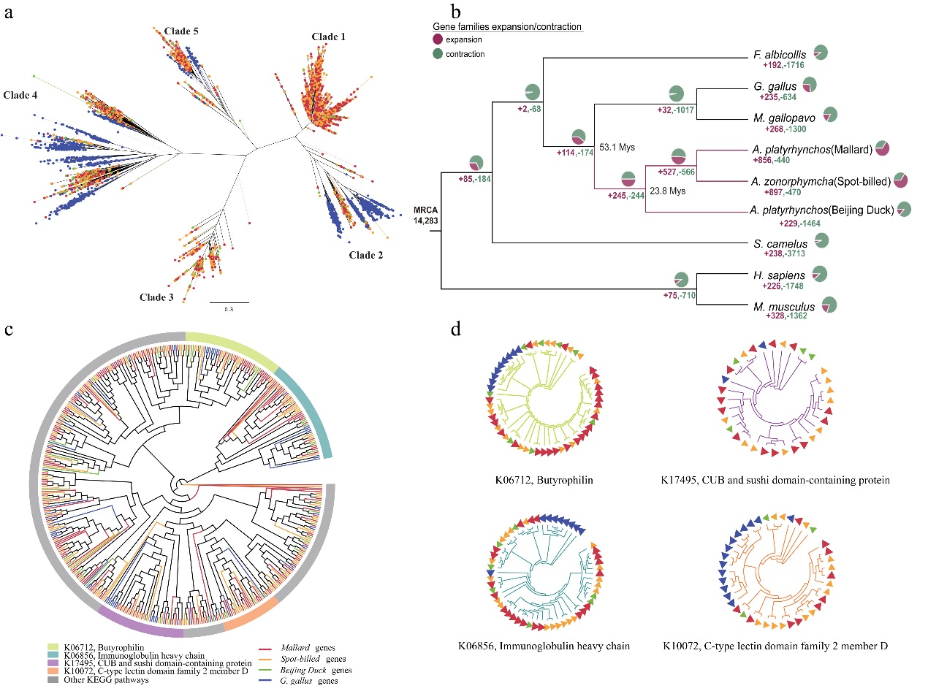
Figure 1: Expansion and contraction of transportable element and gene in mallard, spot-billed and Beijing duck genome. Green, red, yellow and blue in a and c panel represent Beijing duck, mallard, spot-billed and chicken, respectively. (a) Phylogeny of CR1 retrotransposons in four bird genomes. (b) Numbers of gene family losses and gains across ten vertebrates. Pie chart and numbers nearby indicate the number of expanded and contracted gene families in each branch. (c) Phylogeny of gene families expanded in spot-billed and mallard. Top four families ranked by the number of gene gained are indicated in color arcs. KEGG pathway annotation of those four families are listed in the bottom. Other families are indicated in grey color. (d) Detailed phylogeny of four gene families expanded in spot-billed and mallard duck as indicated in (c).
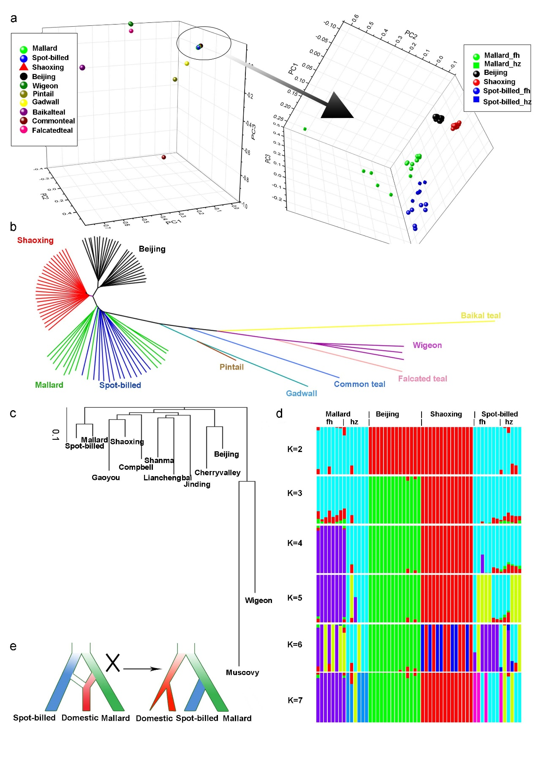Figure 2: Inference of phylogenetic topology in wild and domestic ducks. Beijing and Shaoxing ducks representing domestic ducks were used the Principal Component Analysis (PCA), phylogenetic analysis based on identity-by-state (IBS) and genetic structure analyses. “_fh” and “_hz” mean spot-billed and mallard collected from Fenghua and Hangzhou respectively. (a) PCA plot constructed for Principal Component 1 (PC1), PC2 and PC3 using 10,525 high-quality filtered SNPs from 27 Beijing and 27 Shaoxing ducks and 35 wild ducks (one bailkal teal, one gadwall, one pintail one falcated teal, common teal, three wigeon, 13 spot-billeds and 14 mallards) shows that domestic ducks are close to spot-billed and mallard wild ducks. (b) Neighbor-joining tree based on IBS distance of 80,505,576 SNPs. (c) Neighbor-joining tree based on genome wide pairwise fixation index (F_{ST}) of 44,852,612 SNP. (d) Genetic structure analyses of 13 spot-billed and 14 mallard wild ducks, together with 14 Beijing and 14 Shaoxing domestic ducks, using admixture ranging K from two to seven. (e) The inferred demographic models for wild and domestic ducks inferred based on genetic analysis of a-d (right). The traditional demographic model, hypothesized that domestic ducks were originated from mallard or the descendant of a mixture of spot-billed and mallard (left) are incompatible with observations in neighbor-joining trees (b-c) and genetic data(d).
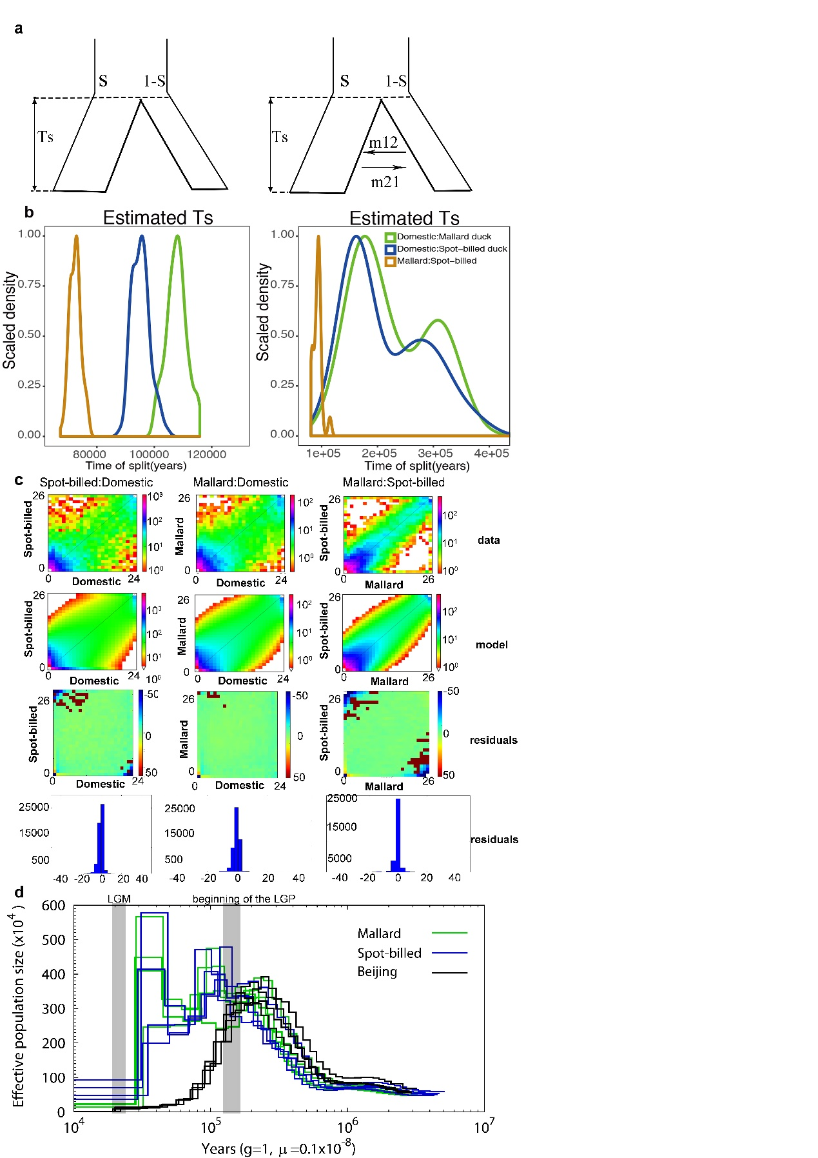
Figure 3: Inference of joint demographic history of ducks. Wild ducks included spot-billed and mallard ducks. Domestic ducks included Beijing, Cherryvalley, Compbel, Gaoyou, Jingding, Lianchengbai, Shaoxing and Shanma. (a) Illustration of the two models (with/without migration) used in the history inference through the $∂$a$∂$i analysis. Parameters corresponding to the code that were provided in supporting information. (b) Distribution of estimate Ts (divergence time) in 100 simulations between spot-billed and mallard (orange), mallard and domestic lineage (green), spot-billed and domestic lineage (blue), respectively. Corresponding model of each panel were shown above in (a). (c) Comparison between the observed, the model joint Site Frequency Spectrum (SFS) for divergence and its residuals between spot-billed and mallard, domestic lineage and mallard/spot-billed, respectively. (d) Demographic history inference of mallard duck, spot-billed duck and beijing duck through the PSMC analysis.
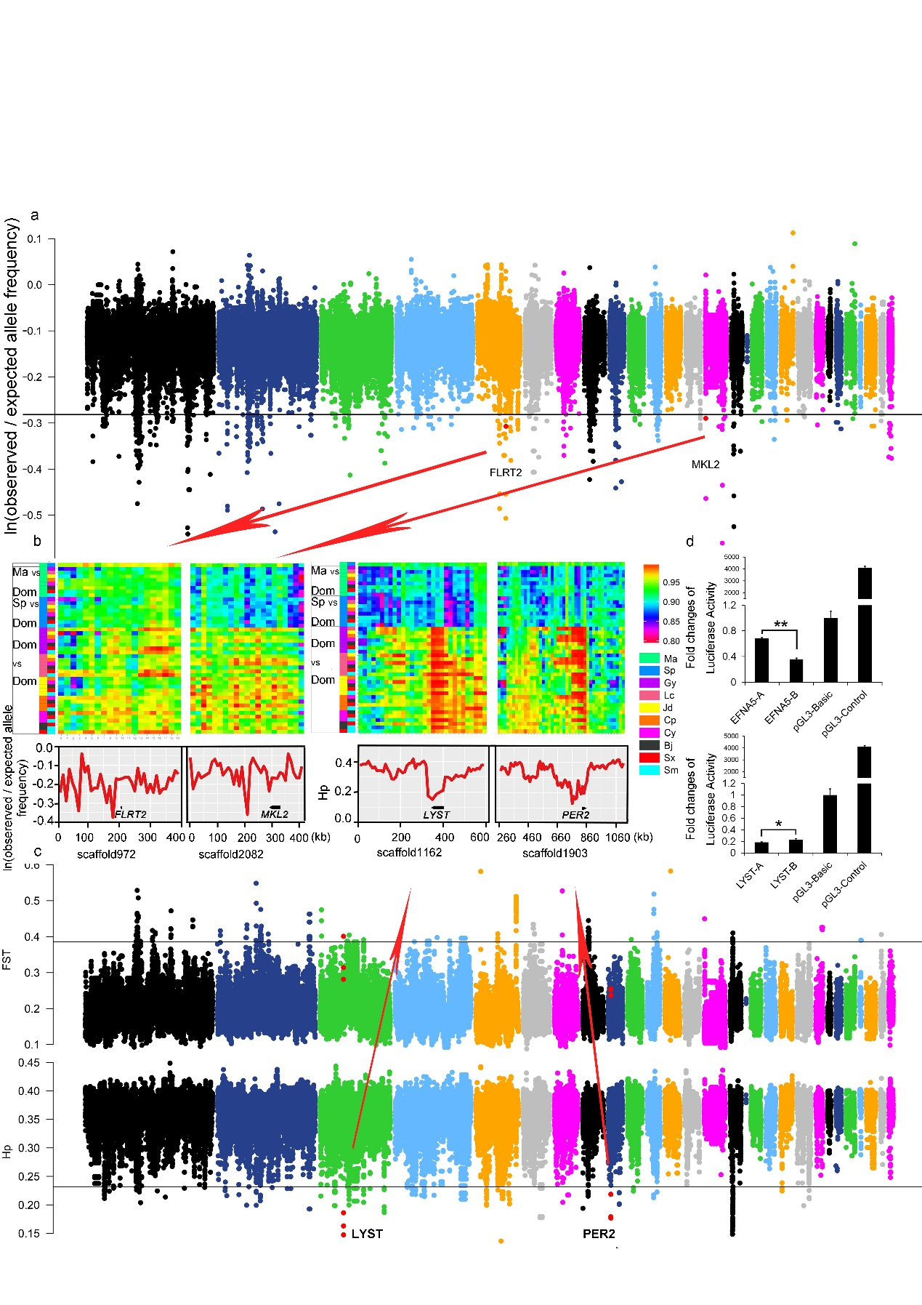Figure 4: Summary of selective sweep analyses of the early wild duck lineage and domestic duck. (a) Distribution of ln(observed/expected derived allele frequency) that is calculated in 20 kb window with a sliding size of 10 kb along scaffolds that is arranged according to their alignment to the chicken autosomes. The horizontal black line indicates the threshold at ln(observed/expected derived allele frequency) = -0.3136 (mean of ln values - 4 standard deviations). Outlier regions that were detail visualized by identity scores (IS) and re-computing values in more smaller window size in (b) were highlight with red dots. (b) Details of four putative selective sweep regions around the FLRT2, MKL2, LYST and PER2 genes. Upside of each panel shown degree of haplotype sharing in pairwise comparisons among populations. Color boxes (left) indicate the comparison performed on that row. “Ma”, “Sp”, “Dom”, represent mallard, spot-billed and domestic duck respectively. Y-axis (downside) of FLRT2,MKL2, which is associated with retina/heart morphogenesis that were under seletion in wild ancestor, are ln(observed/expected derived allele frequency), whereas y-axis of LYST,PER2 that were under selection in domestic duck are hp. (c) Distribution of F_{ST} between the wild and the domestic duck, and Hp in the domestic duck that is calculated in 40 kb with a sliding size 20 kb along scaffolds that is arranged according their alignment to the chicken autosomes. The horizontal black line indicates the threshold at F_{ST} = 0.3858 or Hp=0.2319 (mean of ln values - 4 standard deviations). Red dots indicate the location of outlier genes (4 standard deviations away from hp means) that were detail visualized in (b). (d) Comparison in luciferase activity of major alleles of MRPS27 and EFNA5 in wild (spot-billed and mallard) and domestic (Beijing) duck in DF1 (chicken embryonic fibroblast) cells. “A” and “B” represent wild duck and domestic duck, respectively. “*” P ≤ 0.05. DF1 cells were transfected with recombinant pGL3 luciferase reporter plasmids and luciferase activity was measured at 24 hours after transfection.
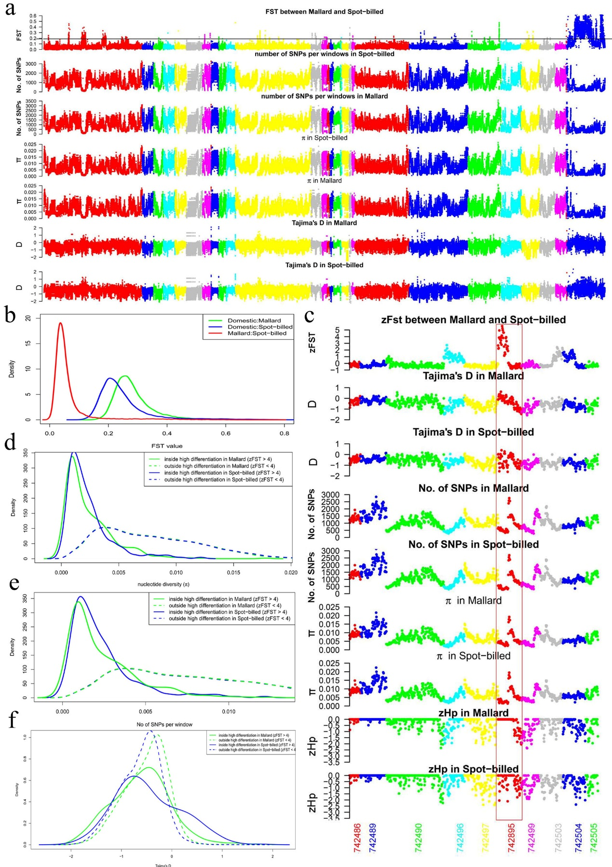Figure 5: The genomic landscape of species divergence between spot-billed and mallard ducks. (a) Distribution of population genomic parameters of the Beijing duck assembly, in 40 kb windows sliding 20 kb steps. The blue scaffolds in the right were referred as duck Z scaffolds. The black horizontal line indicates the threshold at F_{ST} = 0.1888 (mean of F_{ST} + 4 standard deviations, referred it as Z(F_{ST}) = 4). The plots show the F_{ST} between spot-billed and mallard, number of SNPs per window, nucleotide diversity (π), Tajima’s D for spot-billed and mallard respectively. (b) Distribution of pairwise F_{ST} for 40 kb windows sliding 20 kb steps. The red line shows the plot in the first row of (a). The blue and green line show the pairwise F_{ST} between spot-billed/mallard and domestic ducks (combination of 8 domestic breeds). (c) Distribution of population genomic parameters along ten scaffolds. (d-f) Distribution of nucleotide diversity (π), number of SNPs per window and Tajima’s D inside/outside high differentiation regions in Beijing duck assembly (version 1.0).
Tables
Table 1. Comparison in features of the mallard, spot-billed and Beijing duck
genomes
Genomic features | Mallard | Spot-billed | Beijing duck
Assembled genome size (Gb) | 1.27 | 1.31 | 1.11
Contig N50 (bp) | 38,271 | 33,061 | 26,114
Scaffold N50 (bp) | 2,489,142 | 2,054,876 | 1,233,631
GC content (%) | 41.90 | 41.90 | 40.90
Repeat rate (%) | 10.71 | 10.55 | 7.31
Heterozygosity rate (×10⁻³) | 3.60 | 3.54 | 2.40
Predicted protein-coding genes | 21,056 | 21,123 | 20,629

Table 2. Enriched gene ontology related to biological process terms for genes under positive selection in the early spot-billed and mallard ancestors
Gene ontology term | P-value | Number | Size
Synapse organization | 0.0031 | 4 | 22
Fatty acid transport | 0.0041 | 3 | 12
Blood vessel morphogenesis | 0.0042 | 4 | 24
Protein polyubiquitination | 0.0044 | 6 | 55
Metanephros morphogenesis | 0.0046 | 2 | 4
Epithelial cell migration | 0.0046 | 2 | 4
Nerve growth factor signaling pathway | 0.0046 | 2 | 4
L-glutamate import | 0.0046 | 2 | 4
T cell receptor signaling pathway | 0.0057 | 4 | 26
Head development | 0.0064 | 3 | 14
Positive regulation of MAPK cascade | 0.0073 | 6 | 61
Respiratory system development | 0.0075 | 2 | 5
epithelial cell differentiation | 0.0084 | 5 | 45
positive regulation of protein ubiquitination | 0.0084 | 5 | 45
Smooth muscle cell differentiation | 0.0095 | 3 | 16
negative regulation of extrinsic apoptotic signaling  pathway in absence of ligand | 0.0095 | 3 | 16
negative regulation of peptidyl-threonine  phosphorylation | 0.0110 | 2 | 6
serotonin metabolic process | 0.0110 | 2 | 6
Lung epithelium development | 0.0110 | 2 | 6
Lung morphogenesis | 0.0113 | 3 | 17
mitotic cytokinesis | 0.0133 | 3 | 18
Ventricular cardiac muscle tissue morphogenesis | 0.0133 | 3 | 18
Cardiac right ventricle morphogenesis | 0.0152 | 2 | 7
Positive regulation of heart rate | 0.01526 | 2 | 7
Negative regulation of programmed cell death | 0.0152 | 2 | 7
Bud elongation involved in lung branching | 0.0152 | 2 | 7
Positive regulation of mitotic cell cycle | 0.0154 | 3 | 19
Nucleotide-excision repair | 0.0178 | 3 | 20
Neutrophil chemotaxis | 0.0178 | 3 | 20
Dorsal/ventral pattern formation | 0.0180 | 4 | 36
Full lists of enriched terms are presented in Supplemental Table 15. Terms that considered to be associated with enhancement of long range flight ability were in bold. Size represents total number genes of this term.

