Name: Zixi Luo
ID: Y1719843d
Profesor: Victor Josué Peinado Herencia
Group: T2

The language instinct

The language instinct is a book by Steven Pinker. This book argues that human are born with an innate capacity for language. He claims that much of language knowledge is innate, implying that children only need learn certain parochial features of their mother tongue. In these 3 chapter Pinker introduce that language is a tool to express though, human thought not based on language. Then is syntax, the grammar of English and the last one how computer and human brain understand the sentence and how computer and human brain deal with the information.

Chapter 3 : mentalese

At the beginning of this chapter, Pinker gives a introduction of the language newspeak. Newspeak is a word from a fiction nineteen eighty-four by George Orwell. It creates by totalitarian states as tool to control people’s thought. Then Pinker said: There is a straw of hope for human freedom, he asks a question that is thought dependent on words? Do people literally think in English, Cherokee, or, by 2050 Newspeak?

The linguistic determinism hypothesis is related to the Edward Sapir and Benjamin Lee Whorf. According to Sapir-Whorf hypothesis of linguistic determinism, human’s thoughts are determined by the categories made available by their language, and its weaker version, the differences among languages cause differences in the thoughts of their speakers.

Pinker indicates that all these are wrong. It’s totally ridiculous that thought is the same with language. For example, some times we cannot tell a proper word to express our feeling. When we hear or read, we usually keep the main idea in mind, not the exact words. And if thought depended on words, it is impossible to translate, or coin a word, or children to learn a word.

The experiment by Karen Wynn shows that babies can do some simple forms of mental arithmetic. Another test by Dorothy Cheney and Robert Seyfarth shown that monkeys know their groupmates among them and they can identify their sister and brother. A lot famous artists indicate that they are think not in words but in mental images. Like Joan Didion, he insists that the vivid mental picture come first in his mind but not words when he works on his acts of creation.

So how the brain deal with images, numbers, kinship relations without being couched in words? The scientifically philosopher Alan Turing suggests “Turing Machine”. By looking at how this machine works, we can find out how human mind to think in mentalese.

Pinker said, basically, new knowledge comes from old knowledges. If we know all men are mortal, and Socrates is a man, then we can easily get the conclusion that Socrates is mortal. Then he gives a important definition: representation, that is a physical object whose parts and arrangement correspond piece for piece to some set of ideas or facts. Pinker explains the example of “Socrates isa man every man ismortal”. First, he said, we need a processor that can deal with a fixed number of reflexes. Whenever this machine notices isa, it moves to the left and copies the ink marks. Then we can ger symbol “Socrates”. Second, find isa again, then get itself to the right of that isa and copy the ink marks. Third, the machine check for ink marks shaped the same “every”. If find some, check if the marks to the right align with the new cutout line. Finally, when find the same symbol, machine moves to the right and copy it. Then we can get “Socrates ismortal”. This machine can do anything mind can do.

Pinker makes a conclusion that any language in this world cannot serve as internal medium of computation. 1. Ambiguity 2. Lack of logical explicitness 3.co-reference 4. Deixis. 5. Synonymy. We can see language in many ways opposite what we want to express actually. To study a language is to learn how to translate mentalese into strings of word and vice versa. People can have mentalese without using language.

Chapter 4 : How language works

Language conveys news, Pinker explains that how people use a code which is called grammar to translate the order of word, and he goes on to research that how language makes infinite use of finite media.

A grammar is an example of a “discrete combinatorial system”. Choose words from a finite number of word system by random, and combine them. So the way language works is that a mental dictionary in our brain, we combine the words by rules and express this sentence.

This combinatorial system has two important consequences. First is the sheer vastness of language. For example, if we read a book, it is hard to find a same sentence is the book. Actually people can create a huge number of sentences in their life. Second is that it is a code that is autonomous from cognition. We all read some sentences we can interpret but they are not properly formed. Why we feel that way? Pinker indicates that because we have a fixed code for interpreting sentence. Also, it is can happen as well that sentence make no sense but still be perfectly organized by grammar.

So how grammar works? Pinker quotes a explanation from Michael Frayn’s fiction The Tin Man. Pinker calls it a word-chain device. A work-chain device is a bunch of lists of words and a set of directions for going from list to list. A processor builds a sentence by selecting a word from one list, then a word from another list, and so on, an then recognize a sentence. Pinker also mention other study of grammar like-transition probabilities. That is human language is based on a huge word chain, called stimulus-response theories. But all these attempts fall. Because it is hard to remember all early choices in reality use.

Then, Pinker goes on to- explain that the ideal of a sentence is a chain is wrong, but instead, it is a tree. The words in the sentence are grouped into phrase. We give the phrase name. Fro example the phrase“the happy boy”. It a noun phrase. “the” is determiner, “happy”is adjectives, “boy”is the center word, its a noun. In English grammar, determiner is optional and can use adjectives as many as you want in a noun phrase.
Here is a rule defines tree branch.
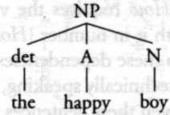
We can have verb phrase too. So Pinker calls it “phrase structure grammar”.-- defines a sentence by linking the wording to brank on an inverted tree.
This tress structure explain sentence. Then Pinker suggests we need identify which words are belong to which categories. Noun: boy, girl, candy. Verb : eats, likes, bites. For instants. Accoding to these we can defines sentence.
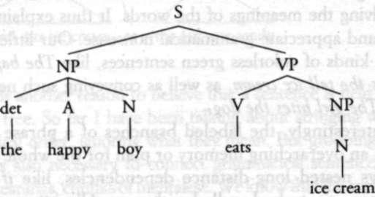
This tree show the structure of the sentences, and explain why we can use the same kind of phrase in many different position in a sentence, and at the same time eliminates the problem of word-chain devices. Noun phrase can be subject in a sentence also can be a object of a verb phrase, indirect object or object of a preposition.

After this, Pinker gives another evidence to improve that sentence is held together by mental tree. When we create a sentence, we also need consider their meaning. The tree structure determines meaning, and one way to prove it is that language and thought have to be different as mentioned in chapter 3.
We can get two distinct meaning of sentence “discuss sex with Dick Cavett”, but these two meaning come from the different structures of sentence. First, with Dick Cavett is the prepositional phrase of the whole sentence, but in the second structure with Dick Cavett is prepositional phrase of the noun sex.
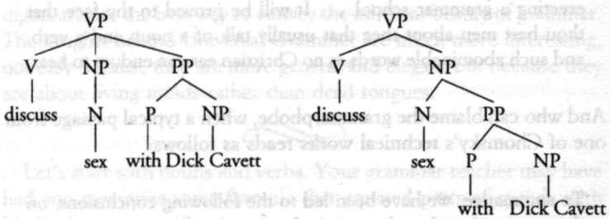
Now, Pinker introduces the phrase. He said that linguistics discover that there a common anatomy in all phrase in all phrase in all the world’s language. A noun phrase of English for example, the cat in the hat. It is a noun phrase, this phrase refers a kind of cat, not a hat. We call this center word -the “head” of the phrase. Secondly, phrase also refers to players that interact with each other in a particular way, each with a specific role. In the sentence Sergey gave the document to the spy. It choreographs three entities: Sergey, the giver. Document, the present. And a spy, the recipient. We call the role player “argument”. This is the term used in logic and mathematics for a participant in a relationship. A explanation by tree structure.
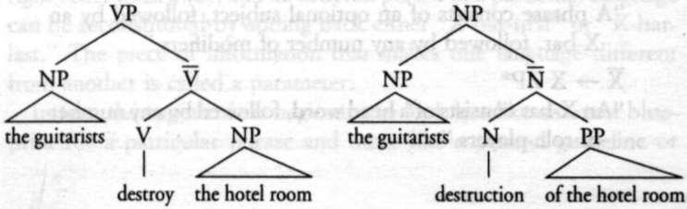

Now, Pinker remind us, noun phrase and verb phrase have a lot in common. In fact, the design pops up all over the place. With this common design, there is no need to write a long list of rules, we can use a variable X to present the noun, verb, etc. We can call it X phrase.

Pinker discuss syntax in this chanter, explain to us how language works and how our brain recognise the sentence

Chapter 7

For the last 35yesar, AI(artificial intelligence) find that the hard problems are easy and the easy problems are hard. In fact, it is not easy to understand the meaning. The first step to understand a sentence is “parse”. Then Pinker repeats the knowledge of syntax. But to program a computer to do this can be really hard. Why? Pinker said when we analysis a sentence, first ,we had to keep track of the dangling phrase that needed particular kinds of words to complete them. Second, when a word or phrase was found on the right-hand side of two different rules, we had to decide which to use to build the next branch of the tree. According to hard problems are easy and the easy problems are hard. Its easy for computer to memory but hard to human, and easy for us to make decision but hard for computers.

But then, Pinker proves another question that why people cannot or feel hard when deal with sentences are like onions or Russian dolls? The thing is human parser in not the amount of memory needed but the kind of memory: keeping a particular kind of phrase in memory. Intending to get back to it, at the same time as it is analyzing another example. When a type of phrase has to be remembered more than once and identical type of phrase it is inside of , can be completed in order. The phrases cannot be completed properly

Decision-making, which people are good ar but computer are bad at. So computer will find ambiguities that are quite legitimate. Pinker gives a funny example. For us there is no problem to understand time flies like an arrow. But computer can offer 5 different meaning
1 Time proceeds as quickly as an arrow proceeds, (the intended
reading)
2 Measure the speed of flies in the same way that you measure
the speed of an arrow.
3 Measure the speed of flies in the same way that an arrow
measures the speed of flies.
4 Measure the speed of flies that resemble an arrow.
5Flies of a particular kind, time-flies, are fond of an arrow.

In order to solve the problem,computer scientists come up with “dreadth-first search” and “depth-first search”. The psycholinguist David Swinney gets a suggestion from his experiment that the serval meaning of a work come out, but the brain can find proper one and the irrelevant meanings are not stay long.

Then Pinker discusses about depth-first search. He tells a type of sentence called “garden path”. Because their first words lead the recipient “up the garden path” to an incorrect analysis. This sentence shows that human’brain are unlike computer, gives all possible trees of the sentence. So people mainly use depth-first search.

Recently, in psychological textbook, there is no “psychological reality”. Pinker presents a sentence:
The policeman saw the boy that the crowd at the party
accused (trace) of the crime.
Easily to find that the boy is the person be crimed. Even this word is not following the accused. Pinker said that a person trying to understand the sentence must undo the effect of the transformation and mentally put a copy of the phrase back in the position of the trace.

At the last of the chapter, Pinker gives suggestion how to understand the meaning behind the sentences and how speak and write correctly. Metaphor and humor are useful ways to summarize the two mental performance that go into understanding a sentence as well.

