INTERACTIVE FULL-STACK
PORTFOLIO PLATFORM
ENGINEERING DOCUMENTATION PACK
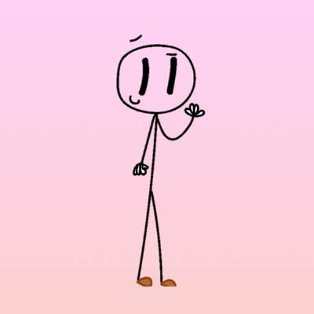
Public Portfolio • Admin CMS • Private Desk
Next.js • NestJS • PostgreSQL • Prisma • GSAP
Version 1.0
10 August 2026
Baseline: Local-first implementation through Phase 8 (LOCAL COMPLETE)

Document purpose
Bộ tài liệu kỹ thuật đầy đủ cho project portfolio có backend/CMS. Tài liệu production được thiết kế trước nhưng không triển khai cho tới sau LOCAL COMPLETE, đúng roadmap hiện tại.
Document map
No. | Document | Purpose
01 | Vision / BRD | Goals, stakeholders, scope
02 | SRS | Functional + non-functional requirements
03 | Use Cases | Detailed interaction flows
04 | Architecture HLD | System/component boundaries
05 | Design LLD | Modules, validation, state
06 | Database Design | ERD, integrity, migrations
07 | API Specification | REST contracts
08 | UI/UX System | Visual + interaction specification
09 | Admin CMS | Content/editor workflows
10 | Security | Threat model + controls
11 | Test Strategy | QA + acceptance
12 | Local Runbook | Development operations
13 | Production Plan | Deferred production target
14 | DevOps/Ops | Backup/monitoring/CI-CD
15 | RTM | Requirement traceability
16 | Roadmap/Risk/ADR | Planning + decisions
17 | Definition of Done | Phase quality gates

Contents
- 00. Document Control & Documentation Index
- 01. Vision, Business Requirements & Scope (BRD)
- 02. Software Requirements Specification (SRS)
- 03. Use Case Specification
- 04. Software Architecture Document / High-Level Design (HLD)
- 05. Software Design Specification / Low-Level Design (LLD)
- 06. Database Design Specification
- 07. REST API Specification
- 08. UI/UX, Interaction & Design System Specification
- 09. Admin CMS & Content Workflow Specification
- 10. Security Specification & Threat Model
- 11. Test Strategy, QA Plan & Acceptance Tests
- 12. Local Development Environment & Runbook
- 13. Future Production Deployment & Operations Plan
- 14. DevOps, Backup, Monitoring & CI/CD Specification
- 15. Requirements Traceability Matrix (RTM)
- 16. Project Roadmap, WBS, Risk Register & Architecture Decisions
- 17. Definition of Done, Phase Gates & Checklists

00. Document Control & Documentation Index
Project: Interactive Full-stack Portfolio Platform
Version: 1.0
Date: 2026-08-10
Status: Baseline specification for local-first implementation

Purpose
This documentation pack is the engineering baseline for the portfolio platform. It is intentionally local-first: Phases 0-8 are implemented and validated locally before any production deployment work begins.

Document hierarchy
Document | Primary purpose | Main audience
01 Vision / BRD | Why the system exists, business goals, scope | Owner, designer, developer
02 SRS | Functional and non-functional requirements | Developer, QA
03 Use Cases | Detailed actor-system interactions | Developer, QA, UX
04 Architecture / HLD | System boundaries and major components | Developer, reviewer
05 Design / LLD | Module behavior, interfaces, validation, states | Developer
06 Database Design | Data model, constraints, lifecycle | Backend developer
07 API Specification | REST contracts and error model | FE/BE developer
08 UI/UX Design System | Visual language and interaction rules | Designer, FE developer
09 Admin CMS | Content workflow and editor behavior | Owner, developer
10 Security | Auth, authorization, threats, controls | Developer, ops
11 Test Strategy | Test levels, test cases, acceptance | QA, developer
12 Local Runbook | Local setup and daily development | Developer
13 Production Plan | Future production architecture and deployment | Ops, developer
14 DevOps / Backup / Monitoring | Reliability and operations | Ops, developer
15 Traceability Matrix | Requirement-to-design-to-test mapping | QA, reviewer
16 Roadmap / WBS / Risk / ADR | Planning, decisions and risks | Owner, developer
17 Definition of Done | Quality gates for each phase | Developer, QA

Source-of-truth rules
- The SRS owns requirement IDs.
- The API spec owns HTTP contract semantics until OpenAPI becomes generated source-of-truth.
- The database design owns entity definitions until Prisma schema is implemented; afterward Prisma schema is authoritative.
- The UI/UX spec owns the visual system; Figma may supersede dimensions and screen-level layout when created.
- Architecture Decision Records (ADR) capture deliberate technical choices and must be updated when a decision changes.
- Production/deployment documents are future-phase specifications; they must not block Local Complete.

Versioning
Use semantic document versions: MAJOR.MINOR. Increase MAJOR when requirements or architecture change incompatibly; increase MINOR for clarifications and additive scope.

Change control
Every material change should record: date, affected requirements, reason, impacted modules, migration impact, test impact and deployment impact.

01. Vision, Business Requirements & Scope (BRD)
Project: Interactive Full-stack Portfolio Platform
Version: 1.0
Date: 2026-08-10
Status: Baseline specification for local-first implementation

1. Product vision
Build a personal digital space that is simultaneously: (1) a distinctive public portfolio for clients/recruiters, (2) a real content-managed product rather than hardcoded showcase pages, and (3) a private workspace for the owner.
The product should communicate a hybrid identity: amateur designer with a playful hand-drawn visual language, Upwork freelancer, and full-stack Node.js developer using Next.js/React/NestJS.

2. Business goals
- BG-01: Present development and design work in a memorable, credible format.
- BG-02: Allow all portfolio content and milestones to be maintained through an owner-only CMS.
- BG-03: Demonstrate full-stack engineering ability through the portfolio product itself.
- BG-04: Support case-study storytelling rather than shallow project cards.
- BG-05: Create a reusable private utility area that makes the site useful to the owner beyond self-promotion.
- BG-06: Keep recurring infrastructure costs near zero by enabling future self-hosting on an existing computer.
- BG-07: Keep deployment work late in the roadmap; reach a fully usable local system first.

3. Stakeholders
Stakeholder | Need
Owner | Easy content editing, private utilities, strong personal identity
Prospective client | Rapid evidence of design/development quality and project outcomes
Recruiter / technical reviewer | Architecture, stack, code/project depth, clear role and responsibilities
Casual visitor | Fast, responsive, enjoyable browsing
Future operator (owner) | Safe backup, repeatable deployment, low maintenance

4. Scope

In scope for Local Complete
- Public home, work, project detail, journey, playground and about surfaces.
- Dynamic content from PostgreSQL through NestJS APIs.
- Owner authentication and authorization.
- Admin dashboard and CRUD for projects, milestones, playground items, media and site settings.
- Structured case-study block builder.
- Local media upload/storage.
- Light and dark themes.
- Responsive behavior.
- GSAP-based storytelling and an original stickman mascot system.
- Private Desk foundation and a small initial set of utilities.
- Automated tests sufficient for the local quality gate.

Explicitly deferred until after Local Complete
- Domain configuration.
- Home-server operating system setup.
- Production Docker topology, Nginx, Cloudflare Tunnel and public TLS.
- Live production PostgreSQL deployment.
- Production backup jobs and monitoring.
- CI/CD deployment pipeline.

5. Out of scope for v1
- Multi-tenant CMS or public user registration.
- Client accounts.
- E-commerce/payment processing.
- Public comments/social feed.
- Complex team permissions.
- Native mobile applications.
- Enterprise analytics platform.

6. Success criteria
Local Complete is achieved when the owner can create a project in /admin, upload/select media, build a case study, publish it, and immediately see the public project without source-code edits or reseeding. The same principle applies to milestones and playground items.

7. Product principles
- Content first, animation second. Animation supports storytelling and never hides information.
- Original identity. The stickman/doodle language is inspired by the provided reference but is implemented as an original mascot system.
- Calm interface. Approximately 70% editorial/minimal UI and 30% doodle personality.
- Server authority. Backend enforces permissions and validation; frontend hiding is not security.
- Local-first delivery. Production complexity is intentionally postponed.
- Maintainability over novelty. Use conventional data models and explicit contracts beneath the playful interface.

02. Software Requirements Specification (SRS)
Project: Interactive Full-stack Portfolio Platform
Version: 1.0
Date: 2026-08-10
Status: Baseline specification for local-first implementation

1. System overview
The system is a monorepo containing a Next.js web application, a NestJS REST API, and PostgreSQL accessed through Prisma. It has three experience zones: public portfolio, owner-only Admin CMS, and owner-only Private Desk.

2. Actors
- A-01 Visitor: anonymous public user.
- A-02 Owner: authenticated administrator and private-desk user.
- A-03 Local Developer: operates the system in development.
- A-04 Production Operator: future role, normally the owner.

3. Functional requirements

Public portfolio
- FR-PUB-001: The system shall render a public home page containing hero, about preview, selected work, journey preview, playground preview and contact area.
- FR-PUB-002: The system shall list only projects whose status is PUBLISHED on public surfaces.
- FR-PUB-003: The system shall provide a /work project index.
- FR-PUB-004: The system shall provide /work/[slug] case-study pages assembled from persisted project blocks.
- FR-PUB-005: The system shall provide a public journey/timeline built from visible milestones.
- FR-PUB-006: The system shall provide a playground/experiments page built from published playground items.
- FR-PUB-007: The system shall expose contact and professional links configurable through site settings.
- FR-PUB-008: Public pages shall support light and dark themes.
- FR-PUB-009: The site shall preserve core content and navigation when motion is reduced or JavaScript animation is unavailable.

Authentication and authorization
- FR-AUTH-001: The system shall authenticate the owner using email and password.
- FR-AUTH-002: Successful authentication shall create an authenticated session using an HttpOnly cookie-based mechanism.
- FR-AUTH-003: Backend authorization shall protect all mutating Admin and Private Desk endpoints.
- FR-AUTH-004: Invalid credentials shall not reveal whether an email exists.
- FR-AUTH-005: The owner shall be able to log out and invalidate the current session.

Project CMS
- FR-PRJ-001: Owner shall create, read, update and archive projects.
- FR-PRJ-002: Each project shall have unique slug, title, summary, type, status, year, role and display order.
- FR-PRJ-003: Project metadata may include client, services, technologies, repository URL, live URL and external portfolio URL.
- FR-PRJ-004: Owner shall mark projects as featured and control their display order.
- FR-PRJ-005: Owner shall transition projects among DRAFT, PUBLISHED and ARCHIVED states.
- FR-PRJ-006: Slug uniqueness shall be enforced server-side and in the database.
- FR-PRJ-007: Public queries shall exclude drafts and archived projects.

Case-study builder
- FR-CS-001: A project shall contain an ordered sequence of content blocks.
- FR-CS-002: Supported v1 blocks shall include heading, paragraph, full-width image, image pair/gallery, quote/callout, video/embed reference and code/technical block.
- FR-CS-003: Owner shall add, edit, reorder and delete blocks.
- FR-CS-004: Owner shall preview the case study before publishing.
- FR-CS-005: Block payloads shall be validated based on block type.

Milestones / journey
- FR-MIL-001: Owner shall create, update, delete/archive and reorder milestones.
- FR-MIL-002: A milestone shall contain title, description, date, type, visibility and sort order.
- FR-MIL-003: Public journey shall display only visible milestones in deterministic order.

Playground
- FR-PLAY-001: Owner shall manage playground items independently of client projects.
- FR-PLAY-002: Playground items shall support draft/published status, title, slug, summary, links and flexible content.

Media
- FR-MED-001: Owner shall upload image assets locally during development.
- FR-MED-002: System shall persist media metadata including path, MIME type, size and alt text.
- FR-MED-003: Owner shall browse and select existing assets from the Admin media library.
- FR-MED-004: Upload endpoints shall reject unsupported MIME types and files above configured limits.
- FR-MED-005: Public image output shall include meaningful alt text where the image is not purely decorative.

Site settings
- FR-SET-001: Owner shall manage contact links, headline copy and selected global presentation settings without source changes.
- FR-SET-002: Site settings shall be stored as validated key/value configuration.

Private Desk
- FR-DESK-001: /desk shall require owner authentication.
- FR-DESK-002: The desk shall provide a dashboard and extensible utility modules.
- FR-DESK-003: Initial utilities may include JSON formatter, JWT decoder, UUID generator and timestamp converter.
- FR-DESK-004: Private utility data shall never be returned by public API routes.

4. Non-functional requirements

Performance
- NFR-PERF-001: Public page interactions shall remain responsive on modern mobile and desktop devices.
- NFR-PERF-002: Expensive animation shall avoid layout thrashing and unnecessary continuous work.
- NFR-PERF-003: Media shall be appropriately sized and optimized for delivery.

Accessibility
- NFR-A11Y-001: Semantic headings, landmarks, keyboard navigation and visible focus states shall be implemented.
- NFR-A11Y-002: Motion-sensitive users shall receive reduced or disabled non-essential animation through prefers-reduced-motion.
- NFR-A11Y-003: Color contrast shall remain readable in both themes.

Security
- NFR-SEC-001: Passwords shall be stored only as strong cryptographic hashes.
- NFR-SEC-002: Protected operations shall require server-side authorization.
- NFR-SEC-003: Authentication cookies shall use HttpOnly; production cookies shall also use Secure and an appropriate SameSite policy.
- NFR-SEC-004: Backend shall validate all external input.
- NFR-SEC-005: Database credentials and secrets shall not be committed to source control.
- NFR-SEC-006: File upload processing shall prevent path traversal and executable file upload.

Reliability and data integrity
- NFR-REL-001: CMS writes affecting multiple related records shall be transactional where partial state would be invalid.
- NFR-REL-002: Database constraints shall protect uniqueness and referential integrity.
- NFR-REL-003: Production design shall include recoverable database/media backups before public launch.

Maintainability
- NFR-MNT-001: Web and API shall be separated into clear modules with shared types/validation where appropriate.
- NFR-MNT-002: No public project or milestone content shall require editing page source files after CMS is complete.
- NFR-MNT-003: Architecture decisions that materially affect the system shall be captured as ADRs.

Compatibility
- NFR-COMP-001: Public UI shall support current mainstream Chromium, Firefox and Safari families.
- NFR-COMP-002: Layout shall support mobile, tablet and desktop breakpoints.

5. Data requirements
- Persistent project, block, media, milestone, playground and setting data shall live in PostgreSQL.
- Uploaded media is file-backed in local development with metadata in PostgreSQL.
- A stable media abstraction shall allow future migration to another storage backend without changing public content semantics.

6. Constraints
- Primary stack: TypeScript, Next.js/React, NestJS, PostgreSQL, Prisma.
- GSAP is the primary advanced animation engine.
- Local development precedes production setup.
- v1 is single-owner; no generic user-management UI is required.

7. Local Complete acceptance condition
All FR-* requirements marked for local scope must be demonstrable on a clean local setup, with critical flows covered by automated tests and no dependence on domain, Cloudflare, or a production server.

03. Use Case Specification
Project: Interactive Full-stack Portfolio Platform
Version: 1.0
Date: 2026-08-10
Status: Baseline specification for local-first implementation

UC-001 Browse portfolio
Actor: Visitor. Precondition: none. Trigger: visitor opens /.
Main flow: system loads published portfolio content; renders hero and selected work; visitor navigates to work, journey, playground or contact.
Alternate: API/content failure displays a graceful error/empty state without exposing stack traces.
Postcondition: no data mutation.

UC-002 View project case study
Actor: Visitor. Precondition: project is published.
- Visitor opens /work/[slug].
- System resolves project by slug with published status.
- System loads ordered blocks and media.
- UI renders case study and external links.
- If slug is absent/unpublished, return not-found behavior.

UC-003 Owner login
Actor: Owner.
- Open /admin/login.
- Submit credentials.
- Web calls authentication API.
- API validates payload, verifies password hash and issues authenticated cookie.
- User is redirected to /admin.
Failure: generic authentication error; no user enumeration.

UC-004 Create project
Actor: Owner. Precondition: authenticated.
- Open project editor.
- Enter title, slug, summary, metadata and status.
- Add technologies/services and media references.
- Save as draft.
- Server validates and stores project.
- Admin displays success and stable project URL.

UC-005 Build case study
Actor: Owner.
- Open existing project editor.
- Add blocks using block picker.
- Configure content for each block.
- Drag/reorder or use accessible move controls.
- Save changes.
- Preview uses the same rendering primitives as the public project page.

UC-006 Publish project
Actor: Owner.
- Open valid draft.
- Choose Publish.
- System verifies required public fields and block validity.
- Transaction changes status to PUBLISHED.
- Public project appears in query results according to ordering/feature rules.

UC-007 Manage milestones
Actor: Owner.
Owner creates/edits/reorders a milestone, toggles visibility, saves, and verifies the public journey timeline reflects the persisted state.

UC-008 Upload/select media
Actor: Owner.
- Open Media Manager or media picker.
- Upload supported image.
- Server validates type/size and assigns safe filename/path.
- Metadata is stored.
- Owner enters/edits alt text.
- Asset becomes available to project/case-study selectors.

UC-009 Switch theme
Actor: Visitor/Owner.
User toggles light/dark theme. Preference is persisted client-side; system avoids an obvious flash of incorrect theme on next navigation where feasible.

UC-010 Reduced motion
Actor: motion-sensitive visitor.
When OS/browser requests reduced motion, non-essential GSAP timelines are replaced with static/reduced transitions while all content remains available.

UC-011 Use private utility
Actor: Owner. Precondition: authenticated.
Owner opens /desk, selects a utility, processes local input, and optionally stores utility-specific private state. No private state is available to anonymous routes.

UC-012 Logout
Owner chooses logout; server invalidates/clears authentication state; protected routes require login again.

UC-013 Local developer bootstrap
Developer clones repo, configures environment variables, starts PostgreSQL, installs dependencies, runs Prisma migration/seed, starts web/API, and verifies health endpoints.

UC-014 Local database reset
Developer intentionally resets local DB, reapplies migrations and seed data. This is development-only and must never be documented as a production operation.

UC-015 Future production release
Deferred until post-local phases. Operator takes backup, builds production images, applies production migrations, starts services, verifies health and rolls back on failure.

04. Software Architecture Document / High-Level Design (HLD)
Project: Interactive Full-stack Portfolio Platform
Version: 1.0
Date: 2026-08-10
Status: Baseline specification for local-first implementation

1. Architectural style
A modular monorepo with a web presentation application and a standalone REST API. PostgreSQL is the authoritative application data store. The design deliberately avoids microservices for v1; the workload and ownership model do not justify distributed-system complexity.
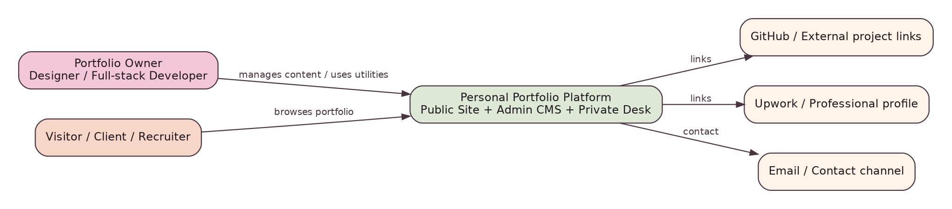
System Context

2. Local logical architecture
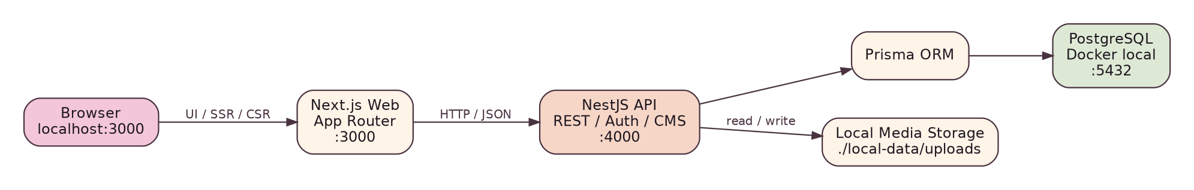
Local Architecture

Web responsibilities
- Public rendering and navigation.
- Admin and Private Desk UI.
- Theme handling and presentation state.
- GSAP animation orchestration.
- API consumption; no direct database access.

API responsibilities
- Authentication and authorization.
- Business validation.
- Project/case-study lifecycle.
- Milestones, playground and global settings.
- Media upload metadata and local storage abstraction.
- Persistence through Prisma.

Database responsibilities
- Durable structured state.
- Referential integrity and uniqueness.
- Ordered content relationships.
- Transactional updates.

3. Component view
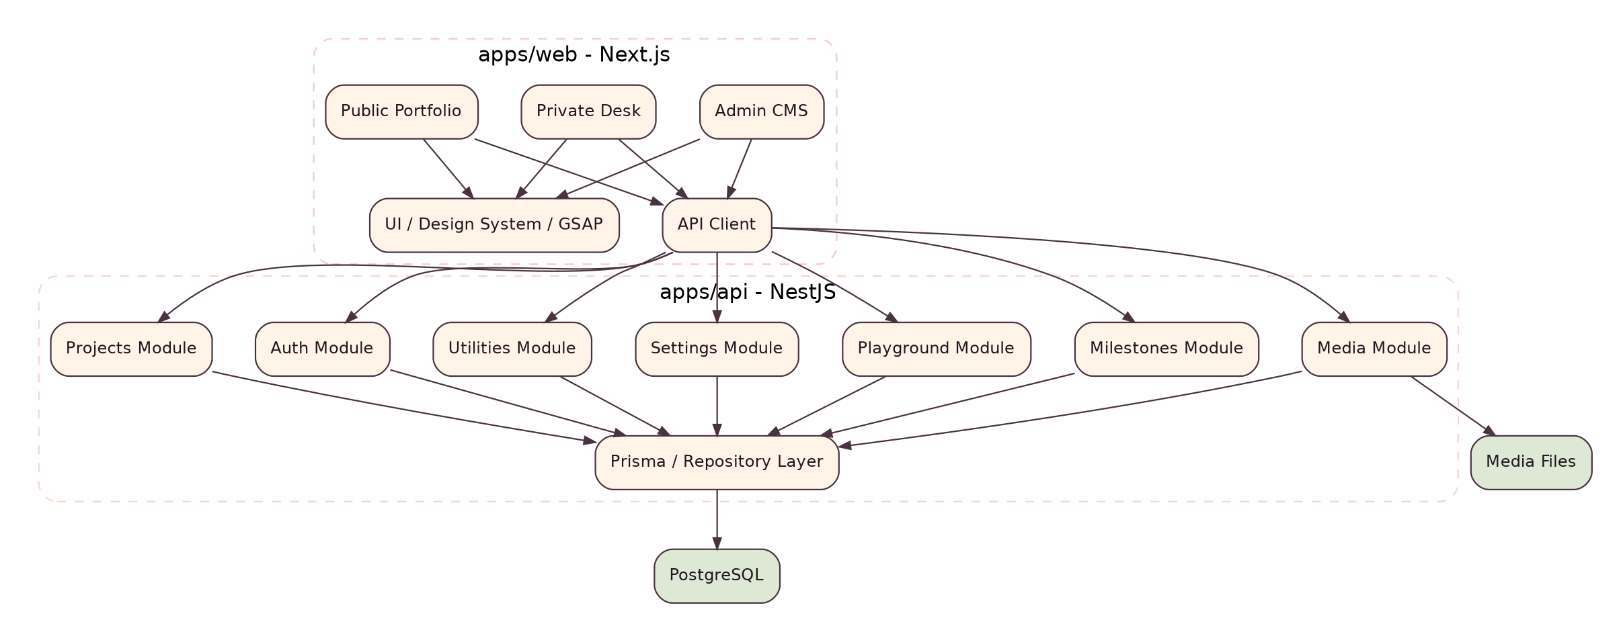
Component Architecture

4. Public information architecture
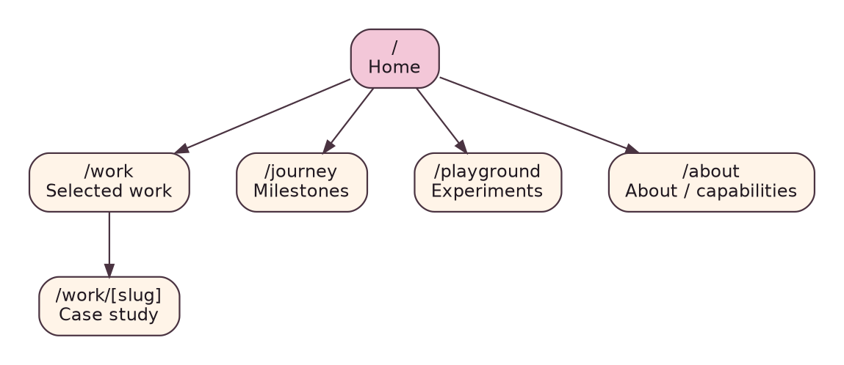
Public Sitemap

5. Admin information architecture
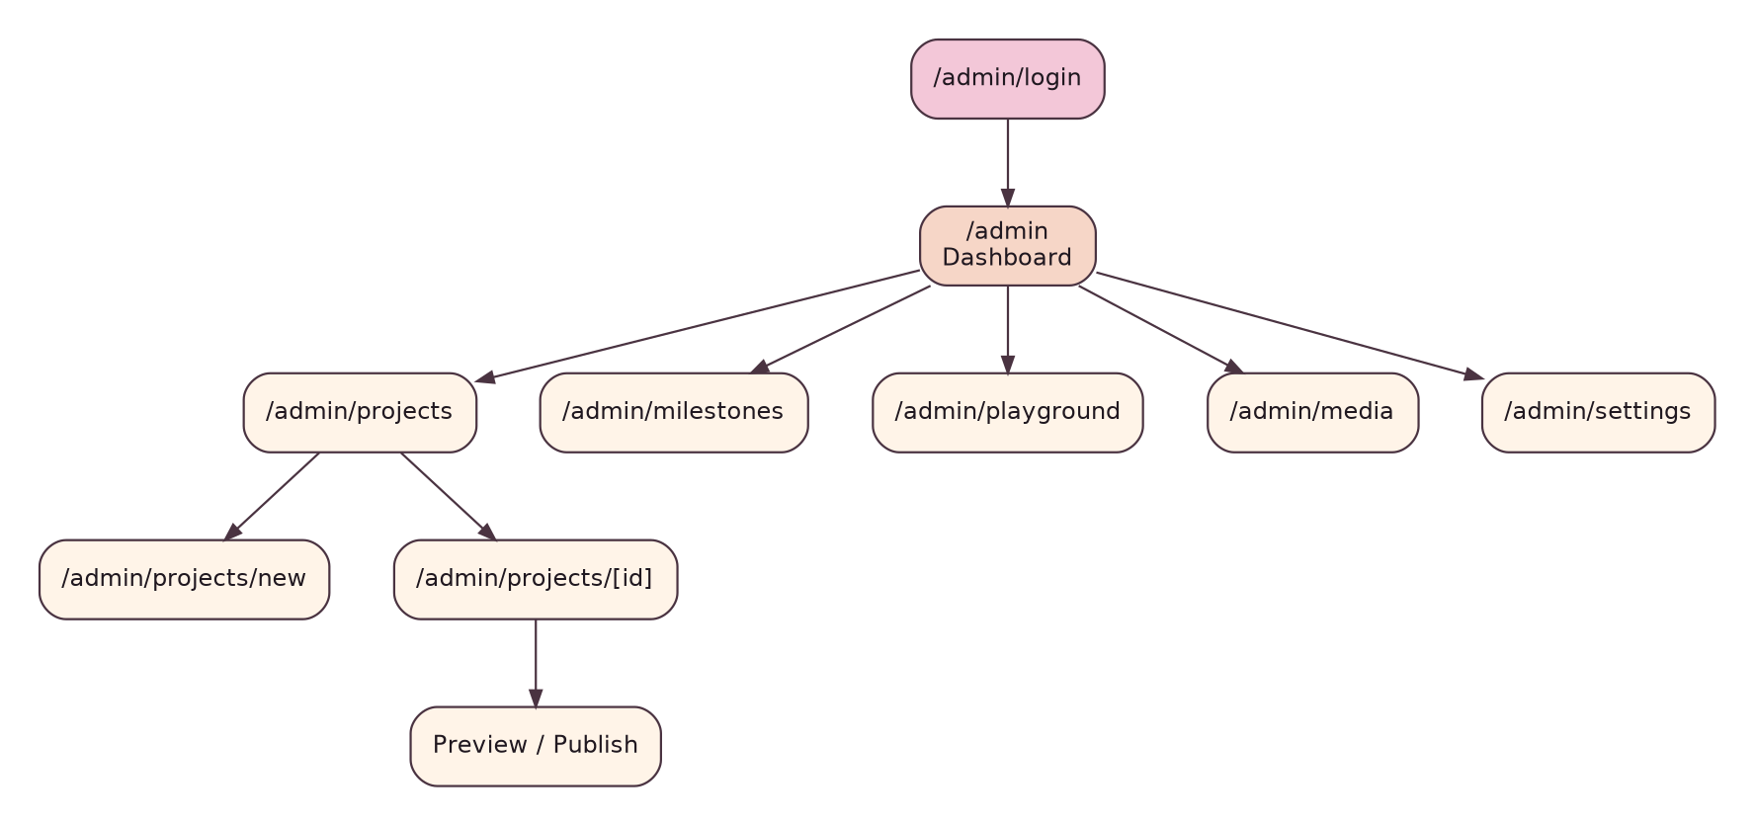
Admin Sitemap

6. Architectural boundaries
- UI components must not import Prisma or database code.
- API modules should expose service interfaces rather than cross-module table access.
- Public API read paths must apply publication/visibility rules at the service/query layer.
- Admin write routes require auth + owner role guard.
- Media filesystem access must be encapsulated so storage can change later.

7. Rendering strategy
Use server rendering/server components for public content where it improves initial load and SEO. Use client components only for interaction, theme controls and GSAP timelines. Admin screens may use more client-side state because edit workflows are interactive.

8. Error handling architecture
- API returns a consistent error envelope with status code, stable error code, message safe for UI and optional field issues.
- Web maps not-found, unauthorized and validation failures to purpose-built states.
- Internal stack traces are development diagnostics only.

9. Caching strategy
Local v1 should favor correctness over complex caching. Public project/settings reads may use framework-level caching/revalidation after baseline behavior is correct. CMS mutations must invalidate affected public data.

10. Future production architecture
Production is deliberately a later phase. The target model is single-node Docker Compose on a home server behind an outbound Cloudflare Tunnel and reverse proxy, with PostgreSQL and media inaccessible directly from the Internet.
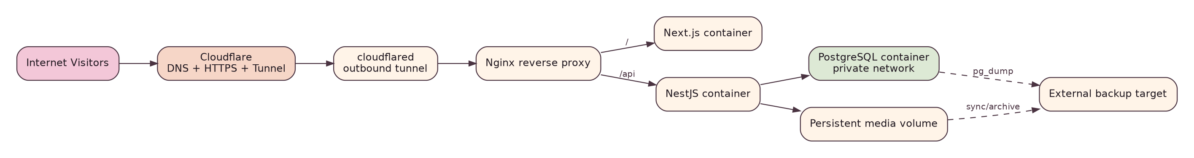
Future Production Architecture

05. Software Design Specification / Low-Level Design (LLD)
Project: Interactive Full-stack Portfolio Platform
Version: 1.0
Date: 2026-08-10
Status: Baseline specification for local-first implementation

1. Web application modules

Route groups
- (site): public pages and shared public layout.
- admin: login, dashboard and CMS editors.
- desk: private utility workspace.

Component layers
- components/ui: buttons, inputs, dialogs, typography, badges, tabs.
- components/portfolio: hero, project teaser, timeline, case-study renderer.
- components/admin: editors, forms, media picker, sortable block list.
- components/mascot: original stickman SVG poses and animation hooks.
- animations: GSAP timeline factories and ScrollTrigger integration.
- lib/api: typed API client and error normalization.

2. API module pattern
Each NestJS feature should follow:
Controller -> DTO validation -> Service -> Repository/Prisma -> Database.
Controllers own transport concerns; services own business rules; persistence queries remain explicit and testable.

3. Project service behavior

Create
- Normalize/validate slug.
- Reject duplicate slug.
- Default status to DRAFT unless explicitly allowed.
- Persist metadata and relation lists transactionally.

Update
- Fetch existing project or throw not-found.
- Enforce optimistic update strategy if later needed; v1 may use last-write-wins for single owner.
- Validate state transitions.
- Replace/reconcile ordered relations inside transaction.

Publish
Minimum publish validation: title, slug, summary, year/type/role, cover or intentional no-cover state, and valid block payloads. Publishing changes visibility but never bypasses validation.

4. Case-study block types
Type | Required payload | Notes
HEADING | level, text | level restricted to semantic range
PARAGRAPH | rich/structured text | sanitize any rendered HTML
IMAGE | mediaAssetId, caption? | alt text comes from asset/override
IMAGE_GROUP | mediaAssetIds, layout | 2-column or gallery layout
QUOTE | text, attribution? | visual callout
VIDEO | provider/url, caption? | allow-list protocols/providers
CODE | language, code, caption? | escape output; no executable code
TECH_CALLOUT | title, body, tags? | architecture/engineering notes

Prefer discriminated JSON DTOs and validate by type. Database stores type plus JSON payload to keep ordering simple while maintaining strict application validation.

5. Project state machine
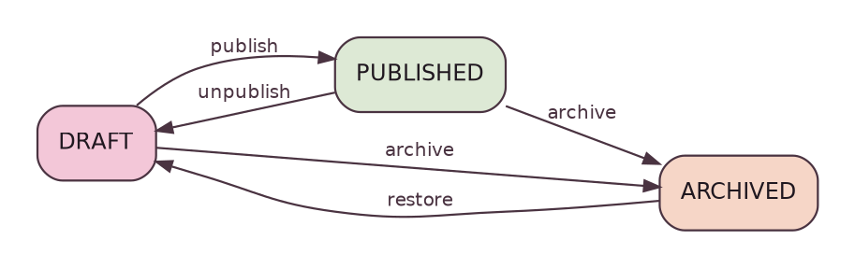
Project State
Rules:
- DRAFT is editable and never public.
- PUBLISHED is public and editable; significant edits may be saved directly for single-owner v1.
- ARCHIVED is non-public and retained for recovery/history.
- Hard delete should be rare and can be limited to drafts without dependencies.

6. Authentication flow
Authentication Flow

7. Publish flow
Publish Flow

8. Validation rules
- Slugs: lower-case URL-safe segments, deterministic normalization, unique.
- URLs: https preferred; validate scheme.
- Sort order: integer; normalize when items are reordered.
- Year: reasonable 4-digit range; milestone uses full date.
- Text limits: enforce useful limits for titles/summaries, larger bounded payloads for case-study content.
- Media: MIME and signature checks where feasible, safe generated filename, no user-controlled filesystem traversal.

9. Theme design
Theme tokens live as CSS variables; components consume semantic tokens rather than raw colors. Theme preference should be reflected before first meaningful paint when feasible to avoid flashing.

10. GSAP design
Animation functions must be scoped to mounted components and cleaned up on unmount. ScrollTrigger instances must be refreshed after layout-affecting media loads when necessary. Reduced-motion path must bypass non-essential timelines.

06. Database Design Specification
Project: Interactive Full-stack Portfolio Platform
Version: 1.0
Date: 2026-08-10
Status: Baseline specification for local-first implementation

1. Entity relationship diagram
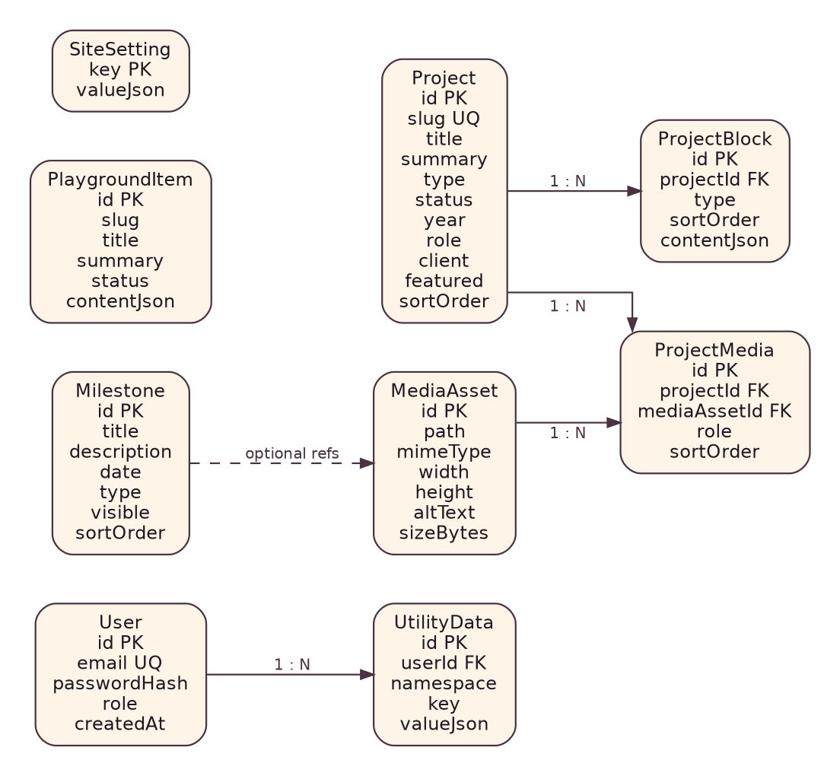
ERD

2. Core entities

User
Single-owner v1 authentication record. Fields: UUID id, unique normalized email, password hash, role, timestamps. Role initially OWNER; schema may remain extensible without building multi-role UI.

Project
Primary portfolio entity. Use UUID primary key and unique slug. Important indexes: (status, featured, sortOrder) for public listing and unique slug lookup.

ProjectBlock
Ordered case-study blocks. Composite index (projectId, sortOrder). contentJson holds a discriminated payload whose shape is enforced by application validation.

MediaAsset
Stable metadata record for a stored file. Avoid placing arbitrary absolute host paths in public JSON; store logical relative path/key. Include alt text, MIME type, byte size, width/height when known, timestamps.

ProjectMedia
Optional explicit relationship for cover/gallery/media roles beyond block references. A role enum/string may represent COVER, GALLERY, THUMBNAIL, etc.

Milestone
Journey item with event date, type, visibility and sort order. Use date for chronological meaning; sort order allows editorial control.

PlaygroundItem
Independent experiment/creative item. Similar publication semantics to projects but simpler data.

SiteSetting
Key/value JSON for global content such as social links and homepage copy. Keys must be allow-listed/validated to prevent the table becoming an unstructured dumping ground.

UtilityData
Private owner data scoped by namespace/key; excluded from all public services.

3. Example Prisma-oriented enums
Role = OWNER
ProjectStatus = DRAFT | PUBLISHED | ARCHIVED
ProjectType = DEVELOPMENT | DESIGN | HYBRID
BlockType = HEADING | PARAGRAPH | IMAGE | IMAGE_GROUP | QUOTE | VIDEO | CODE | TECH_CALLOUT

4. Integrity constraints
- Unique: User.email, Project.slug, PlaygroundItem.slug, SiteSetting.key.
- Required FK cascade strategy must be explicit. ProjectBlock should normally cascade on project deletion; media assets should not be silently deleted while referenced.
- Project slug changes should not cascade to DB relationships because relations use IDs.

5. Deletion policy
Prefer archive/soft lifecycle for portfolio content. Hard deletion of media must check references first. For local v1, a deletedAt column is optional; status-based archival is sufficient for projects/playground.

6. Transaction boundaries
Use transactions for:
- project + technologies/services + media role updates;
- project block reorder/replacement;
- deletion that removes dependent blocks/relations;
- publish actions that require multiple related writes.

7. Seed data
Seed must create exactly one local owner from environment/config and representative demo content. Seed is a development bootstrap, not a content migration strategy for production.

8. Migration rules
- Every schema change uses a committed Prisma migration.
- Never edit an already-applied production migration later.
- Local destructive resets are allowed only in development.
- Production phase uses migrate deploy with a backup gate.

07. REST API Specification
Project: Interactive Full-stack Portfolio Platform
Version: 1.0
Date: 2026-08-10
Status: Baseline specification for local-first implementation

1. Conventions
Base path: /api. JSON request/response. Timestamps use ISO 8601. IDs are UUID strings. Public GET endpoints do not require authentication; all mutations and private routes do.

2. Standard success envelope
{
"success": true,
"data": {},
"meta": {}
}

3. Standard error envelope
{
"success": false,
"error": {
"code": "VALIDATION_ERROR",
"message": "Some fields are invalid.",
"fields": {"slug": "Already in use"}
}
}

4. Authentication endpoints
Method | Route | Access | Purpose
POST | /api/auth/login | Public | Authenticate owner and set session cookie
POST | /api/auth/logout | Owner | Clear/invalidate session
GET | /api/auth/me | Owner | Return current owner profile/session state

Login request
{"email":"owner@example.com","password":"..."}
Never return password hash, token secret or sensitive session material in response JSON when cookie auth is used.

5. Projects
Method | Route | Access
GET | /api/projects | Public; published only
GET | /api/projects/:slug | Public; published only
GET | /api/admin/projects | Owner; all statuses
GET | /api/admin/projects/:id | Owner
POST | /api/admin/projects | Owner
PATCH | /api/admin/projects/:id | Owner
POST | /api/admin/projects/:id/publish | Owner
POST | /api/admin/projects/:id/unpublish | Owner
POST | /api/admin/projects/:id/archive | Owner

Suggested list query parameters: page, limit, type, featured, q, sort. Public sort defaults to editorial sortOrder then date/year.

Create/update project DTO sketch
{
"title": "Sa Sa Tole",
"slug": "sasa-tole",
"summary": "Brand identity and visual materials.",
"type": "DESIGN",
"status": "DRAFT",
"year": 2026,
"role": "Designer",
"client": "Sa Sa Tole",
"featured": true,
"sortOrder": 10,
"technologies": [],
"services": ["Brand Identity", "Poster", "Price List"],
"links": {"live": null, "github": null, "external": null}
}

6. Project blocks
Method | Route | Access | Purpose
POST | /api/admin/projects/:id/blocks | Owner | Add block
PATCH | /api/admin/projects/:id/blocks/:blockId | Owner | Edit block
DELETE | /api/admin/projects/:id/blocks/:blockId | Owner | Delete block
PUT | /api/admin/projects/:id/blocks/order | Owner | Persist full ordering

Block update uses discriminated DTO: {type, content}. Reject unknown keys when practical.

7. Milestones
Public GET /api/milestones; owner CRUD under /api/admin/milestones.

8. Playground
Public published list/detail and owner CRUD under /api/admin/playground.

9. Media
Method | Route | Access
GET | /api/admin/media | Owner
POST | /api/admin/media | Owner; multipart upload
PATCH | /api/admin/media/:id | Owner; metadata/alt
DELETE | /api/admin/media/:id | Owner; only when safe

Public media bytes are delivered through a stable URL mapping; API should not expose host filesystem paths.

10. Site settings
- GET /api/settings/public: public allow-listed settings.
- GET /api/admin/settings: owner complete editable settings.
- PUT /api/admin/settings/:key: owner update with per-key schema validation.

11. Private Desk
Private routes live under /api/desk/*; all require owner authorization. Utility endpoints should be added only when server execution/persistence is needed; pure formatting utilities can remain client-side.

12. HTTP status behavior
- 200 read/update success.
- 201 create success.
- 204 deletion/logout where no body is needed.
- 400 malformed request.
- 401 unauthenticated.
- 403 authenticated but unauthorized.
- 404 entity not found or intentionally hidden unpublished public entity.
- 409 uniqueness/state conflict.
- 413 upload too large.
- 415 unsupported media type.
- 422 optional for semantic validation if standardized; otherwise use 400 consistently.

13. Future contract source
When implementation stabilizes, generate and maintain OpenAPI from NestJS decorators. Client types may then be generated from OpenAPI to reduce drift.

08. UI/UX, Interaction & Design System Specification
Project: Interactive Full-stack Portfolio Platform
Version: 1.0
Date: 2026-08-10
Status: Baseline specification for local-first implementation

1. Creative direction
Visual identity: playful hand-drawn stickman/doodle character on a calm editorial interface. The provided image is a mood reference for thin black linework, pastel pink background, intentional imperfection and friendliness. The final mascot must be original rather than a direct trace/copy.

2. Design balance
Target approximately 70% clean editorial UI / 30% doodle personality. Doodles are accents and storytelling devices, not a replacement for hierarchy or usability.

3. Initial semantic palette

Light
- Background: #F8CEDF family / blush pastel.
- Surface: warm near-white/pale cream.
- Text/line: near-black plum (#171417 family).
- Muted: desaturated mauve/gray.
- Accent: restrained warm brown/peach.

Dark
- Background: deep muted plum/near-black.
- Surface: slightly lighter plum.
- Text: warm off-white/pink-white.
- Accent: dusty peach/brown.
Exact tokens are adjusted during visual QA, but components must consume semantic variables such as --background, --surface, --text, --muted, --accent, --line.

4. Typography
- Headline: thin geometric/grotesk sans with strong editorial spacing.
- Body: clean sans with excellent Vietnamese diacritics and readability.
- Handwritten font: annotation only, never long body text.
- Avoid skill percentage bars and overused developer-portfolio tropes.

5. Layout
- Generous whitespace.
- Strong asymmetric editorial project layouts.
- Content max-width with intentionally oversized headings on desktop.
- Mobile collapses to a clear single-column narrative without reproducing desktop animation mechanically.

6. Core components
Buttons, text links, theme toggle, navigation, project teaser, metadata cluster, case-study block renderer, media frame, tags, timeline item, admin form controls, status badges, dialogs, toast/feedback, drag/reorder controls and empty/error states.

7. Public homepage narrative
- Hero: greeting + “I design things / I build things” + mascot.
- About: Figma ↔ VS Code hybrid identity.
- Selected Work: editorial alternating layouts.
- Journey: vertical story line with mascot poses.
- Playground: experiments “nobody asked me to make”.
- Contact: quiet closing scene.

8. Mascot system
Create reusable SVG poses: wave, walk, sit, laptop, draw, celebrate, sleep/tired, point, hold sign. Maintain consistent head/body proportions and stroke style. Poses are components/data, not scattered inline SVG copies.

9. GSAP interaction tiers
- Tier 1: hover/focus/micro-interactions.
- Tier 2: section reveals, SVG line drawing, gentle parallax.
- Tier 3: only major storytelling sections: hero, selected work, journey.
Animation principles: preserve scroll control, avoid excessive pinned sections, never animate every paragraph, clean up timelines, test mobile separately, and provide reduced-motion variants.

10. Accessibility UX
- Keyboard-operable navigation and admin controls.
- Visible focus rings aligned with visual language.
- Sufficient text contrast despite pastel palette.
- Decorative mascot marked appropriately for assistive technology unless conveying content.
- Every form has programmatic label and error association.

11. Responsive breakpoints
Use content-driven breakpoints rather than device names. Suggested implementation starting points: compact mobile, wide mobile/tablet, laptop, large desktop. Breakpoint values may live in shared CSS tokens.

12. Admin aesthetic
Admin should feel like a private creative desk, not enterprise SaaS. However, usability wins over decoration: dense forms, clear statuses, autosave indication if later implemented, preview/publish distinction, and reliable keyboard/mouse controls.

09. Admin CMS & Content Workflow Specification
Project: Interactive Full-stack Portfolio Platform
Version: 1.0
Date: 2026-08-10
Status: Baseline specification for local-first implementation

1. Objective
Give the owner complete control over public portfolio content without editing application source files.

2. Admin dashboard
Display counts for projects, published projects, drafts, milestones and recent edits. Provide direct actions: New Project, New Milestone, Upload Media, View Site.

3. Project editor sections

Identity
Title, slug, short summary, project type, year, role, client.

Publication
Status, featured toggle, display order, optional publication timestamp in a later version.

Capabilities
Technologies and services as ordered chip/tag lists. Avoid storing a comma-separated string when structured relations/JSON arrays are cleaner.

Links
GitHub, live URL, Behance/external case-study URL.

Media
Cover asset, gallery/media references and alt text status.

Case study
Ordered block editor with add menu, drag/drop plus accessible up/down actions, inline editing, delete confirmation and preview.

4. Save behavior
v1 may use explicit Save buttons. Each save clearly reports success/failure and preserves unsaved input on recoverable validation errors. Do not implement hidden autosave until explicit saving is reliable.

5. Publish behavior
Publishing is a distinct action from saving. Publish performs stricter validation and displays missing requirements. The editor should communicate whether the public version is currently visible.

6. Media manager
Grid/list with thumbnail, filename, dimensions, MIME, size, usage references, alt text completeness and delete eligibility. Upload accepts only configured image formats in local v1.

7. Milestone manager
List/table + timeline preview. Required: title, date, description, type, visible flag, sort order. Ordering can default chronological but remain editorially adjustable.

8. Site settings
Typed settings categories: Identity, Contact/Social, Homepage, SEO basics and feature flags. Each key has a known schema and friendly form; avoid editing raw arbitrary JSON in the normal UI.

9. Preview model
Case-study preview must use the same renderer/component library as public detail pages, so Admin preview is representative rather than a separate approximate rendering.

10. Empty and destructive states
- Empty list explains the next action.
- Archive is preferred to hard delete for important content.
- Hard delete requires explicit confirmation and dependency checks.
- Media deletion is blocked if referenced unless a replacement workflow is provided.

10. Security Specification & Threat Model
Project: Interactive Full-stack Portfolio Platform
Version: 1.0
Date: 2026-08-10
Status: Baseline specification for local-first implementation

1. Security objective
Protect owner authentication, unpublished/private content, database integrity and uploaded media while keeping a single-owner portfolio simple.

2. Trust boundaries
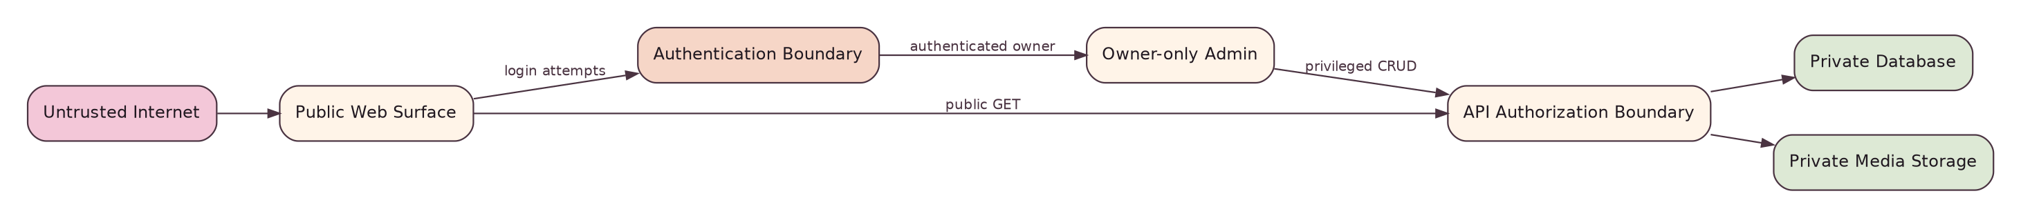
Trust Boundaries

3. Primary threats and controls
Threat | Example | Required control
Credential theft | leaked password | strong hash, unique strong password, rate limiting later
User enumeration | login error reveals owner email | generic auth failure
Session theft | script reads token | HttpOnly cookie; Secure in production
CSRF | malicious site triggers mutation | SameSite + CSRF strategy for unsafe cross-site scenarios
XSS | rich text/embed injection | structured blocks, escaping, sanitizer/allow-list
Broken access control | direct call to admin API | server-side auth + owner guard on every mutation
SQL injection | crafted input | Prisma parameterization + input validation; avoid raw SQL
Path traversal | upload filename ../../x | generated names, fixed upload root, no trust in client path
Malicious upload | executable/script payload | MIME/signature allow-list, size limit, non-executable storage
Secret leakage | .env committed | gitignore, examples only, secret rotation if exposed
Information disclosure | stack traces | production-safe error responses

4. Password handling
Use a modern password hashing function/library with per-password salt and a work factor appropriate to the runtime. Never log plaintext credentials. Owner password change/recovery can remain manual/admin-operator in v1 rather than adding insecure reset complexity.

5. Authorization matrix
Resource/action | Visitor | Owner
Read published projects | Yes | Yes
Read drafts | No | Yes
Create/update/publish project | No | Yes
Manage media | No | Yes
View /desk | No | Yes
Read private utility data | No | Yes
Read public settings | Yes | Yes
Edit settings | No | Yes

6. Content security
Structured case-study blocks are preferred over unrestricted HTML. If rich text is introduced, store a controlled document model or sanitize on input/render. External embeds must use an allow-list.

7. Local development security
Local .env files remain untracked. Local database ports may bind to localhost only. Local owner credentials are development credentials and must not be reused in production.

8. Production hardening (future)
No public DB/API/app ports except through the intended proxy/tunnel path; HTTPS-only cookies; security headers; firewall; SSH keys; backup encryption as appropriate; dependency/security update process.

9. Security verification
Tests must cover unauthenticated access to every protected route, invalid state transitions, validation bypass attempts, upload restrictions and public exclusion of drafts/private data.

11. Test Strategy, QA Plan & Acceptance Tests
Project: Interactive Full-stack Portfolio Platform
Version: 1.0
Date: 2026-08-10
Status: Baseline specification for local-first implementation

1. Test pyramid
- Unit tests: services, validation helpers, block schemas, slug rules, utilities.
- Integration tests: Nest modules with test DB; auth; project persistence; publication filtering.
- Component tests: critical forms/renderers where cost-effective.
- E2E tests: browser flows for public browsing and owner CMS.
- Manual visual QA: animation, responsive layout, dark/light mode and accessibility interactions.

2. Critical automated scenarios
- Login valid/invalid, logout, protected route rejection.
- Create project draft; duplicate slug rejection.
- Publish valid project; invalid project publish blocked.
- Public list excludes draft/archived.
- Case-study blocks persist order and render correctly.
- Milestone visibility rules.
- Media upload rejects oversized/unsupported type.
- Settings expose only public allow-listed keys.
- Desk/private API unavailable anonymously.

3. E2E golden path
Login -> Create Project -> Add Cover -> Add Case Study Blocks -> Preview -> Publish -> Open Public /work/[slug] -> Verify content -> Edit -> Unpublish/Archive

4. UI test matrix
Area | Desktop | Tablet | Mobile | Light | Dark | Reduced motion
Home | ✓ | ✓ | ✓ | ✓ | ✓ | ✓
Work list | ✓ | ✓ | ✓ | ✓ | ✓ | ✓
Case study | ✓ | ✓ | ✓ | ✓ | ✓ | ✓
Journey | ✓ | ✓ | ✓ | ✓ | ✓ | ✓
Admin forms | ✓ | ✓ | Basic | ✓ | ✓ | N/A/minimal

5. Accessibility QA
Keyboard-only navigation; visible focus; logical heading order; form label/error associations; alt text; reduced motion; no essential information conveyed only by animation/color.

6. Performance QA
Inspect layout shift, oversized images, JS bundle growth from animation libraries, long tasks during scroll and accidental always-running animation loops. Optimize only after measuring.

7. Data integrity QA
Run migration on clean DB; seed; exercise CRUD; reset local DB; verify foreign-key behavior and media reference protection.

8. Local Complete exit criteria
- No blocker/critical known defects.
- All critical requirements have passing acceptance tests or documented manual verification.
- Clean-machine/bootstrap runbook has been validated.
- Public content is fully database-driven.
- Owner can recover from ordinary validation failures without losing work unexpectedly.

12. Local Development Environment & Runbook
Project: Interactive Full-stack Portfolio Platform
Version: 1.0
Date: 2026-08-10
Status: Baseline specification for local-first implementation

1. Local target architecture

Local Architecture

2. Recommended daily model
Run PostgreSQL in Docker for repeatability. Run Next.js and NestJS directly with pnpm dev for fast hot reload.

3. Bootstrap flow
Local Bootstrap

4. Expected environment files
- apps/web/.env.local
- apps/api/.env
- root/local compose environment as needed
Commit .env.example files with names/descriptions only; never real secrets.

5. Local ports
- Web: http://localhost:3000
- API: http://localhost:4000/api
- PostgreSQL: localhost:5432 (local development only)

6. Suggested commands
docker compose up -d postgres
pnpm install
pnpm db:generate
pnpm db:migrate
pnpm db:seed
pnpm dev
Exact package scripts should be normalized in the repository so the runbook stays short.

7. Development database lifecycle
Use a dedicated local database. Destructive reset is allowed only when intentionally rebuilding development state. Prefer migrations for schema evolution and seed data for representative fixtures.

8. Media storage
Use a repository-external or gitignored folder such as local-data/uploads. The API owns file write/read mapping. Tests should use a temporary directory.

9. Troubleshooting checklist
- DB container healthy?
- DATABASE_URL points to expected host/port/database?
- Prisma client generated after schema change?
- Migration applied?
- API CORS/origin configuration matches local web origin?
- Cookie settings are development-compatible (Secure must not accidentally block localhost HTTP)?
- Uploaded path directory writable?

10. Rule: stop at Local Complete
Do not introduce Nginx, Cloudflare, public DNS or a home-server requirement into normal feature development. Production specs exist only to prevent architectural dead ends.

13. Future Production Deployment & Operations Plan
Project: Interactive Full-stack Portfolio Platform
Version: 1.0
Date: 2026-08-10
Status: Baseline specification for local-first implementation
Deferred: This document is a target design for phases after Local Complete. It is not a current implementation requirement.

1. Target topology

Production Architecture
A dedicated old PC is preferred over the daily workstation. Target OS: a supported Ubuntu Server LTS at deployment time. Services run in Docker Compose: web, api, postgres, reverse proxy and cloudflared. Media and database data use persistent host/volume storage.

2. Domain model
One primary domain. Keep API same-origin under /api unless a later requirement justifies a subdomain. www redirects to canonical apex (or vice versa, choose once).

3. Network exposure
Do not expose PostgreSQL, NestJS or Next.js directly to the public Internet. Public requests enter through Cloudflare/Tunnel/reverse proxy. SSH should be restricted and key-based.

4. Production data
PostgreSQL uses persistent storage. Uploaded media uses persistent storage outside disposable containers. Secrets live outside Git.

5. Release flow
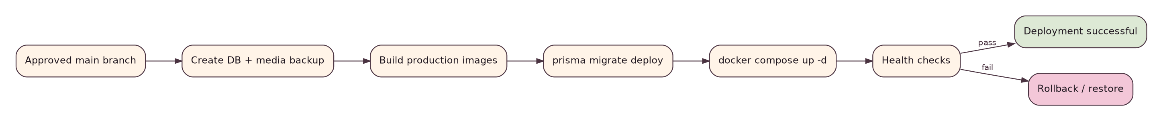
Deployment Flow
Required release gates: backup, build success, migration success, health check and rollback path.

6. Migration policy
Production uses committed migrations and a non-development migration command. Back up before risky schema changes. Test migrations against a staging/copy when data value warrants it.

7. Availability trade-off
Home hosting means availability depends on household power and Internet. BIOS auto-power-on, Docker restart policies and cloudflared reconnection reduce manual recovery. UPS is an optional later reliability upgrade.

8. Production readiness checklist
- Local Complete signed off.
- Tests green.
- Production secrets generated.
- Database/media backup + restore tested.
- Reverse proxy/tunnel configured.
- Admin authentication hardened.
- No database port exposure.
- Logs/health endpoints available.

14. DevOps, Backup, Monitoring & CI/CD Specification
Project: Interactive Full-stack Portfolio Platform
Version: 1.0
Date: 2026-08-10
Status: Baseline specification for local-first implementation

1. Backup design
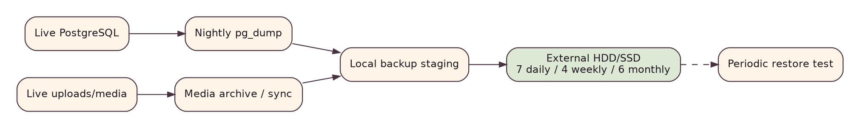
Backup Flow

Minimum policy
- Nightly logical PostgreSQL dump.
- Nightly/scheduled media backup.
- Copy backups to an external physical device rather than only the same system disk.
- Suggested retention: 7 daily, 4 weekly, 6 monthly.
- Periodic restore test; a backup that has never been restored is unproven.

2. Observability
At minimum provide:
- API /health endpoint.
- Container/service health checks.
- Structured application logs with timestamp, level, request correlation where useful.
- Disk usage monitoring for DB/media/backups.
- Alerting can be added later; the first goal is diagnosability.

3. Logging privacy
Never log passwords, session cookies, authorization headers or full secret-bearing payloads. Avoid logging private Desk data unless explicitly diagnostic and safe.

4. CI checks before deployment
- dependency install from lockfile;
- formatting/lint;
- type check;
- unit/integration tests;
- production build;
- migration sanity where possible.

5. Future CI/CD
CI/CD Flow
Start with manual one-command deploy before automating. Automation should invoke the same tested deploy script rather than duplicate deployment logic in CI YAML.

6. Rollback
Rollback application image/version separately from irreversible DB migrations. Schema changes should favor backward-compatible expand/migrate/contract patterns when rollback risk becomes material.

7. Incident mini-runbook
- Identify whether failure is DNS/tunnel, proxy, web, API, DB, disk or power/network.
- Preserve logs and avoid destructive resets.
- If deployment-caused, revert application version and assess migration impact.
- If data corruption/loss, stop writes and restore from verified backup.
- Document cause and preventive action as an ADR/runbook update if architectural.

15. Requirements Traceability Matrix (RTM)
Project: Interactive Full-stack Portfolio Platform
Version: 1.0
Date: 2026-08-10
Status: Baseline specification for local-first implementation

Traceability principle
Every high-value requirement must map to implementation ownership and a verification method.
Requirement | Design/module | Primary verification
FR-PUB-002 | Project public query filter | Integration + E2E: drafts absent
FR-PUB-004 | ProjectBlock renderer | E2E case-study render
FR-AUTH-001..005 | AuthModule + cookies/guards | Integration + E2E auth flows
FR-PRJ-001..007 | ProjectsModule/Admin editor | Service tests + E2E CRUD/publish
FR-CS-001..005 | ProjectBlock model + editor | Unit schema + E2E reorder/preview
FR-MIL-001..003 | MilestonesModule | Integration + public journey E2E
FR-MED-001..005 | MediaModule/Media Manager | Upload security + E2E selection
FR-SET-001..002 | SettingsModule | Integration + UI edit check
FR-DESK-001..004 | Desk routes/modules | Authorization + utility tests
NFR-A11Y-001..003 | All UI | Keyboard/manual + automated audit where useful
NFR-SEC-001..006 | Auth/guards/validation/media | Security test checklist
NFR-REL-001..003 | Services/DB/ops | Transaction tests + future restore drill
NFR-MNT-001..003 | Repo architecture/ADR | Code review / structure audit

Phase ownership
- P0-P2 satisfy UI shell/public structural requirements with mock/seed-backed data.
- P3 makes persisted API/DB behavior authoritative.
- P4-P5 satisfy CMS, case-study and media requirements.
- P6 satisfies advanced motion without violating accessibility.
- P7 satisfies Private Desk baseline.
- P8 verifies Local Complete.
- P9+ harden and operationalize production requirements.

16. Project Roadmap, WBS, Risk Register & Architecture Decisions
Project: Interactive Full-stack Portfolio Platform
Version: 1.0
Date: 2026-08-10
Status: Baseline specification for local-first implementation

1. Phase roadmap
Roadmap

P0 - Foundation
Monorepo, package conventions, environment examples, local PostgreSQL compose, baseline lint/type/test scripts.

P1 - Design System
Tokens, typography, theme, layout primitives, mascot component foundation, responsive shell.

P2 - Public Portfolio
Home, work, case-study shell, journey, playground, about/contact with seed/mock API shape.

P3 - Backend + Database
Prisma schema/migrations, Nest modules, public/admin query separation, auth foundation.

P4 - Admin CMS
Dashboard, project/milestone/playground/settings CRUD, validation and status workflow.

P5 - Case Study + Media
Block builder, shared renderer, upload/media manager, preview/publish.

P6 - GSAP + Mascot Storytelling
Hero, selected work, journey animation; reduced-motion; performance pass.

P7 - Private Desk
Authenticated workspace and initial utilities.

P8 - LOCAL COMPLETE
End-to-end local validation, clean bootstrap, content migration from demo to real owner content.

P9-P15 - Post-local
Testing/hardening, production preparation, home server, domain/tunnel, deploy FE+BE+DB, backups/monitoring, CI/CD.

2. Work breakdown structure (WBS) highlights
- 1.x Product/design system
- 2.x Public routes and components
- 3.x API/domain modules
- 4.x Persistence/migrations/seeds
- 5.x Auth/security
- 6.x Admin/CMS
- 7.x Case-study/media
- 8.x Motion/accessibility/performance
- 9.x Private Desk
- 10.x QA/documentation
- 11.x Production/ops (deferred)

3. Risk register
ID | Risk | Probability | Impact | Mitigation
R-01 | Over-animation hurts usability/performance | Medium | High | animation tiers, reduced motion, mobile-specific design
R-02 | CMS scope expands endlessly | High | High | v1 block types fixed; explicit Local Complete gate
R-03 | JSON block model becomes unvalidated | Medium | High | discriminated schemas + versioning discipline
R-04 | Media storage couples to local paths | Medium | Medium | storage abstraction + logical asset keys
R-05 | Auth implemented only in frontend | Low | Critical | Nest guards on every protected endpoint
R-06 | Production work distracts from product | High | High | defer domain/server until P9+
R-07 | Home server outage/data loss | Medium | High | future external backups, auto restart, restore drills
R-08 | Single huge page JS bundle | Medium | Medium | client-component discipline, lazy animation modules
R-09 | Visual identity looks childish | Medium | Medium | 70/30 editorial-to-doodle balance, thin typography
R-10 | Source/docs drift | Medium | Medium | requirement IDs, ADRs, update docs at phase gates

4. Architecture Decision Records (ADR)

ADR-001: Separate Next.js and NestJS applications
Decision: Next.js is presentation; NestJS is authoritative API.
Reason: demonstrates full-stack architecture, protects private/admin logic, keeps CMS/domain logic centralized.
Trade-off: more local processes and API contract work than Next-only.

ADR-002: PostgreSQL + Prisma
Decision: relational durable store with Prisma ORM/migrations.
Reason: structured relationships, constraints, TypeScript integration, future self-hosting.
Trade-off: schema/migration discipline required.

ADR-003: Single-owner authorization model for v1
Avoid generic user/role management until there is a real stakeholder need.

ADR-004: Structured case-study blocks
Prefer ordered typed blocks over a single raw HTML blob. Improves validation, responsive rendering and long-term design control.

ADR-005: Local media filesystem first, abstracted storage interface
Cheapest/easiest local workflow while preserving future migration path.

ADR-006: GSAP for advanced storytelling, CSS for simple transitions
Use the heavier animation tool only where it provides clear value.

ADR-007: Local Complete before production deployment
Production concerns are documented but deliberately scheduled after P8.

ADR-008: Future same-origin /api
Production reverse proxy should route /api to NestJS under the same site origin unless a later requirement justifies separation.

17. Definition of Done, Phase Gates & Checklists
Project: Interactive Full-stack Portfolio Platform
Version: 1.0
Date: 2026-08-10
Status: Baseline specification for local-first implementation

Global Definition of Done for a feature
- Requirement/acceptance behavior is explicit.
- TypeScript builds without errors.
- Relevant lint/format checks pass.
- Server validation exists for external input.
- Authorization is applied where required.
- Loading, empty and error states are handled.
- Responsive behavior checked.
- Dark/light behavior checked if visual.
- Reduced-motion behavior checked if animated.
- Tests added at the appropriate level.
- No secret or local artifact committed.
- Documentation/ADR updated when design contract changes.

P1 Design System gate
Tokens exist; basic components are consistent; both themes readable; Vietnamese text renders correctly; navigation/footer responsive.

P2 Public Portfolio gate
All public routes exist; content hierarchy is believable; no critical hardcoded assumptions block API integration; core SEO metadata structure exists.

P3 Backend + DB gate
Clean migration works; seed works; public/admin query separation works; API error model is consistent; auth baseline passes integration tests.

P4 Admin gate
Owner can CRUD projects/milestones/playground/settings; validation messages useful; status changes reliable; unauthorized requests blocked.

P5 Case Study + Media gate
Owner can upload/select media, create/reorder blocks, preview and publish; public renderer matches preview; media references remain valid.

P6 Motion gate
Hero/project/journey animation works on desktop and adapted mobile; reduced-motion path works; no major scroll jank or content invisibility.

P7 Private Desk gate
Authentication protects /desk; initial utilities work; no private data leaks to public APIs.

P8 LOCAL COMPLETE gate
- Fresh clone/bootstrap succeeds using runbook.
- Login succeeds with local owner credentials.
- Create -> case study -> publish -> public display works end-to-end.
- Milestone change appears publicly without code edit.
- Playground item change appears publicly without code edit.
- Themes, responsive layout and reduced motion verified.
- Critical automated tests pass.
- Database-driven content confirmed; no reseed needed for normal content changes.
- Known issues documented and no blocker remains.

Post-local production gate (later)
Only begin domain/home-server deployment after P8 sign-off and P9 hardening. Deployment must include backup, secure secrets, private database networking, health checks and restore procedure.

