CENTRO PAULA SOUZA
ETEC PROFª MARIA CRISTINA MEDEIROS
Curso Técnico em Informática para Internet Integrado ao Ensino Médio
Fulano de tal
Beltrado de Tal
Feltrano de Tal
Geltrano de Tal
Heltrano de Tal
FREETECS: Portal para Voluntariado em Projetos Empresariais
Ribeirão Pires
2026
Fulano de tal
Beltrado de Tal
Feltrano de Tal
Geltrano de Tal
Heltrano de Tal
FREETECS: Portal para Voluntariado em Projetos Empresariais
Trabalho de Conclusão de Curso apresentado ao Curso Técnico em Informática para Internet da ETEC Profª Maria Cristina Medeiros, orientado pela Prof. Cíntia Maria de Araújo Pinho, como requisito parcial para obtenção do Título de Técnico em Informática
Ribeirão Pires
2026
Aqui vai ficar a ficha catalográfica

DEDICATÓRIA

Colocar aqui a Dedicatória

AGRADECIMENTOS

Escrever aqui os agradecimentos

"Às vezes, são as pessoas que ninguém espera nada que fazem as coisas que ninguém consegue imaginar"
Alan Turing
RESUMO
Aqui vai ficar o Resumo

ABSTRACT
Aqui vai ficar o resumo em inglês

INDICE DE ILUSTRAÇÕES

FIGURAS
Figura 1 - brainstorming 14
Figura 2 - ideias 15

GRÁFICOS
Gráfico 1- Idades 18

QUADROS
Quadro 1 - caderno de sensibilidade 17

TABELAS
Tabela 1 - Custo do serviços 20

SUMÁRIO

1 INTRODUÇÃO 12
1.1 Problemática 12
1.2 Justificativa 12
1.3 Objetivos 13
1.3.1 Objetivo Geral 13
1.3.2 Objetivos Específicos 13
1.4 Metodologia 13
1.5 Resultados Esperados 13
2 REFERECIAL TEÓRICO 15
2.1 Teste nível 2 15
2.1.1 Teste nível 3 16
2.1.1.1 Teste nível 4 16
2.1.1.1.1 Teste nível 5 17
3 IMERSÃO 18
3.1 Caderno de Sensibilidade 18
3.2 Pesquisa de campo 19
4 ANÁLISE E SÍNTESE 20
4.1 Brainstorming 20
4.2 Persona 20
5 Aspectos estratégicos 21
5.1 Planejamento financeiro 21
REFERENCIAS 22

INTRODUÇÃO
Lorem Ipsum is simply dummy text of the printing and typesetting industry. Lorem Ipsum has been the industry's standard dummy text ever since the 1500s, when an unknown printer took a galley of type and scrambled it to make a type specimen book. It has survived not only five centuries, but also the leap into electronic typesetting, remaining essentially unchanged. It was popularised in the 1960s with the release of Letraset sheets containing Lorem Ipsum passages, and more recently with desktop publishing software like Aldus PageMaker including versions of Lorem Ipsum.

Problemática
Lorem Ipsum is simply dummy text of the printing and typesetting industry. Lorem Ipsum has been the industry's standard dummy text ever since the 1500s, when an unknown printer took a galley of type and scrambled it to make a type specimen book. It has survived not only five centuries, but also the leap into electronic typesetting, remaining essentially unchanged. It was popularised in the 1960s with the release of Letraset sheets containing Lorem Ipsum passages, and more recently with desktop publishing software like Aldus PageMaker including versions of Lorem Ipsum.
Lorem Ipsum is simply dummy text of the printing and typesetting industry. Lorem Ipsum has been the industry's standard dummy text ever since the 1500s, when an unknown printer took a galley of type and scrambled it to make a type specimen book. It has survived not only five centuries, but also the leap into electronic typesetting, remaining essentially unchanged. It was popularised in the 1960s with the release of Letraset sheets containing Lorem Ipsum passages, and more recently with desktop publishing software like Aldus PageMaker including versions of Lorem Ipsum.

Justificativa
Lorem Ipsum is simply dummy text of the printing and typesetting industry. Lorem Ipsum has been the industry's standard dummy text ever since the 1500s, when an unknown printer took a galley of type and scrambled it to make a type specimen book. It has survived not only five centuries, but also the leap into electronic typesetting, remaining essentially unchanged. It was popularised in the 1960s with the release of Letraset sheets containing Lorem Ipsum passages, and more recently with desktop publishing software like Aldus PageMaker including versions of Lorem Ipsum.

Objetivos

Objetivo Geral
Lorem Ipsum is simply dummy text of the printing and typesetting industry. Lorem Ipsum has been the industry's standard dummy text ever since the 1500s, when an unknown printer took a galley of type and scrambled it to make a type specimen book. It has survived not only five centuries, but also the leap into electronic typesetting, remaining essentially unchanged. It was popularised in the 1960s with the release of Letraset sheets containing Lorem Ipsum passages, and more recently with desktop publishing software like Aldus PageMaker including versions of Lorem Ipsum.

Objetivos Específicos
- Lorem Ipsum is simply dummy text of the printing and typesetting industry. Lorem Ipsum has been the industry's standard
- dummy text ever since the 1500s, when an unknown printer took
- a galley of type and scrambled it to make a type specimen book. It has survived not only
- five centuries, but also the leap into electronic typesetting, remaining essentially unchanged. It was popularised in the 1960s with the release of
- Letraset sheets containing Lorem Ipsum passages, and more recently with desktop publishing software like Aldus PageMaker including versions of Lorem Ipsum.

Metodologia
Lorem Ipsum is simply dummy text of the printing and typesetting industry. Lorem Ipsum has been the industry's standard dummy text ever since the 1500s, when an unknown printer took a galley of type and scrambled it to make a type specimen book. It has survived not only five centuries, but also the leap into electronic typesetting, remaining essentially unchanged. It was popularised in the 1960s with the release of Letraset sheets containing Lorem Ipsum passages, and more recently with desktop publishing software like Aldus PageMaker including versions of Lorem Ipsum.

Resultados Esperados
Lorem Ipsum is simply dummy text of the printing and typesetting industry. Lorem Ipsum has been the industry's standard dummy text ever since the 1500s, when an unknown printer took a galley of type and scrambled it to make a type specimen book. It has survived not only five centuries, but also the leap into electronic typesetting, remaining essentially unchanged. It was popularised in the 1960s with the release of Letraset sheets containing Lorem Ipsum passages, and more recently with desktop publishing software like Aldus PageMaker including versions of Lorem Ipsum.

REFERECIAL TEÓRICO
Lorem Ipsum is simply dummy text of the printing and typesetting industry. Lorem Ipsum has been the industry's standard dummy text ever since the 1500s, when an unknown printer took a galley of type and scrambled it to make a type specimen book. It has survived not only five centuries, but also the leap into electronic typesetting, remaining essentially unchanged. It was popularised in the 1960s with the release of Letraset sheets containing Lorem Ipsum passages, and more recently with desktop publishing software like Aldus PageMaker including versions of Lorem Ipsum.

Teste nível 2
Lorem Ipsum is simply dummy text of the printing and typesetting industry. Lorem Ipsum has been the industry's standard dummy text ever since the 1500s, when an unknown printer took a galley of type and scrambled it to make a type specimen book. It has survived not only five centuries, but also the leap into electronic typesetting, remaining essentially unchanged. It was popularised in the 1960s with the release of Letraset sheets containing Lorem Ipsum passages, and more recently with desktop publishing software like Aldus PageMaker including versions of Lorem Ipsum.
Figura 1 - brainstorming
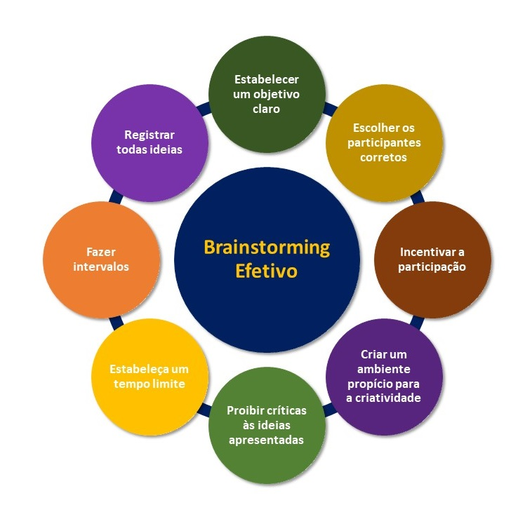
Fonte: Gomes, 2023

Figura 2 - ideias

Fonte: Gomes, 2023

Teste nível 3
Lorem Ipsum is simply dummy text of the printing and typesetting industry. Lorem Ipsum has been the industry's standard dummy text ever since the 1500s, when an unknown printer took a galley of type and scrambled it to make a type specimen book. It has survived not only five centuries, but also the leap into electronic typesetting, remaining essentially unchanged. It was popularised in the 1960s with the release of Letraset sheets containing Lorem Ipsum passages, and more recently with desktop publishing software like Aldus PageMaker including versions of Lorem Ipsum.

Teste nível 4
Lorem Ipsum is simply dummy text of the printing and typesetting industry. Lorem Ipsum has been the industry's standard dummy text ever since the 1500s, when an unknown printer took a galley of type and scrambled it to make a type specimen book. It has survived not only five centuries, but also the leap into electronic typesetting, remaining essentially unchanged. It was popularised in the 1960s with the release of Letraset sheets containing Lorem Ipsum passages, and more recently with desktop publishing software like Aldus PageMaker including versions of Lorem Ipsum.

Teste nível 5
Lorem Ipsum is simply dummy text of the printing and typesetting industry. Lorem Ipsum has been the industry's standard dummy text ever since the 1500s, when an unknown printer took a galley of type and scrambled it to make a type specimen book. It has survived not only five centuries, but also the leap into electronic typesetting, remaining essentially unchanged. It was popularised in the 1960s with the release of Letraset sheets containing Lorem Ipsum passages, and more recently with desktop publishing software like Aldus PageMaker including versions of Lorem Ipsum.

IMERSÃO
A fase de imersão no Design Thinking corresponde ao momento inicial em que a equipe busca compreender de forma aprofundada o contexto do problema, considerando tanto a perspectiva da organização quanto a do usuário final. A coleta de insights ocorre a partir da observação e da interpretação das experiências dos usuários, contribuindo para a construção de soluções mais adequadas. Além disso, essa fase também auxilia na definição do escopo do projeto e na identificação dos principais atores envolvidos no processo (Martins et al., 2016).

Caderno de Sensibilidade
Quadro 1 - caderno de sensibilidade
Frase | sentimento
Lorem Ipsum has been the industry's standard dummy text ever since the 1500s, | 😀
Lorem Ipsum has been the industry's standard dummy text ever since the 1500s, | 😀
Lorem Ipsum has been the industry's standard dummy text ever since the 1500s, | 😀
Lorem Ipsum has been the industry's standard dummy text ever since the 1500s,e | 😀

Fonte: os autores, 2026

Pesquisa de campo
Aqui vai a introdução explicando a pesquisa
Gráfico 1- Idades

Fonte: os autores, 2026

ANÁLISE E SÍNTESE

Brainstorming
O brainstorming como “uma contribuição de ideias por um ou mais indivíduos em uma tentativa de inventar ou encontrar a solução de um problema”. Parece familiar, certo? É possível fazer brainstorming por conta própria, mas essa técnica é usada com frequência em grupos para compartilhar ideias com liberdade, servindo como base para construir a partir delas. O brainstorming prevalece no mundo do trabalho de hoje (você já deve ter participado de algumas sessões), mas ele tem algumas raízes históricas significativas. A técnica foi apresentada pela primeira vez em 1948 pelo executivo de publicidade Alex F. Osborn no livro “O Poder Criador da Mente”. Como proprietário de uma agência de publicidade, ele estava procurando maneiras de tirar ideias melhores de seus funcionários, algo que ele chamava de “inventar”. Com esse objetivo em mente, estabeleceu vários princípios e características de brainstorming, que a gente vai analisar mais a fundo depois. (Atlassian, 2026)

Persona
Lorem Ipsum is simply dummy text of the printing and typesetting industry. Lorem Ipsum has been the industry's standard dummy text ever since the 1500s, when an unknown printer took a galley of type and scrambled it to make a type specimen book. It has survived not only five centuries, but also the leap into electronic typesetting, remaining essentially unchanged. It was popularised in the 1960s with the release of Letraset sheets containing Lorem Ipsum passages, and more recently with desktop publishing software like Aldus PageMaker including versions of Lorem Ipsum.

Aspectos estratégicos

Planejamento financeiro
Tabela 1 - Custo do serviços
Plano | preço
C | 10
C+ | 100
C++ | 1000
C# | 10000

REFERENCIAS

MARTINS, Amilton Rodrigo de Quadros; SIGNORI, Gláuber Guilherme; CAPELLARI, Márcia Rodrigues dos Santos; SPINELLO SOTILLE, Suellen; KALIL, Fahad. Uso de Design Thinking como Experiência de Prototipação de Ideias no Ensino Superior. Future Studies Research Journal: Trends and Strategies, v. 8, n. 1, p. 208–224, 2016. Disponível em: https://future.emnuvens.com.br/FSRJ/article/view/227/342. Acesso em: 2 abr. 2026.

ATLASSIAN. Brainstorming: o que é e como conduzir reuniões de brainstorming eficazes. 2026, Disponível em: https://www.atlassian.com/br/work-management/project-collaboration/brainstorming. Acesso em: 9 abr. 2026.

